THIRD SUNDAY AFTER PENTECOST
June 26, 2022
8:30 am and 10:00 a.m.

Mass: Rite II

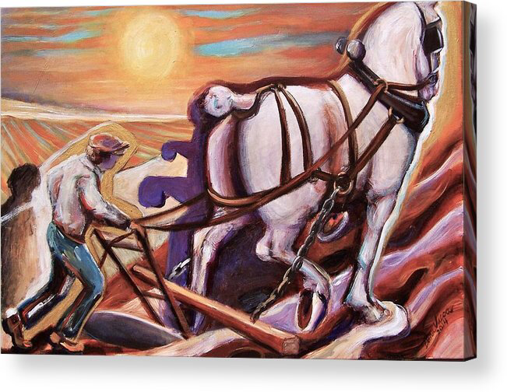

We are delighted to welcome you to our online/in-person hybrid liturgy. Fully vaccinated clergy and lay leaders may remove their masks while speaking or singing, according to diocesan guidelines. All other participants are asked to remain masked and maintain a 3-foot distance from members of other households.

The Prelude Le Cigne C. Saint-saens
The Welcome

The Introit Hymn: McKee Hymnal#529 [Standing]

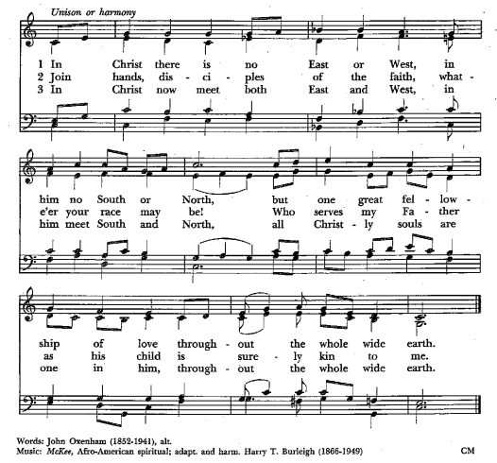

Permission to podcast/stream the music in this service obtained from ONE LICENSE, License # A-720479. All rights reserved.
Reprinted with permission under ONE LICENSE #A-720479. All rights reserved.

Celebrant: Blessed be God: Father, Son, and Holy Spirit.

All: And blessed be God’s kingdom, now and for ever. Amen.

All: Almighty God, to you all hearts are open, all desires known, and from you no secrets are hid: Cleanse the thoughts of our hearts by the inspiration of your Holy Spirit, that we may perfectly love you, and worthily magnify your holy Name; through Christ our Lord. Amen.

The Gloria: Hymnal S#280
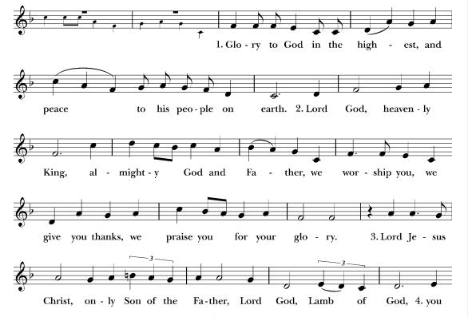
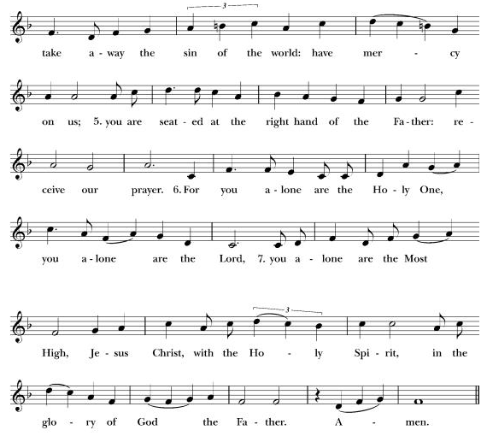
The Collect of the Day
Celebrant: Let us pray.

Almighty God, you have built your Church upon the foundation of the apostles and prophets, Jesus Christ himself being the chief cornerstone: Grant us so to be joined together in unity of spirit by their teaching, that we may be made a holy temple acceptable to you; through Jesus Christ our Lord, who lives and reigns with you and the Holy Spirit, one God, for ever and ever. Amen.

2 Kings 2:1-2, 6-14
When the Lord was about to take Elijah up to heaven by a whirlwind, Elijah and Elisha were on their way from Gilgal. Elijah said to Elisha, "Stay here; for the Lord has sent me as far as Bethel." But Elisha said, "As the Lord lives, and as you yourself live, I will not leave you." So they went down to Bethel.
Then Elijah said to him, "Stay here; for the Lord has sent me to the Jordan." But he said, "As the Lord lives, and as you yourself live, I will not leave you." So the two of them went on. Fifty men of the company of prophets also went, and stood at some distance from them, as they both were standing by the Jordan. Then Elijah took his mantle and rolled it up, and struck the water; the water was parted to the one side and to the other, until the two of them crossed on dry ground.
When they had crossed, Elijah said to Elisha, "Tell me what I may do for you, before I am taken from you." Elisha said, "Please let me inherit a double share of your spirit." He responded, "You have asked a hard thing; yet, if you see me as I am being taken from you, it will be granted you; if not, it will not." As they continued walking and talking, a chariot of fire and horses of fire separated the two of them, and Elijah ascended in a whirlwind into heaven. Elisha kept watching and crying out, "Father, father! The chariots of Israel and its horsemen!" But when he could no longer see him, he grasped his own clothes and tore them in two pieces.
He picked up the mantle of Elijah that had fallen from him, and went back and stood on the bank of the Jordan. He took the mantle of Elijah that had fallen from him, and struck the water, saying, "Where is the Lord, the God of Elijah?" When he had struck the water, the water was parted to the one side and to the other, and Elisha went over.

Reader: The Word of the Lord.

All: Thanks be to God.

Psalm 77:1-2, 11-20 Voce mea ad Dominum
[Seated at 8.30/Standing at 10]
St Meinrad Mode V (6-line)
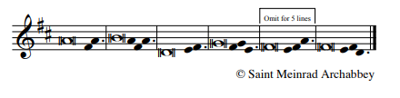

I will cry aloud to God;
I will cry aloud,
and he will hear me.
In the day of my trouble I sought the Lord;
my hands were stretched out by night and did not tire;
I refused to be comforted.

I will remember the works of the Lord,
and call to mind your wonders of old time.
I will meditate on all your acts
and ponder your mighty deeds.
Your way, O God, is holy;
who is so great a god as our God?

You are the God who works wonders
and have declared your power among the peoples.
By your strength you have redeemed your people,
the children of Jacob and Joseph.
The waters saw you, O God;
the waters saw you and trembled;

The very depths were shaken.
The clouds poured out water;
the skies thundered;
your arrows flashed to and fro;
The sound of your thunder was in the whirlwind;
your lightnings lit up the world;
The earth trembled and shook.
Your way was in the sea,
and your paths in the great waters,
yet your footsteps were not seen.
You led your people like a flock
by the hand of Moses and Aaron.

The Epistle: Galatians 5:1,13-25
For freedom Christ has set us free. Stand firm, therefore, and do not submit again to a yoke of slavery.
For you were called to freedom, brothers and sisters; only do not use your freedom as an opportunity for self-indulgence, but through love become slaves to one another. For the whole law is summed up in a single commandment, "You shall love your neighbor as yourself." If, however, you bite and devour one another, take care that you are not consumed by one another.
Live by the Spirit, I say, and do not gratify the desires of the flesh. For what the flesh desires is opposed to the Spirit, and what the Spirit desires is opposed to the flesh; for these are opposed to each other, to prevent you from doing what you want. But if you are led by the Spirit, you are not subject to the law. Now the works of the flesh are obvious: fornication, impurity, licentiousness, idolatry, sorcery, enmities, strife, jealousy, anger, quarrels, dissensions, factions, envy, drunkenness, carousing, and things like these. I am warning you, as I warned you before: those who do such things will not inherit the kingdom of God.
By contrast, the fruit of the Spirit is love, joy, peace, patience, kindness, generosity, faithfulness, gentleness, and self-control. There is no law against such things. And those who belong to Christ Jesus have crucified the flesh with its passions and desires. If we live by the Spirit, let us also be guided by the Spirit.

The Gospel: Luke 9:51-62

[Standing]
Celebrant: The Holy Gospel of our Lord Jesus Christ according to Luke
All: Glory to you, Lord Christ.

When the days drew near for Jesus to be taken up, he set his face to go to Jerusalem. And he sent messengers ahead of him. On their way they entered a village of the Samaritans to make ready for him; but they did not receive him, because his face was set toward Jerusalem. When his disciples James and John saw it, they said, "Lord, do you want us to command fire to come down from heaven and consume them?" But he turned and rebuked them. Then they went on to another village.
As they were going along the road, someone said to him, "I will follow you wherever you go." And Jesus said to him, "Foxes have holes, and birds of the air have nests; but the Son of Man has nowhere to lay his head." To another he said, "Follow me." But he said, "Lord, first let me go and bury my father." But Jesus said to him, "Let the dead bury their own dead; but as for you, go and proclaim the kingdom of God." Another said, "I will follow you, Lord; but let me first say farewell to those at my home." Jesus said to him, "No one who puts a hand to the plow and looks back is fit for the kingdom of God."
Celebrant: The Gospel of the Lord.
All: Praise to you, Lord Christ

The Sermon [Seated]

The Nicene Creed BCP, page 358
We believe in one God, the Father, the Almighty, maker of heaven and earth, of all that is, seen and unseen.

We believe in one Lord, Jesus Christ, the only Son of God, eternally begotten of the Father, God from God, Light from Light, true God from true God, begotten, not made, of one Being with the Father. Through him all things were made. For us and for our salvation he came down from heaven: by the power of the Holy Spirit he became incarnate from the Virgin Mary, and was made man. For our sake he was crucified under Pontius Pilate; he suffered death and was buried. On the third day he rose again in accordance with the Scriptures; he ascended into heaven and is seated at the right hand of the Father. He will come again in glory to judge the living and the dead, and his kingdom will have no end.

We believe in the Holy Spirit, the Lord, the giver of life, who proceeds from the Father. With the Father and the Son he is worshiped and glorified. He has spoken through the Prophets. We believe in one holy catholic and apostolic Church. We acknowledge one baptism for the forgiveness of sins. We look for the resurrection of the dead, and the life of the world to come. Amen.

The Intercessions: (Kneeling)

If we live by the Spirit, brothers and sisters, let us also be guided by the Spirit. And, guided by the Spirit, let us lift our prayers to the Lord, saying, “We cry aloud to you; O God, hear us.”
We give you thanks, O God, that for freedom Christ has set us free. Though at times it challenges our patience, we also give you thanks for the freedom, through love, to become servants of one another.
We cry aloud to you;
O God, hear us.

Gracious God, give us the will and the strength to prepare the way for your Kingdom to come. May love heal our factions and peace overcome strife.
We cry aloud to you;
O God, hear us.

Your paths are in the great waters, mighty Redeemer. We thank you that by the waters of baptism you have made us members of your household.
We cry aloud to you;
O God, hear us.

Lord Jesus, you rebuked your disciples James and John when they desired the destruction of others. Instill in us gentleness and self-control that we might learn to love even those with whom we strongly disagree.
We cry aloud to you;
O God, hear us.

You are the God who works wonders. We offer to you our sincere prayers for our hurting loved ones. Work wonders in their hearts and lives, we pray. We pray especially for Yvonne Sidell, Jerelyn Weber, Charlene Adolph, and Miles Martin
We cry aloud to you;
O God, hear us.

By your strength, O God, you redeem your people. Lead us by your Spirit and make us fit for your heavenly Kingdom.
We cry aloud to you;
O God, hear us.

For what else shall we pray? [Everyone is invited to say their prayer intentions out loud or in their hearts]

All: Grant these our prayers, O Father, for Jesus Christ’s sake, our only Mediator and Advocate. Amen.
The Confession & Absolution [Kneeling]
God is love and we are God’s children. There is no room for fear in love. We love because God loved us first. Let us confess our sins in penitence and faith. (Silence)
All: God our Father, we confess to you and to our fellow members in the Body of Christ that we have sinned in thought, word and deed, and in what we have failed to do. We are truly sorry. Forgive us our sins, and deliver us from the power of evil. For the sake of your Son who died for us, Jesus Christ, our Lord. Amen.
Celebrant: Almighty God have mercy on us, forgive us all our sins through our Lord Jesus Christ, strengthen us in all goodness, and by the power of the Holy Spirit keep us in eternal life. Amen.
[Please Stand]

The Peace
Lord Jesus Christ, you said to your apostles, “Peace I leave with you; my own peace do I give you:” Regard not our sins, but the faith of your Church, and grant us peace and unity according to your will, who lives and reigns God throughout all ages, world without end. Amen.

Priest: The peace of the Lord be always with you.
All: And also with you.
Priest: Let us offer one another some sign of Peace.

The Offertory Sentence: If we live by the Spirit, let us also be guided by the Spirit.
The Offertory: On Eagle's Wings M. Joncas

Priest: And now, as our Savior Christ taught us, we are bold to say:

Our Father, who art in heaven,
hallowed be thy Name,
thy kingdom come, thy will be done,
on earth as it is in heaven.
Give us this day our daily bread.
And forgive us our trespasses,
as we forgive those who trespass against us.
And lead us not into temptation,
but deliver us from evil.
For thine is the kingdom, and the power, and the glory
forever and ever. Amen

The Fraction:
We break this bread to share in the Body of Christ.
All: Though we are many, we are One Body, because we all share in one bread.

The Gifts of God for the people of God.
The Agnus Dei: Hymnal #S165

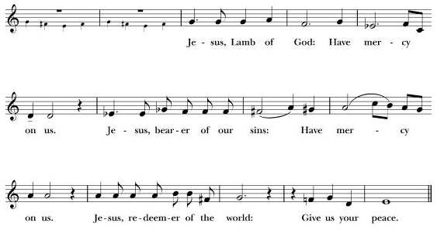

Everyone is invited to come forward for Holy Communion (under one kind during the pandemic). If you would rather not receive the Eucharist, you are invited to cross your arms for a blessing.

The Post-communion Prayer:
Father, your steadfast purpose is the completion of all things in your Son. May we who have received the pledge of the kingdom, live by faith, walk in hope, and be renewed in love, until the world reflects your glory and you are all in all; through Christ our Lord. Amen.

The Announcements

The Benediction: [Standing]

All: The peace of God, which passes all understanding, keep our hearts and minds in the knowledge and love of God, and his Son Jesus Christ our Lord; And the blessing of God almighty, (+) the Father, the Son, and the Holy Spirit, be among us and remain with us always. Amen.

The Recessional Hymn: Old 100th Hymnal #380 [Standing]

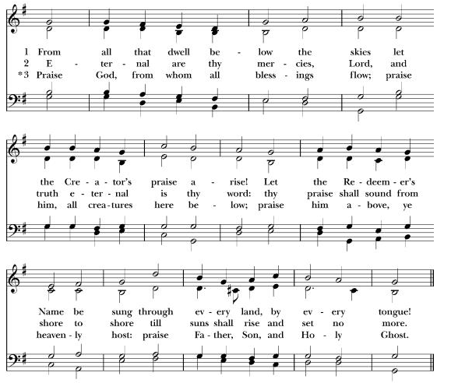

Permission to podcast/stream the music in this service obtained from ONE LICENSE, License # A720479

THE DISMISSAL (Please Stand). Hymnal #S175

Let us bless the Lord:
All: Thanks be to God.

Postlude: Go Now In Peace N. Sleeth

ANNOUNCEMENTS

Weekly Calendar
DAY | DATE | TIME | EVENT
Sunday | Jun 26 | 8:30 am | Mass
Sunday | Jun 26 | 10:00 am | Mass
 |  | 10:00 am | Youth Grp Mtg, Courtyard
Monday | Jun 27 | 1:00 pm | Zoom Bible Study
Tuesday | Jun 28
Wednesday | Jun 29 | 10:00 am | Contemplative Meditation
Thursday | Jun 30
Friday | July 1
Saturday | July 2
Sunday | July 3

TODAY
Sunday, June 26, 10:00 am Youth Group Meeting, Courtyard

THIS WEEK
Monday, June 27, 1:00 pm Zoom Bible Study. For Zoom link, please contact Daniel Tate at dtate@ses.cdsp.edu or 650-799-7084

Maureen Fromme Prayers & Support
Please provide prayers and support to Maureen Fromme’s son who recently suffered from a stroke.
https://gofund.me/23978e1a

Sea Breeze Donation Bin
Do you have extra clothes and shoes that you need to rid your home of? If so, it is your lucky day! When you come to Church you will find a big green and white donation bin, located near our trash dumpster enclosure. We are using this as a bit of a fundraiser and for each pound of donated clothing and shoes, we will receive a cash donation. Additionally, for each full bin of donations, a tree will be planted someplace. The clothing and shoes that are donated will be used to help the homeless and less fortunate folks in and around our community. Please feel free to use the bin for your donations starting immediately. The company has asked that we do not deposit, trash, toys or household goods. The bin will be available through most of the summer.

Coffee Hour
Join us for Coffee Hour after mass at 11:00 am in the courtyard. Coffee hour will be hosted by the Vestry on the first Sunday of the month. Please volunteer for the other weeks by using the link below or by the signup sheet in the Narthex by the Reflections & Gratitude Board:

Sign Up Genius
https://www.signupgenius.com/go/60B0D4FA5A82CA0F94-coffee1
Sunday School Outdoor Classes
Pre-K - K5 Sunday school is back to in-person! Outdoor classes (courtyard) will be held on the 1st and 3rd Sunday of each month. Spread the word! We can't wait to see BIG smiles in the courtyard, share the good news of Jesus, and have fun altogether! Thank you!
Teacher Raphaele and Teacher Fe

Prayer Support Group
Every 1st and 3rd Sunday after the service at 11:30am, we will be meeting in the Fellowship Hall to have a prayer meeting. Please join us any time as you are able. For questions, please contact Daniel Tate at 650-799-7084, or dtate@ses.cdsp.edu

Choir Rehearsals
St. Ambrose Choir will be on summer break for a few weeks, returning to participate in worship in mid-August. Anyone wishing to join us in singing for worship on Sunday, August 21, please contact Maureen Fromme (mhfromme@yahoo.com OR 415.990.6758)

Worship Leaders Needed
Please sign up as a Lector for our 8:30 am Mass by emailing stambrose@mindspring.com or Church signup sheet

We also need Worship Leader volunteers for our 10:30 am Mass. There are openings for Intercessors, Lectors, Greeters, Ushers and Acolytes, and Livestream Technicians. Contact us at stambrose@mindspring.com or use the following link to signup: Signup Genius or Click on the following link
https://www.signupgenius.com/go/60B0D4FA5A82CA0F94-worship

Rides for Gene Hetzer
Gene Hetzer a longtime church member and Karl his guide dog need rides on an alternating basis from church members. Please contact Jim Neubert to schedule a day for driving.

Contemplative Meditation
Father Shane guides a thirty-minute weekly ‘Zoom-Zen’ contemplative meditation on Wednesdays at 10am, Please send an email to Hamilton Fong (hfongster@gmail.com) or to Nilda Chong (nchongmd@gmail.com) if you wish to be included in the Zoom invitation.

Prayer list: We pray especially for Yvonne Sidell, Jerelyn Weber, Charlene Adolph, Miles Martin, Barbara Milligan, Ed Avakoff, Max Gumbert, Isabella, Jerry Boykin, Carol Newman, Clara Padilla, Bettie Davis, Arjun Katyan, Janet Mc Annally, Marilyn Canon, Alison LeBlanc, Ronnie Rosen, Leo Gauthier, John David Tate, Casey McElroy, Alice Deckel, Randy Fromme, and the pupils and staff of Sea Breeze School.

[Please contact the parish office to add any names of the sick and suffering to be prayed for in our monthly cycle of prayer.]

The Altar Flowers are given by
The Altar Guild to the Glory of God

In the Anglican cycle of prayer we pray for:
Episcopal Church of Sudan; The Diocese of Lake Malawi (Central Africa); The Diocese of Northern Malawi (Central Africa); The Diocese of Southern Malawi (Central Africa); The Diocese of West Malaysia (South East Asia); The Diocese of Malek (South Sudan); The Diocese of Malek Rup (South Sudan)

In the Diocesan cycle of prayer we pray for Reverends:
Laureen Moyer, Matthew Dutton-Gillett, Simon Mainwaring, Este Gardner Cantor, Cn. Abbott Bailey, Jay Watan, Maurice Turner, The Ven. David Stickley, Margaret Deeths, Dr. John Fitterer, Dr. Robert Gregg and Matthew McDermott

The Mission of St. Ambrose Church of Foster City
Is to proclaim the Good News of God
in Jesus Christ as we care for each other and
our larger community. We worship in the
Episcopal and Anglican tradition, extending
an open and inclusive invitation to all
people, welcoming children into our church family
and serving those in need.

Worship Leaders:

Daniel Tate, Seminarian
Dulce Lord/Warren Wong Lectors
Warren Wong Intercessor
Hamilton Fong, Cantor
Frank Saunders, Organist
Daniel Tate, Acolyte
Daniel Tate, Livestream Technician

Worship Leader Rota:

26 Jun Lectors: Dulce Lord, Warren Wong; Intercessor: Warren Wong
Usher: Elliott Dun; Greeter: Warren Wong; Livestream
Technician: Daniel Tate

Fr Shane can be contacted on 845-240-4516, or at FrshaneSH@gmail.com

