**THE LITURGY OF THE WORD**

**Processional Hymn 493 | O** *for a thousand tongues to sing*

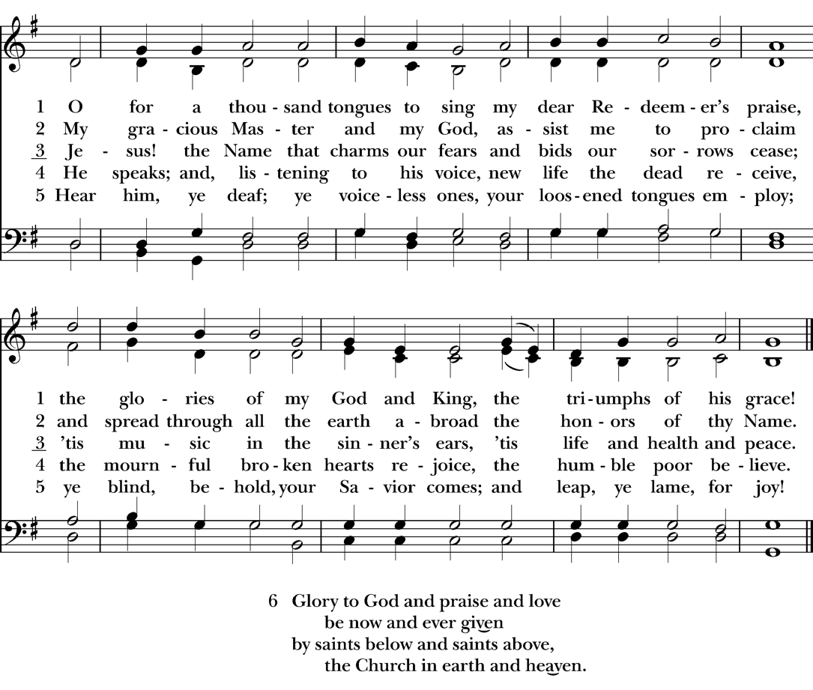

**Opening Sentences**

*Celebrant:* Blessed be God, Father, Son, and Holy Spirit.

***People:* And blessed be God’s kingdom now and forever. *Amen.***

**The Collect for Purity**

Almighty God, to you all hearts are open, all desires known, and from you no secrets are hid: Cleanse the thoughts of our hearts by the inspiration of your Holy Spirit, that we may perfectly love you, and worthily magnify your holy Name; through Christ. ***Amen.***

**The Collect of the Day**

*Celebrant:*The Lord be with you.

***People:* And also with you.**

*Celebrant:* Let us pray.

Grant us, O Lord, to trust in you with all our hearts; for, as you always resist the proud who confide in their own strength, so you never forsake those who make their boast of your mercy; through Jesus Christ our Lord, who lives and reigns with you and the Holy Spirit, one God, now and forever.

***Amen***.

### First LESSON Deuteronomy 30:15-20 (*Seated)*

Moses said to all Israel the words which the Lord commanded him, "See, I have set before you today life and prosperity, death and adversity. If you obey the commandments of the Lord your God that I am commanding you today, by loving the Lord your God, walking in his ways, and observing his commandments, decrees, and ordinances, then you shall live and become numerous, and the Lord your God will bless you in the land that you are entering to possess. But if your heart turns away and you do not hear, but are led astray to bow down to other gods and serve them, I declare to you today that you shall perish; you shall not live long in the land that you are crossing the Jordan to enter and possess. I call heaven and earth to witness against you today that I have set before you life and death, blessings and curses. Choose life so that you and your descendants may live, loving the Lord your God, obeying him, and holding fast to him; for that means life to you and length of days, so that you may live in the land that the Lord swore to give to your ancestors, to Abraham, to Isaac, and to Jacob."

*Reader*: The Word of the Lord.

***People*: Thanks be to God.**

**Psalm 1 (*Seated)***

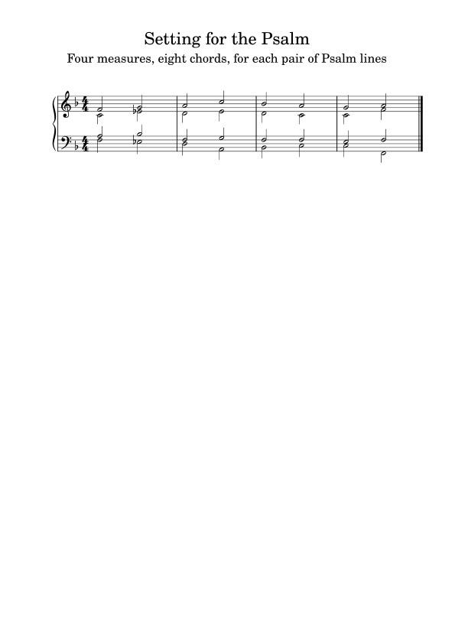

1 Happy are they who have not walked in the counsel of the **wick**ed, *

nor lingered in the way of sinners, nor sat in the seats of the **scorn**ful!

2. Their delight is in the law of the **Lord**,*

and they meditate on his law day and **night**.

3. They are like trees planted by streams of water, bearing fruit in due season, with leaves that do not **with**er, *

everything they do shall **pros**per.

4. It is not so with the **wick**ed; *

they are like chaff which the wind blows a**way**.

5. Therefore the wicked shall not stand upright when judgment **comes**, *

nor the sinner in the council of the **right**eous.

6. For the Lord knows the way of the **right**eous, *

but the way of the wicked is **doomed**.

**Second Lesson Philemon 1-21 (*Seated)***

Paul, a prisoner of Christ Jesus, and Timothy our brother, To Philemon our dear friend and co-worker, to Apphia our sister, to Archippus our fellow soldier, and to the church in your house: Grace to you and peace from God our Father and the Lord Jesus Christ. When I remember you in my prayers, I always thank my God because I hear of your love for all the saints and your faith toward the Lord Jesus. I pray that the sharing of your faith may become effective when you perceive all the good that we may do for Christ. I have indeed received much joy and encouragement from your love, because the hearts of the saints have been refreshed through you, my brother. For this reason, though I am bold enough in Christ to command you to do your duty, yet I would rather appeal to you on the basis of love-- and I, Paul, do this as an old man, and now also as a prisoner of Christ Jesus. I am appealing to you for my child, Onesimus, whose father I have become during my imprisonment. Formerly he was useless to you, but now he is indeed useful both to you and to me. I am sending him, that is, my own heart, back to you. I wanted to keep him with me, so that he might be of service to me in your place during my imprisonment for the gospel; but I preferred to do nothing without your consent, in order that your good deed might be voluntary and not something forced. Perhaps this is the reason he was separated from you for a while, so that you might have him back forever, no longer as a slave but more than a slave, a beloved brother-- especially to me but how much more to you, both in the flesh and in the Lord. So if you consider me your partner, welcome him as you would welcome me. If he has wronged you in any way, or owes you anything, charge that to my account. I, Paul, am writing this with my own hand: I will repay it. I say nothing about your owing me even your own self. Yes, brother, let me have this benefit from you in the Lord! Refresh my heart in Christ. Confident of your obedience, I am writing to you, knowing that you will do even more than I say.

*Reader*: The Word of the Lord.

***People*: Thanks be to God**

***Please Stand***

**Hymn Celtic Alleluia – *two times through***

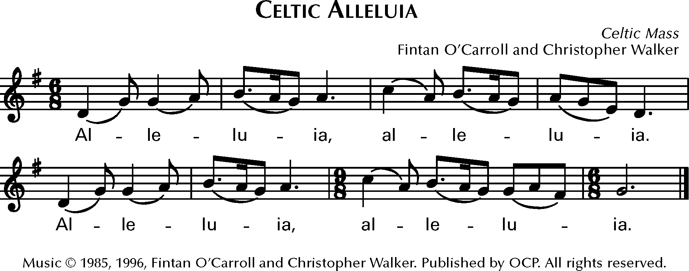

**Holy Gospel Luke 14:25-33**

### *Deacon:* The Holy Gospel of our Lord Jesus Christ according to St. Luke.

### *People:* Glory to you, Lord Christ.

Now large crowds were traveling with Jesus; and he turned and said to them, "Whoever comes to me and does not hate father and mother, wife and children, brothers and sisters, yes, and even life itself, cannot be my disciple. Whoever does not carry the cross and follow me cannot be my disciple. For which of you, intending to build a tower, does not first sit down and estimate the cost, to see whether he has enough to complete it? Otherwise, when he has laid a foundation and is not able to finish, all who see it will begin to ridicule him, saying, `This fellow began to build and was not able to finish.' Or what king, going out to wage war against another king, will not sit down first and consider whether he is able with ten thousand to oppose the one who comes against him with twenty thousand? If he cannot, then, while the other is still far away, he sends a delegation and asks for the terms of peace. So therefore, none of you can become my disciple if you do not give up all your possessions."

### *Deacon:* The Gospel of the Lord.

***People:* Praise to you, Lord Christ.**

**Hymn Celtic Alleluia – *one time through***

**Sermon The Rev. Fr. Jason Lucas-Green**

**The Nicene Creed**

**We believe in one God, the Father, the Almighty, maker of heaven and earth, of all that is, seen and unseen.**

**We believe in one Lord, Jesus Christ, the only Son of God, eternally begotten of the Father, God from God, Light from Light, true God from true God, begotten, not made, of one Being with the Father. Through him all things were made. For us and for our salvation he came down from heaven: by the power of the Holy Spirit he became incarnate from the Virgin Mary, and was made man. For our sake he was crucified under Pontius Pilate; he suffered death and was buried.**

**On the third day he rose again in accordance with the Scriptures; he ascended into heaven and is seated at the right hand of the Father. He will come again in glory to judge the living and the dead, and his kingdom will have no end.**

**We believe in the Holy Spirit, the Lord, the giver of life, who proceeds from the Father and the Son.  
With the Father and the Son he is worshiped and glorified. He has spoken through the Prophets.  
We believe in one holy catholic and apostolic Church.  
We acknowledge one baptism for the forgiveness of sins. We look for the resurrection of the dead, and the life of the world to come. Amen**

### Form III *(Standing)*

*The Leader and People pray responsively*

Father, we pray for your holy Catholic Church;  
That we all may be one.

Grant that every member of the Church may truly and  
humbly serve you;  
That your Name may be glorified by all people.

We pray for all bishops, priests, and deacons;  
That they may be faithful ministers of your Word andSacraments.

We pray for all who govern and hold authority in the nations  
of the world;  
That there may be justice and peace on the earth.

Give us grace to do your will in all that we undertake;  
That our works may find favor in your sight.

Have compassion on those who suffer from any grief or trouble;  
That they may be delivered from their distress.

Give to the departed eternal rest.  
Let light perpetual shine upon them.

We praise you for your saints who have entered into joy;  
May we also come to share in your heavenly kingdom.

Let us pray for our own needs and those of others.

*Silence.* For what else shall we pray? *[Everyone is invited to say their prayer intentions out loud or in their hearts]*

*Celebrant:* Grant these our prayers, O Father, for Jesus Christ’s sake, our only Mediator and Advocate. Amen.

***THE CONFESSION & ABSOLUTION (standing)***

*Celebrant*: Let us confess our sins against God and our neighbor.

*All*: **Most merciful God, we confess that we have sinned against you in thought, word, and deed, by what we have done, and by what we have left undone. We have not loved you with our whole heart; we have not loved our neighbors as ourselves. We are truly sorry and we humbly repent. For the sake of your Son Jesus Christ, have mercy on us and forgive us; that we may delight in your will, and walk in your ways, to the glory of your Name. Amen.**

*Celebrant*: Almighty God have mercy on you, forgive you all your sins through our Lord Jesus Christ, strengthen you in all goodness, and by the power of the Holy Spirit keep you in eternal life. Amen.

**THE PEACE**

*Celebrant*: The peace of Christ be always with you.

***People*: And also with you**

**THE OFFERTORY:**My Song is Love Unknown arr. Jennings

**THE HOLY COMMUNION**

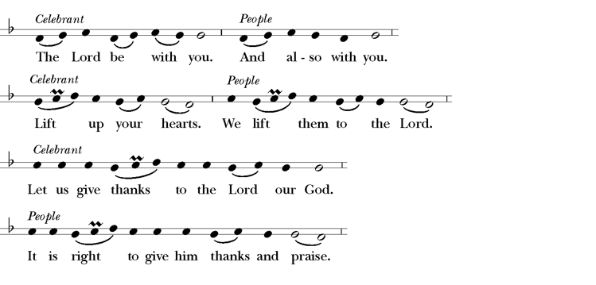

It is right, and a good and joyful thing, always and everywhere to give thanks to you, Father Almighty, Creator of heaven and earth. Of God the Father for you are the source of light and life; you made us in your image, and called us to new life in Jesus Christ our Lord. Therefore we praise you, joining our voices with Angels and Archangels and with all the company of heaven, who forever sing this hymn to proclaim the glory of your Name:

**THE SANCTUS** *Hymnal* #S125

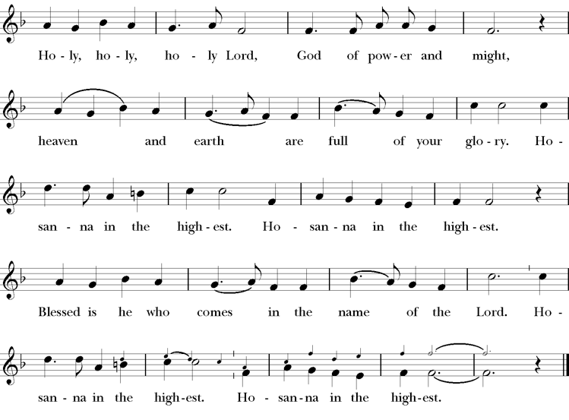

Holy and gracious Father: In your infinite love you made us for yourself; and, when we had fallen into sin and become subject to evil and death, you, in your mercy, sent Jesus Christ, your only and eternal Son, to share our human nature, to live and die as one of us, to reconcile us to you, the God and Father of all.

He stretched out his arms upon the cross, and offered himself in obedience to your will, a perfect sacrifice for the whole world.

On the night he was handed over to suffering and death, our Lord Jesus Christ took bread; and when he had given thanks to you, he broke it, and gave it to his disciples, and said, “Take, eat: This is my Body, which is given for you. Do this for the remembrance of me.”

After supper he took the cup of wine; and when he had given thanks, he gave it to them, and said, “Drink this, all of you: This is my Blood of the new Covenant, which is shed for you and for many for the forgiveness of sins. Whenever you drink it, do this for the remembrance of me.” Therefore we proclaim the mystery of faith:

*Celebrant and People* **Christ has died. Christ is risen. Christ will come again.**

*Celebrant*: We celebrate the memorial of our redemption, O Father, in this sacrifice of praise and thanksgiving. Recalling his death, resurrection, and ascension, we offer you these gifts.

Sanctify them by your Holy Spirit to be for your people the Body and Blood of your Son, the holy food and drink of new and unending life in him. Sanctify us also that we may faithfully receive this holy Sacrament, and serve you in unity, constancy, and peace; and at the last day bring us with all your saints into the joy of your eternal kingdom.

All this we ask through your Son Jesus Christ. By him, and with him, and in him, in the unity of the Holy Spirit all honor and glory is yours, Almighty Father, now and for ever. **AMEN**

**THE LORD’S PRAYER**

**Our Father, who art in heaven, hallowed be thy Name, thy kingdom come, thy will be done, on earth as it is in heaven. Give us this day our daily bread. And forgive us our trespasses, as we forgive those who trespass against us. And lead us not into temptation, but deliver us from evil. For thine is the kingdom, and the power, and the glory, for ever and ever. Amen.**

**THE FRACTION**

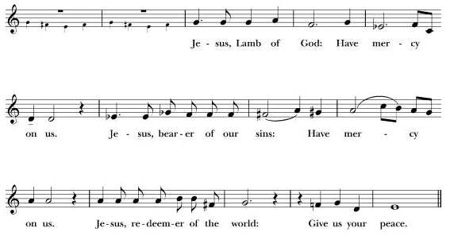

**SPIRITUAL COMMUNION**

**(Those watching at home, may, if they wish, say this prayer during the time of Communion.)**

**In union, blessed Jesus, with the faithful gathered at every altar of our Church where your blessed Body and Blood are offered this day, and remembering particularly my own parish and those worshiping there, I long to offer praise and thanksgiving for creation and all the blessing of this life, for the redemption won for us by your life, death, and resurrection, for the means of grace and the hope of glory. And particularly for the blessings given me: (Here, those watching at home may add particular blessing for which they wish to give thanks). I believe that you are truly present in the Holy Sacrament, and, since I cannot at this time receive communion, I pray you to come into my heart. I unite myself with you and embrace you with all my heart, my soul, and my mind. Let nothing separate me from you; let me serve you in this life until, by your grace, I come to our glorious kingdom and unending peace. Amen**

**The invitation**

*Celebrant:* Brothers and Sisters draw near with faith come to this holy table where ALL are WELCOME, ALL are FED, and ALL are LOVED. These are the gifts of God for the People of God.

**Communion hymn** *Surely it is God who saves me Hymnal #678 [seated]*

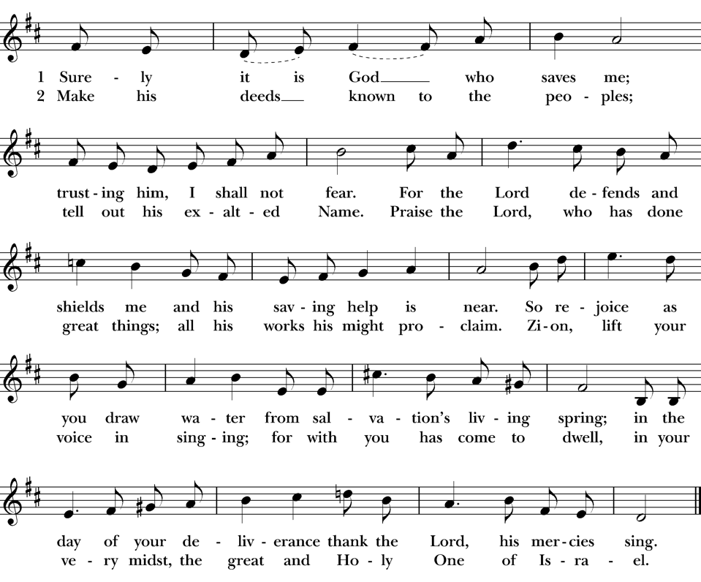

**Post Communion Prayer**

*Celebrant*: Almighty and ever living God, we thank you for feeding us with the spiritual food of the most precious Body and Blood of your Son our Savior Jesus Christ; and for assuring us in these holy mysteries that we are living members of the Body of your Son, and heirs of your eternal kingdom. And now, Father, send us out to do the work you have given us to do, to love and serve you as faithful witnesses of Christ our Lord. To him, to you, and to the Holy Spirit, be honor and glory, now and for ever. Amen.

**The Announcements**

**The Blessing**

***CLOSING HYMN****:* Take my life and let it be *Hymnal #*707 *[Stan*d]

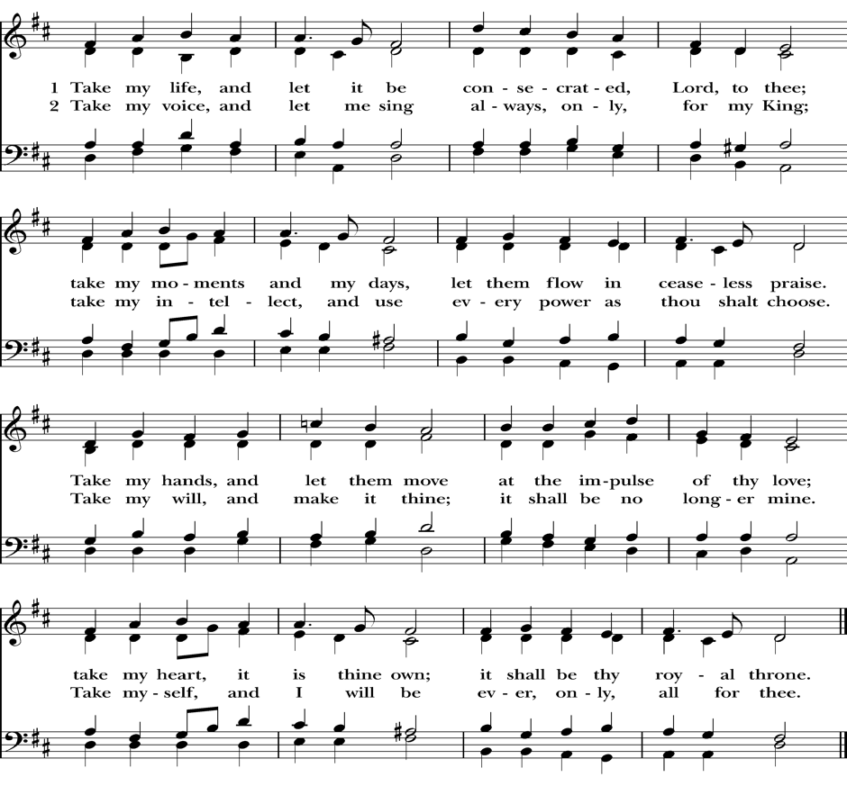

**THE DISMISSAL**

*Celebrant*: Go in peace to love and serve the Lord and one another.

*All:* **Thanks be to God.**

**POSTLUDE:** Peace is flowing like a river C. Landrey

*All music reprinted with permission—One License # A—72047*

***The Mission of St. Ambrose Church of Foster City***

Is to proclaim the Good News of God in Jesus Christ as we care for each other and our larger community. We worship in the Episcopal and Anglican tradition, extending an open and inclusive invitation to all people, welcoming children into our church family and serving those in need.

**Worship Leaders:**

The Rev. Fr. Jason Lucas-Green, Rector

Frank Saunders, Organist

Maureen Fromme, Choir Director

**Worship Leader Rota:**

Shelley Keefe, Intercessor

Warren Wong/Shelley Keefe, Lectors

Elliott Dun, Usher

Alison LeBlanc, Livestream Technician