AUGUST /  
SEPTEMBER

2022

Edition

In This  
SPECIAL Issue:

*Reflections from   
the Rector……….....…P 1*

*Announcements..….P 2-3  
  
Vestry Report……......P 4  
  
Youth Ministry…......P 5-6  
  
Hymn..…..….........…..P 7   
  
Outreach………......P 8-9*

*Sea Breeze   
School News............P 10  
  
Editor’s Corner…......P 11*

*Birthdays &   
Anniversaries…...P 12-13*

**Editor**

*Yvonne Sidell*



The Ambrosian

The Monthly Newsletter of St. Ambrose Episcopal Church

900 Edgewater Boulevard, Foster City, California 94404

***Individual Highlights:***

Inside Story 2

Inside Story 3

Inside Story 4

Inside Story 5

Inside Story 6

Inside Story 7

Last Story 8

***Special Interest Articles:***

• Add a highlight or your point of interest here.

• Add a highlight or your point of interest here.

• Add a highlight or your point of interest here.

Save the Date for Celebration of New Ministry with Bishop Marc on October 22, 2022 at 11:00 a.m.  More details to follow.

# Reflections from the Rector

Announcements

Page 2 of 13

**St. Ambrose Stewardship Dinner**   
  
You are cordially invited to the St. Ambrose Stewardship Dinner on **Friday, October 28 at   
6:00 p.m.** at the William E. Walker Recreation Center, 650 Shell Boulevard in Foster City. Please ensure you RSVP at [Stewardship Dinner](http://evite.me/N5m37T8cj5ctrl)

**Intercession Prayers**

The apostle James tells us to “pray for one another, that you may be healed” (James 5:16).   
  
If you would like the St. Ambrose community to pray with you, please write your intercession in the Blessing book placed in the Narthex or send your request to [stambrosefc@att.net](mailto:stambrosefc@att.net). Your prayer will be included at the following mass service. Please leave your name and contact information in the booklet, in case clarifications are needed.

*Thank you!   
Raphaele*

**St. Ambrose Choir**

The choir will resume rehearsals on Thursdays at 7:30 p.m.   We will be masked and correctly distanced, and would be happy for anyone who wishes to join us.  If you wish to join us, please let Maureen know so she can prepare a folder for you.  You may contact her at [mhfromme@yahoo.com](mailto:mhfromme@yahoo.com) OR 415.990.6758.

**Sunday School is back!**

Class resumes on August 28 after a long and nice summer break!  Teacher Fe and Teacher Raphaele will conduct the class outdoors every week for children Pre-K and up. Class will offer story time, songs, and lots of fun! We are looking forward to seeing your kids, with their big smiles!

To support this program, we would like to engage our community. We are calling for helpers as we (Fe and Raphaele) will each teach every other week and **will need one helper every week** (no special skills required). Please reach to [saintambrosesundayschool@gmail.com](mailto:saintambrosesundayschool@gmail.com) for more information.

Announcements (continued)   
  
 **Blessing of the backpacks on September 11 - Bring your backpack, chromebook or pencil box!**

Page 3 of 13

Kids of all age are invited to receive Blessings as they commit to study and learn in the school year ahead. Adults entering a learning program are welcome too!

*Thank you!*

*Raphaele and Fe*

**Contemplative Meditation Group**

St. Ambrose has a wonderful "Contemplative Meditation" group who meet each week on Hump Days. That's right! After the first two hectic days of the week, it's just time for a much needed 30+ minute break.

Beginning with his monastic early life, Father Shane has a lifetime of meditation.  From this wealth of experience and knowledge, Father Shane draws inspiration from various forms of contemplation as well as meditation.

Of course, we all know that schedules can get in the way of participating...even on Zoom. We have been recording some of the sessions and are making them available for your practice on your own time. How about that?!

Please email me at [hfongster@gmail.com](mailto:hfongster@gmail.com) if you have any questions or would like to request access for the recordings...maybe even the Zoom link to join us.   
  
*Thank you!   
Hamilton*

**Volunteers Needed**

We are looking for volunteers for coffee hour, summer days and stewardship dinner. If you are interested, please contact me at [valentin_fe@yahoo.com](mailto:valentin_fe@yahoo.com)! *Thank you!*

**Free Notary for St. Ambrose**

As a seasoned California Notary Public, Yvonne Sidell always offers free notary services for   
St. Ambrose parishioners. If you need a document notarized, please text or leave a voicemail for Yvonne at 925-808-8801. *Thank you!*

Vestry Report – by Michael Lord

Page 4 of 13

St. Ambrose Parishioners,

Stay tuned for a report next month!

Respectfully Yours,

St. Ambrose Vestry

Youth Ministry and Youth Group News – by Daniel Tate

Page 5 of 13

**July Sandwiches on Sunday Service Project**We had a great time Saturday July 30 making sandwiches and putting together lunches that were distributed the next day at the Fair Oaks Community Center in Redwood City.  A combined gathering of youth and adults showed up to help out. We will be doing it again in October, so keep a look out for an announcement nearer the date.

**August Fundraiser Walk/Run for the Children of Ukraine**

Thursday the August 18, a group of us did the 5K walk/run fundraiser to support the Children of Ukraine in Foster City. We started and ended up at the Amphitheater at Leo Ryan Park. Funds were raised to go toward the purchase of neonatal equipment for maternity houses in Ukraine. The event was part of a worldwide fundraising effort and was sponsored and organized by the Ukrainian Student Association at Stanford University and the Ukrainian Association of Washington State. St. Ambrose made up a large part of the local group.

**Upcoming This Fall**

Pumpkin Carving! Late October after the Church Sunday Thanksgiving Celebration! Date to be determined, possibly in coordination with Sea Breeze Christmas Pageant!

**Opportunities**  
  
**General Election Volunteer and Seasonal Employment***(Thank you to David McIntyre for forwarding the above Election Employment information)*  
The November 8, 2022 Statewide General Election is approaching. The Registration & Elections Division of the Assessor-County Clerk-Recorder's Office is recruiting for several positions, including seasonal employment and single-day volunteers. You can find more information on the positions at: https://www.smcacre.org/elections/election-jobs

Of particular interest to our Youth might be **The Student Democracy Program.** The Student Democracy Program is hiring Student Volunteers (16+) interested in having an inside look at American democracy in action. Student Volunteers will receive a $280 stipend for attending a mandatory training class and working on Election Day. See more information at: https://www.smcacre.org/elections/student-democracy-program

*Election Materials Proofreader:* (Chinese) (Filipino) (Spanish) (Extra-Help Seasonal).  Staff will work on proofreading election materials.  Hourly wage starts at $29.94.

*Vote Center Representatives:* Assist voters at the polls, including verifying voter registration, providing election information, instructing voters in marking their ballots, and deploying/disassembling election equipment. Hourly wage starts at $22.30.

Youth Ministry and Youth Group News (continued)

Page 6 of 13

*Vote Center Trainer:* (Extra-Help, Seasonal). Leads the training of Vote Center Representatives, students and volunteers on San Mateo County Elections Procedures, how to use Vote Center equipment, Vote Center set-up and voter assistance. Will serve as a Vote Center Lead at a four-day Vote Center. Hourly wage starts at $26.77.

*Election Warehouse and Field Technician:* (Extra-Help, Seasonal). Assists in testing functions of electronic voting equipment, stage heavy equipment containers for delivery, inventory and move voting equipment and Vote Center supplies, assist in the delivery of spare equipment and supplies to Vote Centers, troubleshoot voting equipment at Vote Centers, and drive personal vehicles regularly to each Vote Center on an assigned route to make sure that all equipment is properly functioning. Hourly wage starts at $26.37.

*Election worker:* Office Assistant (Extra-Help, Seasonal). Assist in clerical support in the following areas:  Vote by Mail, Voter Registration, Customer Service/Phone Bank, Outreach Services, Voting Equipment, Supplies, and Ballot Retrieval. Hourly wage starts at $21.09.

*Election Worker:* Office Specialist (Extra-Help, Seasonal). Assist as a Vote Center Specialist, Vote Center Tech Support, Onboarding, and Fiscal Support. Hourly wage starts at $26.77.

*Vote Center Volunteers:* Responsible for greeting voters, distributing election materials and voter check-in forms, directing voters, and conducting line management. Volunteers will receive a $280 stipend for attending a mandatory training class and working on Election Day. Volunteers will arrive at the Vote Centers on Election Day at 6:30 a.m. to set up, and the day generally lasts until 9:00 p.m. During the day, you will receive two (2) one-hour breaks.   

**Youth Group Meets Sunday Mornings at 10:00 A.M.**   
We maintain protocols that protect everyone in the church (mandatory face masks, social distancing, cleaning). Join us and re-establish connections with your St. Ambrose friends and invite your friends!  
  
**Acolytes, Readers, and Livestream Technicians**  
We always need Intercessors, Lectors, Greeters, Ushers, Acolytes, and Livestream Technicians.  Please email me at ym_stambrosefc@att.net if you would like to join in with us.   *No experience is necessary.* This is a great low-key way to be of service, and to learn about (and be a part of) the history and tradition of our church.   
   
**Musicians**  
If you like to sing or play an instrument, there are plenty of opportunities to do that at St. Ambrose.  During the service, the prelude, postlude, main anthem, offertory, and hymns all offer a chance for singing or playing an instrument.  If you are a beginner or expert, either one, Maureen Fromme and Frank Saunders, our music leaders, are happy to teach, assist, and accompany.

Respectfully Yours,

Daniel Tate

Hymn – by Maureen Fromme

Page 7 of 13

*“Rejoice, Ye Pure in Heart” – Hymn 556*

Rejoice! Be Happy! Be Joyful!   
  
We can find these words in various verses of Scripture. One that comes to mind is Philippians 4:4 - “Rejoice in the Lord always. I will say it again: Rejoice!” In other venues, some of you might remember the song by Bobby McFerrin in 1988: “Don't Worry, Be Happy” or the book by Charles Schulz, “Happiness is a Warm Puppy”. Happiness is a much sought after feeling.

The writer of the words to this hymn is the British biblical scholar, teacher and minister, Edward Hayes Plumptre (1821-1891). In his effort to foster “rejoicing”, he penned eleven verses for this hymn. It was written as a processional for a choral festival in Peterborough Cathedral. In most hymnals now, usually 4 to 7 verses are used.

The hymn-tune 'Marion' (named after his wife), was composed by Arthur Henry Messiter (1834-1916), an English composer who lived much of his life in the United States. He served as an organist in churches in Philadelphia and New York City. Mr. Messiter was the editor of the 1893 Episcopal Hymnal.

The music and the text paired together do seem to express rejoicing. There are many words throughout the hymn that emphasize that: give thanks, sing, strains of joy and bliss, rapture, mirth, alleluias.

As you listen to the hymn (and sing along with it), may it bring joy and peace to you as we begin a new chapter at St. Ambrose Church.

https://youtu.be/KzuIi4fqjAQ

Respectfully Yours,

Maureen Fromme

Outreach Report – by Steve Yuen

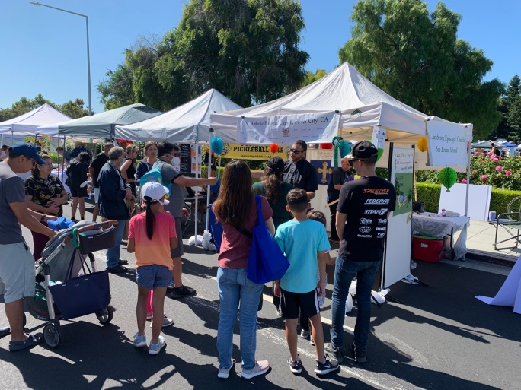

Page 8 of 13

**Foster City Summer Days – August 20-21**

The St. Ambrose booth at the Foster City Summer Days festival was easy to spot – it had a line of children waiting to spin the wheel to win a rubber ducky “Lamb of God” plush toy, snack chips, or cookies.   
  
Meanwhile, parents chatted amiably with volunteers about all manner of subjects, especially St. Ambrose and Sea Breeze School activities.

Father Jason Lucas-Green spent most of his Saturday at Summer Days speaking to fairgoers who stopped at our booth. According to testimonials from church members, and even by the Woody Allen standard (“80 percent of success is showing up”), his first month is an unqualified success!

The St. Ambrose booth came together because of the efforts of many people.

Michael Lord contacted the City, obtained the booth assignment, and provided the canopy. Michael even lent the ice chest that kept the bottled water cold. Over 100 free bottles were distributed.

Jim Neubert, Hamilton Fong, and Larry Buyers set up the booth on the Friday night before, and Larry transported all the bulky materials (canopy, tables, chairs, sandbags) to the location on Shell Blvd. The same crew took down the booth on Sunday and moved everything back to the Parish Hall.

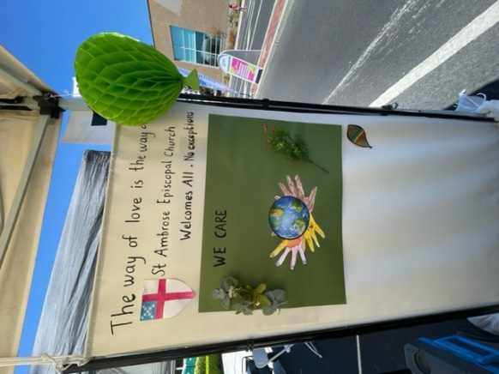Raphaele Gerber and Liva Neyroud provided the marketing inspiration and execution.  The best idea, however, originated from one of our younger members. Aurélia Gerber came up with the spinning wheel that attracted a never-ending stream of children to try their luck.

The printed handouts—St. Ambrose bookmarks with QR codes (arranged by Fe Balamiento), Sea Breeze flyers, and St. Ambrose pens—will be attractive reminders to fairgoers of their experience and may even inspire some to check us out online or even in-person.

Parishioners who staffed the booth were: Fe Balamiento, Larry Buyers, April Cherrington, Hamilton Fong, Maureen Fromme, Alison LeBlanc, David McIntyre, Lydia McIntyre, Jim Neubert, Liva Neyroud, Cathy Rincon, Diane Robertson, Daniel Tate, Nellie Wong, Warren Wong, and Steve Yuen.

While the experience is fresh in everyone’s mind, please send your suggestions, questions, and comments to Steve Yuen (stevebyuen@aol.com).

Outreach Report (continued)

Page 9 of 13

**Sandwiches on Sunday – July 31**

We made 80 brown bag lunches consisting of:

1 ham or turkey and cheese sandwich

1 PB & J sandwich

1 trail mix

1 apple

1 bottled water

Thanks go to all who purchased the ingredients, made the sandwiches, stored them overnight and/or delivered them to Fair Oaks Community Center:

Larry Buyers Elliott Dun

Elliott Dun, Jr. Alison LeBlanc

Valerie Mersh Lily and Conner Moriarty

Daniel Tate Phoebe Venkat

Shai Venkat Nellie and Warren Wong

Steve Yuen

**UPCOMING EVENTS**

|  |  |
| --- | --- |
| **Blessing of the Animals**  The Feast of St. Francis  **When**: **Sunday, October 2**, 12:30 to 2:00 p.m.  (also at the 8:30 a.m. and 10 a.m. services)    **Where:** Foster City Dog Park, Bounty & Foster City Blvd.  **What:** The Reverend Jason Lucas-Green will bless pets and their owners in honor of Saint Francis, the patron saint of animals.  *NOTE: The Dog Park event is tentative. Details still need to be worked out with the City of Foster City.* |  |

**Sandwiches on Sunday – October 30**

We will again assemble the sandwiches and brown bags the day before, i.e., **Saturday, October 29**, at the church from 12:00 p.m. to 2:00 p.m. They will be distributed at the Fair Oaks Community Center in Redwood City on **Sunday, October 30** from 11:45 a.m. to 12:15 p.m. If you would like to help or have any questions, please contact Steve Yuen (650-315-9662, stevebyuen@aol.com).

*​*Sea Breeze School News **–** by Jerelyn Weber, Principal

Page 10 of 13

Summer is over and the School Year has started!

Our Summer Camp was **amazing** and we saw an average of 80 children each day of the eight weeks of camp. We learned about the Ocean, Magicians, Pirates and Camping. It was awesome to see the children become Outdoor Explorers and watch them be amazed by all they found during their daytime adventures. The wide eyed amazement is always so heartwarming for me.

The teachers returned from Summer Break on Wednesday August 17 to prepare for the upcoming school year. In addition to some Teacher Training this day, we were treated to a delicious lunch provided by members of the School Board and Vestry. Not only was lunch delicious, it was so nice to have the opportunity for everyone to meet each other and learn just how the different boards support the school. Teachers enjoyed speaking with those in attendance and I think this was a great way to help strengthen the relationship between the School and the Church. We are very lucky to have the support of the Church and its members!

Father Jason also joined us for a few hours to introduce himself and to share himself with the teachers. He wanted to hear from them about what they thought they may need from him and he shared how he could and would help and support them as well. It was a very good conversation and many walked away feeling heard and very supported.

The 2022-23 School Year started on August 22 and it was a busy week for sure. During COVID, you may remember that parents were not allowed to come on campus and our classrooms were divided into smaller rooms. Now that COVID is a bit better controlled and we have more ways to treat those that get it, we have been able to open the campus up again. The classrooms have been opened up and families may now enter the classrooms and playground to drop off and pick up their children. Everyone is happy with these changes and we are ready for a great year!

As we continue trying to get back to doing things we did before COVID, we are busy planning our Annual Sea Breeze Picnic. Our picnic will be held on Sunday, October 2  from 11:30 a.m. - 1:00 p.m. and I would love to invite all of you to the Picnic as well. It is always a fun time to see families outside of the school and great fun is had by all! I hope to see many of you there.

**Blessings to All!**

Respectfully Yours,

Jerelyn Weber

The Editor’s Corner– by Yvonne Sidell

Page 11 of 13



*“And you shall love the Lord your God with all your heart and with all your soul and with all your mind and with all your strength.”*   
*--Mark 12:30*

The other day, for some reason, I just decided I was going to think back on the days of my childhood. So I began to think as far back as I could.

I asked myself, “What’s the first thing I remember?” And I was amazed at what’s still in my mind from my childhood – things that weren’t in my conscious mind, but I was able to pull up as I thought.

Isn’t it interesting when we think like that how the other senses get into the action? I could almost smell the chalk line on my make-shift hopscotch drawing on the sidewalk and the snow cones at the concession stand of the county fairs. And as I closed my eyes, I could picture in my mind how things looked. And my ears remember how things sounded.

Many times there are things in our mind that we don’t even realize are there. And because the mind is so powerful, we must not separate God and His Word from that powerful tool.

God doesn’t just want your heart, your soul, or your strength. He wants all of you, including your mind. So worship God with your mind by reading His Word and meditating on His wonderful works!

**GOD WANTS YOU TO LOVE HIM WITH YOUR ENTIRE BEING, INCLUDING YOUR MIND.   
SO WORSHIP HIM BY GROWING IN THE KNOWLEDGE OF HIS WORD!**

*Credit: HomeWord Devotionals*August / September Birthdays

Page 12 of 13

|  |  |  |
| --- | --- | --- |
| **August** |  |  |
| Ajit Philip | 1 |
| Ruben Neyroud | 3 |
| David Yates | 8 |
| Ashley Stewart | 9 |
| Andrew Walker | 11 |
| Marilyn Canon | 12 |
| Scott (Timothy) Chang | 13 |
| Rachel Ajit | 14 |
|  |  |
|  |  |
| **September** |  |
| William Bradford (son) | 1 |
| Barbara Milligan | 2 |
| Nilda Chong | 5 |
| Kay Umeda | 7 |
| Shaiji Ajit | 8 |
| Bill Bradford (dad) | 9 |
| Mary Bradford | 14 |
| Kyn Dellinger | 15 |
| Charlene Adolph | 15 |
| Christina Rodriguez | 17 |
| Hugo Franco | 20 |
| Karin Patterson | 20 |
| April Cherrington | 21 |

|  |  |
| --- | --- |
| **August** |  |
| Linda & Sal Censoprano | 8 |
| Belinda & Stephen Yuen | 10 |
| Donna & Edward Avakoff | 16 |
| Michael Radovancevich & Karin Patterson | 13 |
| April & Grant Cherrington | 23 |
| Anita & Robert Richards | 30 |
| George & Janet Gardiner | 31 |
|  |  |
| **September** |  |
| Philip & Shaiji Ajit | 10 |
| Scott Chang & Judy Chen | 17 |
| Raphaele & Jacques Gerber | 30 |

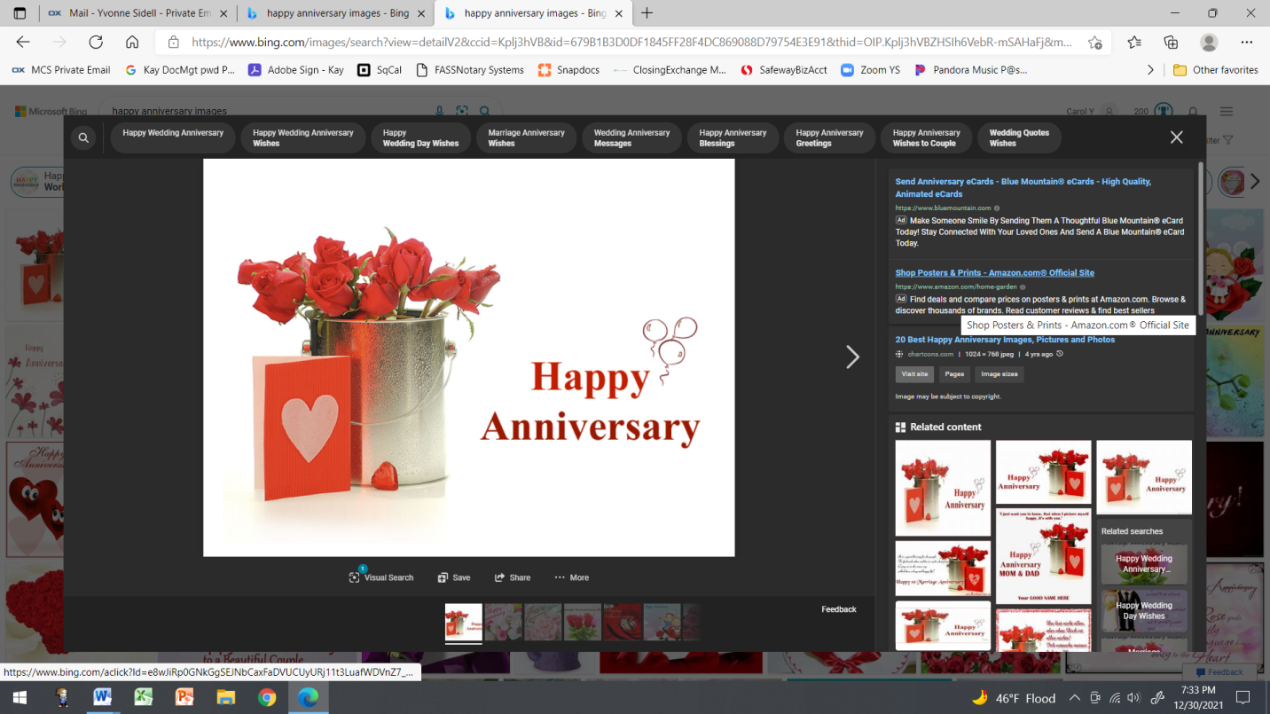August / September Anniversaries

Page 13 of 13