In this Issue:

Reflections on 2015 Lenten Program ..…...P 2

Announcements......P 3-4

Outreach Report..…...P 5

“When Love is Made Real” …..……………P6-7

Sea Breeze School News………..….….….P 7

Interim Editor:
CD & S. Rowsell

The Ambrosian

The Monthly Newsletter of St. Ambrose Episcopal Church

900 Edgewater Blvd, Foster City, California 94404

April

2015

Edition

Individual Highlights:
Inside Story 2
Inside Story 3
Inside Story 4
Inside Story 5
Inside Story 6
Inside Story 7
Last Story 8
Special Interest Articles:

• Add a highlight or your point of interest here.

• Add a highlight or your point of interest here.

• Add a highlight or your point of interest here.

Dear Members and Friends of St. Ambrose Episcopal Church,

Aloha! We begin the month of April in the midst of Holy Week. The movement of this week began with great expectations for Jesus to his betrayal and abandonment by his disciples and finally to ending with his death on a cross and his burial. But the story did not end in the grave and his followers were surprised to discover that He lives!
This movement from great expectations to disappointment and loss continues to happen in our lives, but the movement in our lives does not end there. We entrust our lives to God who raised Jesus the Christ and will give us new life in all circumstances. In faith we are able to see beyond the disappointments and losses in life to the new life that is emerging.
The new life we celebrate as Christians invites us to a life of loving service. We are called to be a people of blessing, to see God’s hand at work in our lives and in the world about us.
I wish you the Easter joy of knowing that Jesus the Christ not only lives, but lives in you so you may continue to live in the power of His Resurrection.

Yours,

David Y. Ota, Rector

Reflections from our Rector

Reflections on the 2015 Lenten Program – – by Rev. David Y. Ota, Rector

The ideas from Alexander Shaia’s book, “The Hidden Power of the Gospels” were quite helpful in understanding how the gospel accounts may have been primarily for different audiences by the gospel writers, Matthew, Mark, John and Luke. His insights provided a fresh way to read and reflect on the gospel accounts as they may have been experienced by the original audience to hear the gospel accounts read.
However, more importantly, Shaia shared how the four gospels revealed the four-fold path of the spiritual journey that each person can make to find greater meaning, purpose and joy in one’s life. And with these four paths we ask four questions:
- How do we change?
- How do we move through suffering?
- How do we receive joy?
- How do we mature in loving service?
Each path with its question had some suggested practices which helps us to move further in our spiritual journey to a transformed life. The initial practices of the first path of recounting a spiritual genealogy and respectful listening to others gives both a hopeful and aspirational practice of remembering how others had overcome challenges in their spiritual journey and a challenging practice of learning to listen to disagreeable voices.
The practices of the second path invite us to move beyond respectful listening, and to (1) hold opposing positions in tension without choosing sides and (2) to be deepened by one’s own suffering. By holding opposites in tension without choosing sides, our anxiety will increase, and we may seek to relieve them by choosing sides. Instead we are encouraged to persevere to hold them in tension, and to pray for the meaning of our internal suffering to be revealed. In this way we may seek the truth.
The practices of the third path invite us (1) to receive the epiphany of God’s grace for us and the unity of all things, and (2) to grow in our awareness of the paradoxical nature of things and to discard our dualistic way of thinking. The first practice helps us to move from constantly doing to learning to simply be. The second practice invites us to keep a journal of our own dualistic judgments and to become more aware.
The practices of the fourth path are varied and invite us to mature into service. We are invited (1) to speak truth and unity, by being genuine and compassionate; (2) to open and engage our hearts by appreciating beauty, collaborating with others in creating beauty; (3) to find the quiet center of our lives through the practice of prayer; (4) to absorb the deeper rhythms of life by quiet observation; (5) to move from seeking security to expanding into risk in order to grow; (6) to learn to let go of past hurts in order to live with joy; (7) to persevere in seeking the reign of God in our lives and in the world; (8) to make the leap of trust based on a courageous heart.
Shaia reminds us that the spiritual journey is not linear, meaning that we may find ourselves on the different paths in a non-sequential order, or even simultaneously. Even after we have reached the fourth path, we may need to go through the different paths as our circumstances and our understanding change. It is important to stay on the spiritual journey by maintaining the practices so our hearts may be encouraged to grow into a wisdom that seeks to serve with compassion and joy.

Thanks
Thanks to everyone who brought soups, salads or bread for our Lenten lunches.
Thanks to David McIntyre who is organizing our efforts for a booth at the Foster City Art and Wine Festival on Saturday and Sunday, May 30th and 31st.
Thanks to Yvonne Sidell who organized the St. Ambrose Foster Community Footprint Task Force to help us become better known and connected in Foster City.
Thanks to Steve Yuen who organized the food boxes for Call Primrose families and to all who donated food.
Thanks to all who prepared food for the Home and Hope families in March.
Thanks to all who brought food or served the homeless at the Fair Oaks Community Center in March.

The Office will be closed on Easter Monday
The church office will be closed on Easter Monday, April 6th as the Rector and the Administrative Assistant will be taking the day off.

Bible Studies in April
The Monday Bible Study group continues to study the Hidden Power of the Gospels on Mondays, April 13th, 20th and 27th from 12:45 p.m. to 2:00 p.m. in the home of Merilyn Vosburg. This Bible Study is led by the Rector.
The Tuesday evening Bible Study group meets on April 7st and 21st in the home Warren and Nellie Wong at 7:00 p.m. They are studying the Gospel according to Luke.
The Wednesday evening Bible Study group meets on April 8th and 22nd in the foyer of the church at 7:30 p.m. They are completing their study of the Book of Revelation, and will begin the study of the Acts of the Apostles.
Each of the Bible Study groups is open and newcomers are invited to join.

S.F. Giants game in April and May
All tickets for the Friday, April 17th Giants and Arizona Diamondbacks game at 7:15 p.m. have been sold. However, we have tickets for the Giants and Atlanta Braves game, Friday, May 29th at 7:15 pm. The cost of the tickets is $22 for adults and $12 for children and youth. If you are interested in going, please speak with Father Ota, or send him an e-mail at dyota@mindspring.com.

Organizing Meeting for St. Ambrose’s booth at the Foster City Art & Wine Festival
Everyone interested in participating in St. Ambrose’s booth at the Foster City Art & Wine Festival is encouraged to attend an organizing meeting on Sunday, April 12th from 11:30 a.m. in the Parish Hall to help develop our plans for the booth. David McIntyre is leading the meeting.

Town Hall Meeting on Ministry to Families with Children and Youth
The Rector and Vestry have called for a Town Hall Meeting on St. Ambrose’s Ministry to Families with Children and Youth, Sunday, April 19th, 11:45 a.m. in the Chapel. They have been seeking input about the possibilities for St. Ambrose to strengthen its ministry with these families, and are contemplating making changes to better serve them. A survey has been sent out via e-mail, can be picked up and completed on Sundays until April 12th, or feedback can be provided on easel size paper sheets in the Parish Hall. Please plan to attend this important meeting.

Holy Baptism
Joyluclemina Small, daughter of Matthew Small and Amelia Morton will be presented for Holy Baptism on Sunday, April 26th at the 8 a.m. service.

Mark Your Calendars
- Maundy Thursday Liturgy: Thursday, April 2nd, 7:30 p.m.
- Good Friday Liturgies: Friday, April 3rd, 12:10 p.m. and 7:30 p.m.
- Great Vigil of Easter: Saturday, April 4th, 8 p.m.
- Easter Sunday: Sunday, April 5th, 8 a.m. and 10 a.m., Easter Egg Hunt, 11:30 a.m.
- Art and Wine Festival Planning meeting: Sunday, April 12th, 11:30 a.m., Parish Hall
- S.F. Giant game with the Diamondbacks: Friday, April 17th, 7:15 p.m., Fireworks Night
- Town Hall Meeting on Ministry to Families with children or youth: Sunday, April 19th,
11:45 a.m., Chapel
- Baptism of Joyluclemina Small: Sunday, April 26th, 8:00 a.m.
- Equipping the Beloved Community event: Saturday, May 2nd,
- S.F. Giant game with the Braves: Friday, May 29th, 7:15 p.m., 7:15 p.m., Orange Mustache Night
- Foster City Art and Wine Festival booth: Saturday, May 30th and Sunday, May 31st, times to be determined
- Vacation Bible School: Monday, June 15-19, 8:45 a.m. to 12 Noon, Parish Hall

Outreach Report - by Steve Yuen
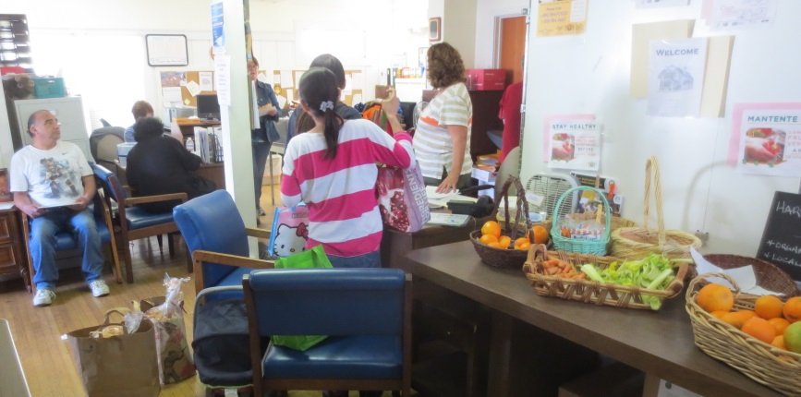
CALL Primrose: St. Ambrose filled four boxes of food for the CALL Primrose Easter “fill a box, feed a family” program. Our parishioners also donated several extra bags of supplies that CALL Primrose volunteers were very happy to add to the pantry. Included in each box was one $20 Safeway gift card purchased from the Outreach budget.
When we dropped off the boxes on a Friday afternoon, the Burlingame office was crowded with volunteers and recipients. The line to receive just one item, such as a bag of rice or a basket of fruit was three-deep. At another desk, families were filling out an application for services.
Thanks to all our donors for helping to make Easter a little happier to some of our neighbors. CALL Primrose (callprimrose.org) is a Burlingame outreach venture founded by the Presbyterian and United Methodist churches and has aided thousands of people since 1983.

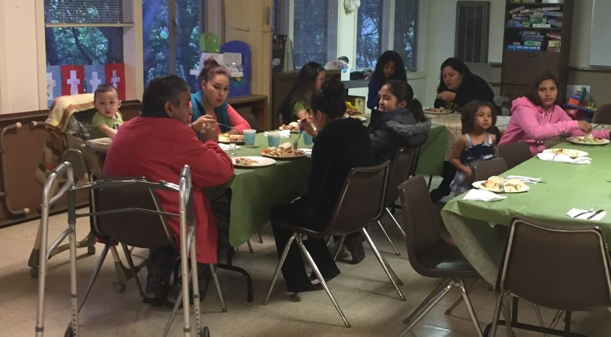
Home and Hope: On March 24th seven members of St. Ambrose prepared dinner for 16 people who are being temporarily sheltered at Hope Lutheran in San Mateo. The menu was roast pork, mashed potatoes, pizza, salad, potato-vegetable casserole, bread, chocolate cake, cookies, and ice cream; we always make sure there’s plenty of dessert.
After serving the families, we joined them at dinner. The teenagers engaged in polite conversation, switching easily from Spanish to English as needed. There were over 20 people talking and eating together and there wasn't a cellphone in sight! The teens, unbidden, bused the plates and washed the dishes. By eight-thirty the leftovers were put away, the dishes were dried, the families had retired to their quarters, and we were headed home.
Home and Hope (homeandhope.net) is a group of 30 Peninsula synagogues and churches who provide emergency shelter to displaced families. Our next outing is in September. If you have any questions, please call Steve Yuen (341-1966, stevebyuen@aol.com).

Sandwiches on Sunday (SOS): St. Ambrose hosted a lunch of baked lasagna and salad to all comers at the Fair Oaks Community Center in Redwood City on Sunday, March 29th. We will report on the event in next month’s Ambrosian.

“When Love is Made Real” – by Rev. Jay Sapaen Watan
One of my favorite hobbies is paying attention to popular media culture. From what we wear, to the cars we drive, our forms of sport and play, the way we communicate, and the music we listen to, most of it comes from an understanding of what people would like. I remember a friend saying to me, “I listen to (this music) because this music makes me feel good.” But like fun sized chocolate bars that give you only a taste of something that you want more of, nowadays so much of our pop culture is presented in sound bites to get us coming back in a way that we may never find wholeness or fulfillment. That is the dysfunction of consumption. The marketing of an idea of who we are and who we ought to be can be either a useful piece of inspiration or a dangerous thing. And yet, I believe pop culture gives us a good gauge into what people are valuing and hold important because it wouldn’t exist unless someone was willing to buy into it. Our challenge is to learn to pay attention to the messages marketed out there, to find the sacred in the all of the secular fluff, and to give meaning to what is life-giving so that the junk of pop culture that devalues life will not be what defines us.
I’m fascinated how movies like The Matrix, The Hunger Games, or even Wall-E, paint a narrative of a very bleak future. I wonder if this is a reflection of how we as a society feel about the future. To think that many of my generation and our own children have been raised with this storyline, then it makes sense to me why younger generations increasingly have a lower level of social trust. We can easily blame the media for the popularized depiction of hopelessness, but this is only a small part of the cultural narrative that seems to be cultivating a sense of joylessness where many of our brothers and sisters have a difficult time naming what is right in the world. I’m not suggesting that we shelter our kids from “reality” or that we ban such forms of popular media. But what I am saying is that God made humankind to be better than we actually think. The scriptures remind us right from the first chapter of Genesis that God made human beings good from the very beginning. “So God created humankind in his image, in the image of God he created them… God saw everything that he had made, and indeed, it was very good.” Yet in the second creation story in Genesis, where the archetype of humanity, Adam and Eve, eat from the tree of the knowledge of good and evil, and we draw our understanding of sin from what happens when human beings think we don’t need God. We move from a place of defining ourselves in relationship to struggling to know who we are in the midst of sin. Sin is more than just doing bad things; it is a separation from the love – the love of God, the love of others, the love of self, and the love of all creation.
When I think about a God who is Love, I am reminded of the Divine Source of All who is willing to give the Christ to us so that we may be fully alive. Love is about what are we willing to give. The defining moment of the Easter story is about what God wants is doing to us in the moment of resurrection, redemption, and renewed life… love transforms all. And what God does is give us in Jesus what comes with an invitation to, “do THIS in remembrance of me.” Love is out there, but we have to be aware of it. We have to look for it, and we have to be willing to create it to make love real. When I engage any work from our popular media culture, I believe such work offers a cultural critique that is necessary to begin a dialogue about the very future we are. And therefore I intentionally seek that sacred story line in what I see. It’s interesting that in all those apocalyptic films I mentioned above, the defining moment is when the awareness and action of love becomes real. Love is what makes the story.
If our very existence is defined by what we do then I believe God made us from love for love. May love be what creates our defining moments… may love be our story!
Stake your claim to the high ground of hope. Find your place of faith and plant your feet firmly in the rich soil of love. This is where you will weather the storm. This is where you will shelter your loved ones. You will not be moved by adversity or chased off your land by fear, but remain like a rock against the cold winds, still there when the bright sun returns to warm you. We are not called to believe without support. God will be beside you. The Spirit will keep the watch as well and your home will be a safe space for prayer, a place of blessing. Be stubborn in the cause of kindness, hold fast to the joy within you. – Bishop Steven Charleston, March 24, 2015.

Sea Breeze School News
Spring has sprung and life at Sea Breeze is as busy as ever. Spring has brought warm weather and sunny skies, and we are all enjoying the extra time outside and looking forward to what the last few months of the school year will bring.
After a very successful Open House we have completed our fall registration period. All of our morning programs are full and we have a few open spaces in our afternoon programs. Summer registration is still open for some programs, so if you or anybody that you know is looking for a fun place to be this summer, please contact the office to learn about current openings. With the new schedule at Foster City Elementary we have added a special 6 week Summer Session to accommodate the needs of the children attending there; and we will continue to offer the two 4 week sessions for children between the ages of 2-5 not attending public school.
The Leprechauns and Easter Bunny visited and the children truly enjoyed all that those visits brought. There were several parties, games and special chapel services. With these events behind us we are now preparing for our Annual Grandparents/Special Persons Day at School. The children have prepared invitations and sent them to their invited guests to join us for a special chapel service, snack and the opportunity to create a special project together. The children are very excited about sharing their school with their special guests and great memories are always made during this event.
If you have any extra time and would like to spend some of it with us, please feel free to stop by and enjoy the laughter of our children. We are always looking for friends to join us for reading, playing games and enjoying special art projects.
The School is on Spring Break March 30-April 6, and once we return the fun will begin again!
Happy Spring!

http://www.pewsocialtrends.org/2014/03/07/millennials-in-adulthood/

