In this Issue:

Reflections (cont. …...P 2

Holy Week and Easter
Service Schedule .….P 2

Announcements …..P 2-4

Outreach Report ....P 4-5

“Who should we pray for?” …...……….…..P 6-7

Sea Breeze School
News ………….…...…P 8

Interim Editor:
David Ota

The Ambrosian

The Monthly Newsletter of St. Ambrose Episcopal Church

900 Edgewater Blvd, Foster City, California 94404

April

2017

Edition

Individual Highlights:
Inside Story 2
Inside Story 3
Inside Story 4
Inside Story 5
Inside Story 6
Inside Story 7
Last Story 8
Special Interest Articles:

• Add a highlight or your point of interest here.

• Add a highlight or your point of interest here.

• Add a highlight or your point of interest here.

Dear Members and Friends of St. Ambrose Episcopal Church,

Aloha! On Sunday, March 26th from 4 pm, Karen and I were able to attend the installation of the Rev. Ruth Casipit Paguio as the first Rector of Holy Family Episcopal Church in Milpitas, California. Ruth had previously served at St. Ambrose as a seminarian intern from 2003-2004, and was married here on June 5, 2004. She became the Vicar of Holy Child Episcopal Church, San Jose upon graduation from seminary and ordination to the diaconate and priesthood. And for the past seven years, she and Holy Child were part of a project to consider merging with St. Joseph Episcopal Church, Milpitas.

Holy Child, San Jose and St. Joseph, Milpitas with their clergy explored the possibility and viability of the “two becoming one.” After seven years of this exploration, they decided to give up their own separate identities and become Holy Family, Milpitas.

I bring up this story because it speaks to our Resurrection faith. Bishop Mary Gray Reeves, the Bishop of the Diocese of El Camino Real, in which Holy Family, Milpitas is a member congregation spoke of the poignancy of the decision the two congregations made. Each congregation had to die, so they could emerge together as Holy Family.

Bishop Mary Gray Reeves speaks from personal experience. About three years ago, her husband was tragically killed in a bicycle accident when an elderly driver hit him. She knows the pain of the loss of her husband. And yet she also testified that her faith sustained her. While she experiences grief, she continues to live in the hope for new life. She said that her journey has not always been easy, as it has not been always easy for Holy Child and St. Joseph to die as separate autonomous congregations. She also said that just as each day has not been easy for her, as she has been able to carry on in faith, so too their life will continue to involve more dying, so more new life can emerge.

We the people of St. Ambrose, Foster City know what it is like to have lived with loss. Over the past few years, many of our members have moved or are in the process of moving and many of our beloved members have passed away. And yet, we who are a people of Resurrection faith need to trust that after death, new life will come.

Reflections from our Rector

Rector’s reflections continued…

We live into this reality of moving from death to new life in Holy Week and Easter. I invite you to join with your brothers and sisters in the faith as we live through Jesus’ triumphal entry into Jerusalem and move through his passion and death until we arrive at the Great Vigil of Easter.

Some signs of the new life for us will occur at the Great Vigil of Easter when Summer Chang, Michelle and Sofia Kimmins will be presented for Holy Baptism. We welcome them into the community of faith as we seek to live out our Resurrection faith together.

I invite you to join with your fellow Christians to worship on Easter Sunday as we celebrate the hope we have in Christ Jesus our Lord in his Resurrection.

Yours,

David Y. Ota, Rector

Holy Week and Easter Services

The Sunday of the Passion: Palm Sunday Maundy Thursday
Sunday, April 9th April 13th
8 a.m. and 10 a.m. 7:30 p.m.
Celebrant: Rev. David Ota Celebrant: Rev. David Ota
Preacher: Rev. Karen Swanson Preacher: Rev. Jay Watan

Good Friday Saturday, Easter Eve, Easter Vigil

April 14th April 15th
12:10 p.m. and 7:30 p.m. 8 p.m.
Preacher: Rev. Jay Watan Celebrant and Preacher: Rev. David Ota

The Sunday of the Resurrection: Easter Day

April 16th
8:00 a.m. and 10:00 a.m.
Celebrant and Preacher: Rev. David Ota
11:30 a.m.
Easter Egg Hunt in the courtyard and playground

Thanks
- Thanks to Shelley Keefe, Charles Saunders and Janet Gardiner for attending meetings of the Deanery of the Peninsula this month.
- Thanks to everyone who brought soup, salads or bread for the Lenten Lunches in March.
- Thanks to Eva Kwong who provided breakfast for the Youth Confirmation class.

Study Groups in April 2017
The Monday Bible Study group will meet on April 3rd, 10^{th,} and 24th from 12:45 pm in the foyer. They are reading the Book of Genesis. This study group is led by the Rector.

The Tuesday Evening Study group usually meets on April 11th and 25th from 7 pm in the Wong’s home.

The Wednesday Bible Study group meets on April 5th and 19th from 7:30 pm in the foyer. They are reading the Book of Daniel.

Each of the study groups is open and newcomers are invited to join.

Lenten Lunches and Lenten Program: Growing in relationship with newcomers
Our Lenten program will conclude this year with some experiential exercises to give us insight on what it is like to be a newcomer to a community of faith, and how we can be present to those who come seeking a spiritual home. The Lenten lunch will be held from 11:15 am followed by the program at 11:45 am.
Sunday, April 2: Growing in relationship with newcomers, the Rev. David Ota and Nellie Wong

South Indian Food Fest
Our South Indian members of St. Ambrose will be hosting the Coffee Hour as a South Indian Food Fest on Sunday, May 7th following the 10 am Holy Eucharist. We have also invited the Rev. Elizabeth DeRuff to be our preacher on that Sunday, as they hope to use the Sonora wheat to make some of the dishes. Plan to come and feast with us.

Mark Your Calendars
Children’s Choir Practice: Sundays, 11:15 am, Chapel
Lenten Lunch: Sunday, April 2, 11:15 am, Parish Hall
Lenten Program, Growing in relationship with newcomers: April 2, 11:45 am, Parish Hall, led by Father Ota and Nellie Wong
Youth Confirmation Class Service Day: Monday, April 3, 9 am to 12 Noon, Bayview Mission, San Francisco
Monday Bible Study, April 3, 10, 24, 12:45 pm, Foyer
Choir Practice, Thursdays, April 6, 20, 27, 7:30 pm, Chapel
Stations of the Cross: Friday, April 7, 12:10 pm, Chapel
Altar Guild Church Clean-Up Day: Saturday, April 8, 9 am, Chapel
Youth Confirmation Class, Palm Sunday: Sunday, April 9, 8:30 am to 11:20 am
Sunday of the Passion: Palm Sunday services: Sunday, April 9, 8 am and 10 am
Tuesday Evening Study Group: Tuesdays, April 11 and 25, 7 pm, Wong’s Home
Maundy Thursday Liturgy: April 13, 7:30 pm, Chapel
Good Friday Liturgies: April 14, 12:10 pm and 7:30 pm, Chapel
Great Vigil of Easter with Holy Baptism: Saturday, April 15, 8 pm, Chapel
Easter Sunday Liturgies: April 16, 8 am and 10 am, Chapel
Easter Egg Hunt: Sunday, April 16, 11:30 am, Courtyard and Playground
Rector at Church Pension Fund Conference: Monday, May 1 to Tuesday, May 2, Bishop’s Ranch
South Indian Food Fest: Sunday, May 7, 11:15 am, Parish Hall
Rev. Elizabeth DeRuff, Guest Preacher: Sunday, May 7, 8 am and 10 am, Chapel
Giants and Cincinnati Reds game: Friday, May 12, 7:15 pm, AT&T Park
Day of Pentecost: Sunday, June 4
Rector at CREDO Conference: Tuesday, June 6 – Monday, June 12, Morgantown, Indiana
Giants and Miami Marlins game: Friday, July 7, 7:15 pm, AT&T Park
Giants and St. Louis game: Friday, September 1, 7:15 pm, AT&T Park
Bishop’s Ranch Weekend: Friday, October 6 to Sunday, October 8, Bishop’s Ranch, Healdsburg

Outreach Report - by Steve Yuen
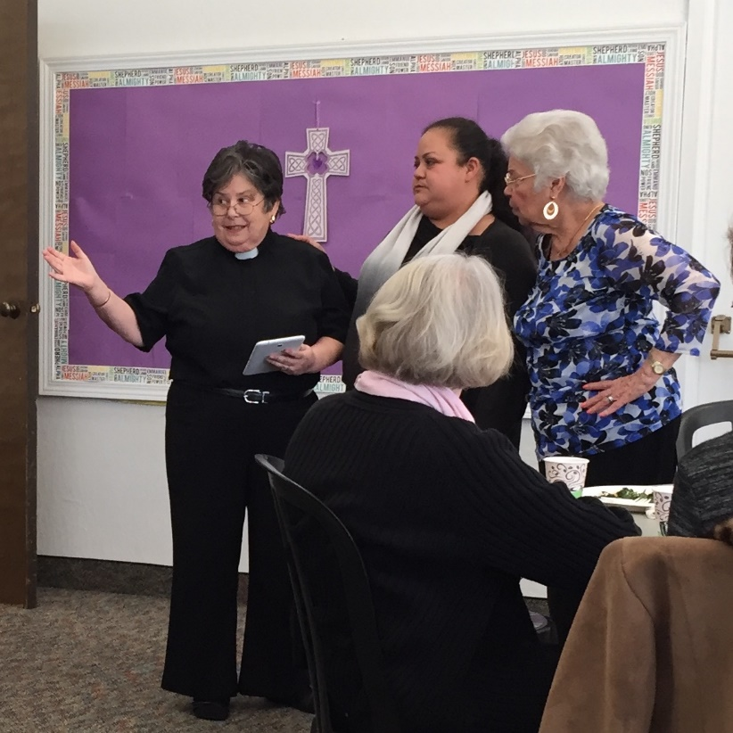
Hot Topic: Immigration

The Reverend Anna B. Lange-Soto, who is the Vicar of El Buen Pastor (its website is elbuenpastor.madreanna.org), spoke to us for over an hour after services on March 12th. El Buen Pastor is the Episcopal Church's Spanish-speaking congregation on the Peninsula. Her focus was about recent difficulties her congregation is facing with stepped-up immigration enforcement.
Mother Anna’s personal observations, not necessarily the official positions of the Episcopal Church or the Diocese of California, were:
- People felt safer under President Obama, who deported criminals but for the most part left other undocumented immigrants alone.

- President Trump says that deporting criminals is the top priority, but U.S. Immigration and Customs Enforcement (ICE) have been detaining everyone who meets the legal criteria, not just criminals.

- 25% of Latinos in the area are undocumented.

- How to support undocumented immigrants:
  - Use churches as a sanctuary; ICE so far has not raided church property.
  - "Rapid response": show up when ICE is conducting a raid. Being present as a witness and/or recording their actions will influence agents' behavior.
  - Accompany people to court hearings. A show of support from the community may affect the outcome.
  - Demonstrate at the Richmond ICE detention facility on the first Saturday of every month.
  - Advocate changes to immigration law through elected representatives.
  - Pray!
As individuals we are free to follow any of Mother Anna's recommendations, but if we are acting under the auspices of the church, we must consider the differing views of all our members as well as the constraints under which the Episcopal Church operates.

We welcome your comments about how to help El Buen Pastor and its members. Please forward your ideas to Steve Yuen (341-1966, stevebyuen@aol.com ).

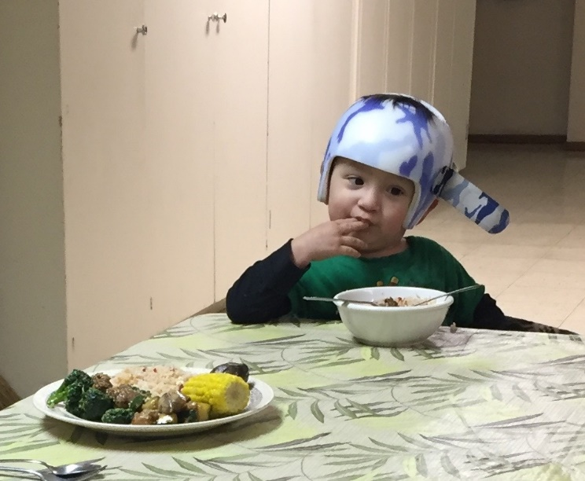
Home and Hope:

During the second week of March we served dinner to two families at Home and Hope (homeandhope.net), the network of 30 Peninsula churches and synagogues that provide temporary shelter to people who have been displaced for reasons such as job loss, family breakup, and large rent increases.
Steve Yuen spoke to Gina Cooper, Program Manager, about the drop-off in applications---usually the organization houses four families at a time, and there had been a long waiting list to get into the program. She said that, for the first time in memory, there is no one on the waiting list.
We have seen "good" declines before--a booming economy enables some homeless to find jobs and housing---but that doesn't seem broadly true this time based on personal observations.
We served dinner to Axel, his mother, and two brothers.

Some potential applicants may have finally given up on making ends meet---Steve has toured models of new two-bedroom Foster City apartments that are renting for $4,600 per month---and they may have departed the Peninsula for economic reasons.
Another reason is that the step-up in immigration enforcement has caused many to leave the area or remain in the shadows.

It’s still much too early to tell whether the dynamics for homeless families on the Peninsula have changed on a long-term basis. We should know more by the time of our next assignment in September.

“Who should we pray for?” by the Rev. Jay Sapaen Watan

One of the life lessons I’ve been teaching my students in the Wednesday Afterschool Enrichment class focuses on prayer. I ask the question, “Who should we pray for?” And like popcorn, many of the children will offer prayers for loved ones, for the poor, for peace in the world, and anyone who they know are sick or in need. Sometimes they will offer prayers for themselves for guidance in school or for that birthday wish to come true. In our time together, they actually get quite a few moments to pray. In Chapel we pray/sing the Sea Breeze Prayer:

Jesus, Lord my friend and guide,
Please be always at my side.
In my work, and rest and play
Lord, be never far way.

Teach me what we ought to do
Help me often think of you
So shall I be safe from wrong
Happy as the day is long. Amen.

It’s a prayer that invites our young ones into the awareness of Christ. In addition we offer a prayer based on the bible lesson (a collect), a birthday blessing prayer, and occasionally we say the Lord’s Prayer. In our enrichment lesson I will also invite our children to create their own prayer of intersession and gratitude using a very simple formula: “I ask God for…” and “I thank God for….”

Prayer invites a way of contemplation, meditation, sending intention, and mindfulness. Our prayer is also a way for us to talk to God and to be in union with that Divine source of all. We pray because it can offer a way for God to transform our heart. It also creates a space for us to be connected with other people and with all creation in our common prayer. And that is powerful. Therefore prayer in itself is not a passive action; in fact it’s an act of being in relationship. And sometimes it’s the only positive action we can take when we’re stuck between a rock and a hard place.

Ever since the election of Donald Trump as President of the United States last November I’ve been asking my afterschool students to pray for the leaders of our community and for the world, including the president. My students would pray for President Obama without question; however, when it came to the current president their willingness to pray changed. These kids are smart, and they are well aware of the president’s position on immigrants and his numerous rants that seem to challenge the values of civility, respect, compassion, human dignity, and love. Given the diversity of my students and our community, I can understand their negative reaction and pain towards offering such a prayer. And yet I challenge them to pray about it. Because if we are to heal the world, then shouldn’t it come from us first? And certainly our president needs God’s help too.

I believe we should prayer for all our leaders, including the president whether we may agree with who’s in office or not. Yet I know it’s not just our kids who think about this. In fact many communities and people of faith have had similar conversations on who we should we pray for. Bishop Michael Curry, the Presiding Bishop of the Episcopal Church said recently,

We can and, indeed, I believe we must pray for all who lead in our civic order, nationally and internationally. I pray for the President in part because Jesus Christ is my Savior and Lord. If Jesus is my Lord and the model and guide for my life, his way must be my way, however difficult. And prayer for others is a part of how I follow the way of Jesus.

This practice of praying for leaders is deep in our biblical and Anglican/Episcopalian traditions. Psalm 72 prays that the ancient Israelite king might rule in the ways of God’s justice, defending “the cause of the poor,” bringing “deliverance to the needy.” 1 Timothy 2:1-2 encourages followers of Jesus to pray earnestly for those in leadership, that they may lead in ways that serve the common good. Even in the most extreme case, Jesus himself said, while dying on the cross, “Father forgive them; for they do not know what they are doing,” was praying for Pontius Pilate, the Governor of Rome who ordered his execution, and for all who were complicit in it.

In this spirit, the Prayer Books of the Anglican/Episcopal way have always included prayer for those “who bear the authority of government,” praying in a variety of ways that they may lead in the ways of God’s wisdom, justice and truth. When we pray for Donald, Barack, George, Bill, George, or Jimmy, Presidents of the United States, we pray for their well-being, for they too are children of God, but we also pray for their leadership in our society and world. We pray that they will lead in the ways of justice and truth. We pray that their leadership will truly serve not partisan interest but the common good. When we pray for them, we are actually praying for our nation, for our world, indeed we are praying for ourselves.

Prayer is not a simplistic cheer or declaration of support. Prayers of lament cry out in pain and cry for justice. Prayer can celebrate. Prayer can also ask God to intervene and change the course of history, to change someone's mind, or his or her heart.

Prayer is real. It can make a difference. It can open our eyes to see the humanity in one another. Prayer can offer us a way to live into love.

Who should we pray for?

Sea Breeze School News

Spring has sprung and Sea Breeze continues to be a great place to be a child!

The leprechauns have come and gone and now the children and teachers are preparing for Easter and Spring Break. The children will be on break from April 3-7 and will return to class on Monday April 10th. The school will be closed for all students on Good Friday, April 14th.

This month we will be celebrating Grandparents/Special Persons Day on April 18th and 19th. This is a day that children invite their grandparents to come to school with them and enjoy a chapel service, as well as a special snack and the opportunity to make a special project with them. We recognize that not all children have grandparents that can attend, so we also open the event up to a special person that may be in their lives. This is a highly anticipated event at Sea Breeze and we greet many people on this day. It is always fun to see the excitement on the faces of the children and their special visitors. There are many Kodak moments and special memories made on this day.

Summer School planning and registration are going well. Due to the changes in the San Mateo Foster City School District calendar, we are offering one 7 week session of camp for children entering kindergarten or first grade and an 8 week camp for preschool aged children that allow families to choose which weeks they want their children to attend. While registration is strong and the 7 week session is full, we do still have limited space available in a few select weeks of our preschool camp. If you know anyone looking for summer fun for their preschool aged child, please refer them to our office. To continue our goal of ensuring our children are ready for the “Big School” our Summer Camp themes will follow the STEM (Science, Technology, Engineering, Math) philosophy this year. The first day of Summer Camp is June 19th.

The Sea Breeze Annual Family Fun Day is almost here! We are excited to offer this event on Saturday May 13th from 10am-1pm, on the courtyard of the school. There will be a Castle for the children to jump in, a face painting booth, several game booths, a DJ, a cake walk and so much more! This event is open to everyone, so please come out and enjoy the fun!

Hope to see you around!

Jerelyn Weber, Principal

http://www.episcopalchurch.org/posts/publicaffairs/statement-episcopal-church-presiding-bishop-curry-regarding-prayers-president

