In this Issue:

Reflections (cont) …...P 2

Announcements …..P 2-4

Outreach Report ........P 4

Year Around Learning for Our Kids …………..…P 5

“Build Together ” ..P 5-7

Sea Breeze School
News ……….…...…P 7-8

Interim Editor:
David Y. Ota

The Ambrosian

The Monthly Newsletter of St. Ambrose Episcopal Church

900 Edgewater Blvd, Foster City, California 94404

August

2017

Edition

Individual Highlights:
Inside Story 2
Inside Story 3
Inside Story 4
Inside Story 5
Inside Story 6
Inside Story 7
Last Story 8
Special Interest Articles:

• Add a highlight or your point of interest here.

• Add a highlight or your point of interest here.

• Add a highlight or your point of interest here.

Dear Members and Friends of St. Ambrose Episcopal Church,

Aloha! As we begin the month of August, I will be on my four week sabbatical “month” through August 27th. I will be taking time to slow down, to walk, rest, read and reflect. I am very privileged to be able to take this time for self-care, and we are very fortunate to have Father Jay Watan and the Rev. Karen Swanson to lead worship during the Sundays of August.

Father Jay will be leading worship on Sundays, August, 6th, 13th and 20th, and the Rev. Karen Swanson will be leading worship on Sunday, August 27th. I will return to the office on Monday, August 28th.

My time off this summer is a little late this year, but allowed either Father Jay or me to be present with the congregation. Inversely as I move into the midst of some quiet and peaceful time, many of you with school-age children will be gearing up for the school year mid-August.

As you know St. Ambrose Episcopal Church operates St. Ambrose Sea Breeze School as both a pre-school and an after-school program. In the years past, both the pre-school and the after-school program operated on the same schedule; yet recently (when the San Mateo-Foster City School district moved to a modified year-round schedule), the calendars of the two programs became different. Foster City Elementary School across the street begins its school year on Tuesday, August 15th, so our after-school program begins that day. The preschool program begins on Wednesday, August 23rd.

One of the joys of operating a preschool and after-school program is that our facilities are used by families with children throughout the week. One of the challenges of operating these programs is to have adequate parking spaces for the parents to drop-off and pick-up their children. Because the parking lot is so crowded at times with parents picking up their children from Foster City Elementary School, we often have a jammed parking lot from Monday to Friday between the hours of 7:30 am and 6 pm.

The School Board at the request of the Principal has approved the purchase of hang-tags for parents and staff to use to identify their cars as

Reflections from our Rector

Rector’s reflections continued…
associated with St. Ambrose Sea Breeze School. Church members and
visitors who come to the church on Monday through Friday during school hours are asked to come into the church office and get a hang-tag to use. The other option is to have an Episcopal Church shield on your bumper sticker or in your window. If you have one on your car then you will not need a hang-tag. The church has purchased 50 bumper stickers and 50 window stickers. They cost $1 each. I suggested the bumper sticker as an alternative to the hang-tags as a way to also promote the Episcopal Church.

Although this may seem to be a small problem for the church, it will be a sign of support of the church for the school who must deal with the parking problem.

I hope that you all will enjoy the rest of the summer, and I look forward returning refreshed to be among you in ministry.

Yours,
David Y. Ota, Rector

Congratulations
Congratulations to Vincent Granato who was baptized on July 2nd. Additional congratulations to Vincent and Lyn Concepcion who were married at the Episcopal Cathedral in Paris.
Congratulations to Marie Mendoza, Crystal Mendoza, Connor Moriarty, Oliver Moriarty and Lily Moriarty who were baptized on July 30th.
Thanks
- Thanks to Father Jay Watan, Brenda Joe-Matsuo, John Miller and Ngoc Rodriguez for supervising our youth on the recent Mission Trip. Thanks to Landon Matsuo, Nathan Matsuo, Lydia McIntyre, Emily Miller, Connor Moriarty, Reuben Ajit Philip, Christina Rodriguez and Emily Rodriguez for participating in the Mission Trip.

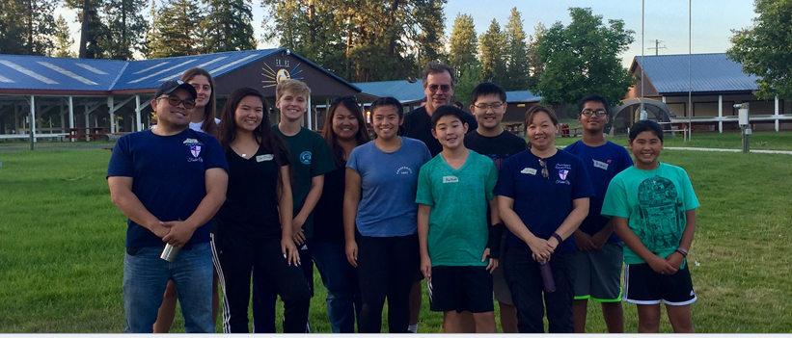

- Thanks to Clara Padilla for leading the Spanish conversation class on the third Sundays of each month.
- Thanks to Debbie White who has served on the St. Ambrose Altar Guild for more than two decades. She will be relocating to San Antonio later this summer. We wish her all the best in her retirement.

Study Groups in August 2017
The Tuesday Evening Study group meets on August 8th and 22nd from 7:00 p.m. in a place to be determined.
The Wednesday Bible Study group meets on August 29th from 7:30 p.m. in the Rector’s office. They will be completing the Book of Daniel.
Each of these study groups is open and newcomers are invited to join.

San Francisco Giants baseball games
St. Ambrose is going to the Giants and Miami Marlins game on Friday, September 1st, 7:15 pm. The cost of the tickets is $29 and the seats are in View Reserve 319, rows 12-14. Join fellow members and friends and enjoy an evening together. We have several tickets for sale for this game. As in the past the cost of the tickets for children and youth will be discounted $10.
St. Ambrose Sea Breeze is going to the Giants and Arizona Diamondback game on Saturday, September 16th from 6:05 pm. The cost of the tickets is $33 and the seats are in View Reserve 307, rows 4-6. They have several tickets available for that game. For more information, please contact Margie Lee at the church office.
- Friday, September 1, 7:15 pm, Giants and St. Louis Cardinals, View Reserve 319, rows 12-14, $29
- Saturday, September 16, 6:05 pm, Giants and Arizona Diamondbacks, View Reserve 307, rows, 4-6, $33

Outing to the Bishop’s Ranch
Join members of St. Ambrose for a weekend at the Bishop’s Ranch in Healdsburg, CA on the weekend of October 6th- 8th, 2017. We will be staying at Harrison House. A sign-up sheet is posted in the Parish Hall. For more information speak with the Rector or Jim Neubert.

Mark Your Calendars:
Rector’s Sabbatical Month: July 31 to August 27
Sunday School Teachers Meeting: Sunday, August 6, 11:30 a.m., Parish Hall
Bible Study: Tuesdays, August 8 and 22, 7 p.m., location to be announced
Spanish Conversation Table, Third Sundays, August 20, and September 17, 11:15 a.m., Parish Hall
Giants and St. Louis Game: Friday, September 1, 7:15 p.m., AT&T Park
Altar Guild Meeting: Saturday, September 9, 9 a.m., Kitchen
Commissioning of St. Ambrose Sunday School and Sea Breeze School Teachers and Staff: Sunday, September 10, 10:00 a.m. Holy Eucharist, (with Back to School Lunch following)
Blessing of the Animals in Honor of St. Francis of Assisi: Sunday, October 1, 8 am and 10 am, Chapel; 12:30 pm, Foster City Dog Park
Bishop’s Ranch Weekend: October 6 to October 8, Bishop’s Ranch, Healdsburg
Diocesan Convention: October 27 and October 28, Grace Cathedral
Stewardship Dinner: Saturday, November 4, 6:00 p.m., Foster City Recreation Center, Lagoon and Blue Bird Rooms

Outreach Report - by Steve Yuen
We recently received a survey from the Episcopal Church regarding the “ways in which our congregations are involved in justice issues.” The survey was interesting because of what it revealed about both the attitudes and priorities of the Episcopal Church. Below is the introduction to the survey, sections of which I have italicized for emphasis.

President Gay Jennings asked the House of Deputies Committee on the State of the Church to examine ways in which our congregations are involved in justice issues. Our focus is on General Convention resolutions that have spurred action at diocesan and local levels.

The committee defines justice as: contesting against structures that produce structural inequities and barriers as we advocate for structures and systems that increase equity and access. We hope to learn about local responses to resolutions that addressed such issues as economic justice, labor relations, fair wages, racism, poverty alleviation, food security, hunger, faith-based organizing, and asset-based community development. We are asking about all areas of community assistance. However, although we recognize that food pantries and feeding programs constitute faithful and essential responses to the Gospel, they are not the transformational, justice-focused programs we are attempting to identify.

St. Ambrose parishioners come from widely varying social and cultural backgrounds. Through observation of other churches we can comfortably say that we have one of the most diverse congregations in the Diocese. St. Ambrose parishioners also have diverse political viewpoints but do not let these differences get in the way of uniting to alleviate hunger (Sandwiches on Sunday, CALL Primrose), homelessness (Home and Hope), and illiteracy (Cambodia Academy).

Generally our Outreach programs have focused on efforts on which all members agree (“food pantries and feeding programs”). We have shied away from supporting organizations that advocate political stances that some members may find worthwhile but that could antagonize other members.

St. Ambrose does participate in two activities that fall into the category of advocacy and/or “social justice.” Members of the congregation write to Congressional representatives under the auspices of Bread for the World, which asks the Federal Government to continue funding food aid. Father Ota and Father Watan are anti-racism trainers and have conducted anti-racism workshops at St. Ambrose and other churches. And, of course, individual members of our congregation can and do support advocacy organizations outside of the Church.

Please contact Steve Yuen (stevebyuen@aol.com, 650-341-1966) to discuss any aspects of our Outreach policies or programs. We welcome your input.

Year Around Learning for Our Kids – by the Rev. Karen Swanson

The all ages summer Sunday School program provides a unique opportunity for the children of St. Ambrose to get to know one another better while growing in their understanding of the Christian faith, and deepening their relationship to God. Highlights of last month included learning a new song about the depth and breadth of God’s love, making a terrarium, scattering seeds, and the witness of one teacher about her and her family’s prayer practices. Two new students, Neel and his younger brother Jay, a Sea Breeze student, had so much fun at Vacation Bible School, that they wanted to give Sunday School a try. Now they know that Sunday School is fun too!

Grateful thanks to the July Christian educators Teresa Rajaratnam, Shaiji Ajit, Gwen Juha, Lois Wilson and Lilian Watan. These women have helped to shape the lives of our beloved St. Ambrose children in heartfelt and creative ways, and deserve our thanks. The summer program will continue in August. We expect it to be another joyful and meaningful month for the kids. Come one, come all!

“Build Together” – by the Rev. Jay Sapaen Watan

I really enjoy road trips, but somehow it always feel that the journey to get somewhere takes so much longer than the trip back home, even if it’s the same distance. Last week our “God Squad” team of 8 youth and 4 adults from St. Ambrose journeyed to the Spokane Indian Reservation in Wellpinit, Washington on a mission trip that ran from July 15 to 23. In Spokane we joined Sierra Service Project and youth groups from Washington, Oregon, Southern California, and the Bay Area to be present with the Spokane people and to grow in faith by building homes and community together with others. Each way was 915 miles, 15 hours, and 2 days on the road trip on the highway.
Mt. Shasta on Hyw. 97 in California.
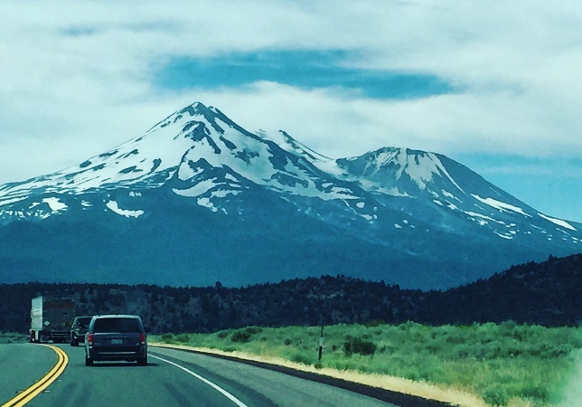

All that driving gave me a lot of time to reflect. It seems to me that much of that feeling of taking a long time to get somewhere has a lot to do with the unknown. And when we do not have a memory to give us familiarity, human beings tend to pay attention. We saw many things… the gigantic Cascade Mountains including Mt. Shasta and Mt. Hood, massive hydroelectric dams along the mighty Columbia River, long trains, farms, cows, and lots of wheat fields. We passed by towns such as Bend, The Dalles, Kennewick, Reardon, Klamath Falls and Redding that have so much history. We loved Weed, California. The climate ranged from hot to hotter with thunderstorms and lots of bugs. There was even a surviving Blockbuster Video store in Redmond, Oregon. The reservation was beautiful and we encountered the friendliest dogs ever. But these mission trips are always about people and the relationships we build along the way.

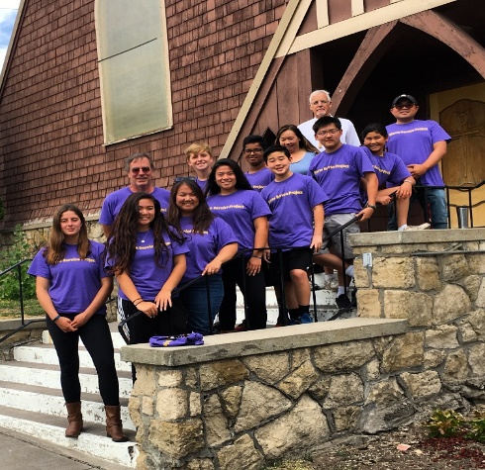
The "God Squad" with The Rev. Jack Coffey at St. Paul’s Episcopal Church in Klamath Falls, Oregon.

The theme for this mission trip set was “Build Together.” In work teams we built decks, awnings, stairs and ramps to make life easier for the elders we met living on the reservation. We connected with the SSP staff, college students who wish to do some good in this world. We also met a few Native Americans, like Luis Bergman, who are determined to preserve and share the stories and culture of the Spokane people. Luis’ family left the reservation when he was young. He later served in the U.S. Air Force, went to college and became an artist in Los Angeles. He ultimately felt the call to return to the reservation and moved back 6 months ago to illustrate the stories of the elders. He took a position at the cultural center to inspire young ones to know who they are and to go out and explore this wider world. Luis guided us on a hike to some of the sacred sites of the Spokane people and shared his artistry. He admitted that there are many challenges for Native people. Depression is high and alcohol and substance abuse are the symptoms. Many young ones don’t even consider college as an option. But he also sees growth and a healthier future. The tribe has invested in the schools and built up the cultural and community centers. Sustainable logging and fishing are viable industries for the people, and there’s renewed passion to learn the dances, history, and the stories.
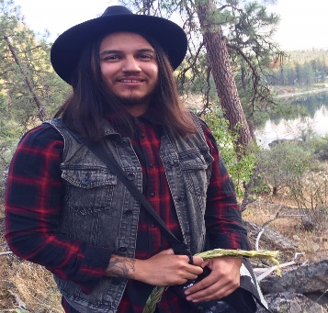
Luis Bergman

There are many stories out there. We met people living happily into retirement, and others struggling on the margins; people who experience the loss of livelihoods and love ones; others swept in a wave of disappointment, while others discovering who they are. We also met some of the most faithful and loving people, proud of who they are and willing to share their story with others. We met some of the most gracious people. In fact, the Tribal Counsel offered the Pow Wow grounds as our “home” and many people on Spokane Indian Reservation shared a warm enthusiasm because we took in interest in being there with them. It seems that the counsel’s welcome invited many on the reservation to trust in who we are, and many on our teams felt obligated to give our best on the build projects. I am grateful to have had the opportunity to know little bit about their story.

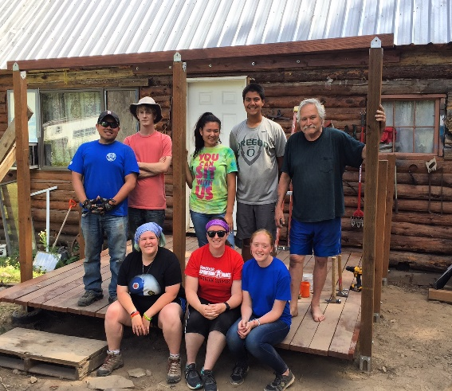
To think that people aren’t interested in history is a misconception. In fact, most people know their history like they know their parent’s names. However, we are not so keen on the history of others. More often we hear just one narrative. History isn’t limited to one narrative; there are multiple stories which paint a fuller picture of who we are together. In this broken and beautiful world I believe we need more opportunities to create connections. Mother Teresa once said, “If we have not peace, it is because we have forgotten we belong to each other.” God’s way is to build together.

With our homeowner, James McMurtey, on the deck we’re building for him.

Sea Breeze School News- by Jerelyn Weber, Principal

Summer Camp is almost over and we are ready for the 2017-2018 School Year!

Summer Camp was full of excitement this year as we followed the Science, Technology, Engineering and Math theme throughout Camp. The children had visits from Orchard Supply Hardware, Home Depot, Hillier Air Museum and Google. They learned about the life cycle of plants and planted their own plants; they built their own helicopters and bird houses using real wood, nails and hammers. They learned about the water cycle, clouds and thunderstorms and they even made robots and learned to create their own codes to manage their robots. It was so much fun for us to see the excitement in the eyes of the children as they saw their “work” really come to life with the finished products of growing plants, flying helicopters and talking robots!
The school year starts for our School Age children on August 15th and we currently have 88 children in the program. Father Jay will continue to lead Chapel and Life Skills classes on Wednesday afternoons and Maureen Fromme will teach Music on Thursday afternoons. In addition, we have added a Chess Club, a Hip Hop Dance Class and a Bollywood Dance to the afterschool program. The Kindergartners also have a sign language class as a part of their weekly curriculum. As you can see we keep them very busy.

Preschool classes start on August Wednesday August 23rd and we currently have 133 children enrolled, with a few part-time spots still available. If you know anybody looking for a quality preschool for their 3 or 4 year old child we would love to see them. This year our preschool children will have gym class and sign language in addition to their regular curriculum.
In addition to everything that the children learned and created over the summer, some of us worked together to gather supplies and build what we are calling our “Mud Kitchen” on the playground. We gathered some recycled materials, old plastic tubs and pallets that were being thrown away, some plastic tubing from around Sea Breeze, along with some random tree stumps from along Highway 101 and some hard work from teachers, spouses and friends and we now have a working “kitchen” for the children outside. There have been many creative meals prepared out there and I am sure there will be many to follow. Please take the time to walk the playground and visit our kitchen when you have a few minutes.

As the school year begins, we will be welcoming volunteers into our classrooms to work with our children. If you have few spare minutes and would like to spend time reading, playing games or doing art with our children, please feel free to contact the school office, we love to see new faces.

Continued Blessings,

Jerelyn Weber

