December

2019

Edition

In This Issue:

Reflections ……..….P 1-2

Announcements…...P 3-5
Desk of Rev.
Karen Swanson…......P 6
Outreach…….…....P 7-9

Sea Breeze
School News…….…P 10
Editor’s Corner….....P 11
Birthdays &
Anniversaries………P 12

Editor:
Yvonne Sidell

The Ambrosian

The Monthly Newsletter of St. Ambrose Episcopal Church

900 Edgewater Boulevard, Foster City, California 94404

Individual Highlights:
Inside Story 2
Inside Story 3
Inside Story 4
Inside Story 5
Inside Story 6
Inside Story 7
Last Story 8
Special Interest Articles:

• Add a highlight or your point of interest here.

• Add a highlight or your point of interest here.

• Add a highlight or your point of interest here.

Dear Members and Friends of St. Ambrose Episcopal Church,
Aloha! The Season of Advent begins on Sunday, December 1 this year. It is the beginning of liturgical year and as our gospel lessons for the season indicates, Advent is about looking forward to how God will change our lives. In the First Sunday of Advent, we are warned to prepare for the coming Son of Man, meaning that there will be a time ahead of us when our faithful lives will be required. (Matthew 24:36-44) Will we be found to be faithful, seeking God’s reign in our lives and God’s world?

In the Second Sunday of Advent, we are reminded of our need to turn our lives around by the coming of John the Baptist. (Matthew 3:1-12) The crowds were coming out to the Jordan River to hear the Baptist preach and be baptized because they truly knew their need for repentance, to amend their lives. John’s baptism signified to them a new beginning. But others who considered themselves righteous came for baptism as well, but they were not sorrowful over the lives they led, and for them it would not be a new beginning. Do we know our own need for an amendment of life? What one relationship can we reconcile? What activity gets in our way of being of more loving and faithful person?

In the Third Sunday of Advent, we are reminded of how we are called to live transformed lives. (Matthew 11:2-11) When John the Baptist’s disciples asked Jesus, “Are you the one who is to come, or are we to wait for another?” Jesus responded, “…tell John what you hear and see: the blind receive their sight, the lame walk, the lepers are cleansed, the deaf hear, the dead are raised, and the poor have good news brought to them.” When Jesus met people, he often changed their lives for the better. Can you recall when was your life was changed for the better? Can you recall when you were able to see another’s point of view more clearly, when someone helped you to stand when you were discouraged, when someone welcomed you when you felt estranged, when someone listened to you deeply, when someone helped you to hope when you lost all hope, or when someone saw value in you when you could not see it in yourself?

Reflections from our Rector

Reflections from our Rector (continued)

In the Fourth Sunday of Advent, we are reminded how God’s love calls us to make difficult choices. Our opportunities to love often come to us in unconventional ways. Matthew describes the birth of Jesus from Joseph’s point of view. (Matthew 1:18-25) Mary was about to give birth without knowing who was the father. What would Joseph do? Would he put her to public disgrace? An angel revealed to Joseph that this child was of the Holy Spirit, was of God. Have you ever made a decision to love, when circumstances didn’t make sense to you? Have you ever been in Mary’s position to have a Joseph love and protect you even though you were compromised?

The Season of Advent is one of my favorite times of year. It is a time for us to consider how are faithful lives are required of us, and how we need to become a bit more self-aware of our need to change, to reflect on how others have made our lives better and how we too can make the lives of others better, and finally how love can be born in us in unexpected ways. The point of Advent is for the love of God to come and be born in us and in one another.

I wish you and yours a time of growth during this Season of Advent so Emmanuel may truly come and live within you.

Yours,
David Y. Ota, Rector

Announcements

Update on the 2020 Pledge Campaign: Caring for our Communities and God’s World
To date, we have received 44 pledges totaling $83,805. We have also received 32 pledges of time and talent. We also received 15 pledges for Altar Flowers. The 2019 pledge total was 62 pledges for $124,082. Thanks to everyone who has turned in a pledge for 2020.

Keith & Charlene Adolph Linda and Rami Amireh Ed and Donna Avakoff
Kay Ballantyne Bill and Charlotte Bradford Sal and Linda Censoprano
Eunice Chee April & Grant Cherrington Nilda Chong & Kyn Dellinger
Bettie Davis Elliott Dun & Teresa Murakami Maureen Fromme
George & Janet Gardiner Don Gundry Eugene Hetzer
Shelley Keefe June Kudzia Alison LeBlanc
Michael and Dulce Lord Judy Marshall Dorothy Matsuo
Kirk & Brenda Matsuo David McIntyre & Cathy Rincon Valerie Mersh
David & Carolyn Moriarty Wilfredo & Oliva Nagar Jim Neubert
David Ota Clara Padilla Don & Elizabeth Peter
Ajit Philip & Shaiji Ajit Diane Robertson Julio & Ngoc Rodriguez
Frank & Barbara Saunders Sandy Schowengerdt Irene Stead
Jon & Marilyn Stephens Susan Sullivan Karen Swanson
Daniel Tate Phoebe Venkat Andy Walker
Warren & Nellie Wong Stephen and Belinda Yuen

If you would like to make a pledge, you still can do so. Pledge envelopes are in the Foyer. The Vestry will be reviewing the final draft of the 2020 Budget at its December 17 meeting. Thanks to everyone who participated in the 2020 Pledge campaign.

THANKS to:
- The Stewardship Dinner Planning Committee: David Ota, Chairperson, Shelley Keefe, Dulce and Michael Lord, Liva Neyroud, Clara Padilla and Josh Rawley; Registrars: Liva Neyroud and Irene Stead.
- Entertainers at the Stewardship Dinner: Frank Saunders on the piano, Maureen Fromme and the St. Ambrose Choir (April Cherrington, Hamilton Fong, Shelley Keefe, Valerie Mersh, Clara Padilla, Barbara Saunders, Supriya Singh and Daniel Tate), the Children’s Choir (Elliott Dun, Mathias Gerber, Lily Moriarty, Oliver Moriarty, Noah Rawley and Shai Venkat), Mathias Gerber on the piano, Nellie Wong on the piano, Danielle Richards on the harp, Daniel Tate singing a solo, Noah Rawley leading a sing-a-long accompanied by Jimmy Rawley, Ruben Neyroud on the violin, Hamilton Fong singing a solo and the Rev. Anna Lange-Soto and members of El Buen Pastor leading a sing-a-long in Spanish.
- Donors of a gift basket for the raffle at the Stewardship Dinner: Kyn Dellinger and Nilda Chong, George and Janet Gardiner, Shelley Keefe, Dulce and Michael Lord, Jim Neubert, Clara Padilla, Josh and Grace Rawley and Cathy Rincon and David McIntyre.
- Landon Matsuo and Lydia McIntyre for preaching on Thanksgiving Sunday.
- Rami and Linda Amireh who graciously donated the wine for the Stewardship Dinner.

Announcements (continued)

Altar Guild Bake Sale
The St. Ambrose Altar Guild is having its annual Bake Sale on Sunday, December 8 following both the 8:00 a.m. and 10:00 a.m. services. This annual fund raiser supports the Altar Guild in providing flowers when there is no donor signed up to provide flowers for Altar. They bake delicious cookies. We hope you will support this important ministry of St. Ambrose.

Study Groups in December

The Monday Evening Study Group will meet this month on Monday, December 9 at 7:00 p.m. The Monday study group will be meeting at the home of Warren and Nellie Wong, 826 Phoenix Lane, Foster City. They are studying the upcoming Sunday lessons.
The Tuesday Bible Study Group will be meet on Tuesdays, December 3, 10 and 17 from 12:45 to 2:00 p.m. in the Foyer. They are currently reading the Apostle Paul’s First Letter to the Corinthians.

The study groups are open to any interested person.

Announcements (continued)

Mark Your Calendars
1st Sunday of Advent: Sunday, December 1, 8:00 a.m. and 10:00 a.m.
Christmas Eve Pageant Rehearsals: Sundays, December 1, 8, 15 and 22, 11:30 a.m., Chapel
Christmas Stocking Stuffers Assembly and Delivery: Thursday, December 5, 7:00 a.m. to 2:00 p.m., Boy Scout Clubhouse, 1305 Middlefield Road, Palo Alto

2nd Sunday of Advent and Altar Guild Bake Sale: Sunday, December 8, 8:00 a.m. and 10:00 a.m., Chapel and Foyer
Buildings and Grounds Committee Meeting: Tuesday, December 10, 6:00 p.m.,
Parish Hall
School Board Meeting: Tuesday, December 10, 7:00 p.m., Parish Hall
3rd Sunday of Advent: Sunday, December 15, 8:00 a.m. and 10:00 a.m.
Family and Senior Sharing Program Deadline: Sunday, December 15, donation deadline for providing gifts for two local families

Vestry Meeting: Tuesday, December 17, 7:00 p.m., Parish Hall
4th Sunday of Advent: Sunday, December 22, 8:00 a.m. and 10:00 a.m.
Christmas Eve Family Service with Pageant: Tuesday, December 24, 4:00 p.m.
Christmas Eve Choral Concert: Tuesday, December 24, 10:00 p.m.
Christmas Eve Candlelight Choral Holy Eucharist: Tuesday, December 24, 10:30 p.m.
Christmas Day Holy Eucharist with Christmas hymns: Wednesday, December 25, 10:00 a.m.
Rector on vacation: Thursday, December 26 to Wednesday, January 1, 2020
1 Christmas: Sunday, December 29, 8:00 a.m. and 10:00 a.m., Holy Eucharist, the Rev. Karen Swanson, Celebrant

Annual Meeting of St. Ambrose: Sunday, January 26, 2020, 11:30 a.m.,
Chapel

The Desk of Rev. Karen Swanson

Christmas Pageant
Period costumes, classical music, time with friends and a chance to re-tell the powerful story of Jesus’ birth . . . what’s not to love about the St. Ambrose youth and children Christmas pageant?

Our youngest children will be cast as stable animals with furry costumes and instructions to “baa”. Those with a dramatic flair and a willingness to take on a challenge will be cast as Mary, Joseph and the archangel Gabriel. Wise ones in regal costumes will sing of the Savior for all, while shining angels talk and twirl. Rough and tough shepherds struck with amazement, and faithful narrators will complete the story-telling team. Others will be needed to help behind the scenes. There is a place for everyone on the team!

Rehearsals will begin on Sunday, December 1 at 11:30 a.m. Before rehearsals begin, participants will relax with one another at the coffee hour and fuel up with a pizza lunch. Rehearsals will last approximately one hour. The schedule follows:
Sunday, December 1
Brief parent meeting. Instructions, exercises, and singing practice for all. Parts finalized. Receive and read through script. Stable animals, shepherds and angels will get their costumes.
Sunday, December 8
Characters with speaking parts and narrators. Singing practice.
Sunday, December 15
Characters with speaking parts and narrators. Singing practice.
Sunday, December 22
Dress rehearsal with music. All cast members needed.
It is understood that cast members may need to miss a rehearsal, or even two. Please speak to Rev. Karen if this is true for you.
All those interested in participating, please contact Rev. Karen at 650-200-8449 or at karen.2.swanson@gmail.com. Can’t wait to see you!

December Outreach Report – by Steve Yuen

Home and Hope
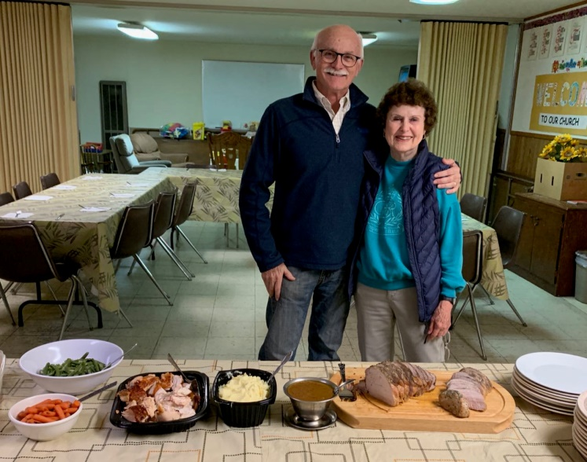
In November we served dinner to four families who were sheltered at Hope Lutheran in San Mateo. Thanks go to our cooks and servers:

Janet Gardiner Diane Robertson
Anoush Kelegian Irene Stead
Dulce Lord Susan Yates
David Ota Steve Yuen
Clara Padilla
Below are Steve’s notes as an overnight monitor on November 5:
“Everyone was in bed by ten, and all were out the door by 6:15 a.m. the next morning without our having to roust them. My overnight partner, Hank Harper, and I could scarcely believe our good fortune. Being done by 6:30 a.m. instead of the usual 7:30 a.m. was a first!”
Our next Home and Hope week of service to homeless families will be in February. If you are interested in preparing food or being an overnight monitor or just have any questions, please contact Steve Yuen (650-341-1966, stevebyuen@aol.com).
Jerry Brooks, Hope Lutheran and Diane Robertson

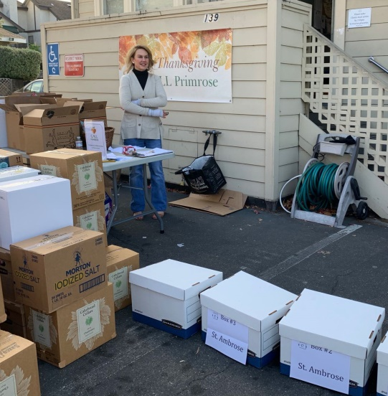
CALL Primrose
St. Ambrose donated four food boxes to CALL Primrose on the week before Thanksgiving. Individuals and organizations donate boxes packed with 20 specified items (e.g., package of mashed potatoes, cans of fruit, etc.); each box is sent to a family in San Mateo County.

CALL Primrose (http://www.callprimrose.org) is a Burlingame outreach venture founded by the Presbyterian and United Methodist churches. St. Ambrose has participated in CALL Primrose’ “fill a box, feed a family” program since 2011.

Outreach Report (continued)

Upcoming Events
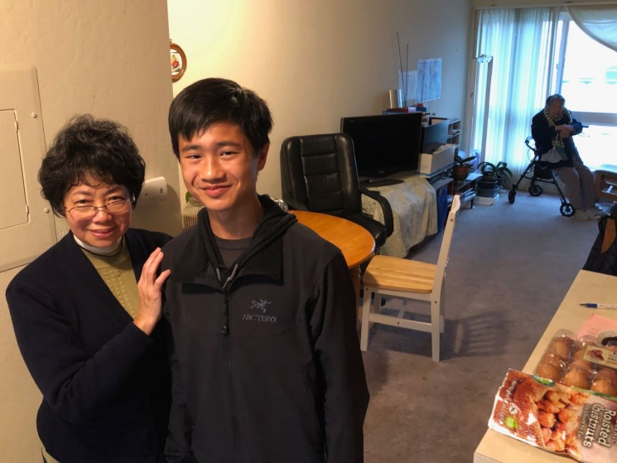
Family Sharing
This Christmas season, we have adopted three (3) Samaritan House clients: two San Mateo families that have three children each; and, one family of mother (89) and daughter (68). Clients frequently speak English on a limited basis. We are grateful to Clara Padilla and Honkai Chang for their help in communicating in their native languages.
Honkai, Milda Beh, and Michael Chang (pictured) got an early start on the holidays by delivering gifts of clothes and groceries to the senior family on December 1.
We are trying to collect at least $1,000, which enables us to buy presents and gift cards. The deadline is Sunday, December 15. All donations should be made to St. Ambrose Episcopal Church, designated "Family Sharing", and deposited in the offering plate or mailed to the church office. Thank you for spreading holiday cheer to members of our community.
Stocking Stuffers
Jill Schwab is again leading the effort to prepare “stocking stuffers” for seniors, veterans, and homeless people on the Peninsula. Volunteers from Santa Clara Thunderbird Club, St. Ambrose, and the Boy Scouts will fill hundreds of gift bags with toiletries, paperback books, socks, beanie caps, gloves, scarves, and candy. If you can help, please deposit such items in or near the box in the back of the Parish Hall.
Assembly and delivery of the gift bags will occur at the Boy Scout Clubhouse, 1305 Middlefield Road, Palo Alto on Thursday, December 5, from 7:00 a.m. to around 2:00 p.m. Even if you can only spare an hour or two, please stop by. Jill will be most grateful for your help….and there will be cookies!

Sandwiches on Sunday (SOS)
The next SOS at the Fair Oaks Community Center in Redwood City will be on December 29 when we will be serving lasagna and salad. If you can prepare a dish and/or help with serving and clean-up, please sign up on the sheet that has been posted on the Parish Hall wall. If you have any questions, please contact Rob Richards (rob.richards@tensorlabs.com, 650-577-8924).
Outreach Report (continued)

The St. Ambrose – Sea Breeze Giving Tree
December 5– Dec. 20

St. Ambrose and Sea Breeze Preschool are once again partnering with Star-Vista’s programs to provide Christmas gifts to children in need in San Mateo County. We had supported the programs of this agency in the past and have returned to support them again this year. Star Vista has given us the opportunity to provide gifts for 100 children. This year all the children are six years or younger. We hope you will open your hearts again this year to help make their holidays a very special one.

Select a gift tag
From the Christmas tree in Parish Hall. Each gift tag will identify whether the child is a boy or girl, the age, the child’s initials and an I.D. number for Star-Vista on one side, and on the back side will be some information about the child, gift suggestions and gift card options.

Shop
All gifts (books, toys, clothing…) should be new and unwrapped – firmly attach the gift tag to the outside, making sure it is visible

Return your gift tag
With the unwrapped gift under the tree by
Friday, December 20

The presents will be distributed through the Star-Vista programs.

For more information about Star Vista, visit
http://www.star-vista.org/whatwedo_services/children.html

Sea Breeze School News – by Jerelyn Weber, Principal

It is hard to believe that it’s already December and time to prepare for Christmas.

Here at school December is a short month, so our celebrations happen well before they would in our church communities or our homes. We already have our classroom trees up, the children are singing Christmas carols and making Christmas decorations and many classrooms are already practicing for their Christmas programs.

The end of November brought the wonderful International Dinner event for our after-school program. This program has over 100 children now enrolled and has outgrown our facility, so the event is now held at the Foster City Recreation Hall. As usual the event was well attended, the fashion show was elegant, the entertainment was wonderful and the feast was delicious.

Our See’s Candy fundraiser has come to an end and I would like to thank all of you that participated. Fundraising is an important part of what we do as the funds raised help support our financial aid program and the eventual replacement of the shade structures outside. Our top selling class celebrates with an ice cream party and the top selling families are always invited to a Pizza Party in the evening.

The last day of school is December 21 and classes will resume for preschool on Monday January 6 and Tuesday January 7 for the after-school program.

Your school wishes you a holy Advent season and a blessed Christmas.

Happy New Year!

Continued Blessings,
Jerelyn Weber, Principal

The Editor’s Corner– by Yvonne Sidell

Do not be anxious about anything but in everything by prayer and petition,
with thanksgiving, present your requests to God. And the peace of God,
which transcends all understanding, will guard your hearts and your minds
in Christ Jesus. –Philippians 4:6,7
Sometimes I work too hard and take life too hard. Last week, I noticed flowers in bloom and I had missed the process of blooming.
Life is too short. Sometimes we need to sit back and enjoy God’s gift to us. Brother Jeremiah was at the end of his life when he reflected on his many years of Christian service. I keep close to my heart these words he wrote:
“If I had my life to live over again, I’d try to make more mistakes next time. I would relax. I would limber up. I would be sillier than I have been this trip. I know of very few things I would take seriously. I would take more trips. I would climb more mountains, swim more rivers, and watch more sunsets. I would do more walking and looking, I would eat more ice cream and less beans. I would have more actual troubles and fewer imaginary ones.
You see, I am one of those people who live prophylactically and sensibly and sanely, hour after hour, day after day. Oh, I’ve had my moments, and if I had it to do over again, I’d have more of them. In fact, I’d try to have nothing else. Just moments, one after another, instead of living so many years ahead each day. I have been one of those people who never go anywhere without a thermometer, a hot water bottle, a gargle, a raincoat, aspirin, and a parachute. If I had it to do over again, I would go places, do things, and travel lighter than I have.
If I had my life to live over, I would start barefooted earlier in the spring and stay that way later in the fall. I would play more. I would ride on more merry-go-rounds. I’d pick more daisies.”*

*Credit: HomeWord Devotionals

