In this Issue:

Reflections …….….P 1-2

Announcements ….P 3-8

Missing! ..……...…P 9-10
Outreach Report .P 11-12

Sea Breeze School
News………..…. .…P 13
Editor’s Corner…....P 14

Editor:
Yvonne Sidell

The Ambrosian

The Monthly Newsletter of St. Ambrose Episcopal Church

900 Edgewater Boulevard, Foster City, California 94404

December

2017

Edition

Individual Highlights:
Inside Story 2
Inside Story 3
Inside Story 4
Inside Story 5
Inside Story 6
Inside Story 7
Last Story 8
Special Interest Articles:

• Add a highlight or your point of interest here.

• Add a highlight or your point of interest here.

• Add a highlight or your point of interest here.

Dear Members and Friends of St. Ambrose Episcopal Church,
Aloha! The month of December is an in-between month. It marks the end of the calendar and the beginning of a new year in the church’s liturgical calendar with the Season of Advent. This year our Season of Advent has been shortened as the Fourth Sunday of Advent is also Christmas Eve. We will have three services of Holy Eucharist and our Christmas Eve Choral Concert on Sunday, December 24:
- 4th Sunday of Advent Choral Holy Eucharist at 10 a.m.
- Family Christmas Eve Holy Eucharist with Pageant at 4 p.m.
- Christmas Eve Choral Concert at 10 p.m.
- Candlelight Christmas Eve Choral Holy Eucharist at
10:30 p.m.
Advent means “coming.” Christ is “coming again” even as we prepare to celebrate the birth of Jesus the Christ. How do we prepare for Christ’s coming?
We are preparing for the celebration of Christmas with the Christmas Eve Family Holy Eucharist with Pageant at 4 p.m. The Rev. Karen Swanson is organizing the Pageant this year, and the first regular rehearsal is on Sunday, December 3.
The St. Ambrose Choir is preparing for its annual Christmas Concert on Christmas Eve at 10 p.m. followed by the Candlelight Christmas Eve Choral Holy Eucharist at 10:30 p.m.
On Christmas Day, Monday, December 25th we will have one service of Holy Eucharist:
- Christmas Day Holy Eucharist with Christmas Hymns, 10 a.m.
The days of December become shorter and darker until the winter solstice on December 21. If you are like me, it reminds me of how I yearn for the light to break into my days and my life. The darkness represents the absence of light and hope, and we look forward to its end. The darkness also represents death and ending.

Reflections from our Rector

Reflections from our Rector (continued)

As you know, I have been contemplating the end of my time among you, albeit a bit prematurely. The Vestry and I have been considering the need for a Capital Campaign to help provide resources for the next rector to find housing in or around Foster City. Last month, with the help of the diocesan consultant for its capital campaign, a series of interviews was held with about 20 households to get their feedback about having a capital campaign.
This month, on the first three Sundays, a survey will be taken during the worship services of those who were not interviewed to receive feedback about having a Capital Campaign. I hope you will make every effort to complete one of the surveys if you did not participate in the interviews. This is another way we are preparing for future leadership for St. Ambrose.

I wish you all a most holy Advent, as we look for light in the darkness and wait for the Christ to be born within our hearts.

Yours,

David Y. Ota, Rector

Announcements

The 2017 Stewardship Dinner and the 2018 Dinner
Our Annual Stewardship Dinner held at the Foster City Recreation Center on Saturday, November 4 was well attended with over 110 people enjoying the evening. Our theme was “Grace Abounds, Pass It On.” There were many moments of grace and sharing. All the raffle prizes were gifts by members of the congregation. And one gift of a flat screen television surprised everyone gathered. The entertainment was performed by members of the congregation with singing to ukuleles playing happy songs, harpists playing classical pieces, a pianist playing background music, the choir singing the hymn, “Pass It On”, a fun song on daylight saving time, another sing-a-long with ukulele, and our guests from El Buen Pastor singing and leading us in song. The appetizers and dinner was again provided by Ning’s Catering. Sadly, the time went by so quickly that there was not time for dancing to close the night. Thanks to everyone who participated in the dinner.

Update on the 2018 Pledge Campaign: Grace Abounds, Pass It On
To date, we have received 67 pledges totaling $144,070. We have also received 46 pledges of time and talent and another 26 pledges for Altar Flowers. The 2017 pledge total was 80 pledges for $145,000. Thanks to everyone who has turned in a pledge for 2018.

Keith & Charlene Adolph Rami & Linda Amireh Donna Avakoff
Christina Brockman & Stan Hui Marilyn Canon Anthony Caponera
Angela Carducci Sal & Linda Censoprano Honkai Chang & Milda Beh
Eunice Chee Grant & April Cherrington Nilda Chong
Bettie Davis Reena Davis Kyn Dellinger
Jeanne DeTorre-Ozeki Elliott Dun & Teresa Murakami Maureen H. Fromme
George & Janet Gardiner Leda V. Girardi Vince Granato & Lyn Concepcion
Don Gundry Caroline Helmuth Eugene Hetzer
Kay Huffman Shelley Keefe Joanne Kerseg
June Kudzia Dulce & Michael Lord Judy Marshall
Dorothy Matsuo Kirk & Brenda Matsuo David McIntyre & Cathy Rincon
Valerie Mersh Jim Miller & Torrie McAllister John Miller & Eva Kwong
Barbara Milligan Kirk & Jessica Morales David and Carolyn Moriarty
Wilfredo & Oliva Nagar Ryan and Melissa Nagar Jim Neubert
David Ota Clara Padilla Karin Patterson
Don & Elizabeth Peter Ajit Philip & Shaiji Ajit Elmer & Alie Pong
Jimmy & Poppy Rawley Peggy Redmond Anita & Rob Richards
Diane Robertson Julio & Ngoc Rodriguez Charles Saunders
Frank & Barbara Saunders Sandy Schowengerdt Irene Stead
Dilip Selvaraj & Teresa Rajaratnam Yvonne Sidell Matt & Meltem Tanner
Jon & Marilyn Stephens Karen Swanson Pedro & Dolores Watan
Phoebe Venkat Andy Walker
Warren & Nellie Wong Steve & Belinda Yuen

If you would like to make a pledge, you still can do so. Pledge envelopes are in the foyer. The Vestry will be reviewing the final draft of the 2018 Budget at its December 19 meeting. Thanks to everyone who participated in the 2018 Pledge campaign.

Announcements (continued)

Thanksgiving Sunday Sermon
Our local tradition of celebrating Thanksgiving on the Sunday-before continued. Mary Bradford, a senior at San Mateo High School was our preacher. Her sermon is copied below and based on Matthew 6:25-33.
Hello, my name is Mary Bradford, a senior at San Mateo High school. I am 17 years old and I am blessed to have been a member of this church ever since I was baptized as a baby. I have three siblings, James, William and Poppy. I am a cheerleader, a member in Jazz Band, president of yoga club. I have a passion for health and fitness and my favorite hobbies are reading and practicing yoga. I have always had a zest for learning that began when I was a small child, and I love grasping new subjects.
Although I have always been very self-motivated and goal-oriented, the past few years I have been in the pursuit of finding a grounded, peaceful and fulfilling life through my spiritual practice, not only through the Bible and Christianity but through Buddhist infused mantras and what is known as mindfulness.
Mindfulness is defined as "the mental state achieved by focusing one's awareness on the present moment, while calmly acknowledging and accepting one's feelings, thoughts, and bodily sensations." Although it's a bit unusual nowadays to see a teenager pursuing a relationship with God through mindfulness, in ways such as meditation and setting a daily intention, my mindfulness and meditation in collaboration with my Christian Faith is what truly keeps me grounded and living a happy, abundant life.
One of my favorite books, by Gabrielle Bernstein, the spiritual Guru and kundalini yoga teacher is a book titled, "The Universe Has Your Back." I was immediately drawn to this book because of its simple title. It reminds me of the part in the scripture when Jesus said, "Your heavenly father knows that you needs these things [basic needs]. But seek first his kingdom and his righteousness, and all these things will be given to you as well." meaning not to value our possessions enough to worry about them and instead seek God's will. Similarly, a mantra that I learned through yoga that helps reminds me to connect to God's will is: “I am exactly where I need to be." By reciting this mantra, not only do I heighten my faith in God but also I take my hand off of the steering wheel of my life and realize that God can accomplish anything with grace and ease just like how the "flowers in the field grow."
When Jesus urged his disciples not to worry about their own food or drink or clothing, he reminds them that having anxiety is resisting the unstoppable will of God and it is not beneficial to the moment we are in or to the future. I apply this to my own life when I catch myself not living in a place of faith and trying to control everything. I remember that sometimes I need to stop worrying about achieving our own plans and get out of the way of God's plans to receive the miracles and blessings he sends from heaven to earth.
One way in which I constantly re-ground myself in my faith is through my yoga practice. Yoga embodies the meaning of living a graceful, faithful life. The physical aspect of yoga, the poses and postures are called "asana" which actually translates in Sanskrit to "ease in the pose." In yoga, aside from the obvious physical benefits, the goal is not to rush through poses just for the sake of looking cool and pleasing the ego. The idea is to find serenity in even the most difficult poses, by using steady breathing to connect the mind with the body. This state of peace heightens overall awareness and clarity in which I am most in touch with my connection to God.
I consider myself quite spiritual and l like to call myself, "a spirit junkie" just like the name of my app on my phone which sends me positive mantras as notifications throughout the day. This morning when I woke up I said my daily prayer to God, which I picked up also from Gabby Bernstein. Every morning I sit up in my bed, close my eyes and recite: "Where would you have me go, what would you have me do, what you have me say, and to whom? I use this prayer to guide me through a 20 minute meditation. When Father Jay first gave me this bible passage I immediately thought of this prayer and how it replaces the materialistic: "what shall we eat" or "what shall we drink" to "what shall we do to serve God,"...Saying this prayer helps me not get wrapped up in the superficial and in my ego's selfish way of living, and instead sets a peaceful tone for the day by reminding myself that God has a plan for us all so we can let go of control, fear or judgment. I also set a strong intention such as "to be kind to myself," and pray that God helps me come back to this intention at times throughout the day when I feel stressed, lost or in need spiritual nourishment. My morning routine also allows me to be grateful for the life I have in the present moment, instead of focusing on what I lack.
Announcements (continued)
I believe that gratitude is the glue that connects personal faith with universal connection and purpose. I googled the definition of gratitude and found, "The quality of being thankful, readiness to show appreciation for and to return kindness." From a very young age we are taught about the importance of being grateful, and during thanksgiving time we would trace our hands and make a turkey out of it, writing down five things we are grateful for. But to me, gratitude is truly what reminds me of God's will, because when we are grateful for our own well-being we are more considerate of others. At times we can get so wrapped up in our own agenda and even our own spiritual practice that we forget to show appreciation for the life that God has already given us and our capacity to contribute our gifts to the world. When we are grateful, we are also more open to learning and teaching with the rest of God's children without "strings attached" or hidden agendas. In yoga there is a philosophy that everyone is teacher and a learner. The other day when I was babysitting the bright and talented Max, who just got baptized here a couple weeks ago, he said to me, "teacher Mary, you need some Goldfish too," Max reminded me of the Zen quote that goes something along the lines of, "before thinking about what you're going to eat, we should think about who we are eating with." Let us slow down and relish time spent with friends and family instead of hastily fulfilling our own needs and desires.
Not worrying about one's needs, however, shouldn't be confused with genuine concern. Sometimes I am concerned about a deadline that such as Calculus Homework, and then I'11 go and complete the task. Concern is what motivates us to take effective action with hopeful intention, while worrying is inherently negative. Worrying is when you can't do anything to help the situation and you don't allow On a similar note, having hope doesn't mean living an adversity-free life. The notion of believing, " When I have this, I will be happy...once I get that job I will be happy, once I get that car I'll be happy, once I get in that relationship I'll be happy...is unrealistic. God focuses on one day at a time, granting us the strength and courage to deal with today, so let tomorrow figure itself out as he reminds us in the scripture that "tomorrow will have trouble of its own"…. Tomorrow promises adversity, so we might as well focus on living in God's grace in the present moment.
Yesterday was the perfect example of allowing God's grace to work through me by showing up for the present moment with an open heart. My Uber driver, Rhonda, was an outgoing, African American woman with a bubbly personality who was a Christian motivational speaker. From a 12 minute Uber ride we learned that she had used her religion to get through her husband's illness and she'd even written a book called the 7 Habits of Rich, Powerful, Famous, Bible Women. Rhonda was severely injured from the last Uber ride she gave which was 6 months ago, when a drunk driver had rammed into her car, and we were her first passengers since the accident. Despite this, her kindness, optimism and cheerful spirit truly touched our hearts. I had even mentioned to her that I was giving a sermon at my church the next day and I was a little nervous, to which she responded, " Well give me a little preview," After hearing a taste she said, "I know you've got it down, you've got the right attitude." Before we left the vehicle we felt as if we've made a great friend and it was almost sad to step out of her car as she wished us farewell and said to me: "God Bless your sermon." Moments like these refuel my spiritual faith and renew my trust in God. God's grace is what puts you in the car with an Uber driver who happened to be a Christian, motivational speaker the day before you give a sermon. And being aware in the present moment allows you to notice His work.
Hope and gratitude enable us to serve God through the practice of non-judgmental and unconditional love. Love comes in limitless forms. Whether it's singing in the choir, performing in a half-time show, volunteering at a Canned Food drive, working as a nurse and saving lives, whatever you do to make an impact on the world, when we are in the state of giving to others, we forget about our ego's manipulative needs and desires. Like anyone else, there's times when I find myself worrying about details of my life that are ultimately insignificant and occupy valuable space in my mind. But instead of being dominated by our self-centered, judgmental inner voices and forgetting that God's love for us is unconditional, immersing ourselves in the work of helping others quiets that negative voice and brings us back into the light. The American lawyer and Civil War Veteran Robert Ingersoll once said, "We rise by lifting others."
If there's one thing my spiritual journey has taught me so far it's to really savor the present moment. Through faith and surrender we can allow God to take from us the desires, judgments, expectations and worries that hold us back from living in our place of truth and light. Let us spend more time living in our place of highest alignment with the Holy Spirit and God's agenda-instead of our own shortsighted plans - focused on how we can serve God by showing love to everyone around us, including ourselves. This Thanksgiving, as we gather around the
Announcements (continued)
table with loved ones and enjoy a nourishing meal, let us stay mindful; let us stay grateful; and let us love one another while trusting that God has our back.

THANK YOU to …
- Shelley Keefe, Eva Kwong, Michael Lord, Liva Neyroud and David Ota for planning the Stewardship Dinner.
- Everyone who provided gifts for the raffle at the Stewardship Dinner.
- Everyone who performed at the Stewardship Dinner: Jimmy Rawley, Mary, William and Jimmy Bradford for singing and providing music; to Kendall and Danielle Richards for playing the harp; thanks to Frank Saunders for playing the piano, to Father Jay for playing the ukulele and leading a sing-a-long, and to El Buen Pastor for singing and leading a sing-a-long.
- Jim Neubert for representing St. Ambrose at the Deanery of the Peninsula Meeting at Christ Church, Portola Valley, on November 9.
- The Altar Guild for cleaning up the chapel and polishing the brass on Saturday, November 11.
- The Buildings and Grounds Committee for arranging to have a new furnace and air conditioner installed, and the trees on the grounds trimmed.
- The Rev. Karen Swanson, parents and children preparing for the Christmas Pageant.

Giving Tree
St. Ambrose and Sea Breeze Preschool are partnering with Star-Vista’s programs to provide holiday gifts to children in need in San Mateo County. We had supported the programs of this agency in the past and have returned to support them again this year. We hope you will open your hearts again this year to help make their holidays a very special one. This year, the process will be a little different. Star-Vista requests that the gifts not be wrapped. You are asked to take a red tag from the Giving Tree which will identify the age and gender of the child. You are then asked to go out and purchase a gift for that child, and return the gift under the tree unwrapped with the red tag attached by Friday, December 15. They will pick up the presents on Monday, December 18.

The presents will be distributed through these Star-Vista programs: Early Childhood Community Team, Differential Response, Healthy Homes, The Children’s Place, and Foster Youth Education Enrichment Service. For more information about Star-Vista, visit
http://www.star-vista.org/whatwedo_services/children.html
Youth Group
Youth group is open to all our youth in middle school and high school. At youth group, we'll grow in God, listen to one another, talk about current events, and if possible, take field trips and hikes to spiritual/sacred sites and gathering places in the nearby Bay Area. Youth group is on Sundays, December 3 and 17 from 8:00 to 9:30 a.m. in Room 5.

Christmas Caroling
Father Jay Watan is organizing all interested in singing Christmas carols this year to visit Foster City Care Homes and shut-ins on Sunday, December 17. More information will come.

Announcements (continued)

Christmas Eve Services
This year, Christmas Eve is the same day as the Fourth Sunday of Advent. Instead of having four services on December 24, we will have the following schedule:
10 a.m. 4 Advent Choral Holy Eucharist
4 p.m. Christmas Eve Family Holy Eucharist with Pageant
10 p.m. Christmas Eve Choral Concert
10:30 p.m. Candlelight Choral Holy Eucharist

Christmas Pageant Preparations
The St. Ambrose Christmas Pageant will form the heart of the 10 o’clock service on Sunday, December 24. All children are encouraged to participate in the dramatic re-telling of this key Christian story, and we will create a place for every interested child. Speaking and non-speaking parts will be available. Parents accompanying very young actors and actresses are also welcome to join the production as costumed characters. Rehearsals are critical to bringing this story to life for the whole congregation.
Please review the schedule below. Rehearsals will be held in the church from 11:35 a.m. to 12:30 p.m., following the church service and the children’s choir practice. Lunch will precede most rehearsals.
Sunday, December 3 All children for blocking and costuming
Sunday, December 10 Children with speaking parts only
Sunday, December 17 All children for dress rehearsal
Sunday, December 24 Arrive no later than 3 p.m. for pageant

Participating families will be asked to contribute food items to one of the four child-friendly lunches on December 3, December 10, or December 17.

Your children’s friends and relatives are welcome to participate. Please invite them to join in!
For more information, please e-mail Rev. Karen (karen.2.swanson@gmail.com).

Study Groups in December
- The Monday Book Study on America's Original Sin: Racism, White Privilege, and the Bridge to a New America, by Jim Wallis, meet on December 11 from 7 p.m. at the home of Warren and Nellie Wong, 826 Phoenix Lane, Foster City.
- The Tuesday Bible Study group meets on December 5, 12, and 19 from 12:45 p.m. in the foyer. They are reading the Book of Joshua. It has been interesting to learn the nuances of this book, as much of it has been written from the point of view of the “Deuteronomist” who valued the Davidic Kingdom. Also, the theologies embedded within this book are challenging for us today.

The study groups are open to any interested person.

Announcements (continued)

Mark Your Calendars
The Giving Tree for Star-Vista Children: November 27 – December 15, Parish Hall
First Sunday of Advent: December 3, Holy Eucharist, 8 a.m., Choral Holy Eucharist, 10 a.m.
Surveys for the Capital Campaign during Worship: Sundays, December 3, 10, 17, 8 a.m. and
10 a.m., Chapel
Christmas Pageant Rehearsal for Blocking and Costuming: December 3, 11:45 a.m., Chapel
Christmas Stocking Stuffers: Thursday, December 7 (time to be announced), Lucie Stern Community Center, 1305 Middlefield Road Palo Alto
St. Ambrose Choir Practice: Thursdays, December 7, 14 and 21, 7:30 p.m., Chapel
Rector Celebrates at the CDSP Community Eucharist: Thursday, December 7, 5:45 p.m.,
All Saints Chapel, CDSP, 2451 Ridge Road, Berkeley
Second Sunday of Advent: December 10, Holy Eucharist, 8 a.m., Choral Holy Eucharist, 10 a.m.
Christmas Pageant Rehearsal for Children with Speaking Parts Only: December 10, 11:45 a.m., Chapel
School Board Meeting: December 12, 7 p.m., Parish Hall
Third Sunday of Advent: December 17, Holy Eucharist, 8 a.m., Choral Holy Eucharist, 10 a.m.
Christmas Caroling: December 17 (to be arranged)
Vestry Meeting: December 19, 7 p.m., Parish Hall
Christmas Pageant Rehearsal for Dress Rehearsal: December 17, 11:45 a.m., Chapel
Fourth Sunday of Advent: December 24, Holy Eucharist, 10 a.m., Chapel
Christmas Eve Family Eucharist with Pageant: December 24, 4 p.m., Chapel
Christmas Eve Choral Concert: December 24, 10 p.m., Chapel
Candlelight Christmas Eve Choral Holy Eucharist: December 24, 10:30 p.m., Chapel
Christmas Day Holy Eucharist: December 25, 10 a.m., Chapel
Rector on Vacation: December 26 – January 1, 2018
Annual Meeting of St. Ambrose: January 28, 2018, 11:30 a.m., Chapel

“Missing!” – by The Rev. Jay Sapaen Watan
I
n November, my uncle, Juan Manghi, disappeared. He had been living with my great uncle Fil’s family in San Francisco for several years, and his daughter and grandson had just immigrated from the Philippines. And he was seemingly growing old with grace.

My uncle was accustomed to being out on his own. When Uncle Juan was younger, he was known in our family for his adventurous spirit, resourcefulness, toughness and talkative nature. But as he grew older, life slowed down for my uncle. Those epic journeys he always enjoyed eventually became short walks. His spirit toned down with health issues. His speech became quiet as he began to lose his hearing. But he always came home. With so many family members tracking Uncle Juan’s coming in and out, no one even thought he would just not return. Yet that’s what happened on November 1, 2017. He was missing! And his closest family went on red alert.
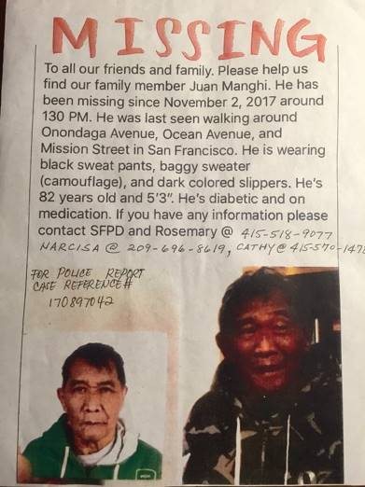
Last seen on his usual path towards Mission Street in San Francisco’s Excelsior District, he was wearing a green camouflage hoodie, dark pants, and flip flops. Uncle was 82 years-old, diabetic, hard of hearing, frail, and now forgetful. It was also around the time that weather in the City began changing from the Indian Summer heat of September and October to the fall cool down of November. It even rained. We were worried. Police and first responders were called. Media was contacted. Family came from all over to form search parties and to post flyers. And people gathered in circles to pray. With limited mobility, without his medications, and no money how could he have gone far? For five days he was missing. Somewhere out there. Every day, no news from the police or fire department meant that they had not come across him. Though frustrating, that was good news in some way. No news offered hope he was still alive, I suppose. We remained faithful.

Faith in God is often intertwined with our faith in people. Trusting God also places great hope that someone would come through with a tip. For days, many in my family were waiting for that call, text or message on social media with some good news. As the days came and went, I felt the tension between hoping for the best and preparing for the worst. I kept on thinking about Jesus’ parable of the Lost Sheep found in Luke 15:3-7, and what that good shepherd said after finding the sheep, “Celebrate with me! I’ve found my lost sheep!” I realize the context of this gospel has more to do with repentance, recovery, and reconciliation, but I just found the words reassuring. In the midst of uncertainty, God’s unconditional love still can be felt and experienced.

On the fifth day, my Auntie Cathy got a tip from a caller. With so many flyers posed on bus stops and lamp poles in the neighborhood, the police had been given numerous tips. But they all were another person of similar build. But this one was different. A man named Ronald was the caller. Ronald was a barista who worked in the Embarcadero and he was Filipino. He encountered an elderly man who had come to his shop for hot tea. That man had been sleeping outside in the nearby park for at least two nights. Ronald wondered if the man was Filipino, so he initiated a conversation. The older man didn’t say much about his personal life, but did share that he was originally from Baguio City, Philippines. Ronald felt this elderly man was out of place. Most Filipino folks don’t leave their family on the streets and this man didn’t have many belongings with him. He saw a flyer of my uncle on his way home that evening, and he wondered about that
“Missing!” (continued)

elderly man he met that day. The following morning on his way to work, he confirmed his intuition and made the connection. Ronald contacted my aunt first, and then the police.

My cousin, Junior, who worked nearby the Embarcadero, got the call from my aunt and went with his co-worker to investigate the call. He headed to the corner of Brennan St. and The Embarcadero. And that’s where they found Uncle Juan, sleeping on the concrete benches in a makeshift bed of newspapers. The small park was occupied by other homeless men, all seniors, and more equipped to take on the cold and the rain. Uncle was tired, not remembering how he got to where he was, yet knowing he was lost and wondering if he would ever make it back home. They hugged and cried tears of joy. Then my cousin noticed my uncle was wearing a blue warm winter jacket, he had food next of him, and even a little money in his pocket. Ronald said that while my uncle was in lost in the park, kind people who were passing by attended to him. Those strangers were like God’s angels. They gave him food, money, and even a warm jacket. After a short stay at St. Luke’s Hospital to treat dehydration and undergo testing for dementia and kidney damage, he was giving a green light to come home. On November 11, we celebrated uncle’s homecoming.

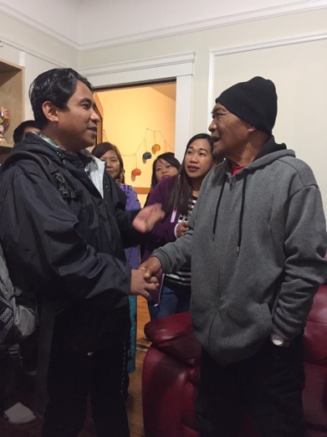
When I think about the human capacity to do good in the world, simply because it the right thing to do, I think about my family’s experience. And I’m grateful to the ones who helped in any way possible. If spirituality is the experience of unconditional love and our mindfulness to share that love with others, then living into love is about making positive choices that invites more goodness and creative action into our world. It’s about being mindful of what connects us as one “great big family.” I’m also grateful for my uncle’s determination and resolve to make it through difficult times. Surviving out in the cold streets for five days, given his health, uncle showed his true grit and strength. The photo to the right is of Ronald meeting my uncle at his homecoming celebration in November. Uncle thanked Ronald for his heart and thoughtfulness, and we treated this stranger in our midst like family. I believe Ronald already felt this lost, and now found, stranger in his midst was already his family. God is Good!

“Celebrate with me! I’ve found my lost sheep!”
Keep the faith, my friends, and may God Bless You!

Outreach Report need – by Steve Yuen
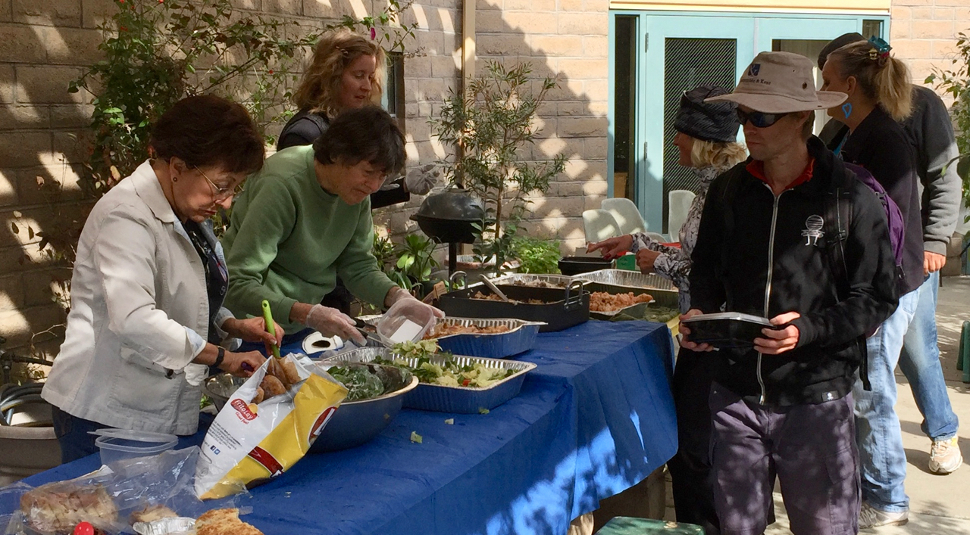
Clara Padilla, Marge DeStaebler (St. Pius volunteer), and Susan Yates served lunch on October 29th.

Sandwiches on Sunday (SOS)
We served chicken and rice, salad, and bread to 55 guests on October 29th. Due to a Halloween event at the church, we only had a “skeleton” crew — Clara Padilla, Brett Yates, Susan Yates, and Steve Yuen — that nevertheless handled the serving responsibilities with grace and aplomb. There were salad, bread, and brown-bag (prepared by St. Pius Catholic Church) leftovers that we took to the Catholic Workers House, 545 Cassia Street, Redwood City.

Our next hosting is December 31 when we will be preparing lasagna. If you can make a dish and/or help with serving and cleanup, please sign up on the sheet that will be posted in December in the Parish Hall. Please contact Rob Richards (rob.richards@tensorlabs.com, 577-8924) if you have any questions.

CALL Primrose
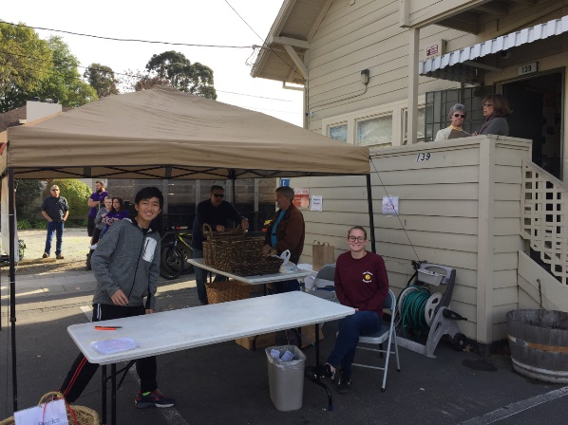
St. Ambrose filled four (4) food boxes. Steve Yuen dropped them off on November 19, the same day the Thanksgiving food distribution began. Clients had filled out a form months earlier and received a claim ticket – from the carefulness with which they removed it from their wallets, it was something special to them.

Our parishioners also donated extra cans and packages for the CALL Primrose pantry. This year a $20 gift card was not included with each box, so we made an $80 donation instead.

Outreach Report (continued)

CALL Primrose (http://www.callprimrose.org) is a Burlingame outreach venture founded by the Presbyterian and United Methodist churches. St. Ambrose has participated in CALL Primrose’s “Fill a box, Feed a family” program since 2011.

Upcoming Events

Home and Hope: We served dinner to three families (3 adults, 8 children) on Tuesday, November 28, and Thursday, November 30. We will have a report in next month’s Ambrosian.

Stocking Stuffers: Jill Schwab and volunteers will be assembling stocking-stuffer bags beginning at 10 a.m. Thursday, December 7 at the Boy Scout Office in Palo Alto. The address is 1305 Middlefield Road, Palo Alto. St. Ambrose will support this year’s effort by a $200 donation for supplies, as well as supplying a number of volunteers. If you have any questions, please contact Steve Yuen (650-341-1966, stevebyuen@aol.com).

Family Sharing: This Christmas season, we have adopted three (3) Samaritan House clients: two San Mateo families who have 2-3 children and one senior couple. We are trying to collect at least $1,000, which will enable us to buy presents and gift cards. The deadline is Sunday, December 17 and the gifts will be delivered later that week. All donations should be made to St. Ambrose Episcopal Church, designated "Family Sharing", and deposited in the offering plate or mailed to the church office. Thank you for spreading holiday cheer to members of our community!

Sea Breeze School News – by Jerelyn Weber, Principal
With Thanksgiving behind us and Christmas before us, the children and the teachers have been working very hard practicing for the Christmas programs they will put on for their families. Many songs are being taught and it is very cute to hear the stories that are being told. The programs are certain to entertain all who attend. Family conferences are complete and the teachers are ready for a well-deserved Christmas break.
The children in the After School Program spent most of November preparing for the Annual International Dinner and Performance. Each year, this group comes together to celebrate the different culture of each child and family as they are invited to dress in cultural attire and participate in a fashion show (followed by an International Potluck provided by the families). The children perform dances and songs from around the world. This year, the children from our hip hop dance class will perform and Mrs. Fromme will lead the children in a couple of songs she has taught them. To best accommodate our growing program, we have moved the performance to the Foster City Rec Center this year. This year’s performance is scheduled for the evening of December 1.
The school will be closed from December 22-January 5 for our Winter break. Classes will resume on January 8 for students in all of our programs.
Many wishes for a Happy and Blessed Christmas Season!

Very truly yours,

Jerelyn Weber, Principal

The Editor’s Corner– by Yvonne Sidell

Be still, and know that I am God.*
Psalm 46:10
Have you ever noticed how easy it is to treat busyness as a badge of honor? Say you happen to run into a friend during Christmas shopping madness who you haven’t seen in awhile BECAUSE you were so busy – the conversation might sound like this one:
“Hey there, how are you doing? Stayin’ busy?”
“Oh, I’m slammed! How about you?”
“Yep, totally in over my head with overtime at work!”
“Wow, I’m crazy busy too. Can’t believe the hectic year it’s been.”
“Phew, I know. Who needs sleep?”
“True true…glad to hear you’re keeping up with it all!”
“Yeah, you too. Yikes! Gotta run!”
Really? Is being this busy truly good? In the eyes of this generation, busyness means you are cool. Busyness is a sign that you’re something. People need you. You’re important. You’ve arrived. But wait, that’s the lie. Do you see it?
I have a good friend who has bought into this lie, is always busy at work and rarely home. As her friend, I felt I could confront her on this situation. She listened, but became defensive and said, “Yvonne, I’ve got to stay busy to pay the bills.” I believe that part of her problem is that she has a lot of unnecessary bills that are more tied to status and success than survival. She recently bought herself a brand-new Jaguar and said she purchased the expensive vehicle because it was “practical.” I’m skeptical.
She has also chosen to live in a neighborhood that is above her means, where she can show off her overpriced vehicle–which she doesn’t really need. So was she telling the truth when she said she was “staying busy to pay the bills”? Oh yeah. She was also busy supporting poor choices that made her feel successful. This type of living is killing people. It’s destroying marriages, crippling families, shriveling hearts and eating away at the ability to experience the fullness of life.
How about your life? Do you wish you could pull back the throttle of your schedule? If so, the solution is to confront the situation and quit justifying busyness.
Consider this Editor’s Corner as your invitation to slow down. Simply allow for small margins of “stop” in the midst of daily life when you can become quiet and connect with God. Cease activity, if only for a few moments and consciously focus your thoughts on God. When you connect with God, you’ll find your focus is clearer, your perspective brighter, your joy richer and you’ll experience more of the fullness of life that God offers.
*Credit: HomeWord Devotionals

