February

2018

Edition

In this Issue:

Reflections …….….P 1-4

Announcements ….P 5-6
From the Desk of
The Rev. Karen……. P 7

Baptism ..……....…P 8-9
Outreach Report .P 10-11

Sea Breeze School
News………..…. .…P 12
Editor’s Corner…....P 13

Editor:
Yvonne Sidell

The Ambrosian

The Monthly Newsletter of St. Ambrose Episcopal Church

900 Edgewater Boulevard, Foster City, California 94404

Individual Highlights:
Inside Story 2
Inside Story 3
Inside Story 4
Inside Story 5
Inside Story 6
Inside Story 7
Last Story 8
Special Interest Articles:

• Add a highlight or your point of interest here.

• Add a highlight or your point of interest here.

• Add a highlight or your point of interest here.

Dear Members and Friends of St. Ambrose Episcopal Church,
Aloha! The month of February includes the beginning of our Lenten discipline on Ash Wednesday, February 14, which is also Valentine’s Day. This odd coincidence of the two celebrations occurring on the same day paradoxically is about love. Valentine’s Day as understood in our culture is about romantic love. Ash Wednesday begins a time of reflection about God’s love for us, our need to die to selfish ways so God’s love may become realized in us, and ends when we are once again surprised by the joy of the Resurrection on Easter Sunday, April 1, which is also April Fool’s Day. To those who do not hold on to the belief that God’s love requires sacrifice and surprise, our Resurrection faith seems foolish. But to us who believe, our Resurrection faith is the foundation of our lives which enables us to love in spite of difficulties, disappointments and apparent disaster.
Before we begin our Lenten discipline, we will have one last party on Sunday, February 11. Instead of a Mardi Gras Party or a pancake breakfast, we will have the Chili Cook-Off organized by Eva Kwong. You are invited to prepare your best chili and compete in this contest which will feed us all.
This year, there will be a special program for children and their families on Ash Wednesday. We moved the Ash Wednesday evening service to 7:00 p.m. instead of 7:30 p.m., so the Children and Family Ministry can have a Children’s Ash Wednesday event beginning at 6:45 p.m. The parents can attend the worship service and then participate in some activities with their children afterwards. We will also have the Ash Wednesday service at 12:10 p.m. as usual.
Our Lenten program will be on the Sundays in Lent: February 18 and 25, March 4, 11 and 18 from 11:45 a.m. to 1:00 p.m. in the Parish Hall. The theme this year is “Healing in the face of racism.” Father Jay Watan and I, who are both anti-racism trainers, will lead the program and slightly adjust it to focus on how we may seek to be healed from the effects of racism and other systemic forms of oppression.

Reflections from our Rector

Reflections from our Rector (continued)

The Lenten program will be preceded by our Lenten lunches of soup, salad and bread from 11:15 a.m. to 11:45 a.m. Please sign up to bring something to share.
As part of our Lenten discipline, I invite you to consider the reality of death in our lives. If we are to be faithful, we must provide for those we love and leave behind a will and instructions for our burial. The Book of Common Prayer calls on the clergy of the congregation to remind the people to make wills while in health, arranging for the disposal of their temporal goods, especially if they have children, and for all people to make bequests for religious and charitable purposes. (Book of Common Prayer, page 445) You will find below the instruction for burial for you to use as you consider what you would like to happen at the time of your death. Of course, we do this in the hope of the Resurrection.
Finally, I want to share with you that the Vestry and I have received the study report from Christina Mathis, the diocesan consultant for the diocese’s capital campaign. The Vestry was very encouraged by those who were interviewed (and those who completed the survey) that St. Ambrose has the capacity to conduct a Capital Campaign for a future rector’s housing. The Vestry accepted the recommendation that we use the diocesan consultant, CCS, which means we will also be supporting the diocesan campaign. In a real sense, our participation in this Capital Campaign will be an expression of our love for the future of St. Ambrose Episcopal Church. It will require some sacrifice, but it will result in great joy.

Yours,

David Y. Ota, Rector

Reflections from our Rector (continued)

INSTRUCTIONS FOR BURIAL
“The liturgy for the dead is an Easter liturgy. It finds all its meaning in the resurrection. Because Jesus was raised from the dead, we, too, shall be raised.
The liturgy, therefore, is characterized by joy, in the certainty that ‘neither death, nor life, nor angels, nor principalities, nor things present, nothings to come, nor powers, nor height, nor depth, nor anything else in all creation, will be able to separate us from the love of God in Christ Jesus our Lord.’
This joy, however, does not make human grief unchristian. The very love we have for each other in Christ brings deep sorrow when we are parted by death. Jesus himself wept at the grave of his friend. So, while we rejoice that one we love has entered into the nearer presence of our Lord, we sorrow in sympathy with those who mourn.” The Book of Common Prayer, page 507.
(When possible, it is suggested that you fill out the following in consultation with your clergy.)
“The death of a member of the Church should be reported as soon as possible to, and arrangements for the funeral should be made in consultation with, the Minister of the Congregation.” The Book of Common Prayer, page 490.
Circumstances permitting, I wish my Burial Service to take place at:
Church ______________________________________________________________
Address: _________________________________ City: _______________________
Celebrant: _________________________________________________________________________________
“Baptized Christians are properly buried from the church. The service should be held at a time when the congregation has the opportunity to be present.” The Book of Common Prayer, page 490.
The service shall be “The Burial of the Dead” from The Book of Common Prayer:
__Rite I or __Rite II
__ I request the Burial Office only be read.
__ I request the Burial Office and Eucharist be done.
Suggested Pall Bearers: __________________________________________________________________________________
__________________________________________________________________________________
_________________________________________________________________________________
If possible, I would like to have the following Psalms and Lessons: (for suggestions, see The Book of Common Prayer, pages 494 ff.) ______________________________________________________________________________
__________________________________________________________________________________
I would especially like the following hymns: _______________________________________________________
_______________________________________________________
“The coffin is to be closed before the service, and it remains closed thereafter. It is appropriate that it be covered with a pall or other suitable covering.”

Reflections from our Rector (continued)

Note: Some parishes permit the use of a pall only, within the church building.

Memorials may be made to: _________________________________________________________________
_________________________________________________________________
I prefer to be: __ Buried or __Cremated
Ashes at Memorial Service: ___Yes or ___No __ Before or __After the Funeral
Disposal of Ashes _________________________________________________________________________
Location of cemetery lot deed, crypt deed, columbarium contract:
_________________________________________________________________________
I have made arrangements to have certain parts or all of my body donated to: _________________________________________________________________________
Funeral Home to use: _______________________________________________________________________
Coffin Specifications: __ Least expensive __ Mid range __ Elaborate
I __do __do not wish to have my coffin open at the funeral home.
Other information for my survivors:
__________________________________________________________________________________
__________________________________________________________________________________
__________________________________________________________________________________
__________________________________________________________________________________
__________________________________________________________________________________
__________________________________________________________________________________
__________________________________________________________________________________
________________________________________________________________________________________________________________________________________________________________
Signature Date

This guide was prepared by the Episcopal Diocese of California to encourage thoughtful funeral preparation.

Announcements

THANK YOU to…
- Ngoc Rodriguez for arranging for the lunch for the Annual Meeting.
- Rev. Karen Swanson for arranging for games and activities for children during the Annual Meeting and afterwards.
- Nellie Wong, Shelley Keefe and April Cherrington for organizing the Fellowship Dinners this year.
- Eva Kwong for organizing the Chili Cook-Off this month.
The Chili Cook-Off
The Chili Cook-Off will be held on Sunday, February 11 following the 10:00 a.m. service in the Parish Hall. Sign up to cook your best chili to enter the contest. Come to the Chili Cook-Off and taste the different chili dishes and vote for your favorite. The one with the most votes will be declared this year’s winner!
Study Groups in February
- The Monday Book Study on America's Original Sin: Racism, White Privilege, and the Bridge to a New America, by Jim Wallis, meet on February 12 and 26 from 7:00 p.m. at a location to be announced.
- The Tuesday Bible Study group meets on February 13, 20 and 27 from 12:45 p.m. in the foyer. They will complete reading the Book of Joshua and choose the next book of the Bible to read.

The study groups are open to any interested person.

The Lenten Program: Healing in the face of racism
The Lenten program this year will be an adaptation of the previous anti-racism program by focusing on healing from the effects of racism in our lives. Each Sunday in Lent, we will delve into an aspect of facing into racism. Racism has in common with other systems of oppression the ability to divide people into people who are valued and privileged vs. people who are under-valued or dis-valued. Each session builds on the previous one. However, if you miss one, you can still participate. Ground rules and guidelines will be used to create a safe environment for this difficult topic. Practices will be suggested each week to help us heal from opening the wounds we have experienced by racism. These practices could be easily adapted to help us heal from the wounds of other dehumanizing experiences. The Rev. Jay Watan and the Rector will be co-leading the classes this year.
February 18: Lenten Lunch, 11:15 a.m.; Lenten Program: Appreciating Diversity, 11:45 a.m., Parish Hall – the Revs. Jay Watan and David Ota
February 25: Lenten Lunch, 11:15 a.m.; Lenten Program: Prejudice Reduction and Spiritual Healing, 11:45 a.m., Parish Hall – the Revs. Jay Watan and David Ota
March 4: Lenten Lunch, 11:15 a.m.; Lenten Program: Social Analysis and Internalized Oppression, 11:45 a.m., Parish Hall – the Rev. Jay Watan
March 11: Lenten Lunch, 11:15 a.m.; Lenten Program: Anti-Oppression, 11:45 a.m., Parish Hall – the Revs. Jay Watan and David Ota
March 18: Lenten Lunch, 11:15 a.m.; Lenten Program: Institutional Racism and Strategies to address it, 11:45 a.m., Parish Hall – the Rev. David Ota
Announcements (continued)
Mark Your Calendars
Rector on vacation: January 31 – February 6
2018 Vestry Orientation Dinner: Friday, February 9, 6:30 p.m., Rector’s home, 963 Vasco Da Gama Lane, Foster City
Equipping the Beloved Community: Saturday, February 10, 10:00 a.m. to 4:00 p.m.,
Grace Cathedral, 1100 California Street, San Francisco
Youth Group: Sunday, February 11, 8:00 a.m., Room 5
Chili Cook-Off Luncheon: Sunday, February 11, 11:30 a.m., Parish Hall
Ash Wednesday for Children and Families: February 14, 6:45 p.m., Parish Hall
Holy Eucharist and Imposition of Ashes: Ash Wednesday, February 14, 12:10 p.m. and
7:00 p.m., Chapel
2018 Vestry Planning Meeting: Saturday, February 17, 9:00 a.m., Parish Hall
Lenten Lunch and Lenten Program: Sunday, February 18, 11:15 a.m. to 1:00 p.m., Parish Hall
Youth Group: Sunday, February 25, 8:00 a.m., Room 5
Lenten Lunch and Lenten Program: Sunday, February 25, 11:15 a.m. to 1:00 p.m., Parish Hall
Picnic and Tide Pool Outing for the Children and Family Ministry: Sunday, February 25,
11:30 a.m. to Fitzgerald Marine Reserve, Moss Beach
Lenten Lunch and Lenten Program: Sunday, March 4, 11:15 a.m. to 1:00 p.m., Parish Hall
Lenten Lunch and Lenten Program: Sunday, March 11, 11:15 a.m. to 1:00 p.m., Parish Hall
Child Friendly Dinner and a Movie: Saturday, March 17, 5:00 to 8:00 p.m., Parish Hall
Lenten Lunch and Lenten Program: Sunday, March 18, 11:15 a.m. to 1:00 p.m., Parish Hall

From the Desk of The Rev. Karen Swanson

Upcoming Child and Family Events

Sunday, January 28 11:45 a.m. – 1:00 p.m.
Outdoor and indoor group games for the children during the annual meeting. Parents join in after the meeting for the last half hour. Sandwich lunch precedes the event.

Ash Wednesday, February 14 6:45 – 8:15 p.m.
The St. Ambrose Ash Wednesday service will be accompanied by a children’s experiential event in the Parish Hall that will bring the meaning of the day to light for older preschool and elementary age children. Fun will be incorporated into the activities. Interested children will join their parents for the imposition of the ashes, and then return to the Parish Hall. Mary Bradford will offer childcare for our youngest children in Room 1. Please speak to Raphaele Gerber or Carolyn Moriarty for more information.

Sunday Afternoon, February 25 After Church
Children, families, and other nature buffs are invited to an afternoon of discovery and wonder as they explore the tide pools of the Fitzgerald Marine Reserve (near Half Moon Bay.) The day has been carefully chosen because the tide is “just right” for participants to see lots of little fish, starfish, sea urchins, sea anemones, etc. Seals and sea lions breed on the far end of the beach, and can often be observed from the cliff above. A potluck picnic near the beach will kick off the seashore adventure. We will carpool from the church at 11:30 a.m. Please sign up in the Parish Hall. For more information, contact Rev. Karen at 650-200-8449 (text and phone) or by e-mail at karen.2.swanson@gmail.com.

Saturday, March 17 5:00 – 8:00 p.m.
Child-friendly dinner and movie night in the Parish Hall. Parents may go out, or stay with their children. Preschool families invited.

Sunday, April 1 After Church
Celebration of Easter and Easter egg hunt.

Sunday, April 29 After Church
Children and family join the Sandwiches on Sunday team to serve lunch to homeless persons.

Sunday, May 13 8:00 – 10:00 a.m.
Children, teens and other kind souls will join together to prepare and serve breakfast to the mothers and women of the congregation.

“What does Baptism have to do with asking for help?”
– by The Rev. Jay Sapaen Watan
W
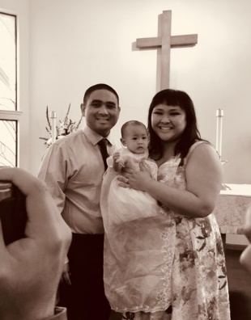
e’re never too young to learn new things about life, and one of the great learnings I’ve come to embrace recently is to ask for help. In fact, the language of baptism invites a spirituality of connection, transformation, and humility. Over that past year, we had many baptisms to celebrate at St. Ambrose. Off the top of my head, I believe we’ve had at least 12 baptisms since the beginning of 2017. For a parish of our size, that’s pretty amazing when considering how many of my clergy friends lament over the closure of churches and shrinking congregations. In addition, we had nine confirmed at Grace Cathedral in June 2017, along with a hundred others from around our diocese, and I feel the vibrancy of faith that’s thriving, not just at St. Ambrose, but for the wider Christian Church.
The Nagar’s celebrating
baby’s baptism

At every baptism, we say aloud the baptismal covenant from the Book of Common Prayer, reminding us that we’re never alone in the faith. After the Apostles Creed, there are statements that affirm our commitment to live into God’s love, saying: “I will, with God’s help.” The spirituality behind baptism informs us that we are never separated from God or community. But I wonder why it can be so hard to ask God for help?
Humans have a history of taking God for granted. The bible gives us many examples. And so does experience. Think about the times we find ourselves intentionally longing for God…is it in the good times or in the bad? Western secular movements of thinking and academic disciplines often separate matters of mind and body, while neglecting the spirit altogether. The American myth of a self-made person, putting high value on independence, may also contribute to an ideology of separation that makes true wholeness hard to grasp. Even though the scriptures reminded us again and again that that we are made from love for love in God’s image, how often do we deny divine truth for the misinformed belief that our imperfections separate us from love unconditional? The pressures to define our “success” in comparison to others adds to a spiritual poverty in modern culture that is reflected in the paradox of less actually meaning more. Many of our people become stuck in a cycle of depression and victimhood, always looking outwards for answers instead of trusting that the peace we seek resides within us. Some of us feel God would never be troubled with our troubles.
An Eastern Orthodox priest once said to me: “Never underestimate the power of sin.” It is a mindful warning that in the age of self-esteem and self-help, all the focus on the pursuit of happiness and on the self can be like having a broken compass that leads us running in circles to nowhere. Pain does carry a purpose. It reminds us that we’re alive. And that we need to pay attention to what is hurting. Pain informs us that we may need to change some of the patterns in our lives, and to let go of attachments which prevent us from giving and receiving love. Life can beat us up, and experiencing pain can lead us to find the grace to affirm the wholeness that never actually left us. Sin is not so much about the devil making us do bad things, or about breaking laws that are punishable in the life beyond, or about the things we feel guilty about. Rather, sin is separation from God. It is separation from people. It is separation from all creation. And it is separation from being the one God created us to be. And the real definition of hell is life without love.
“Baptism” (continued)
One of most humbling and life-giving sentences we can ever say has only three words: “I need help.” Virtually every great spiritual teacher I’ve heard has said life would improve, joyfulness would manifest, energy would shift, and possibilities would open if only we let go of that ego and ask for help. We cannot overcome sin alone. With God’s help, we can overcome the separations caused by our participation in sin. With God’s help, we can celebrate the fullness of our diversity and strengthen what we have in common. With God’s help we can resist evil and name truth. With God’s help, we can learn to love ourselves more, because in God’s grace we experience love unconditional.
Today we can find so many of our brothers and sisters sitting at that busy intersection of life, tired and broken down, stuck in old ways of being that may not always be so life-giving. Life patterns are often formed in childhood. Buddhist meditation teacher Jack Kornfield observed:
“The number of children raised without a nurturing and supportive family is growing. Divorce, alcoholism, traumatic or unfortunate circumstances, painful child-rearing practices, latchkey children, and child rearing by daycare and television all can produce people who lack an inner sense of security and well-being…their pain is reinforced by the isolation and denial of feeling that is common in our culture.”

In this brokenness, turning to God may not be easy if their image of God is distant. Where are people wounded by the realities of living supposed to go?

Don’t be afraid to ask for help! The beauty in baptism is that God knows who we are – broken and beautiful, imperfect and whole, made from love for love. When we say, “keep the faith,” what we’re saying is, “don’t stop believing.” Faith is about believing. Belief holds a much stronger intention than hope, because it invites us to see possibilities, to own of our actions, and to trust in God who is love. Baptism is only the beginning of living a full life in Christ. There’s so much more ahead in life, more love…more light.
Keep the faith my friends. Ask for help. Anything is possible, with God’s help!

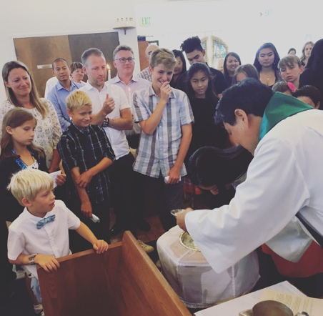
Outreach Report – by Steve Yuen

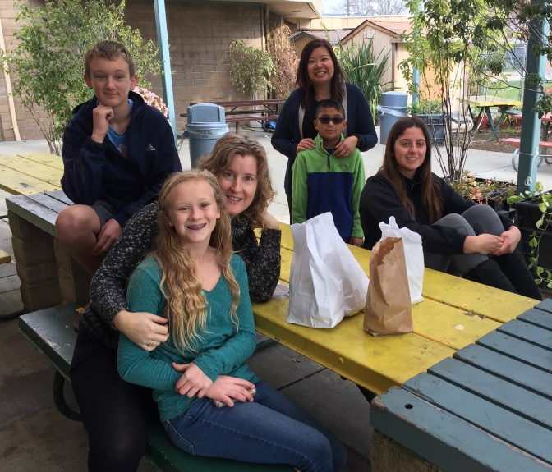
Sandwiches on Sunday

It was New Year's Eve Sunday. Despite many church members being on vacation, we managed to gather a group of 12 volunteers to serve lunch to 60 people on a chilly day in Redwood City.

Some were new to the activity, and others---okay, they're kids---have been doing it half their lives.

Sandwiches on Sunday is an outreach ministry led by St. Pius Catholic Church of Redwood City. St. Ambrose is one of four other churches that take a turn serving Sunday lunches at the community center.
Brett, Lauren, and Susan Yates, Phoebe and Shay Venkat, Lydia McIntyre
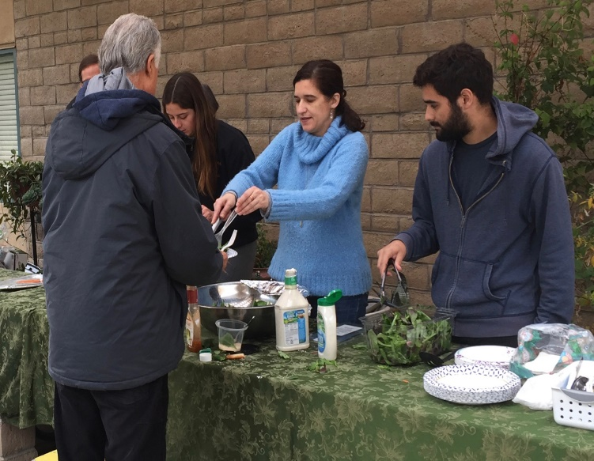
A small group had gathered around a car in the parking lot. A parishioner from St. Pius was handing out coats to the diners. He said it was a grass-roots effort started by church members; they collect and pass out 5-10 coats a week.

[By the way, distributing used cold-weather gear is the primary mission of charities like One Warm Coat (onewarmcoat.org).]

We polished off the apple cider—normally we serve lemonade, but it was New Year’s Eve--and closed up. There were celebrations to attend that night, but nothing more important than this.
Lydia McIntyre, Leda Girardi, and Leda's son, Pablo.
Our next hosting is on April 29 when we will be preparing baked chicken, rice and salad. If you can make a dish and/or help with serving and cleanup, please sign-up on the sheet that will be posted in the Parish Hall. Please contact Rob Richards (rob.richards@tensorlabs.com, 650-577-8924) if you have any questions.

Home & Hope (homeandhope.net/)
Home & Hope is a group of 30 churches and synagogues on the Peninsula that give emergency shelter for up to four families at a time (families can lose their housing suddenly because of family breakup, loss of a job, death of a breadwinner, etc.). For more information, see homeandhope.net
About half the churches have sleeping and bathroom facilities—nothing luxurious, guests sleep on cots or sleeping bags—but it’s better than spending nights in a car. The smaller churches, like St. Ambrose, prepare dinner to take some of the burden off the host parishes.
Outreach Report (continued)

On Tuesday, February 27 and Thursday, March 1, we will be feeding up to 15 people---typically half of them are children--- at Hope Evangelical Lutheran Church, 600 42nd Avenue, San Mateo, CA 94403 from 6:00 to 8:00 p.m. If you would like to help by preparing a dish (it is not necessary to go to the dinner), serve, and/or cleanup, please write your name on the sign-up sheet that will be posted in February in the Parish Hall. Please contact Steve Yuen (650-341-1966, stevebyuen@aol.com) if you have any questions.
In Fondest Memory

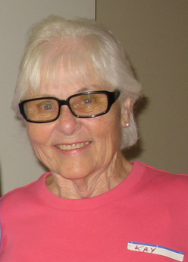
Kay Huffman (1937-2018)
For ten years, Kay Huffman led St. Ambrose’s participation in the Interfaith Hospitality Network, which later became Home and Hope. She organized volunteers, cooked tasty meals, and represented St. Ambrose at coordinator meetings, not to mention served dinner, cleaned the kitchen, and broke bread with the Home and Hope families. She also volunteered for many other Outreach programs and church ministries.

Kay was generous with her time, had a warm smile for everyone, and was a shining example of perfect service. We join her family in mourning her passing.

Sea Breeze School News – by Jerelyn Weber, Principal

With the holidays behind us, everyone has returned to school and settled back into their routines.

January and February are very busy months around campus and Lisa Walker, our Admissions Director, has been busy preparing for Fall and Summer registration that will begin on January 31. We will host our Open House on the evening of January 30 at 6:15 p.m., so if you know of anyone looking for a school for their child, please share this information and ask them to see us or contact our office for more information. Our waiting list is very long, so it is important for people to join the list early if they want to be considered for enrollment.

As the office works on registration, the classrooms are busy with many different activities this month. They will recognize the Lunar New Year with celebrations throughout the month, make valentines to share with their friends (and with the residents at the Atria Senior Living Home), and learn about the importance of good dental health from Pediatric Dentist, Dr. Lee.

Our Afterschool Program continues to thrive and stay busy with their Life Skills Class on Wednesday afternoons with Father Jay, and Music Appreciation with Maureen Fromme. When the children are not doing homework, we try to keep them busy with Bollywood dancing, large chess and checker games, and many outdoor activities.

We are always looking for volunteers to work with our students, so if you have some spare time and would like to volunteer please contact our office!

School will be closed on Monday February 12 for CPR and First Aid training for the staff (and on February 19 for the Presidents Day Holiday).

Very truly yours,

Jerelyn Weber, Principal

The Editor’s Corner– by Yvonne Sidell
My son, if you accept my words and store up my commands within you, turning your ear to wisdom and applying your heart to understanding, and if you call out for insight and cry aloud for understanding, and if you look for it as for silver and search for it as for hidden treasure, then you will understand the fear of the LORD and find the knowledge of God. –Proverbs 2:1-5

Two friends of mine expressed their views on traveling through West Texas. After coming home from trips, they both described their time in West Texas quite differently.
The first friend thought the drive was pretty boring — nothing to see or to do on the road in that part of the state. He found the sole purpose of the drive was to get through as quickly as you can, to arrive where you really want to be.
The second friend saw her drive quite differently, noting the jackrabbits, armadillos, mesas, cactus and canyons, dry riverbeds and underground caverns, to name a few treasures along the way. This friend saw West Texas as a place where one can think, hear God’s voice and there’s enough room to stretch out and not worry so much about what you’re wearing or driving.
These reports on West Texas reminded me that God has created hidden treasures for His people to find and experience. Just like the hidden splendors of West Texas, there are precious jewels of wisdom waiting to be sought out, discovered and enjoyed. King Solomon was given a chance any one of us would have wanted: a wish. God would grant him anything he requested. He did not ask for money, power or fame, he asked for wisdom. Solomon knew that wisdom contained far more treasures than anything. Although there is God-given wisdom, we are still called to seek, look and ask for it from God. As the Scripture from Proverbs notes, it is then that we will have an understanding and fear of the Lord. It is then that He can open our eyes.
Looking back at my friends’ driving experiences, I realize I too am guilty of looking, but not really seeing. Right in front of me, God’s wisdom sits like jewels of heaven ready and waiting to be captured and used. Too often, I “drive” through life not looking left or right but speeding ahead to my next stop. If we aren’t looking carefully, we’ll miss all God has. Wisdom is often found amongst things not easily seen, yet right there all along, to be discovered when you seek it.
Today, be reminded that Jesus said, “Seek and you shall find.” (Matthew 7:7-8)

*Credit: HomeWord Devotionals

