In this Issue:

Reflections (cont) …...P 2

Announcements......P 2-4

Outreach Report…..P 5-7

“The One Who Is Love” ………………………P 8-9

Sea Breeze School Registration School Year 2015-‘16…….….…….P 9

Interim Editor:
CD & S. Rowsell

The Ambrosian

The Monthly Newsletter of St. Ambrose Episcopal Church

900 Edgewater Blvd, Foster City, California 94404

January

2015

Edition

Individual Highlights:
Inside Story 2
Inside Story 3
Inside Story 4
Inside Story 5
Inside Story 6
Inside Story 7
Last Story 8
Special Interest Articles:

• Add a highlight or your point of interest here.

• Add a highlight or your point of interest here.

• Add a highlight or your point of interest here.

Dear Members and Friends of St. Ambrose Episcopal Church,

Aloha and Happy New Year! As the New Year begins I will be in Japan, making the sojourn back to the family home in the mountains of Kainan, Wakayama, Japan for my aunt’s one year memorial service. It is important for me to honor our family connections, especially on behalf of my mother. It is insightful to know from where one comes, but it is equally important to know where one is headed. In the latter case, we are all on a journey as God’s people with God’s reign as our destination. No place is our permanent home. Wherever we may be, if our hearts are open to God’s love within and among us, we are at home.
Our guest Celebrant and Preacher on the Second Sunday of Christmas, January 4th, will be the Rev. Rebecca Goldberg, who was raised up by our congregation for holy orders. Both Father Jay Watan and I will still be out of town, and she has graciously accepted my invitation to serve.
As has been my custom, we are combining the story of the Wise Men (Matthew 2:1-12) and the flight of the Holy Family to Egypt and their return to Nazareth (Matthew 2:13-15, 19-23). What is left out is the slaughter of the Holy Innocents in Bethlehem (Matthew 2:16-18). The Lectionary leaves out this story on Sundays as it is read on its Feast Day, usually December 28th. But we ought not to forget that genocide continues to happen in God’s world, because those who want to hold onto power during their lifetime choose to do so.
On Sunday, January 11th, we will renew our baptismal covenant as we celebrate the Baptism of Our Lord Jesus Christ.
On Saturday, January 17th, the Fellowship Dinner organizing potluck will be held in the Parish hall from 6 p.m. This will be an opportunity to join a dinner group once a month and get to know members of the congregation in a deeper way.
On Sunday, January 18th at the 8 a.m. service, we will bless the new green altar set with the fish design and begin using it.
On Sunday, January 25th at 11:30 a.m. we will have our Annual Meeting in the chapel. I encourage all members of St. Ambrose to attend. 2014 was a “rebound” year for St. Ambrose, as we grew in many ways.

Reflections from our Rector

I will be returning to the office on Thursday, January 8th and look forward to returning home to you all.

Yours,

David Y. Ota, Rector

Thank You
- Thanks to everyone who donated items throughout the year for the Christmas Stocking Stuffers, and to those who went to help make the gift bags on December 4th at the home of Jill Schwab. Thanks again Jill for this great project!
- Thanks to Father Jay for setting up the Giving Tree and to the youth for decorating it.
- Thanks to everyone who gave a present for the Giving Tree for the children of Star-Vista’s Learning Together Program in East Palo Alto.
- Thanks to everyone who went Christmas caroling to shut-ins and nursing homes on December 21st, and especially to Maureen Fromme who led the singers.
- Thanks to the Altar Guild for preparing a beautiful Advent wreath and preparing the chapel for Christmas. Thanks to those who volunteered to put up the wreaths and poinsettias.
- Thanks to the children, youth and parents who put on the Christmas Pageant! Thanks to Tarunpreet Ubhi who created a spotlight! Thanks especially to Gwen Juha and Jessica Morales who directed.

Youth Ministry Winter Trip:
We are headed up to the Rodriguez's family cabin in Twain Harte, CA for a trip to the snow and to visit Yosemite National Park for the weekend January 2nd-4th, 2015. It's a great time to reset for the New Year and to be in "God's Country."

Study Groups in January
Monday Book Study: This study group began reading the book by Alexander Shaia, The Hidden Power of the Gospels: Four Questions, Four Paths, One Journey. The group meets at the home of Merilyn Vosburg and meets on January 12th at 12:45 p.m.
Tuesday Bible Study: This bible study group meets on the first and third Tuesday of the month at the home of Warren and Nellie Wong. They will meet on January 6th and 20th from 7:00 p.m.
Wednesday Bible Study: This bible study group meets every other Wednesday night in the church foyer. They are studying the Book of Revelation and are at chapter 14. They will meet on January 14th and 28th from 7:30 p.m.
You are invited to join any of these study groups.

Under Construction: Fire Sprinkler System
The Sprinkler installation project for Room 1, the Principal’s office and the hallway outside it began on December 20th and should be completed by January 2nd. However, the portion of the project to connect a new water line had to be delayed and will be completed at a later date.

Update on the 2015 Pledge Campaign: What will we do with God’s gifts?
To date we have received 85 pledges to date totaling $152,296. We have also received 55 pledges of time and talent. We also received 21 pledges for Altar Flowers. The 2014 pledge total was 75 pledges for $131,892. Thanks to everyone who has turned in a pledge for 2015.

Keith and Charlene Adolph Rami and Linda Amireh Ed and Donna Avakoff
Bill & Charlotte Bradford Christina Brockman & Stan Hui Larry Buyers
Marilyn Canon Darlene & Tony Caponera Sal and Linda Censoprano
Honkai Chang & Milda Beh Eunice Chee Grant and April Cherrington
Nilda Chong Bettie Davis Reena Davis and Tarunpreet Ubhi
Kyn Dellinger Jeanne DeTorre-Ozeki Betty Dial
Beth and John Dossett Elliott Dun & Teresa Murakami Carolyn & Hugo Franco
Dulce Franke and Michael Lord Maureen H. Fromme George & Janet Gardiner
Raphaele & Jacques Gerber Don Gundry Demian & Lorraine Harvill
Eugene Hetzer Tippy Irwin Jane Jackson
Gwen and Hani Juha Shelley Keefe Joanne Kerseg
Brian and Lizz Klammer June Kudzia Emmon and Joyce Lew
Rosalinda Lindsey Judy Marshall Dorothy Matsuo
Kirk & Brenda Matsuo David McIntyre & Cathy Rincon Valerie Mersh
Jim Miller & Torrie McAllister-Miller John Miller & Eva Kwong Barbara Milligan
Kirk & Jessica Morales Kenneth & Karen Nagar Olivia & Wilfredo Nagar
Jim Neubert David Ota & Karen Swanson Clara Padilla
Karin Patterson Don & Elizabeth Peter Sydney and Cristina Pok
Elmer and Allette Pong Jimmy & Poppy Rawley Peggy Redmond
Rob & Anita Richards Diane Robertson Julio & Ngoc Rodriguez
C.D & Siew Rowsell Ruth Rymer & Ron Borden Deb Sakurai-Horita
Charles Saunders Frank & Barbara Saunders Abe & Sandy Schowengerdt
Jill & Gerald Schwab Dilip Selvaraj & Teresa Rajaratnam Yvonne Sidell
George & Merle Silverman Irene Stead Jon & Marilyn Stephens
Doug & Wendy Stewart Matt & Meltem Tanner Kay Umeda
Noelle and Nick Vitale Merilyn Vosburg Andy Walker
Wendy Walker Jay and Lilian Watan Pedro and Dolores Watan
Debbie White Warren & Nellie Wong Susan and David Yates
Steve and Belinda Yuen

If you would like to make a pledge, you still can do so. Pledge envelopes are in the foyer.

The 42nd Annual Meeting of St. Ambrose Episcopal Church
The 42nd Annual Meeting of St. Ambrose Episcopal Church will be held on Sunday, January 25th from 11:30 a.m. The meeting will be held in the chapel. The congregation will gather to hear reports on the state of the congregation, and will elect new leaders and thank those who have completed their terms of service. New members of the congregation are especially encouraged to attend.
All ministry team and committee leaders are asked to turn in their 2014 reports to the church office by Sunday, January 18th.
We need to elect at least five members to the 2015 Vestry. Rotating off the Vestry this year will be Senior Warden Bettie Davis, Rob Richards and George Silverman. Jim Neubert and Warren Wong will have completed their two year terms, and are willing to be nominated for a third year.
The 2015 Vestry meets immediately following the Annual Meeting to organize and elect Officers for 2015. The Vestry regularly meets once a month on weekday night, usually the fourth Tuesday from 7:30 p.m.
A Vestry dinner is planned for Friday, January 30th and the Vestry Orientation meeting is planned for Saturday, January 31st from 9 a.m. to 12 Noon.
We also need to elect three members to serve as delegates to Diocesan Convention and the Deanery of the Peninsula. Those who served as delegates in 2014 were George Gardiner, convener, Janet Gardiner and Steve Yuen. No Alternates were elected for 2014. Delegates serve at Diocesan Convention to conduct its annual business.
The Diocesan Convention will most likely be held at Grace Cathedral on Friday, October 16th from 4 to 8 p.m. and Saturday, October 17th from 9 a.m. to 4:30 p.m. Delegates also serve as members of the Deanery of the Peninsula which meets four times a year on Saturdays from 10 a.m. to 12 Noon at one of the peninsula congregations.
The Nominating Committee this year consists of Bettie Davis, Rob Richards, George Silverman and the Rector. The qualifications for being nominated to the Vestry are to be “in good standing in this Parish for at least 6 months prior to the date of their election to the Vestry, and regular contributors to the support of this Parish by currently stated pledge.” The qualifications to be a delegate or alternate to Diocesan Convention and the Deanery of the Peninsula are to be a member in good standing in this Parish and regular contributors to the financial support of the Parish.”

FELLOWSHIP DINNERS
2015

Take the opportunity to get to know other people from St. Ambrose!

FELLOWSHIP DINNERS consist of groups of about 6 to 8 people. Each group will meet once a month, February through May, for potluck dinner in a home.

There will be a kick-off Pot-Luck Dinner on Saturday, January 17th, at 6:00 p.m., at St. Ambrose. Here your group will be revealed to you.

Sign-up forms will be in the January Sunday bulletins, and in the foyer.
Deadline to sign up for Fellowship Dinners is Sunday, January 11th.

Call Nellie Wong (650-372-0728, wwong@nd.edu) or April Cherrington (650-574-7449, aprilcherr@aol.com) if you have any questions.

Outreach Report - by Steve Yuen
St. Ambrose concluded 2014 with a busy slate of Outreach events:
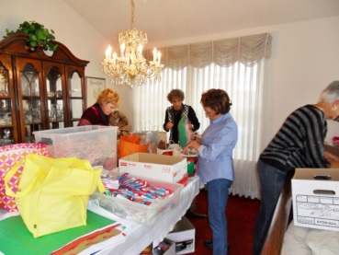
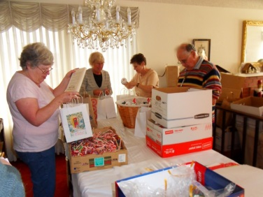
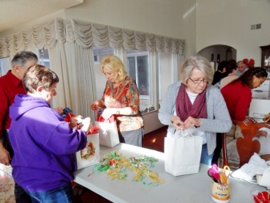

Stocking Stuffers: Jill Schwab and her able volunteers produced and distributed a record 1,380 stocking-stuffer bags. They were delivered to:
400 | Palo Alto Veterans Hospital
150 | Menlo Park Veteran Rehab hospital and homeless shelter
250 | Meals on Wheels through Little House in Menlo Park
70 | Senior Wing of Fair Oaks Community Center
60 | Catholic Charities Adult Day Care Center
55 | Families with terminal health issues - Catholic Charities
90 | Individual Adults 50 - 70 years old with terminal health issues - Catholic Charities
107 | Low Income Seniors
45 | Leland House Seniors with terminal health issues
53 | Treasure Island Supportive housing
100 | Menlo Park Veteran Homeless
1,380 | Total

Clara Padilla, Janet and George Gardiner, and April Cherrington represented St. Ambrose on the assembly line. Other participants who showed up at Jill’s house on a very busy December 4th were from the Santa Clara Thunderbird Club, the Lions Club, the Boy Scouts, and the Foster City Police Department. Kudos to Jill for forming an initiative that has brought holiday cheer to hundreds of people, and thanks to all our volunteers who helped her throughout the year.
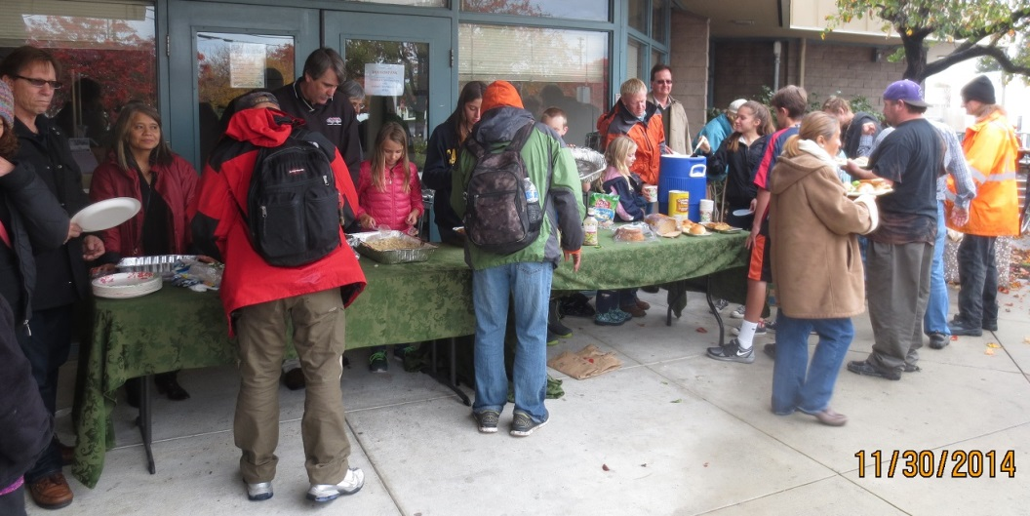
Sandwiches on Sunday: Twenty-two St. Ambrose members, including nine (9) from the youth group, served a lunch of chicken, rice, salad, and bread to all comers at the Fair Oaks Community Center on November 30th. The rainy weather made the picnic area unusable but did not dampen the servers’ enthusiasm. Tables were set up under the overhang near the entrance to the main building, and the rain subsided. We had 50 guests; a number slightly below average, but all the food was eaten or taken home. Thanks go to coordinator Rob Richards and all the cooks and servers who make SOS one of our most well-attended Outreach activities throughout the year. We will post a sign-up sheet at the beginning of March for the March 29th SOS. If you have any questions, please contact Rob (rob.richards@tensorlabs.com, 577-8924).
Family Sharing: Clara Padilla and Janet and George Gardiner delivered Christmas presents to families of six and five, respectively, in San Mateo. There were a total of four young girls under ten years old, all of whom requested a toy from last year’s Disney hit, Frozen. When we began shopping at the beginning of December, all “Elsa” and “Anna” dolls were gone from the stores; thank goodness for Amazon, from which we obtained these desirable items two weeks before Christmas. Thanks also go to St. Ambrose parishioners, whose generosity made Christmas a little brighter for two client families of Samaritan House (www.samaritanhouse.com).
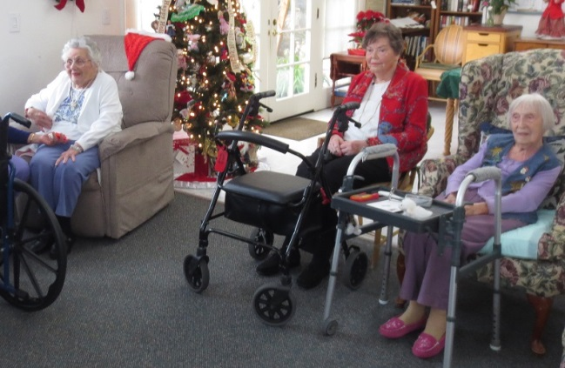
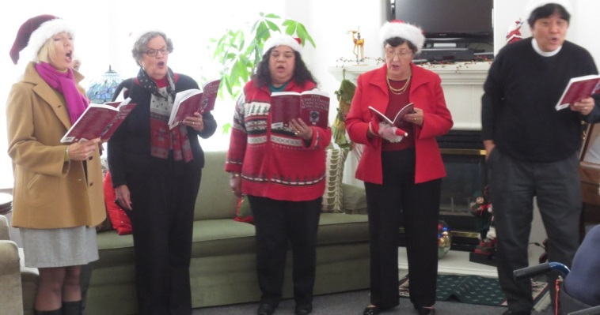

Christmas Caroling: The St. Ambrose choir sang Christmas favorites to Grace Belsky, Merilyn Vosburg, Lilo Zinger, and Foster City retirement home residents. Thanks go to Maureen Fromme and Dulce Franke for organizing this year’s caroling, and thanks to all the singers who brightened the day of our senior citizens.

Giving Tree: St. Ambrose and Sea Breeze School, in partnership with Star Vista Learning Together, provided holiday gifts to children in need in San Mateo County. This is the 6th year of supporting the children of Star Vista, and thanks go to all who took a “red tag” and brought a present to put under the tree

Upcoming Events
If you have any questions about the activities listed below, please contact Steve Yuen (341-1966, stevebyuen@aol.com).

Home and Hope: On Tuesday, January 27th, from 6:00 p.m. to 8:00 p.m., we will be feeding up to 15 people---typically half of them are children--- at Hope Evangelical Lutheran Church, 600 42nd Ave., San Mateo, CA 94403. If you would like to help by preparing a dish (it is not necessary to go to the dinner), serve, and/or clean up, please write your name on the sign-up sheet in the Parish Hall.

Episcopal Charities Action Network: Each year Episcopal Charities makes a grant of $5,000 to $10,000 to one charitable organization in each deanery (Diocese of California deaneries are Alameda, Contra Costa, Peninsula, Marin, and San Francisco). If you would like to participate in this decision for the Peninsula Deanery, the first meeting will be held at 7:00 p.m., Wednesday, January 28th at St. Matthew’s Episcopal Church, 1 S. El Camino Real, San Mateo.

Outreach Calendar (Partial) for 2015:
Won’t you join us? We invite any member of St. Ambrose who is interested in Outreach to attend short (less than 30 minutes) meetings which are normally held on the first Sunday of the month after the 10 a.m. service. The subject matter is typically about upcoming events and consideration of donations to charitable organizations.

Month | Outreach Meeting | Home  & Hope | Sandwiches on  Sunday | CALL Primrose | United Thank  Offering | Blessing  of Animals | Stocking  Stuffers | Family  Sharing
January | None | 27
February | 1
March | 1 | 24 | 29 | 25
April | None
May | 3 |  | 31 |  | 10
June | 7
July | None
August | 2 |  | 30
September | 13 | 22
October | None |  |  |  |  | 4
November | 1 | 10 | 29 | 18
December | 6 |  |  |  |  |  | 3 | 13

“The One Who Is Love” - by Rev. Jay Sapaen Watan
As we enter the New Year, one of the things I have been noticing is just how faith and spirituality is evolving. For many of us in the United States, the cultural cues found in the seasons of Christmas and Epiphany were intended for us to pay attention to the presence of God in Jesus Christ. The Christmas season brought out nativity scenes, angels, icons of Madonna and The Holy Child, and images of wise men following a star. "Rejoice, Christ is born!" In the Christian faith, the celebration of Jesus' birth is a time that carries a message of love, hope, joy, new beginnings, and of light overcoming darkness. Jesus may be the reason for the season, but I am finding that in our ever more secular culture, the hints of faith may no longer carry the same spiritual meaning. In fact much of the theology of Christmas simply goes unnoticed or above people's heads.

The idea that God is love seems so incredibly distant considering all the darkness and sin we see and experience in the world. It may feel that all we can do is wonder, silent with disappointment, whether or not God is even there. Yet the Hebrew Scriptures remind us that the most painful periods of history was in the perceived absence of God. Where did God go? Truth is in the ups and downs of life, God has always been there. But perception is reality. And as long as we choose not to see where God may be, we won't see any god there.

The prologue from the Gospel of John reminds us that God has been present with us since the very start of it all, "In the beginning was the Word, and the Word was with God, and the Word was God. He was in the beginning with God. All things came into being through him, and without him not one thing came into being. What has come into being in him was life, and the life was the light of all people. The light shines in the darkness, and the darkness did not overcome it... He was in the world, and the world came into being through him; yet the world did not know him."

While the holiday season may give us the sentimental images of Santa, Frosty, Rudolf, the Grinch, and Mickey & Mini in holiday gear, they are only seasonal. After the holidays, many of us will put these images in a box and stow it away not to be seen until next year. However, God just doesn't go way or disappear no matter how hard we try. Connect the story of God’s intention and we find that the Divine Source of All is about sharing unconditional love. This is what the late jazz musician John Coltrane referred to as a love supreme. However, unlike Santa who differentiates between the naughty and the nice, God just loves us where ever we are!

I believe one of our great challenges is finding the sacred in the secular. To seek the presence of love in the distractions of life and to pay attention to what is right in the world. And while the understanding of a distant god is the narrative given to us in pop culture, the faith given to us in our Holy Scripture reminds us that God relates to us in much more intimate ways. God created, and God also cared. God gave commandments, and God also forgave. God sent, and God also rescued and restored. Above all else, God invites us to be a light and God gives us Jesus to shine in our heart. The interesting thing is that while we cannot put God in a box, we will find that our relationship with the God who is Love starts with a baby lying in a manger. That's intimate stuff.

God has chosen to be known, present and accessible to us in and through the Word made flesh, Jesus, God’s Son. Jesus reveals to us not just elements of God’s character, but embodies God’s own heart and soul. Jesus will shows us who God really is and, more importantly, who God created us to be.

And so as we reflect on the rest of the Gospel, we are not simply hearing a story about Jesus, but rather we are invited to enter into the story of God, the God who created and sustains all and who has come for us in love. And how we chose to live into love become our story with God. In this New Year may you grow and glow in the awareness and love of the wondrous unknowable God. And may you know especially that the One who is Love is always for us.

Sea Breeze Registration School Year 2015-‘16
Beginning Wednesday, February 4th, and continuing through Thursday, February 5th, Sea Breeze School will be registering present students, their siblings, children of St. Ambrose parishioners, and siblings of former students for Summer School 2015 and School Year 2015-2016. Registrations will be accepted in order received and in priority placement for all classes. All current students must register each year, these registrations will be dated and processed in the order in which they were received.

Summer School is offered in two four-week sessions, June 22nd - July 17th and July 20th - August 14th. Classes will be offered for children who will be 3 years old by December 2nd, 2015 up to children who will be eligible to attend Kindergarten in August.

Sea Breeze is open 5 days a week between the hours of 7:30 a.m. and 6:00 p.m.. School Year, 2015-16, begins in late August, full and part time classes will be offered for 3, 4 and 5 year olds for Preschool and Transitional Kindergarten. After School Care is available for children attending Foster City School Kindergarten and/or Grades 1 through 3.

For applications and additional information, please call Wendy Walker, Registrar,
650-574-5437 on week days between 8:00 a.m. and 3:30 p.m...

