In this Issue:

Reflections …….….P 1-2

Announcements ….P 3-4
From the Desk of
The Rev. Karen….. P 5-6

Circles of Trust …...P 7-8
Outreach Report .P 9-11

Sea Breeze School
News………..…. .…P 12
Editor’s Corner…....P 13

Editor:
Yvonne Sidell

The Ambrosian

The Monthly Newsletter of St. Ambrose Episcopal Church

900 Edgewater Boulevard, Foster City, California 94404

January

2018

Edition

Individual Highlights:
Inside Story 2
Inside Story 3
Inside Story 4
Inside Story 5
Inside Story 6
Inside Story 7
Last Story 8
Special Interest Articles:

• Add a highlight or your point of interest here.

• Add a highlight or your point of interest here.

• Add a highlight or your point of interest here.

Dear Members and Friends of St. Ambrose Episcopal Church,
Aloha and Happy New! A New Year brings with it the opportunity to both reflect on the year that has past and anticipating what it will bring. As a congregation we reflect on the past year at our Annual Meeting which will be held on Sunday, January 28th from 11:30 am in the chapel. The Vestry will be providing a light lunch of sandwiches to feed us all.

Those who are responsible for the different ministries are asked to write reports about what they did with God’s help and many fellow church members. We will need those reports in the church office by Monday, January 22nd so we may produce a packet for each household.

Also at the Annual Meeting we will thank those who served, and elect new members of the Vestry and our delegates to the Deanery of the Peninsula and the Diocesan Convention. We will also recognize all the new people who have joined St. Ambrose in 2017.

I also anticipate that we will have a report of the study done regarding our proposed Capital Campaign for the future housing for the next Rector. Thanks to everyone who were interviewed or completed a survey.

Our ministry, however, is about seeking to follow Jesus the Christ in our daily lives. On Sunday, January 7th at the 10 am Holy Eucharist, Eva Kwong, will be presented for Holy Baptism. Eva has been an active participant in much of our life, but was not raised in the Christian faith. She has taken the intentional and deliberate step to be baptized into the death and new life found in Jesus Christ.

Our baptismal ministry is found in our Baptismal Covenant found on pages 304 and 305 of the Book of Common Prayer. In essence we are each called to base our lives on “the apostles teaching” and the “fellowship” of the church, to be supported by the sacrament of Holy Communion known as “the breaking of bread” and to have a life of prayer.

Reflections from our Rector

Reflections from our Rector (continued)

With this support as our foundation, we are called to “resist evil” in the world. When we lose our way from seeking God’s reign known as when we “fall into sin,” we are to turn around or “repent and return to the Lord.”

We are to be the Body of Christ in the world today, and to “proclaim by word and example the Good News of God in Christ” that all people are beloved of God, and that we were created for the purpose of being the “voice” of Jesus the Christ today to bless others, and the “hands and arms” of Jesus the Christ to help and lift others up.

We are to be a people who seeks “thy kingdom come, thy will be done, on earth as in heaven” as we “strive for justice and peace among all people.”

I am excited to see how God will use us in this New Year! And I am grateful that Eva is joining us in this ministry, and I am grateful for all of you in the ministry we share.

Yours,

David Y. Ota, Rector

Announcements

Thanks to:
- All who gave gifts to the children of Star-Vista through our Giving Tree.
- Maureen Fromme and the Children’s Choir who sang “Jesus loves me” at the 10 am service of Holy Eucharist on Sunday, December 10th.
- Thanks to Dulce Lord and Father Jay Watan who organized Christmas caroling on December 17th, and to all the carolers who visited five Foster City Care Homes.
- Thanks to the members of the choir who sang the Christmas Eve Choral Concert, and to Choir Director, Maureen Fromme, and Minister of Music, Frank Saunders.
- Brenda Joe-Matsuo for organizing the Hot Cocoa and Waffles fund-raiser for the Youth Group on Sunday, December 17th.
- Thanks to all the children, parents and volunteers who worked on the Christmas Pageant and the Rev. Karen Swanson, Coordinator of Children and Family Ministry for organizing it.

Update on the 2018 Pledge Campaign: Grace Abounds, Pass It On
To date we have received 78 pledges totaling $151,900. We have also received 51 pledges of time and talent. We also received 35 pledges for Altar Flowers. The 2017 pledge total was 80 pledges for $145,000. Thanks to everyone who has turned in a pledge for 2018.

Keith & Charlene Adolph Rami & Linda Amireh Donna Avakoff
Bill and Charlotte Bradford Christina Brockman & Stan Hui Marilyn Canon
Anthony Caponera Angela Carducci Sal & Linda Censoprano
Honkai Chang & Milda Beh Scott Chang & Judy Chen Eunice Chee
Grant & April Cherrington Nilda Chong Bettie Davis
Reena Davis Kyn Dellinger Jeanne DeTorre-Ozeki
Elliott Dun & Teresa Murakami Maureen H. Fromme George & Janet Gardiner
Leda V. Girardi Jacques & Raphaele Gerber Vince Granato & Lyn Concepcion
Don Gundry Caroline Helmuth Eugene Hetzer
Kay Huffman Jennifer Huang Gwen and Hani Juha
Shelley Keefe Joanne Kerseg Michelle & James Kimmins
June Kudzia Matt & Jolie Lechner Dulce & Michael Lord
Judy Marshall Dorothy Matsuo Kirk & Brenda Matsuo
David McIntyre & Cathy Rincon Valerie Mersh Jim Miller & Torrie McAllister
John Miller & Eva Kwong Barbara Milligan Kirk & Jessica Morales
David and Carolyn Moriarty Kenneth & Karen Nagar Ryan & Melissa Nagar
Wilfredo & Oliva Nagar Jim Neubert Liva & Alain Neyroud
David Ota Clara Padilla Karin Patterson
Don & Elizabeth Peter Ajit Philip & Shaiji Ajit Elmer & Alie Pong
Jimmy & Poppy Rawley Peggy Redmond Anita & Rob Richards
Diane Robertson Julio & Ngoc Rodriguez Charles Saunders
Frank & Barbara Saunders Sandy Schowengerdt
Dilip Selvaraj & Teresa Rajaratnam Yvonne Sidell Irene Stead
Jon & Marilyn Stephens Karen Swanson Matt & Meltem Tanner
Kay Umeda Phoebe Venkat Andy Walker
Jay & Lilian Watan Pedro& Dolores Watan Warren & Nellie Wong
Steve & Belinda Yuen

Thanks to everyone who participated in the 2018 Pledge campaign.

Announcements (continued)

Study Groups in January
- The Monday Book Study on America's Original Sin: Racism, White Privilege, and the Bridge to a New America, by Jim Wallis, meet on January 8th and 22nd from 7 pm at a location to be announced.
- The Tuesday Bible Study group meets on January 2nd, 9th, 16th, 23rd and 30th from 12:45 pm in the foyer. They continue to read the Book of Joshua.

The study groups are open to any interested person.

The Season After the Epiphany
This year the Season after the Epiphany includes a short six Sundays. The Gospel lessons for these Sundays focus on the manifestation of God in the life of Jesus.
- Sunday, January 7th, the First Sunday after the Epiphany: the Baptism of Our Lord Jesus Christ. Mark 1:4-11 focuses on how Jesus is God’s beloved Son.
- Sunday, January 14th, the Second Sunday after the Epiphany: John 1:43-51 focuses on the call of Philip and his subsequent call of Nathaniel to “Come and see.”
- Sunday, January 21st, the Third Sunday after the Epiphany: Mark 1:14-20 focuses on the arrest of John the Baptist and the call of the fishermen brothers, Simon and Andrew, and James and John.
- Sunday, January 28th, the Fourth Sunday after the Epiphany: Mark 1:21-24 focuses on Jesus teaching in a synagogue in Capernaum with power and authority, rebuking the unclean spirits in a man.
- Sunday, February 4th, the Fifth Sunday after the Epiphany: Mark 1:29-39 focuses on the healing ministry of Jesus.
- Sunday, February 11th, the Last Sunday after the Epiphany: Mark 9:2-9 focuses on the story of the Transfiguration.
During this season we are called to ponder how we are called to manifest the ministry of Jesus the Christ in our lives.

Mark Your Calendars:
Rector on Vacation: December 26 to January 2
Office Closed: Monday, January 1
Bible Study on Joshua: Tuesdays, January 2, 9, 16, 23, and 30, 12:45 pm, Foyer
Choir Practice: Thursdays, January 4, 11, 18, and 25, 7:30 pm, Chapel
Parents of Young Children Meeting: Sunday, January 14, 9 am, Parish Hall
Office Closed: Monday, January 15, Martin Luther King, Jr. Holiday
Sunday School Teachers Meeting: Sunday, January 21, 9 am, Parish Hall
Spanish Conversation Table: Sunday, January 21 following 10:00 am service
Fellowship Dinner Organizing Potluck: Saturday, January 27, 6 pm, Parish Hall
Annual Meeting of St. Ambrose: Sunday, January 28, 11:30 am, Chapel
Chili Cook-Off: Sunday, February 11, 11:15 am, Parish Hall
Imposition of Ashes and Holy Eucharist: Ash Wednesday, February 14, 12:10 pm, 7:30 pm, Chapel
From the Desk of The Rev. Karen Swanson

Children and Family Ministry Planning Meeting
Please join Rev. Karen and others interested in ministry to and with the younger children of St. Ambrose for a planning meeting on Sunday, January 14 from 9:00 to 9:55 a.m. in the Parish Hall. People of all ages with an interest in infants through fifth graders are encouraged to come. The presence of parents is especially helpful. Hot coffee, fruit and coffee cake will be available.
The agenda will include a review of the ministry so far this year; the choosing of children and family activities for winter and spring, and event leadership; information and brainstorming about possible summer activities; and long-term planning and any other topics identified in advance. To save everyone’s time, the meeting will focus on big picture decisions. People who offer to lead an event will be encouraged to consult with others and plan the details.
Those who would like to make suggestions or give input, but are unable to make the meeting are encouraged to call 650-200-8449 or e-mail Rev. Karen (karen.2.swanson@gmail.com) in advance. Your thoughts will be passed on to the larger group.
I hope to see many of you soon! Your ministry to the young ones so cherished by Jesus is very important and much appreciated by Him and the rest of us!

Sunday School Teachers to Meet
St. Ambrose Sunday School teachers will meet on Sunday, January 21 from 9:00 to 9:55 a.m. in the Parish Hall. Hot coffee, fruit and coffee cake will be available to the participants.
The goal of the meeting will be to identify the strengths of the ministry so far this year; to discuss ways to improve our work; to lay plans for the rest of the academic year; and to brainstorm about the summer.
If you are interested in this ministry, and are not yet involved, please contact the Rev. Karen Swanson at 650-200-8449 (cell and text) or at karen.2.swanson@gmail.com (e-mail.) There is always room for another person who longs to love and share faith with God’s children!
Thank you to…
The children and families who dedicated their time and effort to create this year’s Christmas pageant.
Nilda Chong and Kyn Dellinger for repairing and making costumes and props for the Christmas pageant, including a star that shines, and scrolls in Hebrew.
Gwen Juha, Lillian Watan and Maureen Fromme for assisting with lines, with blocking and with the management of children for the Christmas pageant.
Carolyn Moriarty for handling the cast appreciation for the Christmas pageant.

From the Desk of The Rev. Karen Swanson (continued)

Elliott Dun for coordinating the food for the cast, and to April Cherrington, Elizabeth Peters and Subhi Patil for assisting.
Barbara Milligan for her help in revising the pageant script.
Maureen Fromme for her leadership of the pageant music and her patience and support of the director.

Frank Saunders for his accompaniment for the pageant with its new, more complicated script.
The Rev. Jay Watan for managing the sound system for the pageant.
St. Ambrose young adults Poppy and Mary Bradford; Kendall and Danielle Richards, and Ruben Neyroud for adding their musical talent to that of music minister Frank Sanders this Christmas.
Raphaele Gerber for her extra efforts that allowed the children to make a Christmas ornament gift in Sunday School this year.

“Circles of Trust“ by the Rev. Jay Sapaen Watan

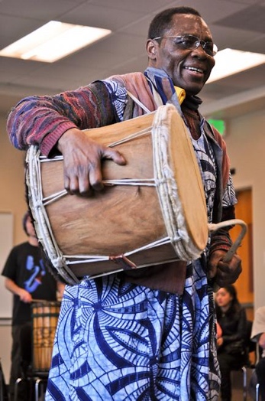
Last year I took an African Drumming Ensemble class at City College of San Francisco, and had the great honor to study with two African drumming masters: S. Kwaku Daddy and Idrissa Gueye. Professor Daddy is a Grammy nominated artist who comes from a family drum masters from Ghana, and has played with many musical legends, such as Dizzy Gillespie, Santana, and the Grateful Dead. He’s taught African drumming and folklore to students at CCSF for over 30 years. Professor Gueye was the master drummer for the National Ballet of Senegal for 25 years before immigrating to the United States. Now in semi-retirement, he still teaches drummers and seekers ways to make the drum sing and to invite the people to dance. Both professors preferred to be called by their given names, and Idrissa was our class’s teacher when Kwaku was away.
Master Drummer Kwaku Daddy

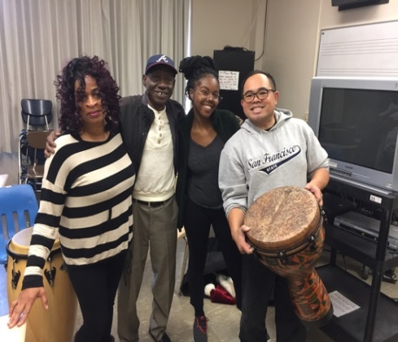
I signed up for the class because I had been praying to enter new ways to create sacred ground for healing, reconciliation and connection. Especially in this popular culture when fear, suspicion, and division are magnified, we are in need of more circles of trust. The paradox I find is that the newness often reflects ancient wisdom. And the drum has been a part of humanity since creation. Both my teachers understand their roll from African tradition and culture in that drumming masters are keepers of the culture and healers in the community. In the rhythm of song and story, they pass on the life lessons, faith, and values through folklore and the drum. That rhythm also reconnects us to the heartbeat we sometimes forget in the brokenness and busyness of life. The drum invites healing energy to flow in the circles that help create movement again and dance. Drums also evoke a way to create community and trust without words just by the very nature of drumming itself. Noise is not pleasant to the ears. Confusion, chaos, and sounds that compete for recognition will often cause the shy soul in us to retreat. But when the drum sounds find togetherness and syncopation we get ideas that work together to create polyrhythms and beauty that layers the space with wholeness, intention and joy.
With fellow CCSF students and Master Drummer Idrissa Gueye

Last month, I became the steward of a set of 16 drums donated by my old teacher from SF State, Dan Begonia. Professor Begonia used these drums to form percussion ensembles and drum circles among students taking Asian American Studies and Psychology classes at San Francisco State University prior to his retirement. In his travels around the world he saw how the drums and gongs cultivated a culture of trust and togetherness, and how in that trust and togetherness can offer our people a starting point to move forward in healing dialogues and honoring our story. Drum circles also evoked rituals that invite reflection and mindfulness. In this spirit, I’ve introduced drumming to our youth at St. Ambrose and with our afterschool students at Sea Breeze School.

As we enter the new year, I would like to invite us to seek ways that are new. It may very well be rooted in ancient wisdom that invites us to get up and dance. Keep the faith, my friends, and may God Bless You!
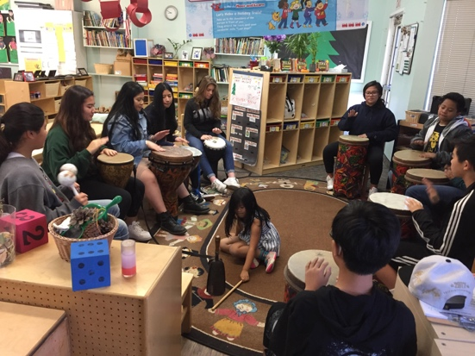
St. Ambrose Youth jamming on the drums on Dec. 3, 2017
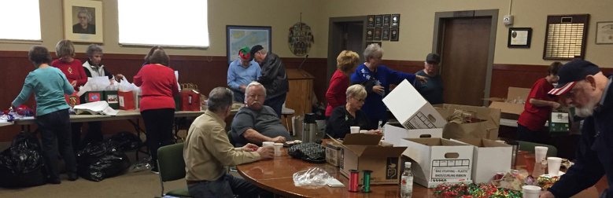
Outreach Report – by Steve Yuen

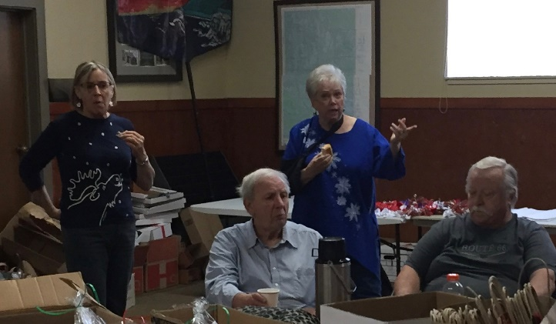
Stocking Stuffers
Jill and Jerry Schwab moved to Sonora in 2016, but Jill has returned to the Peninsula every December. For 15 years, Jill’s calling has been to create "stocking stuffer" bags for elderly shut-ins, residents of veterans' hospitals, and the homeless.
Her example has inspired a cadre of volunteers at St. Ambrose, the Boy Scouts, and the Santa Clara Thunderbird Club (note to the younger generation: the Ford Thunderbird was manufactured from 1955 to 2005).
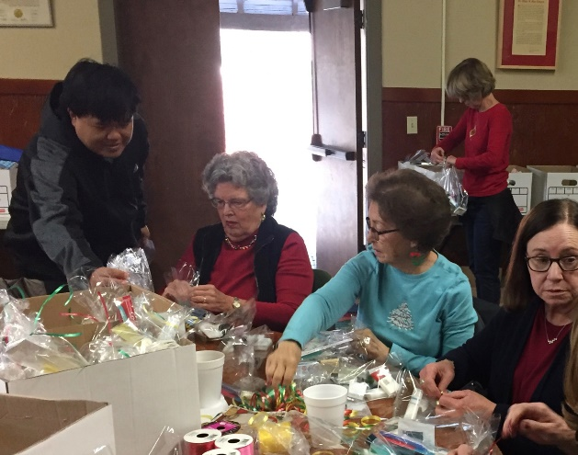
Assembly day was Thursday, December 7 at the Palo Alto Boy Scouts Center on Middlefield Road. When we arrived at 11 a.m., the production line was ramping up. Each bag had toothpaste, soap, shampoo, body lotion, a book, candy, comb/nail clipper/grooming item, and a scarf or small pillow.

We assembled about a thousand bags, which were transported by other volunteers that afternoon. We don't know how long Jill can keep doing this, but we'll be there.

Outreach Report (continued)

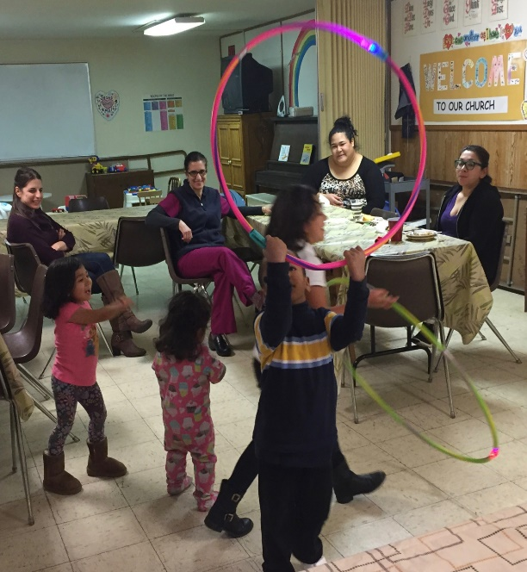
Home and Hope
After a dinner of spaghetti, green beans, and chicken, the kids grabbed the hula hoops and raced around the room. The cooks remembered a time when children should be seen and not heard, but those days are gone forever…

On the bright side, social interaction, even the raucous kind, was welcome. It was refreshing to see children---strangers---from different families playing together sans electronic devices.

The last three days of November was our turn to make dinner for Home and Hope (homeandhope.net), a network of 30 Peninsula churches and synagogues that provide temporary shelter for displaced families.

It was also a chance for people from different circumstances to spend a few hours together. We swapped stories about the places we grew up and how we came to live in the most beautiful place on earth. We talked about our childhood and parents.

Thanks go to our cooks and servers: Liv Dahdah (and her friend Lorie), Leda Girardi, David Ota, Clara Padilla, Diane Robertson, and Irene Stead. Steve Yuen was also an overnight monitor on Thursday, November 30.

Our next nights for hosting are Tuesday, February 27 and Thursday, March 1. A sign-up sheet will be posted in the Parish Hall. Please contact Steve Yuen (650-341-1966, stevebyuen@aol. com) if you have any questions.

Upcoming Events

Family Sharing
St. Ambrose parishioners made Christmas brighter for three families, including five children and one elderly couple, who live in San Mateo and who are clients of Samaritan House (www. samaritanhouse.com). We spent $1,017 on gifts for the families. Clara Padilla and Honkai Chang purchased and delivered the presents to the happy recipients before Christmas. Thanks go to all church members who donated to this long-running Outreach activity.

Christmas Caroling
The choir and the St. Ambrose youth sang Christmas favorites in Foster City on December 17 (see separate report).

Outreach Report (continued)

Giving Tree
St. Ambrose and Sea Breeze School, in partnership with Star Vista Learning Together, provided holiday gifts to children in need in San Mateo County. Thanks go to all who took a “red tag” and brought a present to put under the tree.

Sandwiches on Sunday
We served a hot lunch to all comers at the Fair Oaks Community Center in Redwood City on December 31. We’ll file a report in next month’s Ambrosian.

Appeal for Volunteers

The items noted in this month’s report represent only some of the ways in which St. Ambrose volunteers help the community. Whether you are interested in one program or five, or can contribute one hour or ten, we would love to have you join us!
Attending an Outreach Committee meeting on first Sundays after the 10:00 a.m. service is a good way to become acquainted with our activities, but attending our meetings is absolutely not a requirement. If you have questions, please contact Steve Yuen (650-341-1966, stevebyuen@aol.com).

Sea Breeze School News – by Jerelyn Weber, Principal

Sea Breeze Registration School Year 2018-2019

Beginning Wednesday, January 31, and continuing through Thursday, February 1, Sea Breeze School will be registering present students, their siblings, children of St. Ambrose parishioners, and siblings of former students for Summer School 2018 and School Year 2018-2019.
Registrations will be accepted in order received and in priority placement for all classes.
All current students must register each year. These registrations will be dated and processed in the order in which they were received.

Summer School will begin June 18. Classes will be offered for children who will be three years old by December 2, 2018 (up to children who will be eligible to attend Kindergarten in August).

Sea Breeze is open five days a week between the hours of 7:30 a.m. and 6:00 p.m.
School Year 2018-2019, begins in late August – full and part time classes will be offered for three, four and five year olds for Preschool and Transitional Kindergarten. After School Care is available for children attending Foster City School Kindergarten and/or Grades 1 through 3.

For applications and additional information, please call Lisa Walker, Admissions Director,
650-574-5437, weekdays between 8:30 a.m. and 2:00 p.m.

Very truly yours,

Jerelyn Weber, Principal

The Editor’s Corner– by Yvonne Sidell

Dear children, let us not love with words or tongue, but with actions and in truth.
–1 John 3:18

The early church father, St. Francis of Assisi said, “Preach the Gospel at all times, and when necessary, use words.” The following story communicates how actions often communicate more than words:

A member of a certain church, who previously had been attending services regularly, stopped going. After a few weeks, the pastor decided to visit him.

It was a chilly evening and the pastor found the man at home alone, sitting before a blazing fire. Guessing the reason for his pastor’s visit, the man welcomed him, led him to a comfortable chair near the fireplace and sat down. The pastor made himself at home, but said nothing. In the grave silence, he contemplated the dance of the flames around the burning logs. After some time, the pastor took the fire tongs, carefully picked up a brightly burning ember and placed it to one side of the hearth all alone. Then he sat back in his chair, still silent.

The host watched all this in quiet contemplation. As the one lone ember’s flame flickered and diminished, there was a momentary glow and then its fire was no more. Soon it was cold and dead.

Not a word had been spoken since the initial greeting. The pastor glanced at his watch and realized it was time to leave. He slowly stood up, picked up the cold, dead ember and placed it back in the middle of the fire. Immediately it began to glow once more with the light and warmth of the burning coals around it.

As the pastor reached the door to leave, his host said with a tear running down his cheek, “Thank you so much for your visit and especially for the fiery sermon. I shall be back in church next Sunday.”
*Credit: HomeWord Devotionals

