January

2020

Edition

In This Issue:

Reflections ……..….P 1-2

Announcements…...P 3-4
Desk of Rev.
Karen Swanson…...P 5-6
Outreach……..…....P 7-8

Sea Breeze
School News……..…P 9
Editor’s Corner….....P 10
Birthdays &
Anniversaries………P 11

Editor:
Yvonne Sidell

The Ambrosian

The Monthly Newsletter of St. Ambrose Episcopal Church

900 Edgewater Boulevard, Foster City, California 94404

Individual Highlights:
Inside Story 2
Inside Story 3
Inside Story 4
Inside Story 5
Inside Story 6
Inside Story 7
Last Story 8
Special Interest Articles:

• Add a highlight or your point of interest here.

• Add a highlight or your point of interest here.

• Add a highlight or your point of interest here.

Dear Members and Friends of St. Ambrose Episcopal Church,
Aloha and Happy New Year! The Year 2020 promises to be a year of renewed ministry. With the consent of the Vestry, and the agreement of the staff involved, I have decided that the Rev. Karen Swanson will assume the role of Associate for Youth, Children and Family Ministry. This means she will be responsible for the oversight of the youth ministry, and will delegate responsibility for the Sunday school, nursery and children’s activities to Fe Balamiento who will assume the role of Minister of Children’s Ministry.

The Rev. Karen Swanson will be the primary person leading the youth ministry. She will work with Daniel Tate in the youth Sunday school. She will also work with the parents of the youth and the youth themselves to plan and organize youth activities as time allows. A schedule of youth ministry activities or events will be developed. Parents Brenda Joe-Matsuo and Ngoc Rodriguez has stepped up to volunteer to help.

Fe Balamiento, as the Minister of Children’s Ministry will oversee the Sunday school and work with the Sunday school teachers and nursery care givers. She will also plan activities with the Rev. Karen Swanson for children about six times a year.

Our Annual Meeting will be held on Sunday, January 26 from 11:30 a.m. in the Chapel. The 2020 Budget passed by the Vestry will be explained to the congregation, and a light lunch will be served following the 10:00 a.m. Holy Eucharist.

Individuals responsible for the different ministries are asked to turn in written reports to the church office by Monday, January 20 so they may be included in the Annual Meeting packets.

Reflections from our Rector

Reflections from our Rector (continued)

We will thank outgoing members of the Vestry and delegates and alternates to the Deanery and the Diocesan Convention. We will elect new members to the Vestry as well as our delegates to the Deanery of the Peninsula and the Diocesan Convention. You may nominate members to the Vestry or delegates or alternates to the Deanery of the Peninsula and the Diocesan Convention by contacting Michael Lord, Jim Miller, Shaiji Ajit, Don Gundry and Barbara Milligan who are serving as the Nominating Committee. We hope to elect three members to the Vestry for a three-year term, one member to the Vestry for a two-year term, and one member to the Vestry for a one-year term.

I give thanks to God for all of you who make the ministry we share here at St. Ambrose possible. May God continue to bless us in seeking to be God’s people in this place.

Yours,
David Y. Ota, Rector

Announcements

UPDATE – 2020 Pledge Campaign: Caring for our Communities and God’s World
To date we have received 61 pledges totaling $121,067. We have also received 34 pledges of time and talent. We also received 17 pledges for Altar Flowers. The 2019 pledge total was 62 pledges for $124,082. Thanks to everyone who has turned in a pledge for 2020.

Keith & Charlene Adolph Rami and Linda Amireh Ed and Donna Avakoff
Kay Ballantyne Milda Beh and Honkai Chang Bill and Charlotte Bradford
Marilyn Canon Angela Carducci Sal and Linda Censoprano
Scott Chang & Judy Chen Eunice Chee April & Grant Cherrington
Nilda Chong & Kyn Dellinger Bettie Davis Reena Davis & Tarunpreet Ubhi
Jeanne DeTorre-Ozeki Elliott Dun & Teresa Murakami Hamilton Fong
Maureen Fromme George & Janet Gardiner Raphaele & Jacques Gerber
Don Gundry Eugene Hetzer Randy Jew & Katherine Ozeki
Shelley Keefe Joanne Kerseg June Kudzia
Alison LeBlanc Dulce & Michael Lord Judy Marshall
Dorothy Matsuo Kirk Matsuo & Brenda Joe-Matsuo
David McIntyre & Cathy Rincon Valerie Mersh Jim Miller & Torrie McAllister-Miller
Barbara Milligan David & Carolyn Moriarty Kenneth and Karen Nagar
Wilfredo & Oliva Nagar Jim Neubert Liva & Alain Neyroud
David Ota Clara Padilla Karin Patterson
Don & Elizabeth Peter Ajit Philip and Shaiji Ajit Jimmy & Poppy Rawley
Diane Robertson Julio & Ngoc Rodriguez Frank & Barbara Saunders
Sandy Schowengerdt Irene Stead Jon & Marilyn Stephens
Susan Sullivan Karen Swanson Matt & Meltem Tanner
Daniel Tate Phoebe Venkat Andy Walker
Warren & Nellie Wong Steve and Belinda Yuen

If you would like to make a pledge, you still can do so. Pledge envelopes are in the Foyer. Thanks to everyone who participated in the 2020 Pledge campaign.

THANKS to:
- Maureen Fromme, Choir Director, Frank Saunders, Minister of Music and members of the choir who offered the Christmas Choral Concert: Marilyn Canon, Shelley Keefe, Reena Davis, Jeanne DeTorre-Ozeki, Barbara Saunders, Valerie Mersh, April Cherrington, Susan Sullivan, Hamilton Fong, George Gardiner and David Ota.
- The Altar Guild for preparing the Chapel for the services during Christmas

Study Groups in January

The Monday Evening Study Group will meet this month on Mondays, January 13 and 27 at 7:00 p.m. The study group will be meeting at the home of Warren and Nellie Wong, 826 Phoenix Lane, Foster City. They are studying the upcoming Sunday lessons.
Announcements (continued)
The Tuesday Bible Study Group will be meet on Tuesdays, January 7, 14, 21 and 28 from 12:45 to 2:00 p.m. in the Foyer. They are currently reading the Apostle Paul’s First Letter to the Corinthians.

The study groups are open to any interested person.

Mark Your Calendars
Second Sunday after Christmas (Proper for Day of the Epiphany transferred): Sunday, January 5, Holy Eucharist, 8:00 a.m.; Choral Holy Eucharist, 10:00 a.m., Chapel – Celebrant and Preacher, the Rev. David Ota

Bible Study on 1 Corinthians: Tuesdays, January 7, 14, 21 and 28, 12:45 p.m., Foyer

First Sunday after the Epiphany – Baptism of our Lord Jesus Christ: Sunday, January 12, Holy Eucharist, 8:00 a.m. and Choral Holy Eucharist, 10:00 a.m., Chapel – Celebrant and Preacher, the Rev. David Ota, Chapel; Sunday School and Nursery, 10:00 a.m., Rooms 1, 4 and 5

Bible Study on Sunday lessons: Mondays, January 13 and 27, 7:00 p.m., Wong’s home
School Board Meeting: Tuesday, January 14, 7:00 p.m., Parish Hall
Second Sunday after the Epiphany: Sunday, January 19, Holy Eucharist, 8:00 a.m. and Choral Holy Eucharist, 10:00 a.m, Chapel – Celebrant and Preacher, the Rev. Karen Swanson, Chapel; Sunday School and Nursery, 10:00 a.m., Rooms 1, 4 and 5
Buildings and Grounds Committee Meeting: Tuesday, January 21, 6:00 p.m., Parish Hall
Vestry Meeting: Tuesday, January 21, 7:00 p.m., Parish Hall
Third Sunday after the Epiphany: Sunday, January 26, Holy Eucharist, 8:00 a.m. and Choral Holy Eucharist, 10:00 a.m., Chapel – Celebrant and Preacher, the Rev. David Ota, Chapel; Sunday School and Nursery, 10:00 a.m., Rooms 1, 4 and 5
Annual Meeting: Sunday, January 26, 11:30 a.m., Chapel
2020 Vestry Organizing Meeting: Sunday, January 26, 12:15 p.m., Parish Hall
2020 Vestry Dinner: Friday, January 31, 6:30 p.m., home of April Cherrington
2020 Vestry Planning Day: Saturday, February 1, 9:00 a.m., Parish Hall
Rector on vacation: Monday, February 17 to Monday, February 24
Ash Wednesday Services: February 26, 12:10 p.m. and 7:00 p.m., Chapel

The Desk of Rev. Karen Swanson

Youth to Focus on Service

Inspired by senior sermons preached by Landon Matsuo and Lydia McIntyre in which they spoke about how meaningful their own service work has been, the St. Ambrose Youth are focusing on reaching out to the underserved in January. The initial choice of the youth was to volunteer at the Bayview Mission in San Francisco, a diocesan project supported by Grace Cathedral, that distributes food, clothing, and personal items to people in need. Volunteers help with sorting donations and packing grocery bags. The timing of this project is still being worked out, but it is hoped our youth can participate on Sunday afternoon, January 19.

Another possibility is for our youth to join other youth from Episcopal churches across the Bay Area for an overnight at Grace Cathedral on the evening of January 19 followed by participation in the Martin Luther King Jr. march for justice in San Francisco on the morning of January 20. The program for the overnight will be planned by the diocesan youth leader. Further information about each opportunity will be available soon, so that a final plan can be determined. Youth, if possible, please save Sunday afternoon and evening, and Monday morning for our event.

Led by Brenda Matsuo and Ngoc Rodriguez, plans are also underway for St. Ambrose’s participation in the Sierra Service project this summer. Among the preparations will be a mason jar mission sale in March, featuring bean soup and cookies. You can help support the youth now by bringing in pint and quart size glass containers to hold the goodies. Check for a labeled box in the Narthex (foyer) of the church, and please place them there.

When the youth travel to San Francisco for their service work project in January, they will be happy to drop off any gently used clothing or unused personal items like toothpaste, toothbrushes, shampoo, or razors that you would like to donate. Again, check in the Narthex (foyer) of the church for a container to receive these. Thank you for your help!

Thank You for the Pageant!
In a Christmas poem written by Christina Rosetti, the poet takes the perspective of a child present at the time of Jesus’ birth, and ponders the fine gifts given to Jesus at his birth, by the wise men and others. Then the child quietly wonders, “What shall I give him, poor as I am?” The answer comes to her in a God-given insight “I’ll give him my heart.” So it was at this year’s Christmas pageant and family Holy Eucharist that the youth and child actors and actresses gave us their hearts, and in the process filled ours.

The actors and actresses worked especially hard, taking the risk of speaking publicly, and memorizing lines. Key roles were ably filled by Lily Moriarty who played Mary, Noah Rawley who played Joseph, and Oliver Moriarty who played Gabriel. Jimmy Bradford and Emily Rodriguez quickly learned their lines as shepherds, which freed them to guide the six stable animals to the Holy Family with the assistance of Fe Balamiento. Our young stable animals included Bradley Balamiento, Cameron and Sydney Jew, Logan Kimmins, Elizabeth Rawley and Samaira Ubhi.

The Desk of Rev. Karen Swanson (continued)

Our three shining angels, Sofia Kimmins, Charlotte Rawley, and Simran Ubhi, sparkled as they twirled and sang their praises to God. Christina Rodriguez and William Bradford were their guardian angels, capably ensuring their arrivals and departures at just the right time. Michael

Michael Chang added to his role as first narrator that of the oldest and wisest of the three kings, a regal group which also included Neel and Jay Ambarge. Neel and Jay, along with third narrator Rachel Ajit, played the role of the largely inhospitable innkeepers as well. New to the cast this year was “the star of the show” Elias Dahdah, who played the Star of Bethlehem. Michael Chang, Elliott Dun, and Rachael Ajit as narrators added to the proclamation of the Christmas gospel by moving the story along, and filling in the details. Youth also filled key roles in the rest of the worship service including Christina Rodriguez and William Bradford as lectors; Nathan Matsuo as litanist; and Connor Moriarty and Reuben Ajit as acolytes.

It takes a village to raise a child, and also to proclaim the Christmas gospel. Thank you to all the adults who actively participated as the support team. Rev. Karen Swanson, pageant director; Maureen Fromme, pageant musical director and Daniel Tate, assistant director, led this team. Frank Saunders accompanied the music for the liturgy and much of the pageant with grace. Fe Balamiento was very helpful, jumping in wherever she was most needed. She and Grace Salum distributed the children’s costumes. Nilda Chong and Kyn Dellinger, who attend the eight o’clock service, created crowns for the kings that lit up, and repaired and modified other costumes as needed. Like Fe, Christina Rodriguez and William Bradford offered to help in whatever way was needed, which was a great comfort to the leadership team, given the unexpected things that so often happen. Mahalo nui loa! Alison Le Blanc and Dulce Lord also assisted. Their help as parishioners who aren’t parents was a meaningful indication of how youth and children are beloved and cherished by this congregation. Hungry actors and actresses must eat, which meant that the food provided for the youth and children was highly appreciated. Those responsible for the refreshments included Elliott Dun and Teresa Murakami, Mildeh Beh and Honkai Chang, Cathy Rincon and David McIntyre, Shavangini Patil, and Carolyn Moriarty. Thank you to the village, and especially its youth and children, for the meaningful presentation of the Christmas Gospel this year.

January Outreach Report – by Steve Yuen
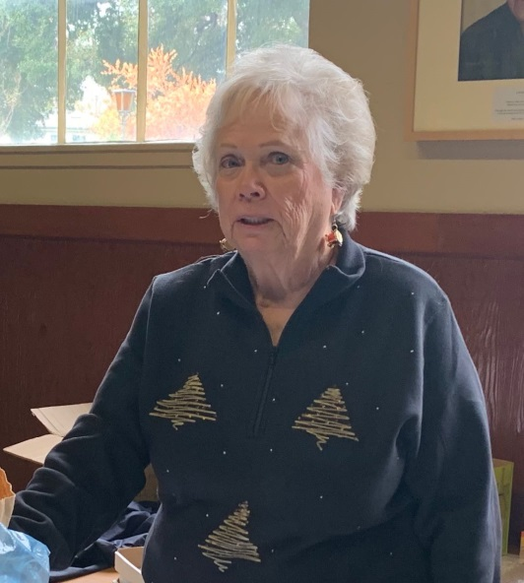
Outreach activities culminated in December with programs that made the Holidays a little brighter for members of the community.

Stocking Stuffers: Four years after she and Jerry moved to Sonora, Jill Schwab again returned to the Peninsula to lead the event that she started in 2003.

Her merry band of volunteers from St. Ambrose, Santa Clara Thunderbird Club, and the Boy Scouts assembled over a thousand gift bags for elderly shut-ins and those who reside in assisted-living facilities. Recipients were:

VA Hospital Palo Alto | 200
Meals on Wheels | 500
VA Hospital Menlo Park | 200
San Carlos Adult Day Care | 40
Defenders Lodge | 40
Fisher House | 41
 | 1,021

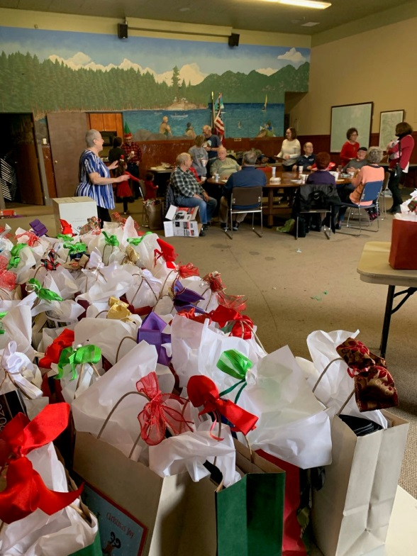
Jill also set aside six bags for elders in Foster City; Dulce and Michael Lord delivered them to a residential care facility on Sandpiper Court.
Kudos to Jill for continuing this valuable ministry, and thank also to our volunteers and especially Jill’s husband Jerry for their support.

Family Sharing: The congregation opened its hearts and wallets to three local families, two families of five and one senior mother and daughter. We collected $1,235, more than enough to ensure a brighter Christmas for the recipients. We spent $1,054, and the excess of $181 will be donated to Episcopal Relief and Development.

Thanks go to Milda, Honkai and Michael Chang, who visited with the senior couple, and to Clara Padilla, who spent days on the phone and wrapped and delivered gifts for the six children and four adults.

Outreach Report (continued]

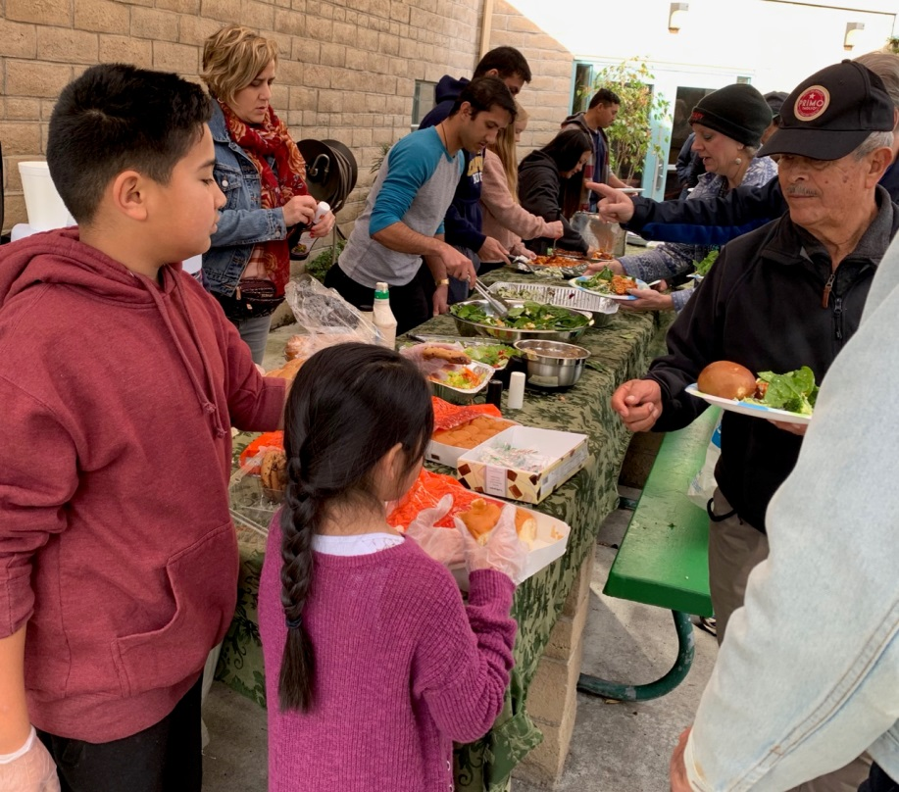
Sandwiches on Sunday: On December 29th we had an unexpected--and wonderful—turn out of volunteers on what is normally a “low” Sunday after Christmas. (Digression: the official “Low Sunday” refers to the return to normalcy on the Sunday after Easter.) Helping to serve and clean up at the Fair Oaks Community Center were:

David, Susan, Brett, and Lauren Yates
The Yates’ friends: Jenny, Murtz, Abbas, and Nabeil
Liv and Elias Dahdah
Michael Lord
Grace, Josh, Noah, and Charlotte Rawley
Rob Richards
Anders Zhou and his friend Esther
Steve Yuen

We served lasagna, salad and bread to 70 people. We expected that nine (9) trays of lasagna would produce leftovers, but the customers came back for seconds and thirds and took the rest home in containers. In addition to the above-mentioned servers, those who prepared dishes were:

Irene Stead
Jim Neubert
Valerie Mersh
April Cherrington

Thanks go to all our cooks and servers for helping with one of our most popular ministries. The next Sandwiches on Sunday is March 29, 2020. If you have any questions or comments, please contact Rob Richards (rob.richards@tensorlabs.com).

Upcoming Events:
During the month of January we have no Outreach activities scheduled.

May you use this “quiet” period to recover from the holidays, reflect upon your goals and plan the new year, hopefully sparing room for one or two Outreach activities on your calendar. Please contact Steve Yuen (stevebyuen@aol.com) if you have any questions.

.

Sea Breeze School News – by Jerelyn Weber, Principal

Sea Breeze Registration School Year 2020-2021

Beginning Wednesday, January 29, and continuing through Thursday, January 30, Sea Breeze School will be registering present students, their siblings, children of St. Ambrose parishioners and siblings of former students for Summer School 2020 and School Year 2020-2021. Registrations will be accepted in order received and in priority placement for all classes. All current students must register each year. These registrations will be dated and processed in the order in which they were received.

Summer School will begin June 22. Classes will be offered for children who will be three years old by December 2, 2020 up to children who will be eligible to attend Kindergarten in August. Sea Breeze is open five days a week between the hours of 7:30 a.m. and 6:00 p.m. School Year 2020-21 begins in late August, and full / part time classes will be offered for three, four and five year olds for Preschool and Transitional Kindergarten.

Due to some reorganization, we have been able to add an additional 24 spots for three year olds. After School Care is available for children attending Foster City School Kindergarten and/or Grades 1 through 3.

For applications and additional information, please email Lisa Walker, Admissions Director at lwalker@seabreezeschool.com

Continued Blessings,
Jerelyn Weber, Principal

The Editor’s Corner– by Yvonne Sidell

All athletes practice strict self-control. They do it to win a prize that will fade away, but we do it for an eternal prize. So I run straight to the goal with purpose in every step. I am not like a boxer who misses his punches. I discipline my body like an athlete, training it to do what it should. Otherwise, I fear that after preaching to others I myself might be disqualified. –1 Corinthians 9:25-27

Every year at the beginning of January, consumers are inundated with advertisements to lose weight, quit smoking, to finish school and more. Companies do what they can to cash in on the “New Year’s Resolutions” tradition.

In early January, the weight machines and cardio areas of fitness clubs everywhere are filled with people who are hoping to lose their holiday season weight gain or to start getting into better shape. However, the busyness doesn’t last long. By the end of February or beginning of March, the annual fitness fads die and the crowds thin out as the unmotivated drop off. Here’s a challenge for you: don’t refer to your spiritual commitments as “New Year’s Resolutions.”

Generally, people tend not to keep them. An athlete works out each day and slowly builds muscle, stamina and endurance as they train over the long haul. Paul, in his letter to the Christians in Corinth, tells them that they must discipline themselves like athletes. The Christian walk requires hard work, self-denial, and difficult preparation. You are called to be on the field, not merely a spectator. Christians are called to be disciplined in prayer, reading the Bible and worship. It is these areas that will help you live with purpose and stamina.

Resolve in our new year and the decade ahead (including life) to be disciplined each day by spending time in God’s word and praying so that you can build your spiritual muscles.

*Credit: HomeWord Devotionals

