In this Issue:

Reflections (cont) …...P 2

Announcements …..P 2-4

Outreach Report .....P 5-6

“Volunteers” ….….P 7-8

Sea Breeze School
News ……..….….…P 8-9

Interim Editor:
David Y. Ota

The Ambrosian

The Monthly Newsletter of St. Ambrose Episcopal Church

900 Edgewater Blvd, Foster City, California 94404

June

2017

Edition

Individual Highlights:
Inside Story 2
Inside Story 3
Inside Story 4
Inside Story 5
Inside Story 6
Inside Story 7
Last Story 8
Special Interest Articles:

• Add a highlight or your point of interest here.

• Add a highlight or your point of interest here.

• Add a highlight or your point of interest here.

Dear Members and Friends of St. Ambrose Episcopal Church,

Aloha! The month of June is usually a month of transition from the School Year to the summer months of vacations, rest and reflection. This year, however, June also marks milestones and farewells.

On Saturday, June 3rd from 10 am at Grace Cathedral, Ruben Ajit, Jimmy Bradford, Amarine Gerber, Michael Lord, Landon Matsuo, Lydia McIntyre, Emily Miller, Christina Rodriguez, Emily Rodriguez and Daniel Tjandra will be presented for Confirmation in the Episcopal Church. The congregation is invited and encouraged to attend this special worship service to celebrate with the confirmands and their families. It is a witness to the ministry of the congregation to have nine youth and one adult presented, and is part of our ministry of forming ourselves into the life, ministry, death, resurrection and ascension of our Lord Jesus Christ. Thanks to the parents who made it possible for their youth to attend the special classes and activities. Special thanks go to Father Jay Watan who prepared these young people. I had the joy of preparing Michael Lord.

On Sunday, June 4th we celebrate the birth of the Christian Church on the Day of Pentecost. On this day we invite you to wear red in honor of the Holy Spirit. It will be the final day of our regular Sunday School this year. It will also be the day we say farewell and Godspeed to Tippy Irwin at the 10 am service of Holy Eucharist. Tippy has blessed us with her gifts of leadership and can do spirit. We wish her well as she will be going on a year-long trip before she settles in the East Coast.

I will be attending a CREDO conference for clergy from June 6th to 12th in Morgantown, Indiana. This conference will allow me to take time apart to rest and reflect on my ministry among you.

As I will be away on Sunday, June 11th, the day when our choirs take their summer break, Father Jay Watan will lead worship on that day. The one room Summer Sunday School will begin. There will also be a special Filipino Food Fest for the coffee hour on June 11th, and a make your own Ice Cream Sundae for the Children’s Choir and the Sunday School.

Reflections from our Rector

Rector’s reflections continued…
From Monday, June 19th through Friday, June 23rd, Father Jay Watan is organizing an Evening Vacation Bible School from 5 pm to 8 pm. This will be the first year we are doing an early evening “Parents Week Out” Vacation Bible School. We are taking applications for children between the ages of 5 and 10 years of age. We are also looking for a few more adults who would like to volunteer to help. For more information contact the Rev. Jay Watan at 415-309-8968 or email at RevJWatan415@gmail.com.

On Sunday, June 25th from 12 Noon the acolytes of St. Ambrose will have a party at the home of David McIntyre and Cathy Rincon and their daughter Lydia. It will also be the day when we say farewell and Godspeed to Lizz and Brian Klammer who will be moving to North Carolina. They have only been with us for three short but meaningful years, as they have been involved in many of our ministries.

As we live into the month of June, I give thanks for what God has done among us through our members and pray that we will take the time to rest and be refreshed to respond to God’s call to us to love and serve.

Yours,

David Y. Ota, Rector

Thanks
- Thanks to Lizz Klammer who presented a science booth at the Family Fun Day.
- Thanks to everyone who donated a cake or baked good for the Family Fun Day.
- Thanks to the children of the Children’s Choir and Maureen Fromme Choir Director.
- Thanks to Lizz Klammer, George Silverman and Joanne Kinney who complete terms on the School Board.

Study Groups in June 2017
The Monday Bible Study group will meet on June 5th, 19th and 26th from 12:45 p.m. in the foyer. They continue to read the Book of Genesis. This study group is led by the Rector.
The Tuesday Evening Study group meets on June 13th and 27th from 7:00 p.m. in a place to be determined.
The Wednesday Bible Study group meets on June 14th and 28th from 7:30 p.m. in the foyer. They are reading the Book of Daniel.
Each of the study groups is open and newcomers are invited to join.

Filipino Food Fest
Our Filipino members of St. Ambrose will be hosting the Coffee Hour as a Filipino Food Fest on Sunday, June 11th following the 10 am Holy Eucharist. Plan to join us for the Food Fest.

Make Your Own Sundae
In honor of our Children’s Choir, Maureen Fromme is organizing a “Make Your Own Sundae” for the children of the congregation on Sunday, June 11th between the Parish Hall and Room 1.

Wonder: a Vacation Bible School based on Godly Play
On the week of June 19-23, 2017, St. Ambrose will be offering a summer VBS camp in the evenings from 5 PM – 8 PM. We offer this time for families with children between the ages of 4-10 to have a “Parents Night Out” for the whole week rather than just one day. Our theme comes from Bible stories and Christian tradition taught in the ways of Godly Play, an interactive time for all to wonder how God is active in the stories and in our lives. At the VBS camp our children will engage their faith with life lessons from the Bible and Christian Tradition through the wonders of Godly Play. They will also be served dinner, get a t-shirt, and share in fun games, songs and crafts.

When: June 19-23, 2017, 5-8 PM.
Who: Children ages 4-10
Cost: $95, includes crafts, t-shirt and dinner. Financial aid available.
How: Sign-up sheet is in the parish hall. Registration forms available in the parish office.

CONTACT: For more information or questions please contact the Rev. Jay Watan at 415-309-8968 or email at RevJWatan415@gmail.com.

San Francisco Giants Game
Join members and friends of St. Ambrose to root for the San Francisco Giants as they play the Miami Marline on Friday, July 7th from 7:15 pm. Tickets for this game cost $30 and $20 for children and youth. For more information, please speak with the Rector or sign up on the sign-up sheet in the Parish Hall.

Summer Mission Trip with Sierra Service Project to Spokane, Washington – July 15 to 23, 2017
This year our youth mission trip team will go to the Spokane Indian Reservation in Washington State to seek and serve Christ in others and grow our connections in the global community. It will be from July 15 to 23, 2017.

The Spokane Indian Reservation in Wellpinite, Washington, is located just outside the city of Spokane and is home to 2,700 tribal members. Here we will join with Sierra Service Project and other faith communities to repair homes and meet the people of the Spokane Tribe of Indians. For 40 years Sierra Service Project has facilitated meaningful service opportunities for young people to live faith in action, gain a greater awareness of God and our world and build connections between people from different cultures and locations. This will be our 6th mission trip with SSP.

Registration for this service project week is $450 and open to youth in Middle School & High School. Cost will cover transportation, building supplies, t-shirt, meals, relationship building and lots of fun! Scholarships are available upon request.
CONTACT: For more information please contact the Rev. Jay Watan at 415-309-8968 or via email at RevJWatan415@gmail.com.
Outing to the Bishop’s Ranch
Join members of St. Ambrose for a weekend at the Bishop’s Ranch in Healdsburg, CA on the weekend of October 6th- 8th, 2017. We will be staying at Harrison House. A sign-up sheet is posted in the Parish Hall. For more information speak with the Rector or Jim Neubert.

Mark Your Calendars:
Future Rector Housing Meeting: Thursday, June 1, 6:30 pm, Parish Hall
Choir Practice: June 1, 7:30 pm, Chapel
General Confirmation: Saturday, June 3, 10 am, Grace Cathedral, S.F.
Day of Pentecost: Sunday, June 4
Monday Bible Study Group: June 5, 12:45 pm, Foyer
Rector at CREDO Conference: Tuesday, June 6 – Monday, June 12, Morgantown, Indiana
Filipino Food Fest: Sunday, June 11 following the 10 am Holy Eucharist, Parish Hall
Children’s Choir and Sunday School Make Your Own Sundae Treat: Sunday, June 11 following the 10 am Holy Eucharist, Playground
Evening Vacation Bible School – June 19-23, 5:00-8:00 pm Parish Hall
Acolyte Party – June 25, 12 Noon, McIntyre and Rincon home
Deanery of the Peninsula Meeting – June 29, 7:00 pm, Holy Family, Half Moon Bay
Giants and Miami Marlins game: Friday, July 7, 7:15 pm, AT&T Park
Summer Mission Trip with Sierra Service Project: July 15 to 23 Spokane, Washington
Giants and St. Louis game: Friday, September 1, 7:15 pm, AT&T Park
Bishop’s Ranch Weekend: Friday, October 6 to Sunday, October 8, Bishop’s Ranch, Healdsburg

Outreach Report - by Steve Yuen

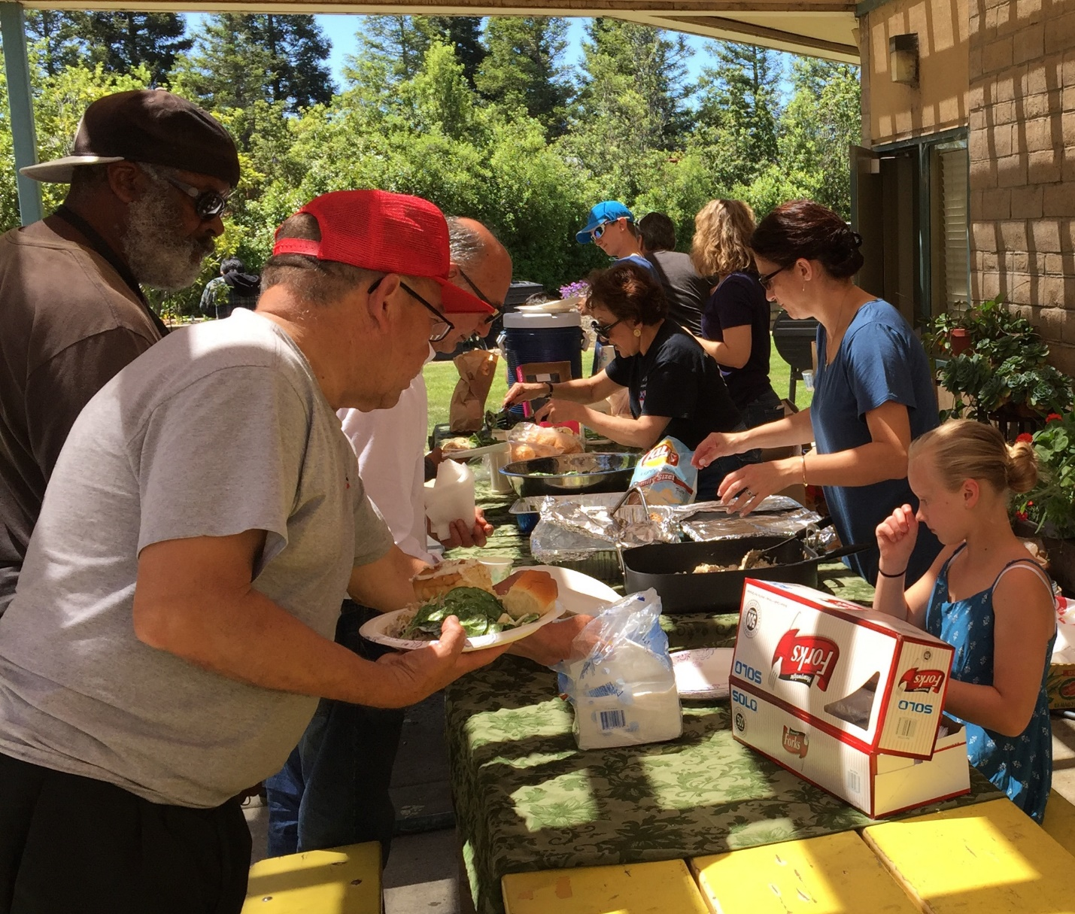

Sandwiches on Sunday (SOS): We served chicken and rice, salad, and bread to 60 people at the Fair Oaks Community Center on April 30th. A Children’s Day festival in the parking lot provided a minor delay, and everyone managed to find their way around the buildings to the back entrance and the picnic table.

Though we prepared enough food for 100 people, an hour later it was all gone, packed in containers that diners took home with their bagged lunches. Thanks go to our servers: Leda Girardi, David McIntyre, Clara Padilla, Rob Richards, Cathy Rincon, Brett Yates, David Yates, Lauren Yates, Susan Yates, and Steve Yuen. The next SOS will be on July 30th, when we will be serving baked lasagna. Please contact Rob Richards (577-8924, rob.richards@tensorlabs.com) if you have any questions.

United Thank Offering: Thanks to everyone who donated to the United Thank Offering during May. Offerings from parishes will be presented at the Diocesan Convention in October. The United Thank Offering has supported the missions of the Episcopal Church since 1889.

Humanitarian Aid to the Diocese of Venezuela: Venezuela was once the most prosperous economy in South America, but a decade of falling oil prices and economic mismanagement has resulted in a humanitarian crisis. The degree of the collapse has been startling. From the Wall Street Journal on May 5, 2017 (https://www.wsj.com/articles/venezuela-is-starving-1493995317):

Hordes of people, many with children in tow, rummage through garbage, an uncommon sight a year ago. People in the countryside pick farms clean at night, stealing everything from fruits hanging on trees to pumpkins on the ground, adding to the misery of farmers hurt by shortages of seed and fertilizer. Looters target food stores. Families padlock their refrigerators.

The government of Venezuela has refused to accept aid from international relief organizations like the Red Cross and WHO. However, assistance may be sent indirectly through Catholic Charities, the Episcopal Church, and other religious organizations. (The Diocese of Venezuela is a member of the Episcopal Church of the United States.)

During the month of June St. Ambrose will be donating to the Diocese of Venezuela. If you would like to add an individual tax-deductible contribution, please make a separate check to St. Ambrose Episcopal Church, designated “Venezuela”, and include it in the Sunday collection or send it to the church office. All donations will be sent to an account through which aid will be transmitted to our sister Diocese. Please direct your questions to Steve Yuen (stevebyuen@aol.com, 341-1966) or Father Ota (dyota@mindspring.com, 574-1369)

Outreach Donations: At its May 7th meeting the Outreach Committee unanimously approved $1,590 in donations, as shown below. The total year-to-date is $4,770, and the Outreach budget for 2017 is $8,500:

Program |  | Approved  Feb 12 | Approved May 7
CALL Primrose – Safeway Gift cards |  | $ 80
Cambodia Academy |  |  | $ 590
Church Divinity School of the Pacific |  | 1,800
El Buen Pastore – Musician |  | 600 | 600
Home and Hope |  | 300
Hope Lutheran Church (Home and Hope supplies) |  | 100
Ombudsman Services of San Mateo County |  |  | 400
Sandwiches on Sunday (St. Pius Church) |  | 300
Total from Outreach Budget |  | $ 3,180 | $ 1,590
Notes on May donations:
- Cambodia Academy – this donation covers the $295 yearly cost of tuition, uniforms, books, food, and transportation for two students.
- El Buen Pastore – this is the second of three $600 installments to the Peninsula’s Spanish-speaking Episcopal ministry.
- Ombudsman (OSSMC)– Diane Robertson is a volunteer and Tippy Irwin has recently retired as Executive Director. OSSMC’s charter is to ensure that long-term elder care facilities comply with health and safety codes. OSSMC receives some government funding, but it is reliant on grants and donations to fulfill its mission.

“Volunteers” - by Rev. Jay Sapaen Watan
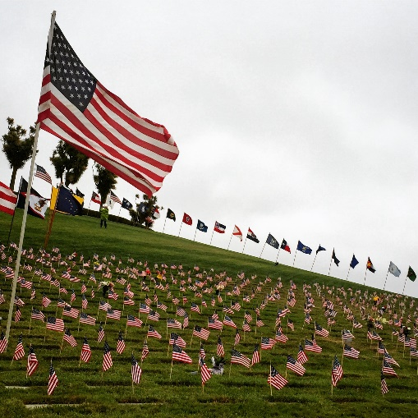

On the morning of Memorial Day – while many people in America prepared for BBQ’s, shopping or were outside somehow celebrating life - my family and I joined a few thousand people at the Golden Gate National Cemetery in San Bruno to honor the lives of the many men and women who served our country so we may live into the freedoms we have. Over 135,000 men and women who served in the United States armed forces, their spouses and children, are interned at this sacred site. A military ceremony evokes connection with God, people, and the communities we serve. There’s a spirituality here rooted in ritual, esprit de corps, hallowed tradition and the stories of those who have gone before us which intersect our present and informs us, in part, to who we are today. And how we honor our fallen speaks to a love unconditional rooted in the deepest sense of agape and sacrifice.

One of the most poignant moments came when Soldiers, Sailors, Airmen, Coasties, and Marines, past and present, were invited to stand and be acknowledged for their service. I saw several elderly veterans wipe away tears as they stood. I wondered what flashback in their story opened the wellspring of emotion. Perhaps they were remembering absent friends? Maybe they were just thankful for life? I do not know. What I do know, as they stood with a quiet dignity, they were not alone. Families and loved ones surrounded them. And we all had each other. Folks who have served in the military come from every segment of society – as diverse as the world we live in - in race, ethnicity, culture, class, gender, orientation, lifestyle, generation, ideology, personality, education, wisdom, experience, religion and spirituality. However, what unites such a diverse set of people comes from working together for a common mission - to serve this nation, make the world a better place, show gratitude by giving back, and to make sacrifices and care for our brothers and sisters so we have a chance to return home.

While the draft of generations ago ensured a common experience for many in this country, today those serve in the military reflect a small community. Nowadays, the U.S. Military – active duty and reserve - is an all-volunteer force that comprises less than 1% of the United States population. The majority serving in our military now comes from 5 states: California, Virginia, Texas, North Carolina, and Georgia. (It’s no coincidence that many of our out top universities are in these states too.) But they are also from U.S. territories: Puerto Rico and American Samoa. As a result, Mike Haynie, director for the Institute for Veterans and Military Families at Syracuse University believes, “We’ve disconnected the consequences of war with the American public.” It is a small group tasked with such a great responsibility. Yet the impact on society is large. There has been so much press made about the struggles of veterans reintegrating into civilian life and the effects of war on their mind, body and spirit. Yet I have also seen many from our military contribute in civilian life as leaders, teachers, coaches, participants and parents in our communities, government, workplaces, and at home.

I know military life is not for everyone. I serve because of the reasons above, to answer a call from God, and because it’s part of my family’s legacy. But it’s not the only way you and I can serve. We all have the potential to be the difference and contribute to something bigger than ourselves for the common good of our nation, for world, and for others.

As I stand with our 9 youth and 1 adult from St. Ambrose who will be confirmed at Grace Cathedral on June 3, 2017 by Bishop Marc Andrus, I am sincerely excited in who they are and what they are getting themselves into. They will be confirmed to Christian faith in the tradition of the Episcopal Church that believes in the unconditional love of God, the Holy Spirit that transforms the heart, and in a Christ who in Jesus invites us to walk in the tender spots of the world. That’s awesome! And I am more than hopeful about the people they will become because I know they will seek how God is connecting them. My late friend, The Rev. Wilson De Ocera, a community organizer and activist from the Philippines and former pastor of Daly City United Methodist Church, would say,” the Church is the largest volunteer community organizing force on earth. We meet 52 times a year (not including Christmas, Holy Week, weddings and funerals)… and we gather in so many places. Who else does that?” Pastor Wilson’s point has always stuck in my heart.

Who else does that? Our Presiding Bishop Michael Curry offers this call for the Episcopal Church to live our faith in action out in the world with Jesus:

“The Church must go where the congregation is… Now is our time to go. To go into the world to share the good news of God and Jesus Christ. To go into the world and help to be agents and instruments of God’s reconciliation. To go into the world, let the world know that there is a God who loves us, a God who will not let us go, and that that love can set us all free.”

The beauty of the Jesus Movement is that we all have something to offer. And while the notion of making sacrifices or selfless service may not sound appealing to the self-serving and ego-centric values of this world… what I do know is that love, joy, real meaning, and a sustainable life is absolutely related to what we are willing to give. We know this world is broken; our Earth needs our help and so do many people hurting. Times today feel bleak and outright cynical. And yet, there is hope… Good News exists to be shared. It’s a love that we can give when we become aware of being a part of something far greater then ourselves. Give to live… and volunteer for life and this Jesus Movement.

Sea Breeze School News- by Jerelyn Weber, Principal

June is here and as the school year begins to wind down we find ourselves amazed with the progress that the children have made and proud of all they have accomplished. This is a time of year filled with mixed emotions among all of us. So many friendships have been made and as many of the children leave us to go on to “big school” we are happy that they are ready to move forward and sad that we will not see them each day. We wish them all the best of luck.

School ends on June 8th for the preschoolers and on June 15th for the After School Program. Summer Camp starts for both programs on Monday June 19th, and all programs are completely full. To make sure the children are prepared for the “big school” and still having fun, our camp this year will follow the S.T.E.M. approach. The children will learn all about Science, Technology, Engineering and Math through their play. We have partnered with Orchard Supply, Home Depot, Hillier Aviation and Google this summer and great things will be happening around your St. Ambrose Sea Breeze School.

Fall enrollment is very strong with only a few openings remaining. If you know of anybody looking for a quality program for their 4 year old, please send them our way quickly. Once again we learned of a great need for After School care in the community. Registration for our program opened in February and we filled all our spots within 72 hours and quickly formed a long waiting list. With this information we decided to request an increase in capacity from the State of California and after going through the process we were approved for 28 additional spaces. We opened those spaces to the families on our waiting list and we now have 86 children enrolled in our afterschool program. This is the largest enrollment this program has seen and we are now preparing to hire additional staff to care for these children!

Our Family Fun Day was held on May 13th in the courtyard and was a huge success. Many thanks to all of you that baked cakes for our ever popular cake walk. We had a total of 17 cakes, brownies and cupcakes, they all looked delicious! We are already planning the event for next year and will be recruiting bakers again!

Many of our teachers will be traveling this summer and we pray that they each have fun and safe travels. If you are traveling this summer, please be safe and enjoy yourself.

Blessings,
Jerelyn Weber

