June

2020

Edition

In This Issue:

Reflections ……..….P 1-2

Announcements…...P 3-4
Desk of Rev.
Karen Swanson……...P 5
Children’s Ministry…..P 6
Outreach……….…..P 7-9
Sea Breeze
School News…….…P 10
Editor’s Corner….....P 11
Birthdays &
Anniversaries…..P 12-13

Editor:
Yvonne Sidell

The Ambrosian

The Monthly Newsletter of St. Ambrose Episcopal Church

900 Edgewater Boulevard, Foster City, California 94404

Individual Highlights:
Inside Story 2
Inside Story 3
Inside Story 4
Inside Story 5
Inside Story 6
Inside Story 7
Last Story 8
Special Interest Articles:

• Add a highlight or your point of interest here.

• Add a highlight or your point of interest here.

• Add a highlight or your point of interest here.

Dear Members and Friends of St. Ambrose Episcopal Church,
Aloha! The news about our common life and worship is that we will continue the virtual worship using YouTube live-streaming until it is safe for all the congregations to return to in-person worship. Although the Governor of California has allowed in-person worship under specific guidelines, Bishop Marc Andrus announced to the clergy and wardens of congregations the policy that in-person worship will resume only when it is safe for all the congregations to do so.

Each congregation is asked to submit to the Diocesan Task Force plans for ensuring that worship can be conducted safely. A Diocesan Task Force is working on a template for all the congregations to create their own guidelines for ensuring the safety of those worshipping. Our task force consists of Alison LeBlanc; David McIntyre, Chair; and Jim Neubert.

In the meantime, we will continue with our YouTube live-streaming worship. The preaching schedule for June will be:

June 7, the Rev. Karen Swanson
June 14, the Rev. David Ota
June 21, the Rt. Rev. Marc Handley Andrus
June 28, the Rev. David Ota

Please join us for worship using this link:
https://www.youtube.com/channel/UCfCRkqxS1Ii-yYov5kMpvDg

This month, we give thanks for Landon Matsuo and Lydia McIntyre who both graduate from San Mateo High School this month. Landon is enrolled at Cal Poly Pomona. Lydia is enrolled at the University of British Columbia, Okanagan. Congratulations to them both!

Reflections from our Rector

Reflections from our Rector (continued)

Also, we will be celebrating Father’s Day with Bishop Marc Andrus’ “visitation.” He will most likely be video-taping his sermon, and hopefully he will join us for our “coffee hour” on June 21. More information will be sent out with the announcements for that Sunday.

I hope to be able to talk with as many of you during the next couple of months. I hope and trust you are well.

Yours,
David Y. Ota, Rector

Announcements

Mark Your Calendars

Mason Jar Mission Sales: Contact the Rev. Karen Swanson to order your jars of bean soup or chocolate chip cookies – Contact the Rev. Karen Swanson at karen.2.swanson@gmail.com or 650-200-8449

Virtual Zoom Bible Study on 1 Thessalonians: Tuesdays, June 2, 9, 16, 23 and 30 at
1:00 p.m. To be invited, contact the Rev. David Ota at dyota@mindspring.com or 650-200-9331

Virtual First Sunday after Pentecost: Trinity Sunday, Liturgy of the Word from the Holy Eucharist: Rite II, Presider and Preacher, the Rev. Karen Swanson: June 7, 10:00 a.m., YouTube link: https://www.youtube.com/channel/UCfCRkqxS1Ii-yYov5kMpvDg

Virtual Zoom Children’s Sunday School, Preschool to 5th Grade: Every Sunday, 10:00 a.m. Join the Zoom Meeting by contacting Fe Balamiento at valentin_fe@yahoo.com or 415-579-8872

Virtual Zoom Coffee Hour: Every Sunday, 11:30 a.m. To be invited, contact the Rev. David Ota at dyota@mindspring.com or 650-200-9331

Virtual Zoom Youth Group Meeting: Every Sunday, 4:00 p.m. To be invited, contact the Rev. Karen Swanson at karen.2.swanson@gmail.com or 650-200-8449

Monday Zoom Bible Study Group: Mondays, June 8 and 22, 7:00 p.m. To be invited, please contact Warren Wong at wwong@nd.edu

Virtual Second Sunday after Pentecost, Liturgy of the Word from the Holy Eucharist: Rite II, Presider, the Rev. Karen Swanson; Preacher, the Rev. David Ota (video); June 14, 10:00 a.m. YouTube link: https://www.youtube.com/channel/UCfCRkqxS1Ii-yYov5kMpvDg

Virtual Zoom School Board Meeting: Tuesday, June 16, 7:00 p.m.

Bishop Marc Andrus’ Visitation to St. Ambrose:
Virtual Third Sunday after Pentecost, Liturgy of the Word from the Holy Eucharist: Rite II, Presider, the Rev. Karen Swanson; Preacher, the Rt. Rev. Marc Handley Andrus, Bishop of the Diocese of California (video): June 21, 10:00 a.m. You Tube link:
https://www.youtube.com/channel/UCfCRkqxS1Ii-yYov5kMpvDg
NOTE: Sign up to Zoom Coffee Hour to visit with Bishop Marc by sending an email to dyota@mindspring.com

Virtual Zoom Youth Inquirer’s Class: Wednesdays, June 24, July 1, 8, 15, 22 & 29, 4 to 6 p.m. To be invited please contact the Rev. Karen Swanson at karen.2.swanson@gmail.com.

Announcements (continued)

Virtual Zoom Buildings and Grounds Meeting: Wednesday, June 24, 6:00 p.m.

Virtual Zoom Vestry Meeting: Wednesday, June 24, 7:00 p.m.

Virtual Fourth Sunday after Pentecost, Liturgy of the Word from the Holy Eucharist: Rite II, Presider, the Rev. Karen Swanson; Preacher, the Rev. David Ota (video):
June 28, 10:00 a.m. You Tube link: https://www.youtube.com/channel/UCfCRkqxS1Ii-yYov5kMpvDg

Diocesan Convention: Friday, October 16, 2:00 to 8:30 p.m. AND Saturday, October 17, 9:00 a.m. to 3:30 p.m., Grace Cathedral

Harvest Festival Dinner: Saturday, October 24, 6:00 p.m. Foster City Recreation Center, Lagoon Room and Blue Bird Room (This may need to be cancelled as an in-person event and re-imagined as a virtual event.)

The Desk of Rev. Karen Swanson - Youth Ministry

Congratulations Graduates!
St. Ambrose is part of the village that has nurtured and guided Lydia McIntyre and Landon Matsuo through childhood to young adulthood. This month they both graduate from high school. Landon will attend Cal Poly in Pomona, California this fall. He hopes to pursue a career in biotechnology. Lydia will be studying applied sciences and aims to become an engineer. She is enrolled at the University of British Columbia at Okanagan.

Both Lydia and Landon preached outstanding senior sermons last fall. Landon has been active in the church since he was born, participating in Sunday School, Vacation Bible School, and the Christmas pageant as a child. More recently, Landon has served as an acolyte and a senior member of the youth group, with a particular interest in reaching out to those in need. He is the son of Kirk and Brenda Jo Matsuo, and the grandson of Dorothy Matsuo and the late Kiyoshi Matsuo.

Lydia’s parents are David McIntyre and Cathy Rincon; her family joined St. Ambrose in 2009. Earlier in her life, Lydia participated in St. Ambrose children’s ministries. In the past year, in addition to participating in youth group, Lydia has taken on leadership roles as the coordinator of the nursery ministry, and as the organizer of the technological aspects of our online worship services.

As a congregation, we have gifted Landon and Lydia with a framed copy of the St. Ambrose blessing: “Life is short and we do not have much time to gladden the hearts of those who walk the way with us. So let us be swift to love and make haste to be kind. The blessing of God: Father, Son, and Holy Spirit be among you always. Amen.” If you would also like to send them a card to add your good wishes, their addresses follow:

Landon Matsuo, 947 Aruba Lane, Foster City, CA 94404
Lydia McIntyre, 141 Shooting Star Isle, Foster City, CA 94404

Thank you for being part of Landon’s and Lydia’s village! Congratulations to the graduates!

Youth Group Meets on ZOOM
St. Ambrose Youth Group gathers for online meetings on Sundays from 4-5 p.m. College youth, high school youth, and middle school youth, including those who have just completed the fifth grade, are all welcome. Each youth group meeting includes talking about the highs and lows of life in the last week, reflection on Scripture, and an activity or game. Please join us for fun and meaning.

Youth Inquirers’ Class
The Youth Inquirers’ class will begin on Wednesday, June 24 and continue through the end of July. Sessions will run from 4-6 p.m. The sessions will focus on experiencing different ways of connecting with God, as well as learning about the Christian faith as understood by Episcopalians. If you are interested, and have not yet signed up, please contact the Rev. Karen Swanson by texting 650-200-8449 or e-mailing karen.2.swanson@gmail.com so that you will receive the ZOOM invitation to the meetings.

CHILDREN’S MINISTRY– by Fe Balamiento

Dear St. Ambrose (please scroll down and read),

This month, I will be reaching out to parents via telephone calls to get more robust input as to what our plans are for Vacation Bible School (VBS). “To VBS or not to VBS? that is the question”. As restrictions and guidelines for faith-based gatherings are being issued, as well as travel recommendations, I am charged with determining what the children's ministry is doing for VBS.

I have looked into resources for virtual VBS and it would consist of three days for a VBS and then possibly a culminating activity on a Sunday. Last summer, they were only three Saint Ambrose children from the ministry who participated. So I want to be sure that there is an interest before VBS is offered. Feel free to reach out to me at valentin_fe@yahoo.com with date, times or ideas that work for you and your children. I look forward to speaking with you.

Thank you,

Fe

June Outreach Report – by Steve Yuen
In the absence of live sports, TV networks have been running championship games from the past, and so will we.

The Foster City Arts and Wine Festival, now known as CityFEST, used to be held every June.
St. Ambrose regularly staffed a booth and sold ice cream to raise funds for the youth mission trip and the Heifer Project.

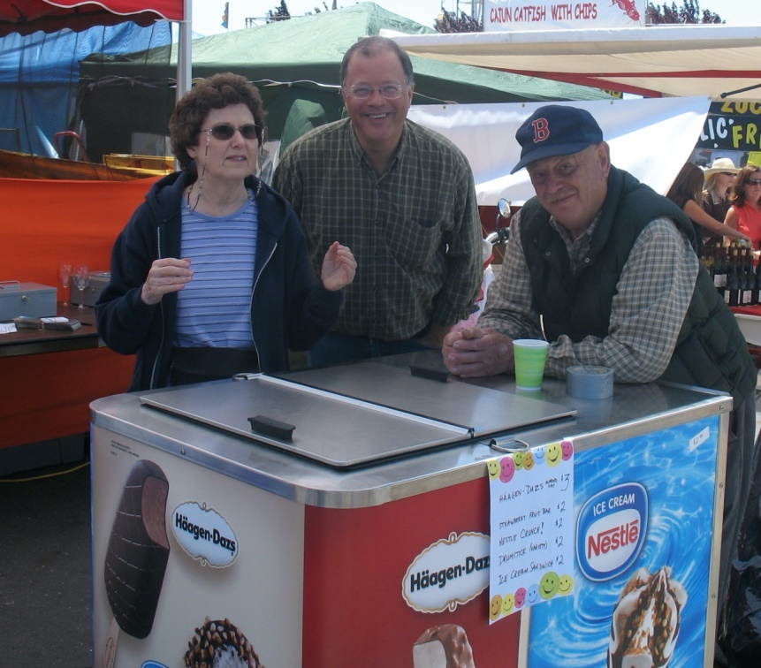
2008: Diane Robertson, Jim Neubert, Fred Holbrook

Our youth group used to visit Foster City elder-care homes (this year visits are cancelled). Residents especially enjoy sharing their life stories with young people.

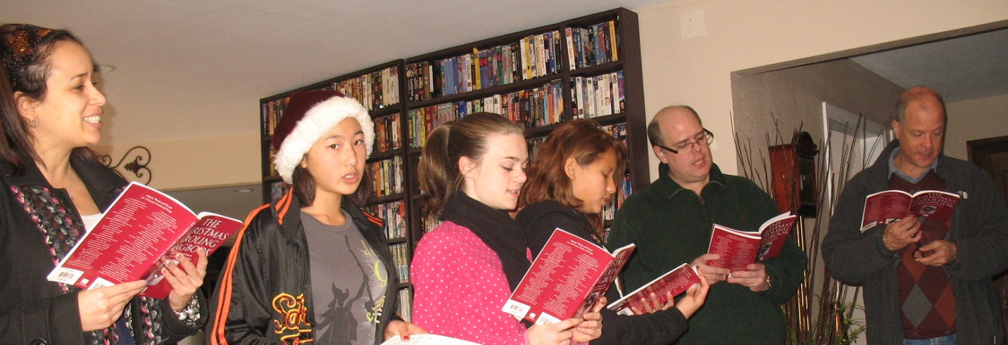
2011: Caroling at a Foster City Elder Care Home

Outreach Report (continued)

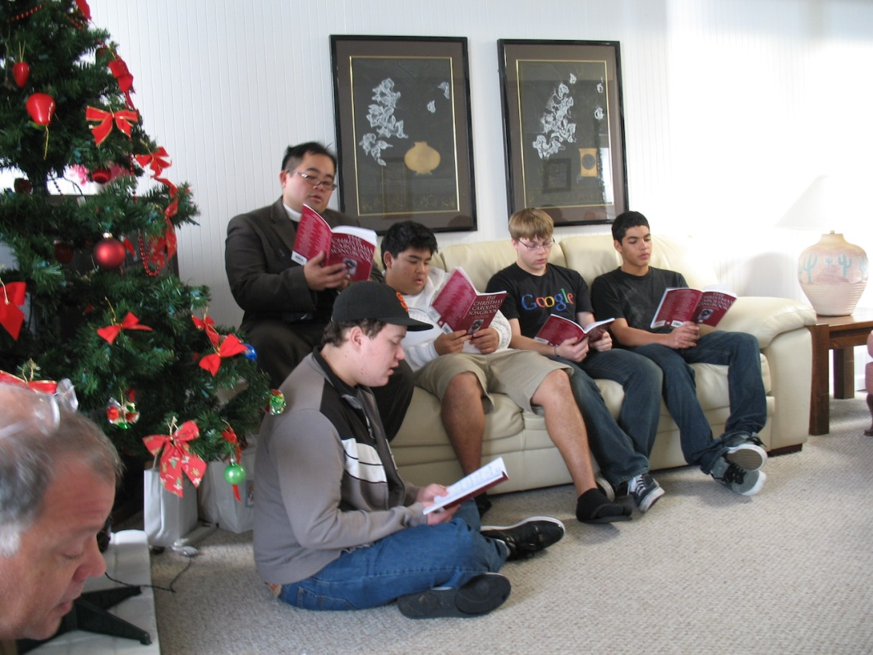
2009: More Caroling

Let’s hope that Outreach activities will resume this year and we can make some new history.

Sea Breeze School News – by Jerelyn Weber, Principal

It is amazing how busy things can be when we are not even on campus these days! The uncertainty of what lies ahead weighs heavily on my mind each day and keeping the teachers centered is a large part of what I do each day.

Zoom Parent meetings were held with individual classrooms during the last week of April and although attendance was not great in some rooms, the information shared and learned enabled us to make changes to some of our sessions to ensure they were valuable to the majority of the children participating. Some of the changes included different times, shorter timeframes, and different or additional content. In general, we heard that the families continue to be grateful for the work that is being done to remain connected to the children and they appreciate our willingness to be flexible in what we are offering.

During the Parent meetings, we announced that we would be adding weekly directed art classes, Bollywood dancing classes and STEAM classes for each age group. All of these classes would be taught by current Sea Breeze teachers and would be offered at the same time each week. Additionally, more sessions with all classroom teachers were going to be offered each day.
Each child in the preschool classrooms would have a minimum of four opportunities to be in a
Zoom session each day, including Music and Sign Language, Yoga and a weekly chapel session.
We would also be posting weekly lesson plans and newsletters for each classroom. The largest and most challenging addition is the creation of our YouTube Channel! Each teacher is responsible for weekly submissions to the channel and the parents can now access the content for their children at any time. There are videos for each learning domain for each age and there are additions each week. It has been difficult, frustrating, fun and successful!

During all of this, we celebrated Teacher Appreciation Week. National Teacher Appreciation week was the first week of the month and some classrooms celebrated their teachers by making videos, sending virtual gift cards, children wearing their teachers favorite colored clothing and a variety of other very creative virtual celebrations. During the second week, the leadership team celebrated the teachers. On Monday, we visited the homes of each teacher to surprise them with a Growing Candle, flowers, a Nothing Bundt Cake and Lotto ticket. This was fun for us and for them. We woke people up, pulled people off of Zoom calls, caught some of them in their “at home best outfits” and worked with some significant others to be sure they would actually be dressed when we arrived! We visited each staff member with the exception of three and surprised each of them. We took pictures and on Friday they were presented with a very nice video presentation of our day! Each day during the week the teachers woke up to (what I thought) an inspiring quote to start their day and remind them that they are important and that their work makes a difference. I think it was a great week.

Continued Blessings,
Jerelyn Weber, Principal

The Editor’s Corner– by Yvonne Sidell

For in six days the LORD made the heavens, the earth, the sea, and everything in them; but on the seventh day he rested. That is why the LORD blessed the Sabbath day and set it apart as holy.
–Exodus 20:11
It seems as though almost daily I hear about the pandemic in the news and how we as people are growing tired and burnt out. In addition, there is so much about other life issues that it is equally exhausting and it goes on and on. I know…it’s real and it’s ugly.
Many people don’t even slow down enough to be faithful to God’s call for Sabbath, which simply means, to rest. I received some great advice early on from a mentor who urged me to faithfully guard and protect that day of rest. My mentor was right! Without intentional action, it’s simply too easy to slip into justifying non-Sabbath actions.
I wonder if many Christians have little clue about what the Sabbath is or how it is observed. Certainly among Christians, there are many different views and practices of the Sabbath. There’s no doubt that it can get confusing.
I also understand that the Sabbath doesn’t come in a one-size-fits-all experience, but for what it’s worth, here’s one approach:
Relaxation – Take it easy, sleep in and don’t fill the day with a lot of activities. Try to maintain an attitude of rest throughout the day.
Recreation – Feel better and accelerate rest after some form of exercise. It may be at the gym (once they open again), but it’s usually a long walk or hike with a friend or neighbor.
Relationships – Choose to spend time with someone (virtually to be safe) on Sabbath, it is a relationship that inspires, breathes into the heart and is rewarding. No work, just friendship.
Reading – For Sabbath, choose light and fun reading.
Reflection/Restoration – Reflection describes extended time with God. Try to reflect on the past week, look through your calendar and think about what you might have missed that God had laid out for you. A busy week doesn’t allow the reflection you really want or need. Restoration describes personal soul-care. It’s time for worship, prayer, silence, Bible, and journaling.
There is no usual order to these areas. Try to experience them all throughout the day while being safe during the pandemic.

