In this Issue:

Reflections (cont) …...P 2

Announcements......P 2-3

Your final plan
form…………….….. P4-8

Outreach Report..…...P 9

“Stop Kicking Your
Own A__………... P10-11

Sea Breeze School News………….….….P 12

Children and Family Ministry ….….….….P 12

El Buen Pastor, Iglesia
Episcopal ………. P13-14

Interim Editor:
CD & S. Rowsell

The Ambrosian

The Monthly Newsletter of St. Ambrose Episcopal Church

900 Edgewater Blvd, Foster City, California 94404

March

2015

Edition

Individual Highlights:
Inside Story 2
Inside Story 3
Inside Story 4
Inside Story 5
Inside Story 6
Inside Story 7
Last Story 8
Special Interest Articles:

• Add a highlight or your point of interest here.

• Add a highlight or your point of interest here.

• Add a highlight or your point of interest here.

Dear Members and Friends of St. Ambrose Episcopal Church,

Aloha! As we enter the month of March, we will be in the midst of our Season of Lent and heading towards Holy Week which begins on Palm Sunday, March 29th. Our Lenten program this year is based on the “Hidden Power of the Gospels” and had a good beginning last month. The premise of this book is that the four gospels were ordered in sequence to reflect the spiritual journey people make when they turn their lives over to God in Jesus the Christ. In the following weeks we will be looking at each gospel account from this perspective and learn about the different practices associated with each stage of the spiritual journey:
- Sunday, March 1st: The Gospel of Matthew, How do we face change?
- Sunday, March 8th: The Gospel of Mark, How do we move through suffering?
- Sunday, March 15th: The Gospel of John, How do we receive joy?
- Sunday, March 22nd: The Gospel of Luke, How do we mature in faith?
The Lenten program begins at 11:45 a.m. and be preceded by a simple Lenten lunch beginning at 11:15 a.m.
On another note, the Vestry and I have resolved to “commit ourselves to this year’s priority of growing the membership, particularly in the area of families with school-age children and becoming better known in the Foster City community.” We are concerned that the numbers of families with school-age children have been declining both in membership and participation. We affirm that St. Ambrose has since its inception value children as part of our community.
The Vestry and I will need your help as we evaluate how we are serving families with school-age children, and will be seeking your input about how we may better reach out to families with children and serve the ones who are already a part of our community.
After we receive input from members about what they value and what they are willing and able to do, we will come up with a plan of action to address this concern. There may be changes in the way we seek to reach out and serve families with children, and hopefully we will be able

Reflections from our Rector

Rector’s reflections continued…
to come up with a plan by June.
In regards to becoming “better known in the Foster City community” we plan to participate in this year’s Art and Wine Festival on Saturday, May 30th and Sunday, May 31st to be present in the community to provide information about both St. Ambrose Episcopal Church and Sea Breeze School. I am grateful to David McIntyre who has taken the lead in initiating this effort.
This year’s Lenten program on the spiritual journey is timely as we consider how we may strengthen the ministry to families with school-age children. We will have to ask the questions, “How do we face change?” “How will we move through resistance? As any change even though well intentioned will have resistance. How will we receive the joy of having new families? How will we continue to grow and mature in our faith?
The practices recommended for these phases of the spiritual journey include creating balance between safety and risk, naming our saints and prophets, attentive listening to disparate voices, holding the different perspectives in tension, seek to be deepened, be open to inspiration, expose dualistic thinking, speak truth and unity, open and engage the truths of beauty, find the quiet center, absorb the deeper rhythms, expand into risk, learn to let go, build the way of peace, and make the great leap of trust.
At the heart of things our journey as Christians is to grow more and more into God’s vision for us as lived by Jesus the Christ to be in love with our God and God’s own creation. During the rest of the Season of Lent we are given the opportunity to pause to reflect on the way we have lived our spiritual journey and to seek to progress in becoming more loving.

Yours,

David Ota, Rector

Thanks
Thanks to Jill Schwab, Charlene Adolph and Valerie Mersh who organized the Mardi Gras Luncheon Party on Sunday, February 22nd. Thanks to Fe Valentin who organized games for the event. Thanks to everyone who brought extra food for the party.
Thanks to the Altar Guild who prepared our chapel for worship during the Season of Lent.

Daylight Savings Time
Remember to turn your clocks one hour ahead before you go to sleep on Saturday, March 7th, as Daylight Savings Time begins on Sunday, March 8th at 2:00 a.m.

Bible Studies in March
The Monday Bible Study group continues to study the Hidden Power of the Gospels on Mondays, March 2nd, 9th, 16th, 23rd, and 30th from 12:45 p.m. to 2:00 p.m. in the home of Merilyn Vosburg. This Bible Study is led by the Rector.
The Tuesday evening Bible Study group meets on March 3rd and 17th in the home Warren and Nellie Wong at 7:00 p.m. They are studying the Gospel according to Luke.
The Wednesday evening Bible Study group meets on March 11th and 25th in the foyer of the church at 7:30 p.m. They are studying the Book of Revelation.
Each of the Bible Study groups is open and newcomers are invited to join.

Mark Your Calendars
- Lenten Lunches and Lenten Program: Sundays, March 1st, 8th, 15th, and 22nd, Parish Hall
- Children and Family Ministry Parents’ meeting: Sunday, March 1st, 11:15 a.m., Parish Hall
- Daylight Savings Time: Sunday, March 8th
- Youth Service Project: Monday, March 30th, 9:00 a.m., Bayview Mission
- S.F. Giant game with the Diamondbacks: Friday, April 17th, 7:15 pm, Fireworks Night
- S.F. Giant game with the Braves: Friday, May 29th, 7:15 pm, 7:15 pm, Orange Mustache Night
- Foster City Art and Wine Festival booth: Saturday, May 30th and Sunday, May 31st, times to be determined

Holy Week and Easter Day at St. Ambrose
- March 29th, the Sunday of the Passion: Palm Sunday at 8:00 a.m. and 10:00 a.m.
- April 2nd, Maundy Thursday at 7:30 p.m.
- April 3rd, Good Friday at 12:10 p.m. and 7:30 p.m.
- April 4th, the Great Vigil of Easter at 8:00 p.m.
- April 5th, the Day of the Resurrection, Easter Sunday, 8:00 a.m. and 10:00 a.m., Easter Egg following the 10:00 a.m. worship service

S.F. Giants game in April
We still have tickets for the Friday, April 17th: the Giants and Arizona Diamondbacks game at 7:15 pm. The cost of these tickets is $19 for adults and $9 for children or youth. The seats are in View Reserve Section 325, rows 6 through 9. This is a Fireworks Night. If you are interested in going, please speak with Father Ota, or send him an e-mail at dyota@mindspring.com.

Time to review your final plans
The Season of Lent is a good time to review your final plans in regards to your will and instructions for Burial. We often delay looking at what is needed at the end of life, but it is a blessing to those we leave behind that we put our affairs in order. It is also helpful to consider having a durable power of attorney for loved ones who may be approaching a time when they will need assistance from a family member or trusted friend. Below you will find “Final Directions and Instructions upon the death of” as created by the Diocese of California Gift Planning Department.

Final Directions and Instructions upon the death of:
Name | Date

File this information where it will be found easily upon your death. It is suggested that you file this with your local church or your attorney, and notify your heirs that this form has been completed for their information.
Name (Complete) ______________________  Address______________________________  Birthdate_____________________________  Place of Birth ________________________  Baptism Date _________________________ | Spouse’s Name ________________________  Address____________________________  Birthdate___________________________  Place of Birth________________________  Baptism Date________________________
Father’s Full Name____________________ Birthdate/Place_____________
Living __Yes __No
Mother’s Full Name___________________ Birthdate/Place_____________
Living __Yes __No
Names, addresses, and phone numbers of living brothers and sisters:
- _____________________________________________________________
- _____________________________________________________________
- _____________________________________________________________
Names, addresses, and phone numbers of persons to notify upon my death:
- _____________________________________________________________
- _____________________________________________________________
- _____________________________________________________________
- _____________________________________________________________
- _____________________________________________________________
Occupation: __________________________ Employer: ________________
Social Security Number: __________________
Last Will/Trust Executed dated: ______________
Will/Trust is located at: _________________
Representative’s name and address: ____________________________________________________________________________________________________________________________________________________
Bank Accounts/Savings Institution Account/Other Income Producing Accounts:
Name of Institution | Type | Account Number
1
2
3
4
5
Safe Deposit Box Number & Location: _____________________________________________
Location of Safe Deposit Box Key: ____________________________________________________________________________________________________________________________________________________
Investment counselor or banker’s name and address: ____________________________________________________________________________________________________________________________________________________
Insurance agent’s name and address: ____________________________________________________________________________________________________________________________________________________
Life Insurance
Company | Type | Amount | Certificate # | Beneficiary
1
2
3
4
Insurance policies are located at: __________________________________________________________________________

Credit Cards and Charge Accounts:
Company | Address | Account #

INSTRUCTIONS FOR BURIAL
“The liturgy for the dead is an Easter liturgy. It finds all its meaning in the resurrection. Because Jesus was raised from the dead, we, too, shall be raised.
The liturgy, therefore, is characterized by joy, in the certainty that ‘neither death, nor life, nor angels, nor principalities, nor things present, nothings to come, nor powers, nor height, nor depth, nor anything else in all creation, will be able to separate us from the love of God in Christ Jesus our Lord.’
This joy, however, does not make human grief unchristian. The very love we have for each other in Christ brings deep sorrow when we are parted by death. Jesus himself wept at the grave of his friend. So, while we rejoice that one we love has entered into the nearer presence of our Lord, we sorrow in sympathy with those who mourn.” The Book of Common Prayer, page 507.
(When possible, it is suggested that you fill out the following in consultation with your clergy.)
“The death of a member of the Church should be reported as soon as possible to, and arrangements for the funeral should be made in consultation with, the Minister of the Congregation.” The Book of Common Prayer, page 490.
Circumstances permitting, I wish my Burial Service to take place at:
_____________________________________________________________________________________ Church
Address: ________________________________________________ City: _______________________
Celebrant: _________________________________________________________________________________
“Baptized Christians are properly buried from the church. The service should be held at a time when the congregation has the opportunity to be present.” The Book of Common Prayer, page 490.
The service shall be “The Burial of the Dead” from The Book of Common Prayer: __Rite I or __Rite II
__ I request the Burial Office only be read.
__ I request the Burial Office and Eucharist be done.
Suggested Pall Bearers: _____________________________________________________________________________________________________________________________________________________________________________________________________________________________________________________________________
If possible, I would like to have the following Psalms and Lessons: (for suggestions, see The Book of Common Prayer, pages 494 ff.) ______________________________________________________________________________________________________________________________________________________________________________
I would especially like the following hymns: ______________________________________________________________________________________________________________________________________________________________________________
“The coffin is to be closed before the service, and it remains closed thereafter. It is appropriate that it be covered with a pall or other suitable covering.”
Note: Some parishes permit the use of a pall only, within the church building.

Memorials may be made to: ______________________________________________________________________________________________________________________________________________________________________________
I prefer to be: __ Buried or __Cremated
Ashes at Memorial Service: ___Yes or ___No
__ Before or __After the Funeral
Disposal of Ashes _______________________________________________________________________________________
Location of cemetery lot deed, crypt deed, columbarium contract:
_______________________________________________________________________________________
I have made arrangements to have certain parts or all of my body donated to: _______________________________________________________________________________________
Funeral Home to use: _______________________________________________________________________________________
Coffin Specifications: __ Least expensive __ Mid range __ Elaborate
I __do __do not wish to have my coffin open at the funeral home.
Other information for my survivors: ______________________________________________________________________________________________________________________________________________________________________________________________________________________________________________________________________________________________________________________________________________________________________________________________________________________________________________________________________________________________________________________________________________________________________________________________________________________________________________________________________________________________________________________________________________________________________________________________________________________________________________________________________________________________________
Signature Date

This guide was prepared by the Episcopal Diocese of California to encourage thoughtful estate planning and funeral preparation. For additional copies or for information on how to remember your parish, mission, or diocese in your will, contact:

Amanda Kieran,
Planned Giving Officer
Episcopal Diocese of California
1055 Taylor Street
San Francisco CA 94108
415 869 7812
amandak@dioCal.org

Outreach Report - by Steve Yuen
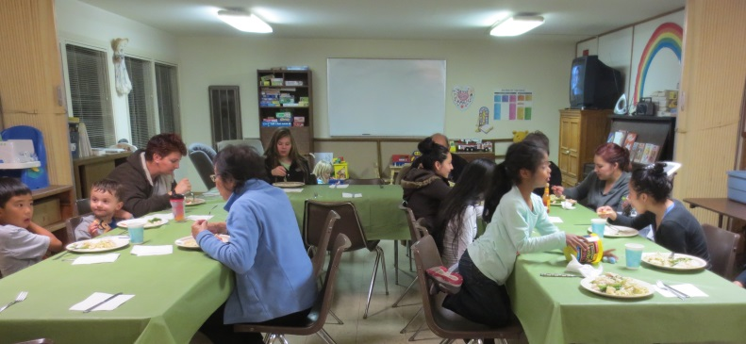
Home and Hope: Our usual chef, Diane Robertson, was away on vacation but there was no need to be concerned. On January 27th St. Ambrose sent a cheerful crew of volunteers to serve dinner to the families of Home and Hope.
Nellie Wong, Warren Wong, Clara Padilla, David Ota, David Yates, Irene Stead, and Steve Yuen prepared dishes for 20 people (themselves included—volunteers dine with the guests) at Hope Evangelical Lutheran Church on January 27th.
Home and Hope (http://homeandhope.net/) is a group of 30 churches and synagogues on the Peninsula who give emergency shelter for up to four families at a time. (Families can lose their housing suddenly because of family breakup, loss of a job, death of a breadwinner, etc.) About half the congregations have sleeping and bathroom facilities—nothing luxurious, guests sleep on cots or sleeping bags—but those accommodations are better than living out of one’s car. The smaller churches like St. Ambrose prepare dinner to take some of the burden off the host parishes.
Our next hosting is on Tuesday, March 24th. Steve Yuen has posted a sign-up sheet in the Parish Hall. If you would like to volunteer to make a dish, serve and clean up, or have any questions, please contact Steve (341-1966, stevebyuen@aol.com).

Sandwiches on Sunday: We will be serving a hot lunch of lasagna, accompanied by salad and bread, to 60-100 people in Redwood City on Sunday, March 29th. If you can make a dish (it is not necessary to be a lunch server—although we would appreciate the help), please sign up on the sheet posted in the Parish Hall. If you have questions, please contact Rob Richards (577-8924, rob.richards@tensorlabs.com).

CALL Primrose- Four (4) Food Boxes: St. Ambrose will deliver four boxes of food to families who are clients of CALL Primrose (http://www.callprimrose.org/), a Burlingame outreach venture founded by the Presbyterian and United Methodist churches. If you can contribute food items, please check them off the lists stapled on each box and bring them to the Parish Hall by Tuesday, March 17th.
Each box will contain: 1 package of pasta, 1 box of instant mashed potatoes, 1 muffin or bread mix, 1 box of macaroni and cheese, 1 can of green vegetables (low sodium preferred), 1 can of corn (low sodium preferred), 2 cans fruit (low sugar preferred), 1 can of soup, 1 can of tomatoes (no glass please), 1 bag of brown or white rice, 2 cans of beans (refried, kidney, black, etc.), and 1 small bottle of cooking oil (plastic only).
Thank you for helping to make the Easter season more joyful for some of our neighbors. If you have questions, please contact Steve Yuen (stevebyuen@aol.com, 341-1966).

“Stop Kicking Your Own A__“ – by Rev. Jay Sapaen Watan
At a local martial arts studio, I saw a sign that was hard to forget, it said, “It is easier to raise strong children, than to fix broken adults.” It was profound to me to wonder how many of us grow up with a negative self-image of who we are. It seems that there are many of us who struggle with loving the one they see in the mirror. And I know there are many who truly feel beat up by life. The brokenness of hurt, trauma and sin in our culture is often followed by the disempowerment and hopelessness that comes with victimhood, self-hatred, guilt or shame. The symptoms of this brokenness are further reflected in addiction, depression, and family dysfunction. Yet I find that many of our brothers and sisters struggle to find healing in a nation and society that values self-reliance and independence.
Henry David Thoreau once said, “To affect the quality of the day that is the highest of arts.” One of the most influential thinkers in American history, Thoreau believed in the inherent goodness of people and nature. He also believed in the simplicity of living and that a self-actualized individual is at core of true community. When I was first introduced to his literary works in high school, I couldn’t understand his call for harmony, self-sufficiency, simplicity, and independence. His thinking seemed counterintuitive to me at the time. Growing up in a large extended Filipino American family I questioned how this sort of mindset of separation could help people find harmony if the goal was connectivity. Where is the family, community and our sources of support? What I didn’t realize was that my own internal junk and ethnocentrism that was getting in the way of listening. God has a way of sharing wisdom so we may figure out an answer. For me Thoreau began to make more sense when people stopped saying to me, “You can be anything you want when you grow up,” and started asking, “What do you want to do in life?” And while that kind of question was at one point a source of anxiety, I learned that living into love was a lot more helpful than acting out of fear. And that love isn’t about how you feel, but rather what you’re willing to give. So if you know who you are, you also know what you can give.
It’s interesting to me that Thoreau’s quest for harmony and independence was not in conflict with this connection with the Holy. Apparently, when his aunt Louisa asked him in his last days if he had made his peace with God, Thoreau responded: "I did not know we had ever quarreled." Staying in harmony with nature is certainly related to our choice to live into love. Love is who God created us to be.
My brother loves the martial arts and he has been practicing one particular form of it for almost a decade, it is known as I Liq Chuan. It is a Chinese martial art originally developed to protect nomadic people from dangers of life on the road and it was passed down only to family members. The co-founder of I Liq Chuan is, Sifu Sam Chin. And over 25 years, Sifu Sam developed the base art from a fighting skill into its present understanding as a “Martial Art of Awareness.” I Liq Chuan applies the self-actuation of mind, body, and spirit using our body's natural structure in powerful and grounded movements to express one’s intention while incorporating the Zen principles of flow, balance, and harmony. In a world where there are many of our brothers and sisters acting out of balance and harmony, it seems the life can really kick our behinds. Yet I also feel that much of our own brokenness is created when we fight with our natural selves. Sifu Sam recently said in a seminar a point of thought that goes beyond the martial arts, but to life:
"We should kick ass, so why do we want to train harmony and balance? Martial arts is not only for fighting… martial arts - Kung Fu, is about cultivation. Therefore it consists of health, martial, and mental / spiritual to understand ‘who you are’. In other words, to have balance and harmony, to be HAPPY. You want to be a happy person. I’m a happy person versus I’m an angry person is different. If I’m a happy person, you are along with nature. Practically speaking, nature has no freedom. If you’re not with nature, you’re against nature. If you’re not with nature, it kicks your ass. That means you kick your own ass. So you train balance and harmony and you still can kick ass."
While I personally have not studied I Liq Chuan, nor do I think martial arts is the only way to healing, harmony and balance, I have studied Tae Kwan Do and Brazilian Jiu Jitsu in my lifetime to know that how one feels inside is connected with what one is doing on the outside.
The belief that faith is a private matter and the modern day attitude of mistrust and cynicism of family and community may not be helping you and I to create the goodness, warmth and fulfillment that we all need in our lives. It is easy to remain stuck in the things we are used to. It seems to me that we put a whole lot of energy into not feeling good about our lives rather than looking for what is right in the world. Why keep beating yourself up? In this season of Lent we are giving the opportunity to repent, be connected, and to redefine how we are in this world.
The healthy response to any sort of separation is human connection. We also know this response as love! Giving love to the one we see in the mirror is as important as loving God, our neighbors, and all creation. As the text of 1 John 4:8 reminds us, “Whoever does not love does not know God, for God is love.” Our challenge is finding and creating love in the places we are called to be. God made us from love, for love… and how we affect the quality of the day for others is one of the highest arts.

Sea Breeze School News
It is a very busy time of year for us and we are all moving very quickly. Registration for Summer and Fall classes opened on February 4th and spaces are filling up quickly. While some of our most popular classes have been filled, there are still some spaces available. If you have children, or know others that have children and are looking for a quality school, please come visit. The office is open 8am – 4pm and Wendy is always happy to help enroll children.
On March 3rd we will be hosting our Annual Open House, Scholastic Book Fair and Bake Sale. We will welcome all currently enrolled families from 6:15pm – 7:00pm and anyone that is not currently enrolled in our school, and would like to learn more about us, can join us from 7:00pm – 8:00pm. We love to meet new families and share our school with them. Please feel free to join us that night and visit our classrooms, the book fair and the bake sale. The funds we raise from the Book Fair and the Bake Sale will help us add technology to the classrooms.
Our classrooms have all received an “Extreme Classroom Makeover” and the children, families and teachers are excited about their new environments. Each room received new cubbies, tables, chairs and shelving; the rooms look fantastic. We are also beginning to introduce a new curriculum component with the Handwriting Without Tears program. This is a very hands on, research based writing program and we are excited to be able to offer this to the children at Sea Breeze.
While the teachers are excited about their new environments and the new curriculum, they are all anxiously awaiting the arrival of Spring Break! Spring Break is scheduled for March 30 – April 6. During this break time, the long awaited sprinkler system installation is scheduled to be completed and all of the classrooms will have Air Conditioning installed. To help ensure the safety of the children during the school day, all classroom doors must remain locked; therefore the classrooms tend to get very hot during the warmer days in Foster City. To assist in making the learning environments as comfortable as possible, the Buildings and Grounds Committee has spent many hours securing bids and confirming a contract to get this work done. WE are very grateful for the work that is being done.
Wishing you many Easter Blessings.

Children and Family ministry– by Fe Valentin
As we approach the end of winter and prepare for spring, our minds shift to Lenten preparation. What will be our focus? How can we grow? Mardi Gras may serve to remind us of the treats we can reserve for festival days. Perhaps we wore colors to show our outward bliss; at our Mardi Gras celebration I learned the colors are of the church calendar. The children had a chance that Sunday to play with streamers, masks and balloons. There was ample food and drink, including King's cakes. We at St. Ambrose did let the good times roll. The upcoming meeting is on Sunday March 1st, after the service. The children and family ministry will meet to discuss future events and ideas. As inner spiritual growth is incubating, I look to the group for guidance and direction.

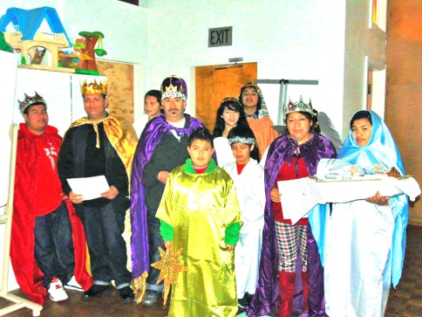
El Buen Pastor, Iglesia Episcopal – by Madre Anna
V. God is good,
R. all the time!
V. All the time,
R. God is good!
I learned this verse and response at St. Augustine’s, Oakland. And it has filled me and moved me ever since.
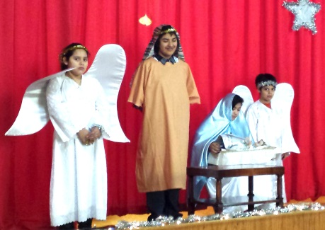
First, thank you for providing for worship music during 2014, and for your commitment to do so in 2015. Live music provides us with a critical element in worship. Especially for newcomers, it expresses welcome, joy, and adoration of our Lord Jesus Christ.
We remembered you particularly at Epiphany, a full year from the time that you joined us in beginning our ministry in this new place, Messiah Lutheran Church. I remember sending you photos. You may not show up in this year’s pictures; but we certainly had you present in our hearts.
Our new location, with Messiah Lutheran Church, continues to be a blessing, as does our relationship with the Evangelical Lutheran Church of America (ELCA) to which it belongs. I just participated in a Missioner’s Training sponsored by the Latino/Hispanic ministries of both the Episcopal Church and ELCA, who more and more are doing things together. The program focused on church planting and congregational development. We each committed to making a 6-month plan. We’ll report regularly to our small group, and then have another plenary in September in Nashville to report on how we’re doing on the plan and to make a new one. Latino ministry and the context that church members experience move so very fast that they’ve determined that we need long-term vision and medium-term plans. The attendees included Latinos and non-Latinos, who spoke one or both English/Spanish, who have already gotten involved in Latino ministry and/or are thinking about it, and who occupy different positions in church hierarchy – a diverse gathering sharing an abundance of experience and insight. We have a Consejo (vestry-like gathering of EBP leaders) tomorrow, and we’ll begin working on the plan.
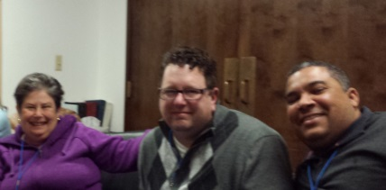
The following pictures are, left to right, with:
Myself (Madre Anna)
The Very Rev. Tom Callard, Dean, Christ Church Cathedral, Springfield, IL
The Rev. Ramón Ubiera Torres, Latino/Hispanic Missioner, Diocese of New Jersey

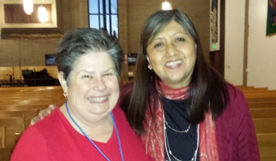
With The Rev. Maria Paiva, Dir.
For Evangelical Mission (DEM), Southwest California Synod, ELCA

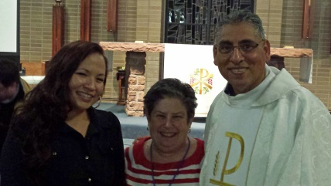

With Ms. Sarah Eagle Heart and the Rev. Anthony Guillen, Episcopal Missioners for Native American and Latino/Hispanic
Ministries of the Episcopal Church
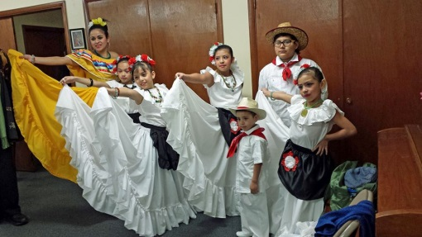
Send-off at the end of the Training from the children at St. Mark’s.

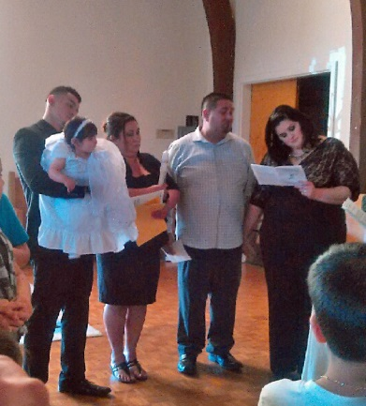
We celebrated Candlemas and the Baptism of Isaura Magaña-Mendoza (below) using many of the candles that you gave us. We didn’t burn anything down, but we certainly had the worship space alight. The good news is that we married Isaura’s parents, Juan and Lucero, in July of 2013! We’ll confirm their nephew this year. Rocío Cortez, who came to EBP many years ago for her Quinceañera, first Communion, and the baptism of her babies, has now brought her nieces for their confirmation. We’ve become a multi-generational congregation (grandparent, who immigrated here, and their children and grandchildren who were born here) with different ages and different levels of Spanish. The three candidates for Confirmation are predominantly English-speaking. Follow-up with succeeding generations presents a huge challenge, and is requiring serious planning, within El Buen Pastor and at many levels in the ELCA and the Episcopal Church.
I’ll bet that you want to see the numbers. Because we are made up of extended families, it seems to be feast or famine. Our attendance is bi-modal: approximately 9-12 or 30 - 40 on a given Sunday, depending on which families show up. Nevertheless, because of the newcomers and the people who have deepened their commitment to Christ and to his church, I am optimistic. Also, you should know that the signage that St. Ambrose has purchased for us with your grant, is working great at attracting newcomers. We are working with Messiah to keep our signage up for the whole week, rather than taking it down after our service. We have made signage that I think they will be comfortable with our leaving up; and that will show the neighborhood that we’re not just passing through. This will be especially important since St. Pius, the Roman Catholic Church next door, started a Mass in Spanish over the summer. We are all friends; and I pray that our working side-by-side in Latino ministry (albeit with a tad of competitive spirit – can’t help it) will be a blessing for the entire community.
The biggest news at the last! The Diocese has told us that they want us to become a full-fledged mission. The Consejo and I are working to find out what that entails and how to make it happen. The goal is for the upcoming Diocesan Convention in October. Please keep us in your prayers, that EBP can fulfill its potential in mission and ministry.

May you experience a holy Lent.

