In this Issue:

Reflections (cont) …...P 2

Announcements......P 2-3

Outreach Report …….P 4

Try a Little Tenderness….....….P 5-6

Sea Breeze School News………….….…...P 6

Interim Editor:
CD & S. Rowsell
The Ambrosian
The Monthly Newsletter of St. Ambrose Episcopal Church
900 Edgewater Blvd, Foster City, California 94404



May

2015

Edition

Dear Members and Friends of St. Ambrose Episcopal Church,

Aloha! For the past two months the Vestry and I have been considering how we might strengthen our ministry to families with children and youth. We are fortunate to have both a Youth Minister and a Coordinator for Children and Family Ministry along with volunteer Sunday School teachers to work with the youth and children. However, as you all may realize there are many competing activities for the attention of families with children and youth. We have noticed a decline in the number of children participating in Sunday School and in our Children and Family Ministry events. Fortunately, we have had pretty consistent participation for the Youth Sunday School as many of our children have now grown into Middle School youth.

We gathered information by conducting a survey, put up poster board with a summary of questions asking for feed-back and held a Town Hall Meeting on April 19th. The good news is that we have seven volunteers who are willing to teach Sunday School in the fall which means we will be able to continue our regular Sunday schedule of the 8 a.m. Holy Eucharist and 10 a.m. Holy Eucharist and Sunday School. Shelley Keefe will continue to teach the Summer Sunday class and can use helpers.

We also decided to experiment to have an evening Holy Eucharist at 5:30 p.m. either on Saturday or Sunday twice a month. We decided to do this to provide an opportunity for worship and fellowship for those who from time to time have other commitments on Sunday mornings.

You may wonder why we are taking such steps. The answer for me is found in the service for Holy Baptism found on page 303 in the Book of Common Prayer:

“Will you who witness these vows do all in your power to support these persons in their life in Christ?”
People We will.”
I believe one of the most important ministries a congregation can provide is the nurture of children and youth in the knowledge and love of our Lord Jesus Christ. Of course, this happens on many different levels with
.

Reflections from our Rector

Rector’s reflections continued…

the parents passing down and modeling what it means to be a faithful Christian, to learning the stories of the faith and applying them to our lives, to worshipping and praying for the guidance of the Holy Spirit, and to live our lives in loving service.

I invite you to pray for our ministry to families with children and youth so that we may support them in their life in Christ and be a blessing to them.

Yours,

David Ota, Rector

Thanks
Thanks to everyone who brought plastic eggs and candies for our Easter Egg Hunt.

The Administrative Assistant will be on vacation
Gina Perez, our administrative assistant will be on vacation from Monday, May 11th through Friday, May 15th.

The Rector will be on vacation
The Rector will be on vacation from Wednesday, May 6th through Wednesday, May 13th. He will return to the office on Thursday, May 14th. He and his wife will be going to Honolulu to celebrate the graduation of their son Paul from Chaminade University.

Study Groups in May
The Monday Bible Study group continues to study the Hidden Power of the Gospels on Mondays, May 4th and 18th from 12:45 to 2:00 p.m. in the home of Merilyn Vosburg. This Book Study is led by the Rector.

The Tuesday evening Bible Study group meets on May 5th and 19th in the home Warren and Nellie Wong at 7:00 p.m. They are studying the Gospel according to Luke.

The Wednesday evening Bible Study group meets on May 20th in the foyer of the church at 7:30 p.m. They are reading the Acts of the Apostles.

Each of the Bible Study groups is open and newcomers are invited to join.

S.F. Giants game in May
Members of St. Ambrose will be attending the Giants and Atlanta Braves game on Friday, May 29th at 7:15 pm. The cost of the tickets is $22 for adults and $12 for children and youth. Tickets are still available. If you are interested in going, please speak with Father Ota, or send him an e-mail at dyota@mindspring.com.
The Day of Pentecost
The Day of Pentecost this year is Sunday, May 24th. It is the day we celebrate the gift of the Holy Spirit to the apostles gathered in Jerusalem, and is commonly understood to be the birthday of the Church. Before the empowering by the Holy Spirit, the apostles have not yet started their mission of the church to proclaim the Good News of Jesus the Christ in the power of the Resurrection. The color of the day is red for the Holy Spirit indicating the fire and passion that the Spirit brings. Wear red on this day in celebration of the Holy Spirit.

Volunteers needed for the Art and Wine Festival
St. Ambrose Church and Sea Breeze School will have an informational booth at the Art and Wine Festival. Volunteers are needed on Saturday, May 30th and Sunday, May 31st to pass out information and answer questions about our community. Volunteers will be given T-Shirts to wear. A volunteer sign-up sheet is posted in the Parish Hall. For more information you can contact David McIntyre at ntkod@sbcglobal.net or you can contact the Rector at dyota@mindspring.com or call the church office at 650 574-1369.

Mark Your Calendars:
- Equipping the Beloved Community event: Saturday, May 2nd, 10 am to 5 pm, St. Matthew’s Episcopal Church, 1 South El Camino Real, San Mateo
- Administrative Assistant on vacation: Monday, May 11th through Friday, May 15th
- Rector on vacation: Wednesday, May 6th through Wednesday, May 13th
- S.F. Giant game with the Braves: Friday, May 29th, 7:15 pm, Orange Mustache Night
- Foster City Art and Wine Festival booth: Saturday, May 30th and Sunday, May 31st, times to be determined
- Vacation Bible School: Monday, June 15-19, 8:45 a.m. to 12 Noon, Parish Hall

Outreach Report - by Steve Yuen

OUTREACH – MAY, 2015
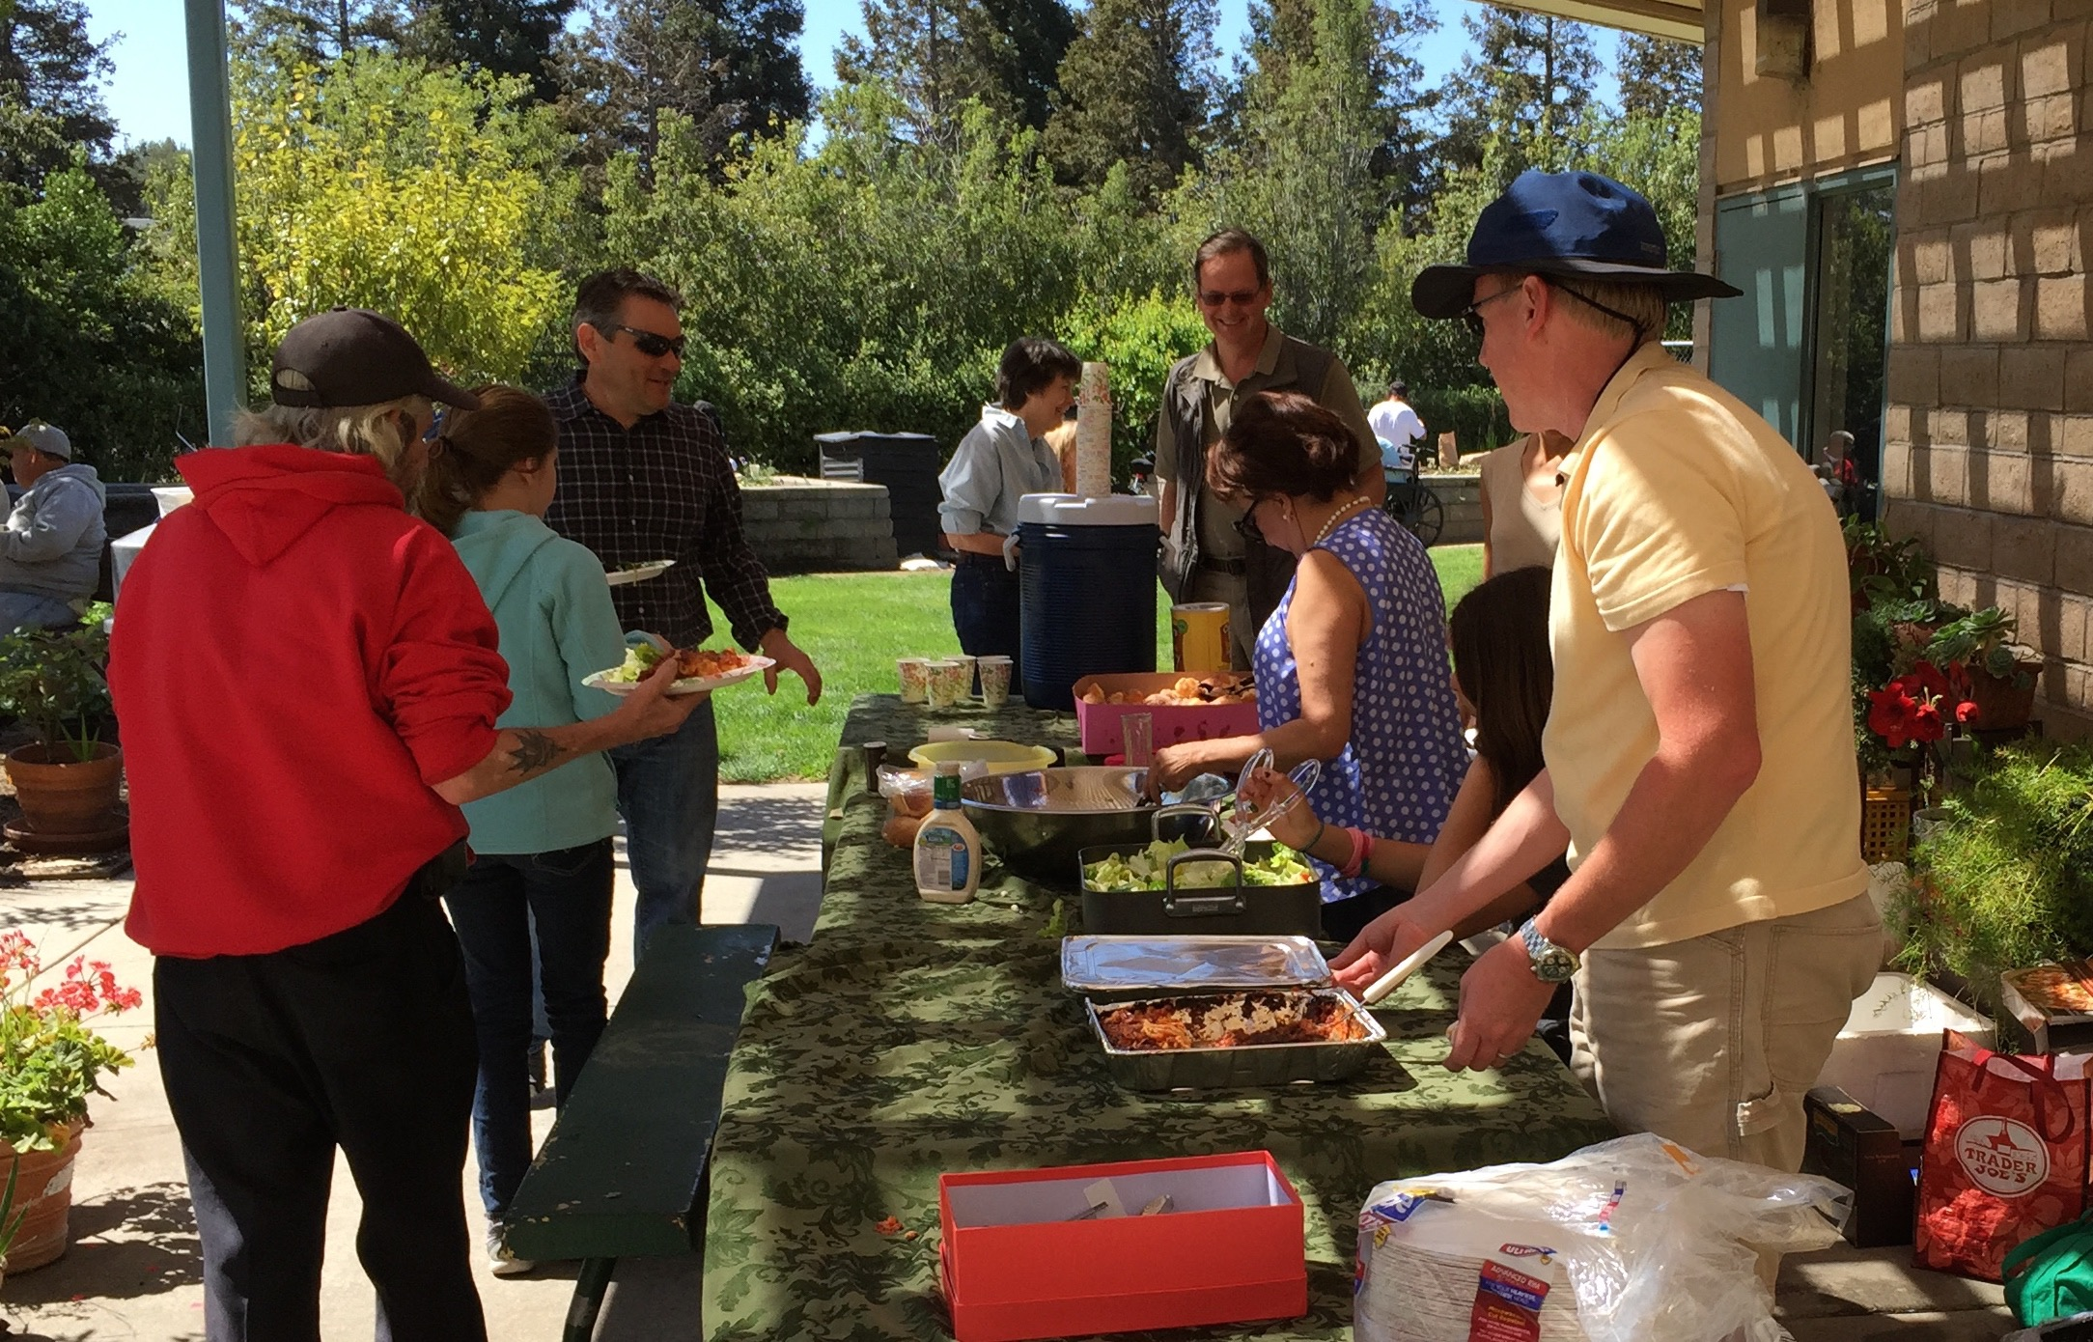

Sandwiches on Sunday (SOS): We served a lunch of lasagna, salad, and bread on March 29th. There were 30 people waiting in line at the opening, and the count eventually grew to 50.
St. Ambrose had 11 servers: the Yates (4), McIntyres (3), and Richards (2) families, plus Clara Padilla and Steve Yuen.

We had prepared enough food for 80-100 diners but did not come home with any leftovers. Lunch-goers helped themselves to second and third helpings and took home the rest in plastic containers (black with clear tops) that Susan Yates had saved from restaurants and grocery stores.

For over ten years St. Ambrose has made a hot lunch for whoever shows up at the community center in Redwood City. (The lead sponsor, St. Pius Catholic Church, makes up bag lunches for diners to take home--hence the name Sandwiches on Sunday.)
The next SOS is on Sunday, May 31st, when we’ll be serving salad and baked chicken and rice. If you can prepare a dish and/or help with serving and cleanup, please sign up on the sheet in the Parish Hall. Please contact Rob Richards (rob.richards@tensorlabs.com, 577-8924) if you have any questions.

United Thank Offering: The United Thank Offering has supported the overseas missions of the Episcopal Church since 1889. By making daily contributions of your loose change to the UTO Blue Box you will help to alleviate poverty in the Anglican provinces, dioceses, and companion dioceses. Perhaps more importantly you will be cultivating an “attitude of gratitude” in you and your family.

We will have the spring ingathering of the blue boxes (there are also blue envelopes for bills and checks) on Sunday, May 17th (the Sunday after Mother’s Day) during the Offertory. Thanks for your help---contributions of any amount will be most welcome.

“Try a Little Tenderness…” by Rev. Jay Sapaen Watan
I’m a fan of music with “soul.” Soul music is a name given for music that is rooted in the African American experience in the United States in the 1950’s and 60’s, that today incorporates and influences elements of rhythm & blues, jazz, rock ‘n roll, hip hop, and gospel. For me it is the kind of music that not only has a classic sound, a good beat and a rhythm… I also find a lot of joyfulness, authenticity, prophetic teaching, heart and spirit. Ray Charles described the soul music of his day as “traditional gospel music with secular lyrics.” If this is so then, without a doubt, faith influences culture. I believe that this dialogue of faith and culture happens because life isn’t lived in a vacuum. Within culture, the context of location and the moment will influence how we engage our faith as well.

In viewing clips from the film Selma, which dramatized the Selma to Montgomery voting rights marches of 1965, I was reminded how soul music was connected to the historic Civil Rights movement. The music itself gave a sound to the hope that justice and peace would overcome fear and sin, and love would reign supreme. This music was part of the national narrative of struggle and change that lead to the passing of such landmark laws such as the 1964 Civil Rights Act and Immigration Act of 1965, which subsequently opened the doors for America to embrace diversity and allowed us the freedom to honor who God created us to be. Soulful music is both powerful and tender. So when Sam Cooke sang, “A Change is Gonna Come,” or when Otis Redding sang, “Try a Little Tenderness”, what I find most moving is that certain tenderness, really a vulnerability, in the singing voices that invites the heart to examine the one who God created us to be.

Today, I hear many people share that they find the popular music of today less meaningful. It may be the case that younger generations place a lot more meaning into the feeling of the beat and flow of the rhyme, than into the content of the lyrics. If it has a good beat and you can dance to it, this is what matters. But “soul” music continues to exist today. And one thing about music and art is that it continues to invite us to give a soundtrack to our own story and to critically examine our common narrative together.

A few years ago Mary J. Blige released a cover of the U2 song One, with U2 being the actual cover band. One was already an anthem for social justice and advocacy in the 1990’s, and while the lyrics did not change from the original song, it was the tender sound of Mary J’s vocals that make me listen to the words she sang,

You say Love is a temple, Love is a higher law
Love is a temple, Love is the higher law
You ask me to enter, Well then you make me crawl
And I can't be holding on, To what you got
When all you got is hurt

The sound of music is like a compass that points us to the most tender spots of the world. So if we are trying to find the sacred in the secular, maybe we need to pay attention to where we are most vulnerable.

What makes tenderness so vital in our journey to live into love is that the heart can be transformed, not though a violence of force, but in our vulnerability – our own weakness. In fact, I believe the shift in American culture a generation ago in the Civil Rights era was a direct outcome of hearts being opened through people like Martin Luther King, Jr., and so many others, who were willing to reject the traditional forms of redemptive violence and go to the cross like Christ. Tenderness requires a spiritual strength that comes with God’s help and a personal motivation to rise above. The late Walter Wink, a theologian from the progressive social justice tradition of the Christian faith, wrote of Jesus’ own vulnerability as divine intention.

“...Jesus did not advocate non-violence merely as a technique for outwitting the enemy, but as a just means of opposing the enemy in such a way as to hold open the possibility of the enemy's becoming just as well. Both sides must win. We are summoned to pray for our enemies' transformation, and to respond to ill-treatment with a love that not only is godly but also, I am convinced, can only be found in God.”

God is always inviting you and me to find a better way to live into love. So as we listen to the voices who challenge the status quo and name truth to power, or to the voices working to heal the brokenness of sin that separate us, or to the voices whose own story relates with our own, we discover that faith and culture come together in a way that allows our hearts to being in divine synchronicity with the other. Spirituality has a lot to do with the experience of connection. In a world where we may feel at risk to even show a part of our heart, if we want to be connected with what matters most in our lives – our family, our friends, and our faith - then maybe we need to try a little tenderness.

Be good to yourself… Be good to one another. God Bless You!

Sea Breeze School News
Spring is in full bloom at school and although we are loving the weather, we are seeing lots of allergy sneezes.

We have returned from a very relaxing Spring Break and are working hard on the many tasks in front of us. Grandparents/Special Persons Day was held during the week of April 20, and was well attended. We saw over 200 special people during the celebration and many great memories were made. All of our guests enjoyed a special chapel service with the children and returned to classrooms to enjoy a special breakfast and to make very special gifts with the children. Our guests that were celebrating birthdays also received a special birthday blessing during chapel and all in attendance sang a very energetic round of Happy Birthday to them.

Summer School registration is open and while spaces are filling up quickly, we do still have a few spaces available. If you or anyone that you know is looking for a fun place to spend the summer, please send them our way. We will have many fun visitors and much fun is planned. Fall enrollment continues to be strong with 194 children enrolled in a variety of programs. There are still some openings in the afternoon programs and we would love to have some new friends join us.

It is difficult for all of us to believe that the end of another school year is upon us. The teachers and the children have worked very hard this year and are beginning to prepare for the “Step-Up” programs that will happen during the second week of June. While it is always great to reflect on the child’s academic growth through the year, we say many sad good-byes to the children that are moving out of the program.

Enjoy the wonderful weather!

