In this Issue:

Reflections ……….P 1-2

Announcements......P 2-3

Children and Family Ministries …….….…. P 4

Outreach Report…..P 5-7

“Migration” .........….P 7-8

Sea Breeze School News………….….…...P 9

Interim Editor:
CD & S. Rowsell

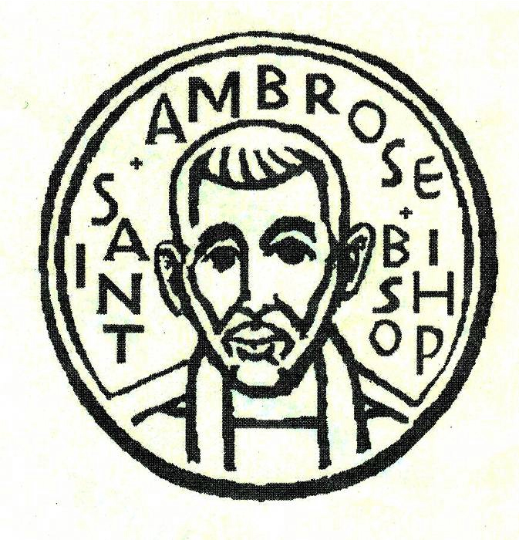

The Ambrosian

The Monthly Newsletter of St. Ambrose Episcopal Church

900 Edgewater Blvd, Foster City, California 94404

October

2015

Edition

Individual Highlights:
Inside Story 2
Inside Story 3
Inside Story 4
Inside Story 5
Inside Story 6
Inside Story 7
Last Story 8
Special Interest Articles:

• Add a highlight or your point of interest here.

• Add a highlight or your point of interest here.

• Add a highlight or your point of interest here.

Dear Members and Friends of St. Ambrose Episcopal Church,

Aloha! My participation in the “Called to Transformation” workshop for Asset Based Community Development (ABCD) facilitator training was quite insightful and challenging for me. It helped me realize that I would like to change my leadership style a bit. I would like to spend more of my time and energy developing the gifts and assets of the members of St. Ambrose and spend less of my time focused on solving perceived problems that need to be fixed. This will be a paradigm shift for me, and I ask for your support as I strive to make this change.

ABCD is a developmental approach towards building a congregation by developing its members to discern, affirm and use their gifts and assets for ministry and to perceive needs and challenges not as problems to be solved, but as opportunities for collaborative and creative responses. This is a very relational process, and relationships are the strength of any community. Instead of perceiving gifts to belong to individuals alone, gifts and assets are intended to be shared for the benefit of all. When our perspective is changed to understand that we are all meant to live in community with one another, then we will be better able to live into God’s will for us.

ABCD assumes that God has already given us all that we need to live faithful lives. It assumes that each person has both gifts and needs, and that each person is capable of sharing gifts with others in a mutually beneficial way.

On Sunday, October 4th, the Vestry has decided that we will begin our 2016 Pledge Campaign. The theme is “A community of sharing, a community of giving.” From an ABCD perspective, a circle of people facing in and holding hands represents a congregation willing to share their lives with one another; this is “a community of sharing.” All of us who participate actively know the joy of sharing our lives with one another here. We get to know others and to be known, and in so doing we know that we are not alone, but that we have brothers and sisters in faith who care for us, and for whom we care.

But a community of giving is imagined as that same circle of people turning outward still holding hands representing a congregation willing to

Reflections from our Rector

give their lives to be in partnership with their neighbors, perceiving their neighbors as possessing both gifts and needs. But in order to create these partnerships it will take a level of relationship and trust building to become collaborative partners.

So I would like to imagine our 2016 Pledge theme, “A community of sharing becoming a community of giving.” What we have to offer is relationship, faith in a loving God as revealed through Jesus the Christ, a willingness to walk with others to both be a blessing and to be blessed by our neighbors.

I invite you to ponder what gifts God has given you and you are willing to not only share but to give to others. Gifts are primarily not monetary, although it includes finances, but our gifts include our passions, our interests, our abilities and even our network of family and friends. These gifts are as diverse as people can be. And all of it, I mean all of it, can be used in community for the sake of ministry, that is to help us and our neighbors to be co-creators of God’s beloved community.

Yours,

David Y. Ota, Rector

Thanks
- Thanks to Betty Dial who donated a Baldwin Baby Grand Piano to St. Ambrose.
- Thanks to Jessica Morales and Teresa Murakami who organized our Back to School luncheon.
- Thanks to Lizz Klammer who organized our Ice Cream Social.
- Thanks to Raphaele Gerber and Liva Neyroud who taught a French cooking class for interested people who visited our booth at the Foster City Art and Wine Festival.
- Thanks to John Milligan for inviting members of St. Ambrose to view his art displayed at the Foster City Recreation Center.
- Thanks to Steve Yuen, Shelley Keefe, Liva Neyroud, Clara Padilla, Diane Robertson and Susan Yates who prepared food for homeless families for Home and Hope at Hope Lutheran Evangelical Church.

Godspeed to the Dossetts
John and Beth Dossett made the decision to return to Utah after living in San Mateo and being part of St. Ambrose for a little more than a year. They quickly became involved in our congregation and John served as a Eucharistic Minister and both John and Beth joined the choir. They made an impact on our community and will be blessed. Their last Sunday with us was on September 20th, and the clergy and congregations prayed for them and wished them Godspeed in the next phase of their life. John’s email address is JohnLDossett@icloud.com.
Saturday Evening Worship began and continues
Our Saturday Evening Worship began on September 5th and 19th at 5:30 p.m. This simpler Holy Eucharist takes only 40 minutes and had 16 and 18 folks participate. It is a worship service that children can participate in, and some of the worship included instructions on the meaning of the liturgy. The next Saturday Evening Worship services will be held on Saturdays, October 3rd and 17th from 5:30 p.m. If you are unable to worship on a Sunday, consider coming on Saturday evening.

Study Groups in October
The Monday Book Study group meets on October 5th, 12th, 19th and 26th at the home of Merilyn Vosburg from 12:45 p.m. – 2:00 p.m. They will continue their study of the book, “The Hidden Power of the Gospels.

The Tuesday evening Bible Study group meets on October 6th and 20th in the home Warren and Nellie Wong at 7:00 p.m. They are studying the Gospel according to John.

The Wednesday evening Bible Study group meets on October 14th and 28th in the foyer at 7:30 p.m. They are reading the Acts of the Apostles and are at Acts 11:1.

An Introduction to the Episcopal Church had to reschedule its first meeting for Sunday, October 18th from 11:45 a.m. to 1:30 p.m. in Room 1. The other classes are scheduled to be held on Sundays, October 25th and November 15th. A light lunch will be provided. The Rector is teaching this class which will cover Episcopal identity and ethos, history of the Episcopal Church and the Anglican Communion, sacramental worship and the mission and ministry of the Episcopal Church. Those who complete the class are invited to be presented for confirmation or reception in the Episcopal Church.

Each of the study groups is open and newcomers are invited to join.

Mark Your Calendars
- Holy Baptism and Holy Eucharist: Saturday, October 3rd, 2 p.m., Chapel
- Saturday Evening Worship: Saturday, October 3rd, 5:30 p.m., Chapel
- Blessing of the Animals: Sunday, October 4th from 12:30 p.m. to 2 p.m., Foster City Dog Park
- 2016 Pledge Campaign Kick-Off: Sunday, October 4th, 8 a.m. and 10 a.m., Chapel
- The Bishop’s Ranch Fellowship Weekend: Friday, October 9th -11th, Bishop’s Ranch, Healdsburg, CA
- Diocesan Convention: Friday, October 16th and Saturday, October 17th, Grace Cathedral
- Saturday Evening Worship: Saturday, October 17th, 5:30 p.m., Chapel
- An Introduction to the Episcopal Church: Sunday, October 18th, 11:45 a.m., Room 1
- An Introduction to the Episcopal Church: Sunday, October 25th, 11:45 a.m., Room 1
- Stewardship Dinner: Friday, November 6th, 6:30 – 9:30 p.m., Foster City Recreation Center’s Lagoon Room and Bluebird Room
- An Introduction to the Episcopal Church: Sunday, November 15th, 11:45 a.m., Room 1
- Thanksgiving Sunday: Sunday, November 22nd, 10 a.m., Sermon by Charlotte Keefe
- Visit by Hans Eide and two Cambodian Youth: Sunday, November 22nd, 10 a.m., chapel
- Christmas Pageant Organizing Meeting: Sunday, November 29th, 11:30 a.m., Chapel

Children and Family Ministries - by Elizabeth “Lizz” Klammer
Come, children, listen to me. Let me teach you how to honor the Lord. Psalm 34:11

As the new Coordinator for Children and Family Ministries, I have the joy of welcoming Sunday school students, retrieving Sunday school registration forms and taking attendance. All children from Pre-K to High School are welcomed to attend and are encouraged to invite friends to join in the fun.

I am thankful to be able to serve you at St. Ambrose and become an active member of my new Church. The Church kicked off its first monthly activity in September with an ice cream social that followed the September 6th 10 a.m. service. Fr. Jay Watan took photos of families enjoying the chocolate and vanilla sundaes.

Upcoming family activities are planned for October, November and December. Fall family fun continues on October 25th with the annual Pumpkin carving contest. The Church will provide pumpkins and pumpkin treats for the children. All children and adults are welcomed to carve pumpkins. A signup sheet will be on the bulletin board in the Parish Hall. In November, families will create a " Prayer of Thankfulness" chain to hang on the Sunday school bulletin board to remind us our blessings.

A big thank you goes to Gwen Juha and Jessica Morales for agreeing to help organize the annual Christmas pageant. Volunteers are still needed to help with costumes, props and support. More information about the Christmas pageant will come in November's newsletter.

In Christ,

Elizabeth "Lizz" Klammer

Outreach Report - by Steve Yuen
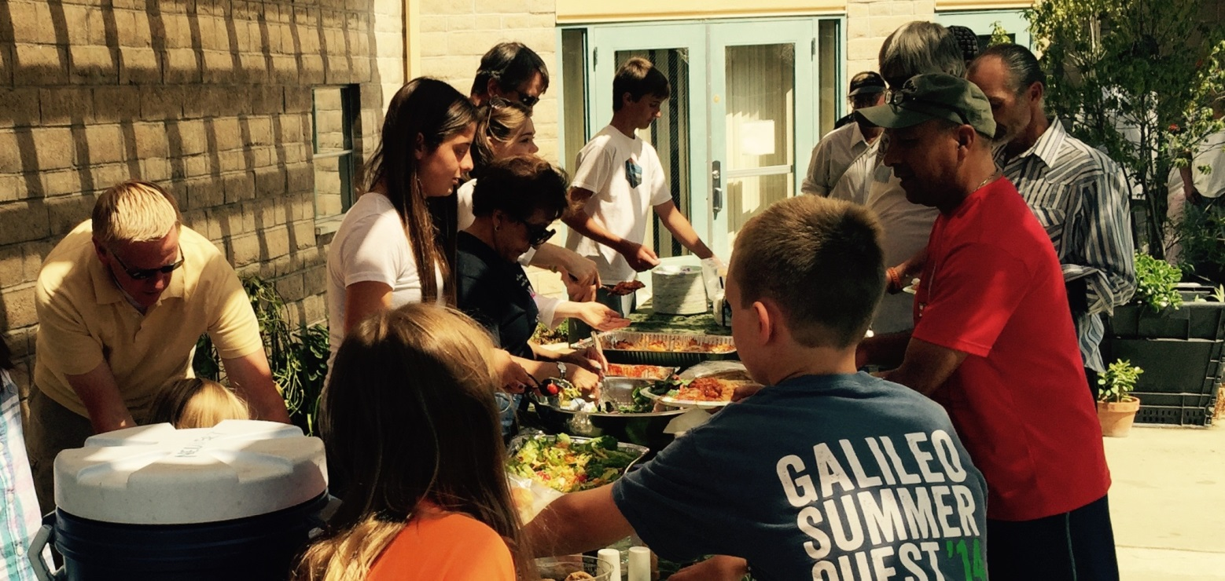

Sandwiches on Sunday (SOS): On August 30th we served lasagna, salad, and bread to 50 guests at the Fair Oaks Community Center in Redwood City. We had an excellent turnout of 22 servers: the Yates (4), Stewart (4), and McIntyre (3) families, Rose Umeda, Jay Watan, Clara Padilla, Charlotte Keefe, Rob Richards, Steve Yuen, Tippy Irwin, and Ngoc Rodriguez, who brought three teenaged visitors, Christina, Suzanne, and Tuva. As in previous outings, Clara Padilla provided loaves and rolls donated by Lucky Supermarket.

The next SOS is on Sunday, November 29th, when we’ll be serving salad and baked chicken and rice. If you can prepare a dish and/or help with serving and cleanup, please sign up on the sheet in the Parish Hall, which will be posted by November 1st. Please contact Rob Richards (rob.richards@tensorlabs.com, 577-8924) if you have any questions.

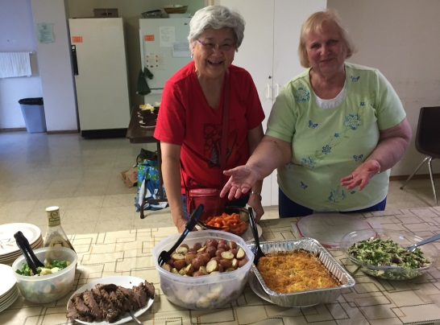
Home and Hope: St. Ambrose members made dinner for five families who were being housed at San Mateo’s Hope Lutheran during the week of September 20th. Thanks go to meal preparers Diane Robertson, Liva Neyroud, Shelley Keefe, Susan Yates, Clara Padilla, Jill Schwab, Irene Stead, Jody Tate, Valerie Mersh, Ellen Six, and Steve Yuen. Steve also was an overnight monitor on Thursday (two volunteers must be on site until the families leave in the morning for work or school).
St. Ambrose is one of 30 Peninsula churches and synagogues that have banded together as Home and Hope, which provides emergency shelter to families. Our next hosting will be on Tuesday, November 10th, and Thursday, November 12th. A signup sheet will be posted by November 1st. Please contact Steve Yuen (341-1966, stevebyuen@aol.com) if you have any questions.
Valerie and Ellen brought dessert

Outreach Donations: The Outreach Committee unanimously approved $1,400 in donations at the September meeting. The total donated so far this year is $6,680. The Outreach budget for 2015 is $8,100:

Program |  | Approved  Previously | Approved September
CALL Primrose – Safeway Gift cards |  | $ 80
Cambodia Academy |  | 500
Church Divinity School of the Pacific |  | 1,800
El Buen Pastore – Musician |  | 1,200 | $600
Episcopal Diocese of No. Cal.– Fire Relief |  |  | 800
Global AIDS Interfaith Alliance (GAIA) |  | 300
Home and Hope |  | 300
Hope Evangelical Lutheran Church (for H&H) |  | 100
Ombudsman Services of San Mateo County |  | 400
Sandwiches on Sunday (St. Pius Church) |  | 300
Stocking Stuffers expenses |  | 300
Total from Outreach Budget |  | $ 5,280 | $ 1,400

Upcoming Events:
Bring Your Pet & Celebrate
The Feast of St. Francis

Blessing of the Animals
Sunday, October 4th, 2015

Just stop by the Foster City Dog Park
(Near the Boat Launch at Foster City Blvd. & Bounty Dr.)
and ask for a blessing
between 12:30 and 2:00 p.m.

United Thank Offering (UTO): We will have our fall ingathering on Sunday, October 11th. The offerings will be combined with our spring ingathering and presented at the Diocesan Convention in San Francisco later in October. Donations to the United Thank Offering provide support to the missions of the Episcopal Church.

Cambodia Academy Luncheon: Hans Eide, who founded the Cambodia Academy in Mongkol Borei, Cambodia, will be visiting St. Ambrose on Sunday, November 22nd. He will be accompanied by two recent graduates. St. Ambrose, Sea Breeze School, and individuals from our community have been sponsoring some of the 300 students at the Academy, which provides an education for children who are too poor to attend public schools. If you would like to help with the luncheon or have any questions, please contact Shelley Keefe (onyourtoz@gmail.com).

Home and Hope Fundraiser: Planning is underway for Home and Hope’s annual fundraiser. “The Journey Home” Walk/Run Fundraising Event will be held on Sunday November 8th at 1:00 p.m. at Seal Point Park in San Mateo. Please contact Steve Yuen (341-1966, stevebyuen@aol.com) if you would like to participate, make a donation, or have any questions.

“Migration” - by Rev. Jay Sapaen Watan
“Where ever you go, there you are.” Sounds like a saying from Winnie the Pooh (or the title of a classic book on mindfulness by Buddhist teacher Jon Kabat-Zinn), but it is something I heard years ago from a meditation teacher who calmly explained a way to open ourselves to find meaning and to be present in the places we already are. I find that this way of mindfulness allows me to trust God’s intention that where I am is right where I need to be. In saying this we also know that there are places in the world where people find themselves, not always by choice, but because of necessity.

Migration has long been a part of the human experience. In the biblical narrative of the Jewish people the Holy Scriptures tell us of the migration of Joseph’s family to Egypt to escape famine, and then of their descendant’s subsequent exodus from slavery. Even Jesus’s family had to move to Egypt for a short while to escape the danger of Herod. It seems that the modern stories of movement and migration are all part of almost all our family narratives.

There are usually factors that push people to leave and conditions that pull people to go where they are called to be. My family has a history of migration. On my mother’s side, my great-great-grandfather was from Mexico and came to the Philippines as a seafarer who escaped Spanish rule and ultimately sought asylum in the Mountain Province of the Cordillera Mountains of the Philippines far away from any Spaniard. He then married my great-great grandmother who was of Filipino Igorot ancestry and the rest is history. My parents sought to leave the Philippines and immigrate to the United States in the 1960’s “for a better life” - my dad through the US Navy and my mom as a nurse. They contributed as citizens and now also call this land “home.” And now our younger generations are doing the same as my brother married a citizen of the United Kingdom and now is working and raising his family in London, England. I have cousins and other family who have settled in Tennessee, Texas, New Jersey, Nevada, Oregon, Singapore, Hong Kong, Canada and Ireland.

The movement and migration of people may be for better opportunities like education, work, economic access and upward mobility; it can also be for love, relationships, marriage and family; and sometimes it is to walk away from personal demons, great loss, or a legacy of brokenness. But more and more migration is about safety and security from the forces of oppression, violence, conflict and dehumanization. Why would one want to stay in a place that is limiting, or even worse keep their family in a place that is blowing up? There will always be a place out there to begin, start over, and to belong. Whatever that place may be, the freedom to create a place to call home, connect as family, and to live into the ones we are called to be is a shared human value.

For those of us who live in the San Francisco Bay Area, it is clear that many of our neighbors come from somewhere else in the world. As we pay greater attention to matters affecting our world, next to climate change, the most significant global change we are experiencing is human migration. Around the world we hear the stories of accounts of refugees from Africa, Vietnam, and more recently from Syria; the narratives of undocumented immigrants from Mexico and Central America, and the stories of professional and skilled workers from Asia and Europe sending remittance back to their homeland. Locally we see new populations, not just from abroad but from other parts of the country like the East Coast and Midwest, changing the character of historic neighborhoods in San Francisco. We also see how the lack of affordable housing is pushing others out of the area towards the California Central Valley, Southern California, the American South or Pacific Northwest. Yes there is a matter of class difference going on here too. Living in the Bay Area has challenges. It is easy to see the migration of people to the Bay Area and simply resist the change it brings, place labels on the other, put up higher fences, and lock down our borders. But that won’t fix the fact that there is a whole of lot of suffering and inequity in our world, and that the promise of hope and a better tomorrow contributes to why people are migrating.

No matter how we come to the places we are, for those who are already there, I believe there are questions that need some reflection, such as: How do we welcome strangers knowing full well that their very presence will change us and our communities without compromising the safety of all? How do we live into the abundance of God’s love knowing that fear and scarcity can keep us from responding in life-giving ways? And how can we see the face of Christ in the other?

As a Christian formed in the tradition of the Episcopal Church, I look to our spiritual leaders for wisdom. And in his address to the United States Congress on September 24th, 2015, I heard Pope Francis offer the Gospel and the living word of Jesus Christ as a way to embrace the change that is happening with faith and integrity:

Our world is facing a refugee crisis of a magnitude not seen since the Second World War. This presents us with great challenges and many hard decisions. On this continent, too, thousands of persons are led to travel north in search of a better life for themselves and for their loved ones, in search of greater opportunities. Is this not what we want for our own children? We must not be taken aback by their numbers, but rather view them as persons, seeing their faces and listening to their stories, trying to respond as best we can to their situation. To respond in a way which is always humane, just and fraternal. We need to avoid a common temptation nowadays: to discard whatever proves troublesome. Let us remember the Golden Rule: “Do unto others as you would have them do unto you” (Mt 7:12).
This Rule points us in a clear direction. Let us treat others with the same passion and compassion with which we want to be treated. Let us seek for others the same possibilities which we seek for ourselves. Let us help others to grow, as we would like to be helped ourselves. In a word, if we want security, let us give security; if we want life, let us give life; if we want opportunities, let us provide opportunities. The yardstick we use for others will be the yardstick which time will use for us. The Golden Rule also reminds us of our responsibility to protect and defend human life at every stage of its development.
Love is what we are willing to give. Love is also the most a challenging thing we may ever do, but it is essential action to healthy and whole living. Because love is the essence of God, it is abundant and unconditional. The Gospel is clear that we have to give to live. As we face at the patterns of human migration and the change it brings may we keep the faith and seek solutions so all of God’s people can embrace the dignity of their humanity, participate in opportunities for growth and giving, and have that place to call home that is necessary, not simply to survive, but to thrive. We are all migrants and descendants of migrants.

Live long and prosper!

Sea Breeze School News
The School year is off to a busy start and the teachers have been working really hard to welcome new children and their families, as well as greeting our returning children and their families. Everyone seems to have settled into their new routines now, and great things are happening around campus each day.

The Teacher Installation was held in September and on behalf of the St. Ambrose Sea Breeze Team, I would like to extend our thanks for your recognition and constant support.
The Annual Back to School Night was held and was very well attended. Many parents participated and were excited about the new classroom environments and the excitement that the year holds. We hosted a BBQ before the event and many families took part and enjoyed a quick bite to eat and the opportunity to meet new and old friends for some conversation.

October is always exciting for us. The Annual Sea Breeze picnic will be held on Sunday October 11th and we would love to see some of you there. The picnic is from 11 a.m. -1:30 p.m. and is held at Boothbay Park. This is a great opportunity for families to meet and make connections and for some of you to meet the staff and families that make Sea Breeze such a great place to be. At the end of the month we will also have our Halloween costume parade and party for the children. The children are dressed in a costume of choice and they are always excited to parade around the campus for all to see. After the parade they will visit the Sea Breeze Pumpkin Patch to select their very own special pumpkin.

With the School year underway we continue to welcome volunteers to spend time reading and playing games with the children during the afternoons. If you have some spare time and are looking to make a positive difference in the life of a young child, please feel free to contact the school office. We would be happy to have you visit.

Important Dates in October:
- October 11th: School Picnic at Boothbay Park 11:00 a.m.-1:30 p.m.
- October 12th -23rd: After School Program on Fall Break
- October 30th: Halloween Parade

