In this Issue:

Reflections (cont) …...P 2

Announcements …..P 2-7

Outreach Report ....P 7-8

“Neighbors”…. …P 9 - 10

Sea Breeze School
News …………..……P 11

Interim Editor:
CD & S. Rowsell

The Ambrosian

The Monthly Newsletter of St. Ambrose Episcopal Church

900 Edgewater Blvd, Foster City, California 94404

October

2016

Edition

Individual Highlights:
Inside Story 2
Inside Story 3
Inside Story 4
Inside Story 5
Inside Story 6
Inside Story 7
Last Story 8
Special Interest Articles:

• Add a highlight or your point of interest here.

• Add a highlight or your point of interest here.

• Add a highlight or your point of interest here.

Dear Members and Friends of St. Ambrose Episcopal Church,

Aloha! The month of October has two opportunities for reflection and recommitment to our common life as members of St. Ambrose Episcopal Church, as members of the Diocese of California.

We will kick-off our 2017 Pledge Campaign on Sunday, October 9th. The theme of this year Pledge Campaign is “Renewal: Where is God calling us?” This is the time when we invite members and friends to consider their commitment of time, talent and treasure for the ministry of what our Presiding Bishop Michael Curry calls “the Jesus movement.” We invite you to take the opportunity of this time to ask yourself, “What gifts do I have to offer to God for the sake of loving God and my neighbor?” We will conclude the 2017 Pledge Campaign on Saturday, November 5th from 6:00 p.m. to 9:30 p.m. with our annual Stewardship Dinner Celebration at the Foster City Recreation Center’s Lagoon and Blue Bird Rooms. The Stewardship Dinner Planning Committee has already arranged Ning’s Catering to serve again as our caterer. You will be receiving a letter and evite to RSVP. We will consecrate our pledges for 2017 on Sunday, November 6th.

The Diocese of California gathers for its annual convention on Friday, October 14th and Saturday, October 15th at Grace Cathedral. Our delegates are Shelley Keefe, Nellie Wong and Steve Yuen. Our alternates are Tippy Irwin and Warren Wong. Father Jay Watan and I will be the clergy delegates. This is the meeting when decisions about our common life as part of the Diocese of California are made. This will be the first “paperless” diocesan convention. All the information can be found on the diocesan websites at www.diocal.org/governance and clicking on the links for the 2016 Convention. Of interest are resolutions related to the diocese’s position on:

- Support of Proposition 62, repeal of the death penalty,
- Replacement of compact fluorescent lights with LEDs
- Support for Proposition 63 for the reduction of gun violence,
- Support for House Resolution 3226, Business Supply Chain Transparency on Trafficking & Slavery Act of 2015;
- Free Speech with regards to Boycott, Divestment and Sanctions including calling for the repeal of Assembly Bill 2844

Reflections from our Rector

Rector’s reflections continued…
- Accompanying our Sisters and Brothers in the Holy Land by supporting the humanitarian work of the Episcopal Diocese of Jerusalem by sending funds to the American Friends of the Diocese of the Episcopal Church

Part of the diocesan convention will include election of members for the Executive Council, Standing Committee, the Secretary and Treasurer of the diocese, as well as our lay and clergy deputies for General Convention in 2018. I have submitted my nomination to run again as a General Convention deputy.

Each year the fall months are filled with activity as is October. You can read about them in the rest of the Ambrosian newsletter. But one activity we need is thrive as Christians is to breathe in God’s love for us and all as we seek to live not only for ourselves but for the One who has given us life and love.

Yours,

David Y. Ota, Rector

Father Jay’s Surgery and Recovery
Father Jay Watan had surgery to repair his Achilles tendon on September 30th and will be in recovery until he returns to his duties on October 17th. The Rector and others will fill in for him in the meantime. Please keep him in your thoughts and prayers.

A new Children’s Choir
Maureen Fromme, our choir director, has begun a new ministry among us by starting a Children’s Choir which meets immediately following the Holy Eucharist at 10 a.m. for 15 minutes each Sunday. We look forward to hearing the children sing from time to time during worship at 10 a.m.. If you are interested in having your child join, please contact Maureen at mhfromme@yahoo.com or by calling her at 415 990-5658.

Blessing of the Animals at the Foster City Dog Park
The annual Blessing of the Animals at the Foster City Dog Park will be held on Sunday, October 2nd from 12:30 p.m. to 2:00 p.m.. This is an opportunity to bring your pets to a comfortable place for a blessing in honor of St. Francis of Assisi. You may also bring your pets to Sunday worship at 8 a.m. or 10 a.m., although more and more people have preferred to go to the Foster City Dog Park.

Memorial Eucharist in Celebration of the life of Lilo Zinger
Last month, our beloved Lilo Zinger passed away on September 5th. We will hold a Memorial Eucharist in celebration of her life on Saturday, October 8th from 2:00 p.m. at St. Ambrose Episcopal Church. We can use some help in providing refreshments. If you would like to do so, please contact the office or sign up on the sign-up sheet in the Parish Hall.

United Thank Offering Ingathering (UTO)
Our United Thank Offering Ingathering will be on Sunday, October 9th. This is the time of year when we count our blessings and make a donation for the UTO. The Episcopal Church Women administers these funds and make grants to projects of the church throughout the world and domestically. Locally, Holy Child and St. Martin, Daly City received a UTO grant to install an elevator for handicapped people. The offerings will be presented at the Diocesan Convention Eucharist on Friday, October 14th.

A Focus on the Housing Crisis
Several clergy who attended a workshop on the Housing Crisis in the Peninsula committed to focus on the Housing Crisis during their worship services or in a forum on the weekend of October 22nd and 23rd. Representatives from San Mateo County working on alleviating the issues related to the Housing Crisis made presentations about how it developed over the decades and what faith communities can do to address it. The Rector will include this as part of his reflections during worship on Sunday, October 23rd.

Holy Baptism on the Sunday After All Saints Day
Candidates for Holy Baptism will be presented at the Holy Eucharist service at 10 a.m. on Sunday, November 6th, the Sunday After All Saints Day. If interested in having your child presented for Holy Baptism, please contact the Rector at dyota@mindspring.com or by calling him at 650 200-9331.

Study Groups in October
The Monday Book Study group continues to read the Hidden Power of the Gospels on Mondays, October 3rd, 10th, 17th and 24th from 12:45 p.m. to 2:00 p.m. in the foyer. They are studying the Eight Essential Practices of the Fourth Path. Alexander Shaia believes that the four paths of the spiritual journey are (1) facing the need to change (Matthew’s Gospel account); (2) moving through suffering (Mark’s Gospel account); (3) receiving joy (John’s Gospel account); and (4) maturing in loving service (Luke’s Gospel account).

The Tuesday Evening Study group meets on the second and fourth Tuesdays of the month, this month being October 11th and 25th from 7:00 p.m. in the Wong’s home. They are reading a book called “Breaking Bread, the spiritual significance of food” by Sara Covin Juengst.

The Evening Bible Study group moved from Wednesday to Monday and meets on October 3rd 17th and 24^{h} in the foyer at 7:30 p.m.. They are now reading Paul’s Letter to the Colossians.

Each of the study groups is open and newcomers are invited to join.

Saturday Evening Worship
The Saturday Evening Worship Services are held on October 8th and 22nd from 5:30 p.m.. The services will be held on the second and fourth Saturdays of each month through December 10th. It is intended to be a family Holy Eucharist that is about 40 minutes including an interactive sermon.

From the Coordinator of Children and Family Ministry
Last Sunday, I saw a wonderful moment in Church when the head ushers guided a young child up to the altar to bring up the elements and to collect the offertory plates. It was his first time to serve in the Church. It reminded me of Proverbs 22:6, “Train up a child in the way he should go; even when he is old he will not depart from it.” Teaching our children strengthens our Church community and ensures our future. Our children are blessed to have a wonderful group of volunteers to teach Sunday school and organize family events.

Sunday school began on September 11th with 17 children and youth registering for Sunday school. This year we have new volunteers, Lois Wilson, Lilian Bulahao-Watan, Shaji Ajit, and Teresa Ranjitha. Lilian has been a very active helper, but now is officially on the roster as a Sunday school teacher. We welcome back Sunday School teachers: Gwendolyn Juha, Christina Brockman, Raphaele Gerber, Liva Neyroud and Sandy Schowengerdt; as well as Barbara Milligan, as our teacher assistant. We are continuing with the Spark curriculum and enriching our classes with arts and crafts.

On Sunday, October 30th, the children of the Church will have a pumpkin carving contest and enjoy Halloween treats. On November 6th, a Family Fall Ice Cream Social will be held after Church in the Parish Hall. At this time, parts for the upcoming Christmas pageant will be discussed. When a child has a positive experience in Church, he or she will develop pleasant and happy memories. We will be training the future leaders of our Church.

In Christ,
Lizz Klammer

The Rector’s Reflections from the Clergy Conference
The theme of the Clergy Conference at the Bishop’s Ranch was “Real Presence, Real Play,” and how play can be like centering prayer. It was led by Darleen Pryds, PhD of the Franciscan School of Theology. I found the time together with other clergy renewing, and the presentations thoughtful and insightful. For example, here are some of the insights.

Centering Prayer helps us to be fully present in the moment. It is the practice of sitting quietly, breathing in and out slowly emptying our minds of our concerns, and breathing in and out God’s love. Likewise, play at its best helps us to be focused on what we are doing. Play must be voluntary and fun. Play uncovers who we really are under the masks, titles and emotional armor that we wear. Play makes us vulnerable and opens us up to let go of judgment and resistance. Perhaps play is one of the best ways for us to become like children who are open, vulnerable and non-judgmental. This is the childlike quality that we are called to have in Matthew 18:3, “And he said: "Truly I tell you, unless you change and become like little children, you will never enter the kingdom of heaven.”

But in order to truly play, we must first become comfortable. She noted how the Danish word, Hygge, which means coziness, comfortable in the company of others, assumes that we will appreciate and welcome one another’s company, and experience joy and mutual respect. She believes play is grounded in Hygge, when we can offer a comfortable place.

However, hospitality is not offered to change people, but is offered to give people a place where change can take place. Hospitality allows the possibility when transcendence can occur, and we can break out of the norms and the prayer books to experience the divine directly.

She shared five practices she learned from the Zen Hospice Project when she was a volunteer to the dying. She shared them to help us be in the moment to live our lives fully:

- Practice the “don’t know” mind. In other words, practice an attitude of “not presuming to know,” so you can be open to others and not closed.
- Find a place of rest. Allow yourself time during the day to take a break to find your center in the midst of all the busyness.
- Welcome everything, push away nothing. Allow yourself to experience what comes to you in the day. We do not have to like everything, but we are encouraged to welcome it. When we push things away we cause inner suffering within us.
- Don’t wait. You don’t know who will be there next week. For example, the young talented baseball pitcher, Jose Fernandez, died in a tragic boat accident recently. Don’t wait to tell the people you care about how you feel about them. Always say good-bye when you leave.
- Bring your whole self and don’t resist. In whatever you do, do it with your full heart and effort. When we resist something then we begin to burn out.

These five practices allow us to be in the moment and also to be open to new possibilities. I will share more from the Clergy Conference in the November Ambrosian.

AROUND THE DIOCESE
Dr. Lisa Miller speaks at Christ Church, Portola Valley
Dr. Lisa Miller, author of “The Spiritual Child,” will be speaking on Sunday, October 16th from 6:30 p.m. at Christ Church, Portola Valley,. If you would like to register, please go to their website at www.ccpvw.org. There is no cost to attend, but you will need a ticket. It will send you to the Eventbrite link.

This Fragile Earth Conference at CDSP
On Saturday, October 22nd, from 10:00 a.m. to 3:30 p.m. laypeople and clergy are invited to CDSP for a day of theological reflection, discussion and worship exploring the church's response to the crisis of climate change. Speakers will include former Presiding Bishop Katharine Jefferts Schori, who is the current St. Margaret's Visiting Professor of Women in Ministry; Bishop Marc Andrus of California, CDSP President and Dean W. Mark Richardson, and Dr. Cynthia Moe-Lobeda, professor of theological and social ethics at CDSP and Pacific Lutheran Seminary of California Lutheran University.
Jefferts Schori will deliver the keynote address, titled "Creation and the Effective Word: Holy Storytelling, Creation, and God's Mission," and Moe-Lobeda will give an address titled "Truthtelling, Inequity, and Christian Action."
The day will culminate with a liturgy to bless CDSP's new installation of solar panels led by Bishops Jefferts Schori and Andrus. The panels, installed on Easton, Parsons, and Shires Halls earlier in 2016, make up the largest solar installation of any seminary in the United States.
Learn more and register online for $35, which includes lunch.
Location: Church Divinity School of the Pacific, 2451 Ridge Road, Berkeley, CA
When: Saturday, October 22nd from 10:00 a.m. to 3:30 p.m.

Rector to celebrate and preach at the CDSP Chapel
The Rector has been invited to serve as the Celebrant and preacher at the Church Divinity School of the Pacific’s chapel on Monday, October 31st beginning at 11:30 a.m.. They are honoring the Feast Day for the Rev. Hiram Hisanori Kano, a Japanese-American priest who through his life and witness became a role model for us in living the faith despite being the object of racial discrimination during World War II.

Mark Your Calendars:
Children’s Choir Practice: Sunday, October 2nd, 11:15 a.m., Chapel
Book Study: Monday, October 3rd, 12:45 p.m., Foyer
Bible Study: Monday, October 3rd, 7:30 p.m., Foyer
The Blessing of the Animals: Sunday, October 2nd, 12:30 p.m., Foster City Dog Park
Altar Guild Meeting: Saturday, October 8th, 9 a.m., Kitchen
Memorial Eucharist in Celebration of the life of Lilo Zinger: Saturday, October 8th, 2:00 p.m., Chapel and Parish Hall
Saturday Evening Worship: Saturday, October 8th, 5:30 p.m., Chapel
Kick-Off for the 2017 Pledge Campaign, “Renewal: Where is God Calling us?”: Sunday, October 9th, 8 a.m. and 10 a.m. services, chapel
United Thank Offering Ingathering: Sunday, October 9th, 8 a.m. and 10 a.m. services, chapel
The Sea Breeze School Picnic: Sunday, October 9th, 11:00 a.m., Booth Bay Park
Children’s Choir Practice: Sunday, October 9th, 11:15 a.m., Chapel
Prayer Group: Sunday, October 9th, 11:45 a.m., Room 1
Book Study: Monday, October 10th, 12:45 p.m., Foyer
Bible Study: Tuesday, October 11th, 7:00 p.m., Wong’s home
Children’s Choir Practice: Sunday, October 16th, 11:15 a.m., Chapel
Dr. Lisa Miller speaking engagement: Sunday, October 16th, 6:30 p.m., Christ Church, Portola Valley
Book Study: Monday, October 17th, 12:45 p.m., Foyer
Bible Study: Monday, October 17t^{h}, 7:30 p.m., Foyer
School Board Meeting: Tuesday, October 18th, 7:00 p.m., Parish Hall
This Fragile Earth Conference: Saturday, October 22nd, 10:00 a.m. to 3:30 p.m., Church Divinity School of the Pacific, 2451 Ridge Road, Berkeley, CA, pre-registration required
Saturday Evening Worship: Saturday, October 22nd, 5:30 p.m., Chapel
A Focus on the Housing Crisis: Sunday, October 23rd, 8 a.m. and 10 a.m., Chapel
Children’s Choir Practice: Sunday, October 23rd, 11:15 a.m., Chapel
Prayer Group: Sunday, October 23rd, 11:45 a.m., Room 1
Book Study: Monday, October 24th, 12:45 p.m., Foyer
Bible Study: Monday, October 24th, 7:30 p.m., Foyer
Bible Study: Tuesday, October 25th, 7:00 p.m., Wong’s home
Vestry Meeting: Tuesday, October 25th 6:30 p.m., Parish Hall
Children’s Choir Practice: Sunday, October 30th, 11:15 a.m., Chapel
Pumpkin Carving Contest: Sunday, October 30th, 11:15 a.m., Parish Hall
Book Study: Monday, October 31st, 12:45 p.m., Foyer
Annual Stewardship Dinner Celebration: Saturday, November 5th, 6:00 p.m. - 9:30 p.m., Foster City Recreation Center’s Lagoon and Bluebird rooms
Consecration of 2017 Pledges: Sunday, November 6th, 8 a.m. and 10 a.m. worship, Chapel
Holy Baptism on the Sunday After All Saints Day: Sunday, November 6th, 10 a.m., Chapel

Outreach Report - by Steve Yuen
Bring Your Pet & Celebrate
The Feast of St. Francis

Blessing of the Animals
Sunday, October 2nd, 2016
Just stop by the Foster City Dog Park
(Near the Boat Launch at Foster City Blvd. & Bounty Dr.)
and ask for a blessing
between 12:30 p.m. and 2:00 p.m.

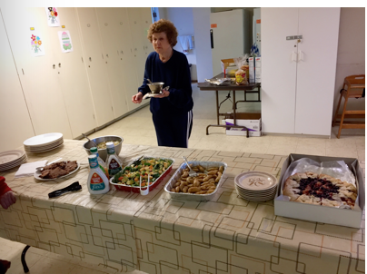
Home and Hope (homeandhope.net): St. Ambrose members made dinner for five families who were being housed at San Mateo’s Hope Evangelical Lutheran Church during the week of September 18th. Thanks go to meal preparers Diane Robertson, Susan Yates, Clara Padilla, David Ota, Irene Stead, Jody Tate, Judy Marshall, and Steve Yuen. Steve also was an overnight monitor on Thursday (two volunteers must be on site until the families leave in the morning for work or school).
St. Ambrose is one of 30 Peninsula churches and synagogues that have banded together as Home and Hope, which provides emergency shelter to families. Our next hosting
Diane's finishing touch: gravy for the pot roast.
will be on Tuesday, December 6th, and Thursday, December 8th. A signup sheet will be posted by November 1st. Please contact Steve Yuen (341-1966, stevebyuen@aol.com) if you have any questions.
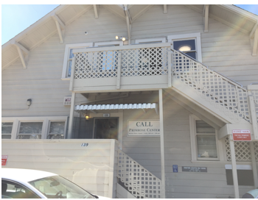
CALL Primrose (callprimrose.org): The collections box that St. Ambrose had placed in the Parish Hall at the beginning of summer had been filled with dry and canned goods, and we delivered the food to the office on Primrose Avenue in Burlingame. The interior is undergoing an overdue renovation. The 1st-floor office space and 2nd-floor food storage are switching places; volunteers were always running up and down the stairs to fill the bags of food to be distributed to hungry Bay Area residents. Soon we will help with their Thanksgiving food drive (see below).
Upcoming Events: Blessing of the Animals: On Sunday, October 2nd, we will celebrate the feast of St. Francis of Assisi by offering blessings and thanksgivings for pets and their guardians at the 10 a.m. service and at the Foster City Dog Park (Bounty & Foster City Boulevard) from 12:30 p.m. to 2:00 p.m.
United Thank Offering (UTO): We will have our fall ingathering on Sunday, October 9th. The donations will be combined with our spring ingathering and offered at the Diocesan Convention the following week. The United Thank Offering (UTO) has supported the missions of the Episcopal Church since 1889. By making daily contributions of your loose change to the UTO blue box you will help to alleviate poverty in the Anglican provinces, dioceses, and companion dioceses.

CALL Primrose’s Fill a Box, Feed a Family: Beginning Sunday, October 16th, St. Ambrose will begin filling four (4) boxes of food for families in need for Thanksgiving. Since 1983 CALL Primrose (a joint venture of the First Presbyterian Church of Burlingame and the United Methodist Church of Burlingame) has been helping low-income residents of the Peninsula and plans to give out food boxes to 300 families.

Each box will contain: 1 can cranberry sauce, 1 bag/box of stuffing, 2 cans green beans (low sodium preferred), 1 bag/box pasta, 1 box instant mashed potatoes, 1 pack/can of gravy, 1 pack/box of cornbread, 2 cans corn (low sodium preferred), 2 cans fruit (low sugar preferred), 2 cans soup, 1 tomato sauce, and 1 boxed rice (rice pilaf, rice-a-roni, etc.)

If you can contribute one or more items, please write your name on the sign-up sheet on one to four boxes in the back of the Parish Hall and bring your item(s) by Sunday, November 13th for delivery later that week.

Bread for the World: On Sunday, October 23rd we will be collecting donations and distributing information on Bread for the World. Bread for the World “is a collective Christian voice urging our nation’s decision makers to end hunger at home and abroad. Our work to change the conditions and policies that allow hunger to persist is supported by all major church bodies and sustained by generous contributions from individuals, families, and congregations.”
Sandwiches on Sunday: On Sunday, October 30th we’ll be serving baked chicken and rice to all comers at the Fair Oaks Community Center in Redwood City. Turnouts have lately risen to about 80 people. If you can prepare a dish and/or help with serving and clean-up, please sign up on the sheet in the Parish Hall. If you have any questions, please contact Rob Richards (rob.richards@tensorlabs.com, 577-8924).

“Neighbors” - by Rev. Jay Sapaen Watan
Who is my neighbor? Mornings of my childhood usually consisted of saying “good morning” to everyone, saying grace, a breakfast of milk with cereal or SPAM with rice, and watching the morning episode of Mr. Rogers’ Neighborhood on PBS. Around the early 1980’s children’s programing began making the shift from simply entertainment and education to what became efforts to market toys like Transformers, G.I. Joe, He-Man, My Little Pony, Care Bears, and Strawberry Shortcake. Around that time there was much press about parents needing to monitor what their children watched. Yet today it seems children’s programing requires even greater discernment because of the fast pace bombardment of negative messages and an orientation towards irreverence. My parents both worked so didn’t really have to time to hover over the things I watched, but they did trust that Mr. Rogers’ show would offer something more meaningful and wholesome than a glorified commercial.

Fred McFeely Rogers was a television icon, an advocate for children and families, and a man of deep faith and humility. Mr. Rogers was also an ordained Presbyterian minister who answered God’s call by creating children’s educational programing that could nurture kids and support families. His show covered topics about creativity, imagination, overcoming fear, acceptance, inclusion, music (particularly jazz) and community. He introduced us “neighbors” to different people who worked in the community from police officers and firefighters to football players, bakers, dancers, builders, artist and musicians. One of my lasting memories was how he would open every episode by walking onto the set singing a jazzy tune he composed titled: Wont You Be My Neighbor (It’s a Beautiful Day in the Neighborhood.)
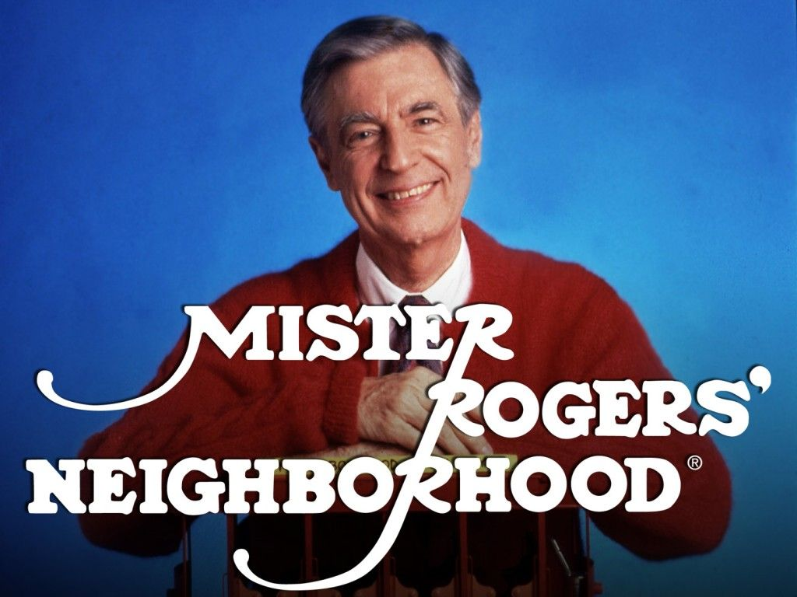

The lyrics went:
It's a beautiful day in this neighborhood,
A beautiful day for a neighbor…
I have always wanted to have a neighbor just like you.
I've always wanted to live in a neighborhood with you.
So let's make the most of this beautiful day,
Since we're together we might as well say,
Would you be mine?
Could you be mine?
Won't you be my neighbor?

In 1969 Mr. Rogers went before congress to testify about the value of public television to give kids hope, to offer social and emotional education, and media’s capacity to help raise up more productive citizens. He succeeded. When ask about people form different cultures, religions, or orientations, his famous response would be, “God love us just the way we are.” He passed away in 2003, but his legacy continues through the continuation of public television and in our capacity to record television programs to watch at a later time. Yes, we can record television shows for our family, events and even football games at home because the US Supreme Court considered Mr. Rogers’ testimony in the VCR time shifting case as a factor in their discussion.

I have always felt that with the advent of all of this new technology that allows people to tape the "Neighborhood" off-the-air, and I'm speaking for the "Neighborhood" because that's what I produce, that they then become much more active in the programming of their family's television life. Very frankly, I am opposed to people being programmed by others. My whole approach in broadcasting has always been "You are an important person just the way you are. You can make healthy decisions." Maybe I'm going on too long, but I just feel that anything that allows a person to be more active in the control of his or her life, in a healthy way, is important.

Mr. Rogers’ really did make a stranger feel like one of his neighbors. He cared for a community in a way that allowed the world to be his family. So as I reflect on this, I have to ask, “who is my neighbor?” When someone asked this question to Jesus, he shared the Parable of the Good Samaritan (Luke 10: 29-37). It’s the classic text on relatedness and our greater capacity to be human in the image of God. The power of love is our willingness to give, even if it’s risky.

Issues in our “neighborhoods” today - from race relations, violence between police and citizens, immigration reform, and housing in an economy of have and have not – invite us to engage in real conversations about “our neighbors” and our own neighborliness. In our climate of fear and hunger for power, I know it’s easy to assume a position of toughness, security and isolation. We’re inclined to set standards of exclusivity about who our neighbors should be because it makes life easier. But I don’t think any of that can sustain any real happiness or hope for a future we want as the world becomes more accessible to our own children. Our kids naturally seek authenticity. And that will come in our capacity to seek possibilities, take courage, live into love, and to go beyond our limited circles to see the beauty of our wider neighborhood. Dear friends, let’s consider a very spiritual question, “Who is my neighbor?”

A little footnote on top of the footnote:
Please know I will be away the first two weeks of October recovering from surgery to repair ligaments in my left ankle and to allow the tendons my Achilles tendon to heal. I anticipate that I will return by October 17, 2016. In the meantime please know you will be in my prayers.

Sea Breeze School News
The School year is off to a busy start and the teachers have been working really hard to welcome new children and their families, as well as greeting our returning children and their families. Everyone seems to have settled into their new routines now, and great things are happening around campus each day. Father Ota has started conducting chapel for our three year olds and Father Jay is conducting chapel for the 4 year olds, Transitional Kindergarten class and the After School Program. Father Jay is also coordinating an enrichment program with our After School program on Wednesday afternoons.

The Teacher Installation was held on September 18th and on behalf of the St. Ambrose Sea Breeze Team, I would like to extend our thanks for your recognition and constant support.
The Annual Back to School Night was held and was very well attended. Many parents participated and were excited about the new classroom environments and the excitement that the year holds. The School outreach group from the church hosted a table with healthy snacks before and during the event and shared the work of the church with interested families. It was great to have this group present during our event.

October is always exciting for us. The Annual Sea Breeze picnic will be held on Sunday October 9th and we would love to see some of you there. The picnic is from 11:00 a.m. -1:30 p.m. and is held at Boothbay Park. This is a great opportunity for families to meet and make connections and for some of you to meet the staff and families that make Sea Breeze such a great place to be. At the end of the month we will also have our Halloween costume parade and party for the children. The children are dressed in a costume of choice and they are always excited to parade around the campus for all to see. After the parade they will visit the Sea Breeze Pumpkin Patch to select their very own special pumpkin and return to their classrooms for parties. It will be a spooktacular day for all!

With the School year underway we continue to welcome volunteers to spend time reading and playing games with the children during the afternoons. If you have some spare time and are looking to make a positive difference in the life of a young child, please feel free to contact the school office. We would be happy to have you visit.

Important Dates in October:
October 9th: School Picnic at Boothbay Park 11:00 a.m. -1:30 p.m.
October 24th-28th: After School Program on Fall Break
October 31st: Halloween Parade

"SONY CORP. OF AMER. v. UNIVERSAL CITY STUDIOS, INC., 464 U.S. 417 (1984)". Supreme Court of the United States of America. 1984.

