In this Issue:

*Reflections …….…..P 1*

*Announcements …..P 2*

*Introducing Seminarian Daniel Tate ……….P 3*

*God’s Dream………P 4-5  
  
Outreach Report ....P 6-7*

*Family Fun and Blessings Too ………………...P 8*

*Sea Breeze School*

*News ……….…. .…P 8*

**Interim Editor:**

*Yvonne Sidell*



The Ambrosian

The Monthly Newsletter of St. Ambrose Episcopal Church

900 Edgewater Boulevard, Foster City, California 94404

September

2017

Edition

***Individual Highlights:***

Inside Story 2

Inside Story 3

Inside Story 4

Inside Story 5

Inside Story 6

Inside Story 7

Last Story 8

***Special Interest Articles:***

• Add a highlight or your point of interest here.

• Add a highlight or your point of interest here.

• Add a highlight or your point of interest here.

Dear Members and Friends of St. Ambrose Episcopal Church,

Aloha! As we enter the month of September, I would like to thank Cathy Rincon, Senior Warden, for assuming leadership of the congregation and handling some administrative tasks, Father Jay Watan and the Reverend Karen Swanson for leading worship and providing pastoral care during my four weeks of sabbatical time.

On Sunday, September 3rd, we will say farewell and Godspeed to Debbie White at the 8 a.m. service of Holy Eucharist. She has been a long-time member of St. Ambrose, and has been the senior member of the Altar Guild. She is relocating to San Antonio for her retirement to live closer to her daughter and her family.

Also on September 3rd, we will welcome seminarian Daniel Tate, who is a member of St. Mary’s By-the-Sea, Pacific Grove in the Diocese of El Camino Real. I will be serving as his field education supervisor, and he will be with us on Sundays and Tuesday evenings during the week. I would like to thank April Cherrington, Torrie McAllister-Miller, Charles Saunders and Warren Wong who will serve as his lay committee to provide him constructive feedback on a monthly basis. Field education is served as an internship for seminarians allowing them to learn while using their gifts for ministry. At the same time, St. Ambrose will benefit from Daniel’s presence among us. I hope you will all take time to introduce yourselves and welcome him.

Next, I encourage each of you to join us for the Commissioning of the Sunday School teachers and the St. Ambrose Sea Breeze School teachers and staff on Sunday, September 10th during the 10 a.m. service of Holy Eucharist, and to join us for the lunch following. It is a great opportunity for us to thank the teachers of the children of the congregation and school.

Finally, please set aside Saturday, November 4th from 6 to 9 p.m. for our annual Stewardship Dinner at the Foster City Recreation Center.

I look forward to engaging with you in ministry.

Yours,

David Y. Ota, Rector

# Reflections from our Rector

# Announcements

**Study Groups in September 2017**

The Monday Bible Study group meets on **September 11th, 18th** and **25th** from **12:45 p.m**.   
in the foyer.

The Tuesday Evening Study group meets on **September 12th** and **26th** from **7:00 p.m.**in a place to be determined.

The Wednesday Bible Study group meets on **September 13th** and **27th** from **7:30 p.m.**in the Rector’s office.

*Each of the study groups is open and newcomers are invited to join.*

**Mark Your Calendars**

Giants and St. Louis Game: **Friday, September 1, 7:15 p.m.,** AT&T Park

Adult Choir: **Thursday, September 7, 7:30 p.m.,** Chapel

Altar Guild Meeting: **Saturday, September 9, 9:00 a.m.,** Kitchen

Commissioning of St. Ambrose Sunday School and Sea Breeze School Teachers and Staff: **Sunday, September 10, 10:00 a.m. Holy Eucharist** (Back to School Lunch following)

Family Fun and Blessings Too: Ice Cream Sundae making, face painting, digging up dinosaur eggs, and games, **Sunday, September 10,** following lunch in the Playground

Sea Breeze School Outing to Giants and Arizona Diamondbacks Game: **Saturday, September 16, 6:05 p.m.,** AT&T Park

Spanish Conversation Table: **Sunday, September 17, 11:15 a.m.,** Parish Hall

Rector at Clergy Conference: **Monday, September 17, 4:00 p.m., to Tuesday, September 18, 3:00 p.m.,** Bishop’s Ranch

Buildings and Grounds Committee: **Tuesday, September 18, 6:00 p.m.,** Rector’s Office

School Board Meeting: **Tuesday, September 18, 7:00 p.m.,** Parish Hall

Vestry Meeting: **Tuesday, September 25, 7:00 p.m.,** Parish Hall

Blessing of the Animals in Honor of St. Francis of Assisi: **Sunday, October 1, 8:00 a.m. and   
10:00 a.m.,** Chapel; **12:30 p.m.,** Foster City Dog Park

Bishop’s Ranch Weekend: **Friday, October 6 to Sunday, October 8,** Bishop’s Ranch, Healdsburg

Diocesan Convention: **Friday, October 27 and October 28,** Grace Cathedral, San Francisco

Stewardship Dinner: **Saturday, November 4, 6:00 p.m.,** Foster City Recreation Center,   
Lagoon and Blue Bird Rooms

**Introducing Seminarian Daniel Tate**

My name is Daniel Tate and I’m a second year seminarian at Church Divinity School of the Pacific in Berkeley. I’m going to be doing my Field Education at St. Andrews this fall and I’d like to introduce myself.

I was born in Oak Park, Illinois and lived in the Chicago area until I was about eleven years old. We then moved to the Bay Area, California.  I had a strong religious upbringing in Baptist and non-denominational Bible churches.  Two of my uncles were pastors, as was my grandfather.  My father was a pastor for a while too and other family members worked in Christian ministry.  My mother was a nurse.

Most of my work life has been in the business world, in IT/Telecommunications, Construction and Real Estate.  I went to UC Berkeley for an English Degree and to the University of San Francisco for an MBA.

While I was working in IT, several years ago I started taking acting and singing classes at A.C.T. Conservatory in San Francisco.  I continued to study there until finally I started doing some acting in community theatre in the Monterey Bay Area.   I also joined a community choir there.

About four years ago a retired Episcopal Priest who was in the choir invited me to come sing at St. Mary’s Episcopal Church in Pacific Grove for a few weeks because they needed baritones. Some of the singers were away for the holidays and they needed people to fill in.  I felt immediately at home and during the first rehearsal I knew I was going to stay. I had been missing the community that I’d had in church in my youth.  Within a year I realized that I needed to work in the church and to seek and serve God there. Soon thereafter I applied to seminary. I’ve come full circle.

In addition to theatre and singing, I enjoy hiking, reading, and the San Francisco Giants (I've been a Giants fan since we came to California).

I’m grateful to be able to serve at St. Ambrose and learn; and at the same time make a contribution.  I’m excited and looking forward to the opportunity and getting to know everyone!

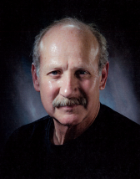

# “God’s Dream… Relationships Matter!” – by The Rev. Jay Sapaen Watan

M

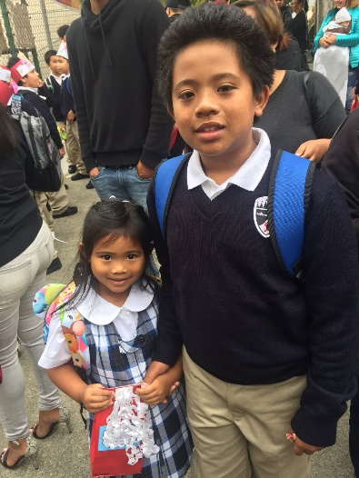y children, Rowan and Kieran, attend St. James Catholic School in San Francisco, and they have to wear uniforms. I’ve worn uniforms for school, sports and service, and I’ve always felt a healthy pride and connection to others who share the uniform. While I was getting my children’s uniforms together, I noticed that their ensemble was truly something global. The polo shirt was made in Laos, the blouse from Vietnam, sweater made in China, the socks from the Dominican Republic and the Philippines, the shoes made in Italy and Korea, the belt made in Slovakia, the khakis made in the Nicaragua, and the jumper, skirts, hair ties, and school patches made in Portland, Oregon in the United States of America. A subtle reminder of the truth of God’s Dream… we are more connected with others around the world than any time ever. Yet why do we seem less connected?

***The First Day of School***

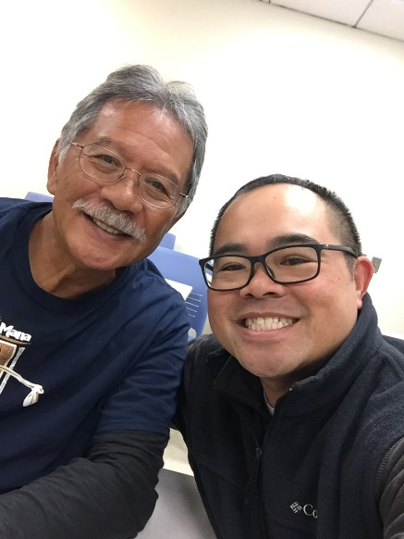  
  
Last month, I signed up for a class on the *Psychology of Race and Ethnic Culture* at City College of San Francisco with one of my former San Francisco State professors, Dan Begonia. It’s a relevant topic given the current state of our nation and the world. And it harken back to the class I took from Prof. Begonia over twenty years ago at San Francisco State - *Asian American Studies: Psychology of Filipino Americans*. Now in retirement, Professor Begonia teaches at CCSF, and generally spends his time hanging out with his grandchildren and living out other passions that keep him spiritually grounded. His class at State impacted my life, along with my brother Mark and so many of our Filipino American peers. We were invited to discover our meaning in the awareness of our own ethnic identity consciousness, to make sense of our family dynamic, and to practice self-respect and discipline to own our destiny as a people of color in America. And while Professor Begonia’s class at City College has shifted more broadly and the student body is much more diverse, we still get life-lessons every day. This includes honoring a person’s name, creating community, and developing social intelligence to create joy, purpose, and satisfaction in life.

***In class with Prof. Dan Begonia***

What does this have to do with race and ethnicity? Bottom line… relationships matter. I believe God created us to mature, grow, evolve and change. It’s part of living a full life. Professor Begonia shared with me that his focus in teaching has evolved and grown over the many decades. As a young teacher, he had a fire to “change the world” with solid academic theory, arguments rooted in common sense, anti-racism that broke down systemic injustice, and activism to empower communities. As a wise sage who has lived a little, changing the world evolved to “sharing the light within” to build up healthy, connected and whole people.

## God’s Dream…Relationships Matter! continued…

Seems to me that if we don’t mature and grow in the time we are given, we risk becoming isolated, stagnant, or engulfed in a cycle of victimhood. And that’s not very happy at all. Given our recent societal dependence on technology, suspicion of the other, hypersensitive egos, and individualistic apathy toward our need for God or community, we as a people find ourselves less competent to be in relationship. Yet, it’s the key to living well.

In our world of multiple truths and alternative facts, it’s harder and harder to see who may have our best interest. Yet, professions exist because they hold the public trust, have a code ethics, and support community. I think about our doctors, nurses and healers, law enforcement, fire fighters and first responders, military, artists, engineers, builders and clergy. I also think about our journalist, lawyers, politicians and public servants. Then we have our teachers – the one profession that impacts our collective well-being like no other. Next to our parents and guardians, our teachers hold the great responsibility of caring for the generations. And these connections can inspire how we engage the world.

Professor Begonia has a proverb about this teaching philosophy, and it’s a standard I hold for myself as a teacher today:

*The poor teacher tells  
The mediocre teacher explains  
The superior teacher demonstrates  
But the outstanding teacher inspires*

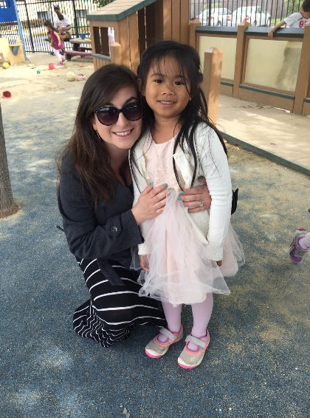

My children are also alumni of St. Ambrose Sea Breeze School. And to this day, they still say their SBS prayers and name their preschool teachers among their favorite. There’s a good reason for this! We are blessed with a cohort of teachers who go out of their way to love and care for our young ones. Our memories inform the heart of what’s right in the world and also what’s wrong with it. And many teachers I’ve encountered have something to do with what’s right. The change in the world we wish to see isn’t going to happen until we *become* that change. And it’s those outstanding teachers who help to inspire to see what’s right in us so we can begin to see what’s good in this broken and beautiful world. In God’s Dream for us… relationships matter. May we be the light!

***Kieran at Sea Breeze with Ms. Bizon***

Outreach Report – by Steve Yuen

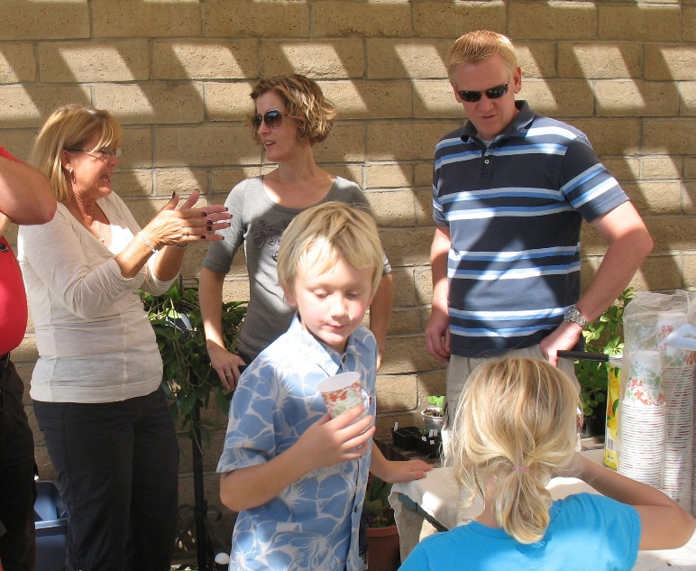**Sandwiches on Sunday**   
  
We served lasagna, salad, and bread to 70 people at the Fair Oaks Community Center on July 30th. Enthusiastic new volunteers made 12 trays of lasagna, 50% above our normal production. Despite concern that we had made too much, diners came back for extra helpings and took the rest home in containers.

The entire Yates family of four (here pictured with Wendy Stewart in 2012) has been volunteering for over five years and did a superb job opening the gate and locking up, buying supplies, and setting up the buffet line. SOS leader Rob Richards will be back for the next SOS on **October 29th**, when we will prepare baked chicken and rice.

Thanks go to all our servers---David, Susan, Brett, and Lauren Yates, Clara Padilla, Vince Granato, and Steve Yuen---who responded admirably to the above-average demand.

A sign-up sheet will be posted in the Parish Hall at the beginning of October – please contact Rob Richards (577-8924, rob.richards@tensorlabs.com) if you have any questions.

**Cambodia Academy of Mongkol Borei (cambodiaacademy.org/)**

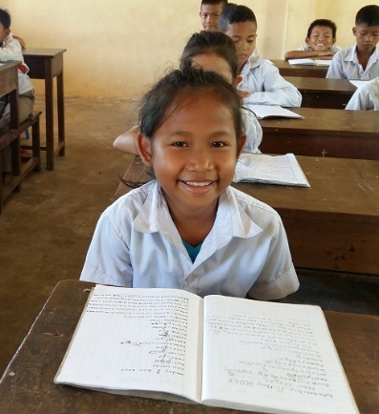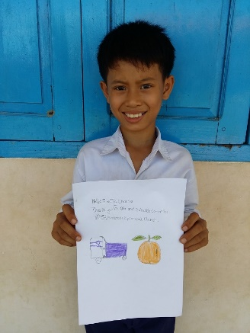Since 2008, St. Ambrose, Sea Breeze School and individual members of our community have sponsored students at the Cambodia Academy of Mongkol Borei. The school was founded by the late Hans Eide, a Foster City resident, who was inspired to help children who were too poor to attend Cambodian public school. Among many other skills, the students learn English (often from native-speaking teachers) and are better equipped to enter the working world than most Cambodian public school graduates.

Our two students are Mai Chantra (boy, 12) and Cheng Vipha (girl, 11). They enjoy receiving cards, letters, and pictures from us, especially Sunday School students. If you would like more information, please contact Karen Swanson (karen.2.swanson@gmail.com) or Steve Yuen ([stevebyuen@aol.com](mailto:stevebyuen@aol.com)).

Outreach Report continued…  
 **Yes, It’s All Connected Department**

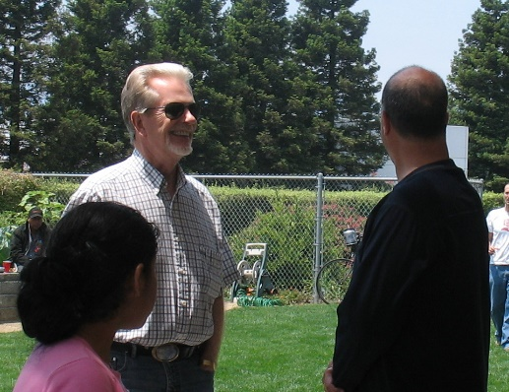

Cambodia Academy founder Hans Eide (pictured talking with Jim Neubert) joined us for Sandwiches on Sunday in 2008.

**Home & Hope** (**homeandhope.net/)**

Home & Hope is a group of 30 churches and synagogues on the Peninsula that give emergency shelter for up to four families at a time (families can lose their housing suddenly because of family breakup, loss of a job, death of a breadwinner, etc. – for more information see homeandhope.net). About half the churches have sleeping and bathroom facilities—nothing luxurious, guests sleep on cots or sleeping bags—but it’s better than spending nights in a car. The smaller churches, like St. Ambrose, prepare dinner to take some of the burden off the host parishes.

On **Tuesday, September 19th** and **Thursday, September 21s**t, we will be feeding up to 15 people---typically half of them are children--- at Hope Evangelical Lutheran Church, 600 42nd Avenue, San Mateo, CA 94403 from 6 p.m. to 8 p.m. If you would like to help by preparing a dish (it is not necessary to go to the dinner), serve, and/or clean up, please write your name on the sign-up sheet in the Parish Hall. Please contact Steve Yuen (341-1966, stevebyuen@aol.com) if you have any questions.

|  |  |
| --- | --- |
| **Blessing of the Animals**  The Feast of St. Francis  **When**: Sunday, October 1st, 12:30 to 2:00 p.m.  **Where:** Foster City Dog Park  Bounty & Foster City Boulevard  **What:** Father Ota and Father Watan will bless pets   and their owners in honor of Saint Francis,   the patron saint of animals. |  |

**Family Fun and Blessings Too** **–**  **by the Rev. Karen Swanson**

On Sunday, September 10 we will welcome Sea Breeze Preschool teachers and families to St. Ambrose to join us as we bless those who teach both preschool and Sunday school children. This day also marks the opening day of St. Ambrose’s family and children’s ministries. We will celebrate all of this with a joint church and preschool luncheon followed by carnival activities for children of all ages on the playground. The carnival fun will include stations for ice cream sundae making, face painting, digging up “dinosaur” eggs, a ping pong ball toss, a lollipop pull, and other games. Older children and kids at heart will also have the opportunity to participate in a three legged race, a sack race and a game of tug and war. Please come and join the fun! If you would like to help by overseeing one of the carnival games, please contact the Rev. Karen Swanson by

e-mail ([karen.2.swanson@gmail.com](mailto:karen.2.swanson@gmail.com)) or by phone or text (650-200-8449.)

Sea Breeze School News **–** by Jerelyn Weber, Principal

It is Back to School and we are moving at full speed!

The teachers and children have returned and are getting settled into routines. We are excited to have many new children join us this year and it is always fun to see our returning children arrive with big smiles. After some first day jitters were calmed, everything was smooth sailing. We are excited about the New Year and all that it holds!

Summer is a typical time of change for families and we were sad to see some of our families leave the Bay Area. We will miss these families and always look forward to receiving updates from them at a later time. While we said good-bye to some families, we are fortunate to welcome several new children and families to our many different programs. Enrollment is very strong this year and we started the School Year with 200 children.

With the growth in our After School Program, we added a few new enrichment classes to keep the children busy. We will continue to enjoy Mrs. Fromme and the Music Appreciation Classes that she teaches on Thursdays, as well as the Life Skills Classes that Father Jay teaches on Wednesday afternoons. We also added a Hip Hop Dance Class, a Chess Club and a Bollywood Dance Class.

There are many exciting things planned for this year and we would love to include you in our fun. We will be singing at the Atria, hosting a BBQ at Boothbay Park, hosting Movie Nights throughout the year and of course, we will have our Annual Family Fun Day in the Spring. Please watch for more information and always feel free to join our fun!

Each year we welcome volunteers into our program and would love to have some of you join us. If you have an extra hour or so and would like to spend time with some fantastic children, please contact the office and we will be happy to show you around.

Have a Wonderful September!

Jerelyn Weber