In this Issue:

Reflections (cont.) …..P 2

Announcements......P 2-4

Outreach Report…..P 4-5

“Not Everyone Who Wanders is Lost” .......P 6-7

Sea Breeze School News………….….…...P 7

Interim Editor:
CD & S. Rowsell

The Ambrosian

The Monthly Newsletter of St. Ambrose Episcopal Church

900 Edgewater Blvd, Foster City, California 94404

November

2014

Edition

Individual Highlights:
Inside Story 2
Inside Story 3
Inside Story 4
Inside Story 5
Inside Story 6
Inside Story 7
Last Story 8
Special Interest Articles:

• Add a highlight or your point of interest here.

• Add a highlight or your point of interest here.

• Add a highlight or your point of interest here.

Dear Members and Friends of St. Ambrose Episcopal Church,

Aloha! This month on Sunday, November 9th we are blessed to have our bishop, the Rt. Rev. Marc Handley Andrus, come to us for his regular Episcopal visit to confirm and receive new members into the Episcopal Church. He will be accompanied by his wife, Dr. Sheila Andrus.
Unlike previous times when Bishop Andrus came, he will lead the worship services at both the 8 a.m. and 10 a.m. services at which members will be confirmed and received into the Episcopal Church. At 8 a.m. Karin and Katherine Patterson will be presented for confirmation, and Don Gundry will be presented to be received. At 10 a.m. Linda Lewis and Barbara Milligan will be presented to be confirmed and Nilda Chong will be presented to be received.
A reception for Bishop Marc and Dr. Sheila Andrus will be held following the 10 a.m. service in the Parish Hall, and I hope many of you will make the time to welcome them to St. Ambrose.
The occasion of our bishop’s visit is an opportunity for him to provide some oversight for our congregation, to learn about a bit more directly about our ministry with our hopes and challenges.
Also, I am looking forward to our Stewardship Dinner Celebration at the Foster City Recreation Center on Saturday, November 15th from 6 to 9:30 p.m. The dinner planning committee has made all the arrangements and once again Ning’s Catering will be preparing our meal, members of the congregation will share their talents to entertain us, a raffle of gift baskets will add some excitement, and Sal Censoprano’s group Classic Vinyl will play for us for some time of dancing. All that we need are for you to come and join us to celebrate our life as a congregation.
Finally, November is a time for thanksgiving. This year we do not have a senior who is able to give a Thanksgiving Day sermon on the Sunday before Thanksgiving. However, we have been invited to join in the Home and Hope Interfaith Thanksgiving Service on Sunday, November 23rd from 7 p.m. at Temple Beth El, 1700 Alameda De Las Pulgas, San Mateo. Those who would like to sing in the “instant choir” are asked to arrive at 5:30 p.m. for the rehearsal. The offering will go to Home and Hope, and the fellowship time will consist of pies or beverages that the people bring. I invite you to join in this worship

Reflections from our Rector

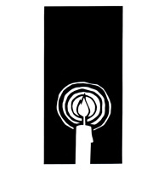
service to give thanks to God and to share our love for our neighbors who struggle to have housing.

Yours,

David Y. Ota, Rector

Thanks
- Thanks to Steve Yuen, Shelley Keefe, Father Jay and Father Ota for offering the Blessing of the Animals at the Foster City Dog Park on Sunday, October 5th.
- Thanks to Janet Gardiner, Steve Yuen, Father Jay and Father Ota for representing St. Ambrose at the Diocesan Convention held on October 17th and 18th at Grace Cathedral.
- Thanks to Raphaele Gerber for organizing the Welcome Lunch on October 19th, and for April Cherrington, Liv Dahdah, Tippy Irwin, Jim Neubert and Nellie and Warren Wong for helping.
- Thanks to Juan, Myra, Jason and Jeffrey Rodriguez of El Buen Pastor for hosting the coffee hour after the 10 a.m. service on October 19th.
- Thanks to Fe Valentin and the Children and Family Ministry who organized the Bring Your Own Pumpkin Event and Chili Cook-off on Sunday, October 26th and to everyone who helped.
- Thanks especially to Jim Neubert and to other members of the Buildings and Grounds Committee, Jerelyn Weber, Principal, Don Peter, April Cherrington and Father Ota for working on the Fire Sprinkler System project.

Bible Studies in November
The Monday Bible Study group will meet on November 3rd, 10th, 17th and 24th from 12:45 p.m. to 2:00 p.m. to study the book by Alexander Shaia, The Hidden Power of the Gospels: Four Questions, Four Paths, One Journey. He calls his approach Quadratos which looks at the four gospels as material for the early church to use for its Lenten retreat. The group will begin to study the four gospels using this perspective.
The Tuesday evening Bible Study group is also studying the Gospel according to Luke and meets on November 4th and 18th in the home Warren and Nellie Wong at 7:00 p.m.
The Wednesday evening Bible Study group will meet on November 12th and 26th in the foyer of the church at 7:30 p.m. They are studying book of Revelation and will be at Chapter 12. This Bible Study is led by the Rector.
Each of the Bible Study groups is open and newcomers are invited to join.

Activities in November
Sunday after All Saints Day, Commemoration of All Souls Departed: Our worship services on Sunday, November 2nd will feature the renewal of baptismal vows and the remembrance of all souls departed as the congregation give thanks to God for loved ones who have passed away. Please send in the names of people whom you want to be remembered in our services to the office at stambrose@mindspring.com or call in to 650 574-1369.
Parents’ Night Out and Fill-A-Box, Feed-A-Family: Take an evening off from watching your children on Friday, November 7th to go out to dinner and drop off your kids at St. Ambrose between 6:00 p.m. and 9:00 p.m. You can drop off your children as early as 6:00 p.m., but the program will begin at 6:30 p.m. and end at 8:30 p.m. You can pick up you children as late as 9:00 p.m. The cost is $10 per child which includes a simple dinner. This is combined with the Call Primrose Fill-A-Box, Feed-A-Family outreach as the children will be putting together the boxes to given to families for Thanksgiving. For more information, please contact Fe Valentin at valentin_fe@yahoo.com or call her at 925-216-5188.
Bishop Andrus’ visitation and confirmation: Join us for the service of confirmation on Sunday, November 9th at 8 a.m. and 10 a.m. with Bishop Marc Handley Andrus as celebrant and preacher. A reception will be held at 11:30 a.m.
Stewardship Dinner Celebration: Join members and friends of St. Ambrose in attending the Stewardship Dinner Celebration on Saturday, November 15th from 6:00 p.m. to 9:30 p.m. at the Foster City Recreation Center. The cost is $15 for a catered meal for adults and youth 13 years and older. Child care is provided with a children’s menu. Please pay in advance so less time will be spent at the registration table.
Polishing the brass: The Altar Guild members will polish the brass on Saturday, November 22nd between 8:30 a.m. and 10:30 a.m. If you have some time, please come help the altar guild prepare our worship space for Advent and Christmas.
Organizational Meeting for the Christmas Pageant: Come to a meeting to organize the Christmas Pageant on Sunday, November 30th from 11:30 a.m. to 12:30 p.m. The Christmas Pageant will be part of the Family Christmas Eve Service held on Wednesday, December 24th beginning at 4:00 p.m. Thanks to Gwen Juha who has volunteered to serve as this year’s Pageant Director. If you are interested in having your child in the Christmas Pageant please plan to attend.
Installation of Fire Sprinkler System in Room 1 and the Kitchen: The School Board and Vestry of St. Ambrose has decided to pursue the installation of a fire sprinkler system in Room 1, the hallway, the Principal’s office, the kitchen and the closets and the adjoining bathrooms in addition to the outside area between Room 1 and the Parish Hall. St. Ambrose has signed contracts and is in the process of seeking the permits to do the work during the Christmas break between December 20th and January 4th, 2015. This is Phase 1 of a two phase process. The second phase will include the parish hall, the chapel, the foyer, the sacristy and the church offices. This work will be scheduled once finances make it possible.
Mark Your Calendars:
- Sunday After All Saints Day and Commemoration of All Souls Departed: Sunday, November 2nd
- Parents’ Night Out and Call Primrose Fill A Box and Feed A Family event: Friday, November 7th, 6:00 p.m., Parish Hall
- Bishop Marc Andrus’ Visitation for Confirmation: Sunday, November 9th
- Peninsula Deanery Meeting: Saturday, November 15th, 10 a.m., St. Elizabeth, South San Francisco
- Stewardship Dinner Celebration: Saturday, November 15th, 6:00 p.m. to 9:00 p.m., Foster City Recreation Center’s Lagoon and Blue Bird rooms
- Polishing the Brass: Saturday, November 22nd, 8:30 a.m. to 10:30 a.m., kitchen
- Home and Hope Interfaith Thanksgiving Service: Sunday, November 23rd, 7:00 p.m., Temple Beth El, 1700 Alameda De Las Pulgas, San Mateo
- Organization of the Christmas Pageant: Sunday, November 30th, 11:30 a.m., Chapel
- Sandwiches on Sundays: Sunday, November 30th, 11:30 am, Fair Oaks Community Center, Redwood City
- Christmas Stocking Stuffers for Seniors and Vets: Thursday, December 4th, 10:00 a.m., 501 Coos St., Foster City
- Altar Guild Bake Sale: Sunday, December 7th
- Crystal Children’s Choir Christmas Concert: Sunday, December 14th, 2:00 p.m., Chapel
- Christmas Caroling at Atria with Sea Breeze School Staff: Wednesday, December 17th
- Christmas Eve Services: Wednesday, December 24th, Family Eucharist with Christmas Pageant, 4:00 p.m.; Christmas Concert by the St. Ambrose Choir, 10:00 p.m., Candlelight Christmas Eve Choral Eucharist, 10:30 p.m.
- Christmas Day: Thursday, December 25th, Holy Eucharist with Christmas hymns, 10 a.m.
- Fellowship Dinner Organizing Potluck Dinner: Saturday, January 17th, 6:00 p.m., Parish Hall

Outreach Report - by Steve Yuen
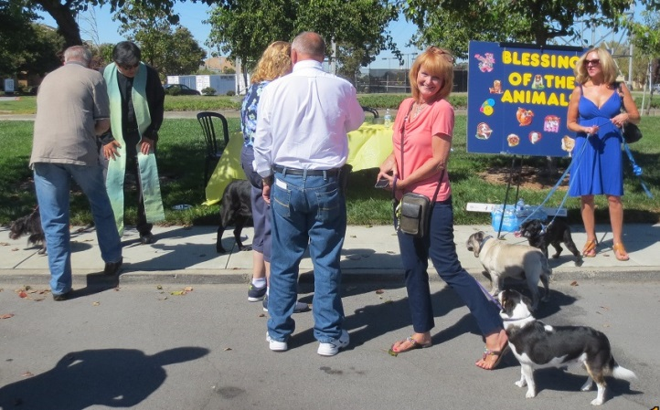
Blessing of the Animals: At the Foster City Dog Park on a very pleasant Sunday afternoon we greeted familiar faces, not all of them human. The occasion was the Blessing of the Animals, also known as the Feast of St. Francis in the Catholic and Anglican traditions.
One lady said that her 8-year-old had been coming for a blessing each year since he was a puppy.
Other owners were curious newcomers who had wandered over from the dog run.
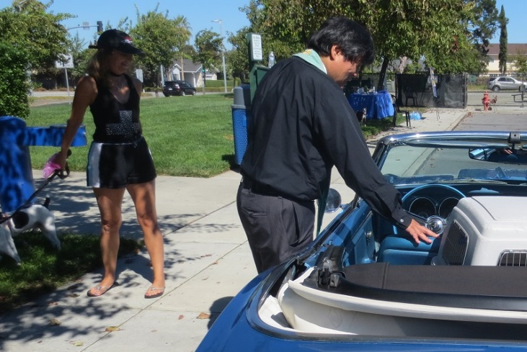
This is the ninth year that St. Ambrose clergy have celebrated the Blessing of the Animals at the Dog Park. The Revs. David Ota and Jay Watan blessed 30 animals and their owners.
Another lady asked Father Ota to pray for her two dogs and for her beloved ’67 Camaro; after seeing how important the latter was to her, he acceded to her wish.
Shelley Keefe collected $78 in donations for Project Bay Cat and the Homeless Cat Network. These organizations have been successful in spaying and neutering the feral cats which live along San Francisco Bay, while making sure that the cats are healthy and fed. Project Bay Cat is also supported by bird protection groups such as the Audubon Society. Cat and bird lovers joining together in common cause---somewhere St. Francis is smiling.

Upcoming Outreach Activities
Parents Night Out and CALL Primrose’s Fill a Box, Feed a Family: The Children and Family Ministry is hosting a Parents’ Night Out on Friday, November 7th from 6:00 p.m. to 8:30 p.m. with part of the night for the children filling six (6) boxes of food for families in need for Thanksgiving. The cost of the event is $10 per child.
CALL Primrose (a joint venture of the First Presbyterian Church of Burlingame and the United Methodist Church of Burlingame that has been helping low-income residents of the Peninsula since 1983) plans to give out food boxes to 300 families.
Each box will contain: 1 can cranberry sauce, 1 bag/box of stuffing, 2 cans green beans (low sodium preferred), 1 bag/box pasta, 1 box instant mashed potatoes, 1 pack/can of gravy, 1 pack/box of cornbread, 2 cans corn (low sodium preferred), 2 cans fruit (low sugar preferred), 1 can soup, 1 tomato sauce, and 1 boxed rice (rice pilaf, rice-a-roni, etc.)
If you can contribute one or more items, please write your name on the sign-up sheet on one or more boxes in the back of the Parish Hall and bring your item(s) by Sunday, November 9th for delivery the following week. (If you bring them earlier, the kids will pack them during Parents’ Night Out on November 7th.)
If you have any questions, please contact Fe Valentin (925-216-1588, valentin_fe@yahoo.com)
Sandwiches on Sunday: We serve a hot lunch to all comers on fifth Sundays of the month at the Fair Oaks Community Center in Redwood City. Turnouts have lately risen to about 80 people. On November 30th we’ll be serving salad and baked chicken and rice. If you can prepare a dish and/or help with serving and clean-up, please sign up on the sheet in the Parish Hall. If you have any questions, please contact Rob Richards (rob.richards@tensorlabs.com, 577-8924)
Senior Stocking Stuffers: Jill Schwab is again leading the effort to prepare “stocking stuffers” for seniors, veterans, and homeless people on the Peninsula. The date is Thursday, December 4th, from 10 a.m. to 3 p.m., and the place is Jill’s house on 501 Coos Court, a few blocks from the church. If you have questions or comments, please call Jill at 571-1079.
Family Sharing: Each year as we approach Christmas our congregation has adopted two San Mateo families who are Samaritan House clients. The families are different each year, but they always have 2-4 children. We are trying to collect at least $750 ($375 each), which will enable us to buy presents and gift cards that will be delivered during the week of December 14th. All donations should be made to St. Ambrose Episcopal Church, designated "Family Sharing", and deposited in the offering plate or mailed to the church office. Thank you for spreading holiday cheers to our neighbors.

“Not Everyone Who Wanders is Lost” - by Rev. Jay Sapaen Watan
Eight years ago I found myself walking the streets in Downtown Manhattan killing time before my flight back home. The skyscrapers and tall buildings created shadows and a canyon pathway, and while I had been to this city place many times before, I remember feeling lost because the lack of sun in the overcast of day can sometimes be disorientating. Also, the pace of walking here is very rushed. However, in the past I was always walking with someone else, so I didn’t really notice. So taking my time actually felt strange. I was in the heart of the Big City. My natural instinct is to seek the center of this place – The NY Stock Exchange, Ground Zero, Trinity Church – for reorientation. Then I saw this quote on a bumper sticker on a car that was covered in stickers on the rear bumper and window of that car. Our cars and certainly our bodies often reflect our theology and life experience - “War isn’t Working”, “COEXIST (using symbols of the world’s faiths)”, “The Episcopal Church Welcomes You”… etc. While it was the Episcopal Church shield decal that initially attracted my eye, on that tailgate collage, the intention of wandering resonated in my heart.
The freedom to walk for the sake of seeking beauty, listening to the heart, simply being present to God’s offering, or for self-discovery is a gift. As a priest, one of the great blessings of my vocation is the opportunity to seek God in everyday life and then share what I discover. I realize that many people may not have the bandwidth, time, or the awareness to go and do such. But my own walking and reflection may actually invite a Holy Spirit moment for someone else, so I invite you into that process of walking for the sake of walking. In it we can experience the sacred in everyday moments and discover the places of spirit where we can meet Jesus along the way. Often it happens when we are not looking for it. In my experience, wandering has lead me to where we need to be even if we’re not sure where we may be going at the beginning.
T.S. Eliot wrote, ‘We shall not ease from exploration and the end of all our exploring will be to arrive were we started and to know the place for the first time.” For myself, the Big City is like walking a labyrinth, you can feel lost at times, but such places allows life to come “full circle” and to help us grow into who we are becoming. Many of my journeys return me to the center, to a place where that sense of being connection resonates like a call from home to remind me of the Sprit that already resides within.
In my neighborhood, the Outer Mission District of San Francisco, there is place called Cayuga Park that became a local pilgrimage destination for 20 years. Because of the wooden carving, made from the park’s fallen tree, lined the park and an eclectic garden named “The Garden of Eden,” crafted and planted by city gardener Demi Braceros. His work drew people from all over to visit the once neglected park, and led to a community-organized movement to renew the park. It subsequently underwent a 3-year renovation in 2010, preserving the carvings, rebuilding the playground in a whimsical shape and providing a new playing field and clubhouse. When it reopened in 2013, Cayuga Park became arguably one of the best small urban parks in the country. When I walk here I am always reminded of how the Lord’s creation and human creativity can come together.
Dr. Lauren Artress, a priest and psychotherapist who reintroduced walking labyrinths as a spiritual practice in the United States writes, “The longing to be a co-creator with the Divine comes from the deep need of all people to discover their true vocation and best contribute their gifts.” I believe Mr. Braceros lived into his calling to help others find theirs. He planted a Redwood grove along with many different plants, trees and shrubs. And his faith is reflected in many of the carvings (Imagine Jesus and Mary standing next to Barry Bonds and Jose Rizal). He actually built an altar table in the middle of the park where I once celebrated the Eucharist during an urban pilgrimage for youth in our diocese. But the spiral pattern in this park is found in the pathways, wide or narrow, out in the open and hidden among the trees that invites us to take a walk. I see many people walk here, slowing their pace to simply be. You can always run in the streets. On the path is a place where spiritual heaviness can be released, because this place was made for walking. Ultimately the pathways, named “The Trail of Hope” return to the center of the park, connecting with a wide trail to the main entrance/exit way. There are no dead ends here… no getting lost, simply a circuit, a pathway to get reconnected to one’s center. That place where God draws our heart to be.

Sea Breeze School News
The excitement of Halloween is over and the children are now busy preparing for Thanksgiving. There are many fall themed activities in the classrooms and the preparations for the Thanksgiving feast in each classroom are well underway.
November is a busy time of year for the teachers as they are preparing for and delivering Parent/Teacher conferences. Parent conferences give us the opportunity to personally speak with each family about their child’s development and learn how we can best serve the family and the child. It is a great opportunity to build relationships with the families that we serve and a great way to open two way conversations in a quiet setting as opposed to trying to converse in a busy classroom.
The children in the Transitional Kindergarten class and in the Afterschool program have been busy working with Maureen Fromme to prepare for the Annual International Dinner. The children will dress in their native clothing and will sing many different songs from many different countries and enjoy a nice Dinner afterwards that will feature food from many different cultures. This dinner will be held at 6:30pm on November 21 and all are welcome to attend.
As the Holiday season is upon us, I challenge each of you to take a deep breath and remember to take care of yourself as you care for others. Think about what is important to you and what you are most thankful for in your lives.
Happy Thanksgiving to all of you from the staff at St. Ambrose Sea Breeze School.

